BOEM Marine Sensitivity Toolkit - Final Report, 2025
2025-11-04 17:28
Contents

List of Figures

List of Tables

Abstract
The Bureau of Ocean Energy Management (BOEM) has developed the Marine Sensitivity Toolkit (MST), a cutting-edge, cloud-native system for assessing the relative environmental sensitivity of marine ecosystems to offshore energy development across U.S. waters. This toolkit integrates over 17,000 spatially explicit species distribution models, comprehensive extinction risk data, and satellite-based primary productivity to deliver a transparent, reproducible, and scalable assessment framework. The MST operates at a high-resolution 0.05° grid, enabling detailed, cell-by-cell analysis that captures nuanced ecological patterns often missed by previous coarse assessments. Sensitivity scoring combines species presence, extinction risk, and productivity, all rescaled within ecologically meaningful ecoregions. The MST is designed for transparency and rapid updates, ensuring that BOEM’s decisions are grounded in the best available science as mandated by Executive Order 14303: Restoring Gold Standard Science.

Background
The Bureau of Ocean Energy Management (BOEM) is legally mandated by Section 18(a)(2)(G) of the Outer Continental Shelf Lands Act (OCSLA) to consider “the relative environmental sensitivity and marine productivity of different areas of the OCS” when making decisions regarding offshore energy development. This analysis is essential for guiding the placement of energy infrastructure and for implementing mitigation measures to minimize impacts on the marine environment.
In direct response to Executive Order 14303: Restoring Gold Standard Science (Federal Register, May 29, 2025), BOEM has modernized its approach by developing and implementing the Marine Sensitivity Toolkit (MST). This innovative, cloud-native toolkit fundamentally revamps BOEM’s previous Relative Environmental Sensitivity Analysis (RESA) (BOEM 2018), delivering a transparent, reproducible, and scalable system that fully aligns with the Executive Order’s requirements for scientific integrity, transparency, and the use of best-available science.
The MST marks a significant advancement over prior RESA methodologies. Earlier approaches (Niedoroda et al. 2014) often relied on aggregated data from a limited set of broad species groups and surrogate species, lacking spatially explicit information for individual organisms. As a result, previous assessments were typically coarse and area-wide, frequently missing critical ecological variation and fine-scale patterns across the OCS. In contrast, the MST utilizes a high-resolution 0.05° grid (averaging 5 km in the lower 48 states and 3.6 km in Alaska), enabling detailed, cell-by-cell analysis that captures nuanced ecological patterns.
Further offshore, observational data becomes increasingly sparse. And observation data is generally only applicable to the time and place of occurrence, unless a relationship is modeled between the environment and the observations. In which case, species distribution models can be applied across the seascape (Elith and Leathwick 2009).
A cornerstone of the MST is its integration of over 17,000 spatially explicit species distribution models, comprehensive extinction risk data (using IUCN Red List categories), and satellite-based primary productivity. This robust data integration delivers a more accurate, comprehensive, and scientifically defensible assessment of marine sensitivity across U.S. waters.
Sensitivity scoring within the MST is fully transparent and quantitative, combining species presence, extinction risk, and productivity, all rescaled within ecologically meaningful ecoregions. The MST is cloud-native, open-source, and designed for transparency, reproducibility, and rapid updates. All 27 OCS planning areas, including the new High Arctic, are included in the sensitivity analysis. The smallest unit of analysis is a 0.05° cell, ensuring fine-scale resolution. Planning Area scores are aggregated from these cells based on percent overlap and are rescaled within each BOEM Ecoregion (BOEM 2018) to ensure comparability across diverse ecological contexts. The High Arctic Planning Area is treated as its own dedicated ecoregion. As the 2025–2030 Program advances, BOEM will continue to refine and enhance this sensitivity analysis, upholding the principles and directives of Executive Order 14303 and ensuring that decisions are grounded in the best available science.

Objectives

Methods
The Marine Sensitivity Toolkit (MST) is BOEM’s comprehensive, next-generation system for assessing the vulnerability of marine ecosystems to offshore energy development across U.S. waters. The MST builds on BOEM’s established framework by integrating advanced species distribution models, extinction risk assessments, and primary productivity data to deliver a unified, spatially explicit vulnerability score. The MST’s conceptual framework is grounded in ecological risk assessment, where vulnerability (V) is a function of exposure (E), sensitivity (S), and adaptive capacity (A):
$$V=f\left(E,S,A\right)$$
The more exposed and sensitive an area is—and the less able it is to recover—the more vulnerable it is to impacts from offshore activities. For spatial implementation, the vulnerability of a cell ($v_{c}$) is calculated as the sum across all species in the given taxonomic group ($S_{g}$) of the products for the species presence in the cell ($p_{sc}$) and a species weight ($w_{s}$), which is the risk of that species going extinct:
$$v_{c}=\sum_{1}^{S_{g}}{p_{sc}}*w_{s}$$
In other words, for each cell in the ocean, we add up the sensitivity of all the species found there.
- $v_{c}$ is the vulnerability of a cell.
- $p_{sc}$ is how likely species s is to be present in that cell (from 0 to 1).
- $w_{s}$ is how at-risk that species is of going extinct (also from 0 to 1; ranging from Least Concern 0.2 to Critically Endangered as 1).
- $S_{g}$ is the total number of species in that taxonomic group.
If a cell has many species that are both likely to be present and at high risk of extinction, it gets a higher sensitivity score. This helps us find places where rare or threatened species are concentrated. Ecoregional rescaling makes it easy to compare areas within the same region and planning area aggregation gives us an overall sensitivity score for each planning area, taking into account both the sensitivity of each part and how big each part is.

Data Sources and Processing
The MST integrates multiple authoritative data sources to provide comprehensive species coverage across taxonomic groups:

Species Distribution Models
The MST incorporates 17,333 species distribution models from five complementary data sources, each providing unique taxonomic or geographic coverage:
AquaMaps Global Species Distribution Models (17,550 species): AquaMaps provides suitability models for marine species (excluding birds) at global scale. Native resolution (0.5° Half-Degree Cell Authority File; ~55 km at equator) was downscaled to 0.05° (~5.5 km) using bilinear interpolation, following methods in ingest_aquamaps_to_sdm_duckdb.qmd. Models provide continuous suitability values [0-100%] based on environmental envelopes including depth, temperature, salinity, primary productivity, and sea ice concentration. The downscaling process involved: (1) reading monthly HDF files from AquaMaps, (2) applying bilinear interpolation to match the 0.05° Bio-Oracle reference grid, (3) masking to BOEM Planning Areas with 10 km buffer, and (4) validating against contemporary OBIS/GBIF occurrence records.
BirdLife Birds of the World (573 species): Expert-reviewed range maps for all seabird species at global scale, processed from BOTW 2024.2 geodatabase. Binary presence/absence maps were rasterized to 0.05° resolution with 50% presence value following standard range map conventions. Taxonomic authority cross-referenced with WoRMS, ITIS, and IUCN databases.
NMFS Critical Habitat (34 species): Designated critical habitat for federally-listed marine species under NMFS jurisdiction. Polygons rasterized to 0.05° with presence values of 70% (Threatened) or 90% (Endangered) to reflect conservation status and regulatory protection levels.
FWS Critical Habitat (29 marine/coastal species): Critical habitat for federally-listed species under FWS jurisdiction, filtered to marine and coastal birds (18 species), marine fishes (3), marine mammals (3), and sea turtles (5). Processing workflow in ingest_fws.gov_critical-habitat.qmd included: (1) extracting marine species using WoRMS isMarine flag, (2) standardizing ESA status codes (Proposed/Final × Threatened/Endangered), (3) rasterizing with 70-90% presence values, and (4) taxonomic validation through WoRMS and ITIS.
FWS Current Range Maps (106 marine/coastal species): Contemporary species ranges for ESA-listed species, providing broader geographic extent than critical habitat. Filtered from 796 total species to 106 marine/coastal taxa (82 birds, 9 fishes, 4 marine mammals, 7 sea turtles, 4 invertebrates) using WoRMS marine classification. Status-dependent rasterization: Least Concern (50%), Threatened (70%), Endangered (90%).
All species distribution data were standardized to a common 0.05° grid (SpatRaster with 2006 × 3103 cells = 6,224,618 cells covering BOEM Planning Areas), ensuring spatial consistency for biodiversity metric calculation. Grid cells range from 2.0-5.5 km width, with finer resolution at higher latitudes.

Taxonomic Integration and Validation
Species names were cross-referenced across multiple taxonomic authorities to ensure nomenclatural consistency and link extinction risk assessments:
- WoRMS (World Register of Marine Species): Primary authority for marine taxa; 16,853 species matched with isMarine and isExtinct flags
- GBIF (Global Biodiversity Information Facility): Secondary authority for broader taxonomic coverage; 682 additional matches
- ITIS (Integrated Taxonomic Information System): Validation of North American species; used for FWS datasets
- IUCN Red List: Extinction risk categories matched for 6,490 species via API and DarwinCore archive
- BirdLife Taxonomic Authority: Authoritative source for avian taxonomy with 11,195 species and synonyms
The taxonomic matching pipeline (detailed in ingest_taxon.qmd) handled outdated classifications, synonyms, and taxonomic revisions by: (1) querying multiple authorities in parallel, (2) prioritizing accepted names over synonyms using taxonomicStatus ordered factors, (3) updating deprecated taxon IDs to current accepted IDs, and (4) reconciling conflicts through expert taxonomic sources.

Extinction Risk
IUCN Red List categories and ESA status codes were standardized to numeric risk scores for use in sensitivity calculations. Risk scores weight species presence by extinction probability, with CR (Critically Endangered) = 1.0, EN (Endangered) = 0.8, VU (Vulnerable) / TN (ESA Threatened) = 0.6, NT (Near Threatened) = 0.4, and LC (Least Concern) = 0.2. For species with multiple assessments (e.g., global and regional), the most recent assessment was used. ESA-listed species without IUCN assessments were assigned equivalent risk scores based on listing status. The precautionary principle was applied when species had multiple conservation statuses (e.g., Threatened in one region, Endangered in another), using the higher risk category.
Table 1: Extinction risk categories from the international IUCN Red List as well as USA Endangered Species Act (ESA) categories and assigned numeric risk scores.
Code | Category | Risk Score | Weight
CR | Critically Endangered (IUCN) | 1.0 | Highest
EN | Endangered (IUCN, ESA) | 0.8 | High
VU | Vulnerable (IUCN) / Threatened (ESA) | 0.6 | Moderate
NT | Near Threatened (IUCN) | 0.4 | Low
LC | Least Concern (IUCN) | 0.2 | Lowest

Primary Productivity
Net Primary Productivity (NPP) was calculated using the Vertically Generalized Production Model (VGPM) (Behrenfeld and Falkowski 1997) with VIIRS satellite data (R2022 version) for the most recently completed decade (2014 to 2023). The VGPM is a chlorophyll-based model that estimates net primary production using a temperature-dependent description of chlorophyll-specific photosynthetic efficiency. Monthly NPP data at 0.083° resolution (2160×4320 global grid) were downloaded from Oregon State University’s Ocean Productivity website as HDF files, processed to extract NPP values (units: mg C m⁻² day⁻¹), and averaged annually for each year. The 10-year mean and standard deviation were then calculated across all years. The high-resolution productivity raster was downsampled to match the 0.05° species distribution grid using bilinear interpolation and masked to the study area. For Planning Area summaries, zonal statistics were computed using area-weighted means, and values were converted to metric tons C km⁻² yr⁻¹ for easier interpretation.

Spatial Aggregation and Rescaling
Scores from individual grid cells are aggregated to BOEM Planning Areas using area-weighted averages. To enable meaningful comparisons across ecologically diverse regions, sensitivity scores are rescaled within BOEM Ecoregions [0-100]. This ecoregional rescaling accounts for natural differences in species richness, productivity, and baseline extinction risk between Arctic, temperate, and tropical waters. Planning Area scores represent the area-weighted average of constituent cell scores, ensuring larger areas do not disproportionately influence regional sensitivity patterns.

Data Quality Control and Validation
Multiple quality control procedures ensure data integrity and biological realism:
Spatial Validation: All species distributions were validated against independent occurrence data from OBIS (Ocean Biodiversity Information System) and GBIF. Distributions showing implausible ranges (e.g., Pacific Walrus presence in Atlantic waters due to outdated AquaMaps data) were flagged for revision using temporal occurrence filters (10, 20, and 50-year windows) and expert validation.
Taxonomic Reconciliation: Duplicate species records arising from taxonomic synonyms were resolved using ordered taxonomicStatus factors (accepted > unassessed > unaccepted). For WoRMS matches with multiple candidate taxa (n=270 species with 2-9 matches each), the accepted name was preferentially selected. Species with conflicting classifications across authorities were manually reviewed.
Range Map Realism: Critical habitat and range map polygons were validated for geometric validity (st_make_valid()) and topological errors. Rasterization artifacts (e.g., slivers < 2 km²) were reassigned to the dominant ecoregion. Anti-meridian crossing geometries were corrected using st_shift_longitude() and st_wrap_dateline() transformations.
Presence Value Calibration: Continuous suitability models (AquaMaps: 0-100%) were used directly, while binary range maps were assigned presence values reflecting data quality: Critical Habitat (70-90%) reflects high-quality, legally-designated areas; expert range maps (50%) reflects broader, less certain extents following IUCN Species Information Service conventions.
Temporal Currency: Primary productivity data (2014-2023) and species assessments (most recent IUCN evaluation) ensure temporal consistency. Historic distributions were updated where contemporary evidence (e.g., recent surveys, range shifts) indicated change.

Geographic Scope
The MST uses BOEM Ecoregions as its primary geographic units. These ecoregions are defined by Large Marine Ecosystem boundaries, bathymetry, hydrography, productivity, and species composition. The analysis is conducted at a 0.05° grid resolution (6,224,618 cells after masking to study area), providing detailed coverage across U.S. waters including all 27 BOEM Planning Areas (19 in lower 48 states/territories, 8 in Alaska) spanning Arctic, temperate, and subtropical marine ecosystems.
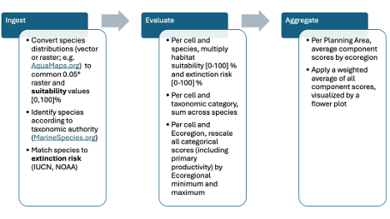
Figure 1: Environmental Sensitivity Score Methodology.
Visualization and Decision Support :The MST utilizes interactive visualizations, such as the Flower Plot, to convey complex vulnerability assessment results. This tool allows stakeholders and scientists to understand the underlying components contributing to an area’s vulnerability to offshore energy development. The length of each petal reflects the sensitivity score for a particular component or taxonomic group, while future iterations may use petal width to represent component weighting. By visualizing these component scores, the Flower Plot helps decision-makers quickly identify which ecological elements are driving vulnerability in a given location, supporting more informed spatial planning and impact assessment.

Results

Species Distributions
Table 2: Species distribution datasets contributing to the Marine Sensitivity Toolkit. Response values indicate presence probability or suitability. Resolution shows native format and standardization method. Critical Habitat presence values vary by ESA status (Threatened: 70%, Endangered: 90%). Range map presence values reflect data certainty (legally-designated habitat: 70-90%, expert range maps: 50%). AquaMaps suitability values represent environmental envelope models. All datasets standardized to common 0.05° grid for analysis.
Dataset | Response | Geography | Taxonomy | # Species in USA | Resolution
AquaMaps | Suitability  [0-100%] | Global | All marine taxa  (except birds) | 17,550 | 0.5° → 0.05°  (bilinear)
BirdLife Birds of the World | Range  [50%] | Global | Seabirds | 573 | Vector → 0.05°  (50%)
NMFS Critical Habitat | Range  [70-90%] | USA | Listed marine species | 34 | Vector → 0.05°  (70-90%)
FWS Critical Habitat | Range  [70-90%] | USA | Marine/coastal  (18 birds, 3 fish,  3 mammals, 5 turtles) | 29 | Vector → 0.05°  (70-90%)
FWS Current Range Maps | Range  [50-90%] | USA | Marine/coastal  (82 birds, 9 fish,  4 mammals,  7 turtles,  4 invertebrates) | 106 | Vector → 0.05°  (status-dependent)
Total (unique species) | Mixed | USA | All marine taxa | 17,333 | 0.05° standard |

Primary Productivity
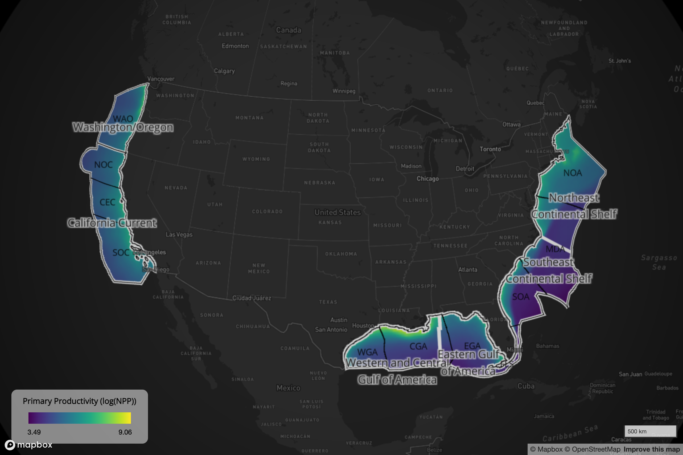
Figure 2: Map of Contiguous US Primary Productivity by pixel.

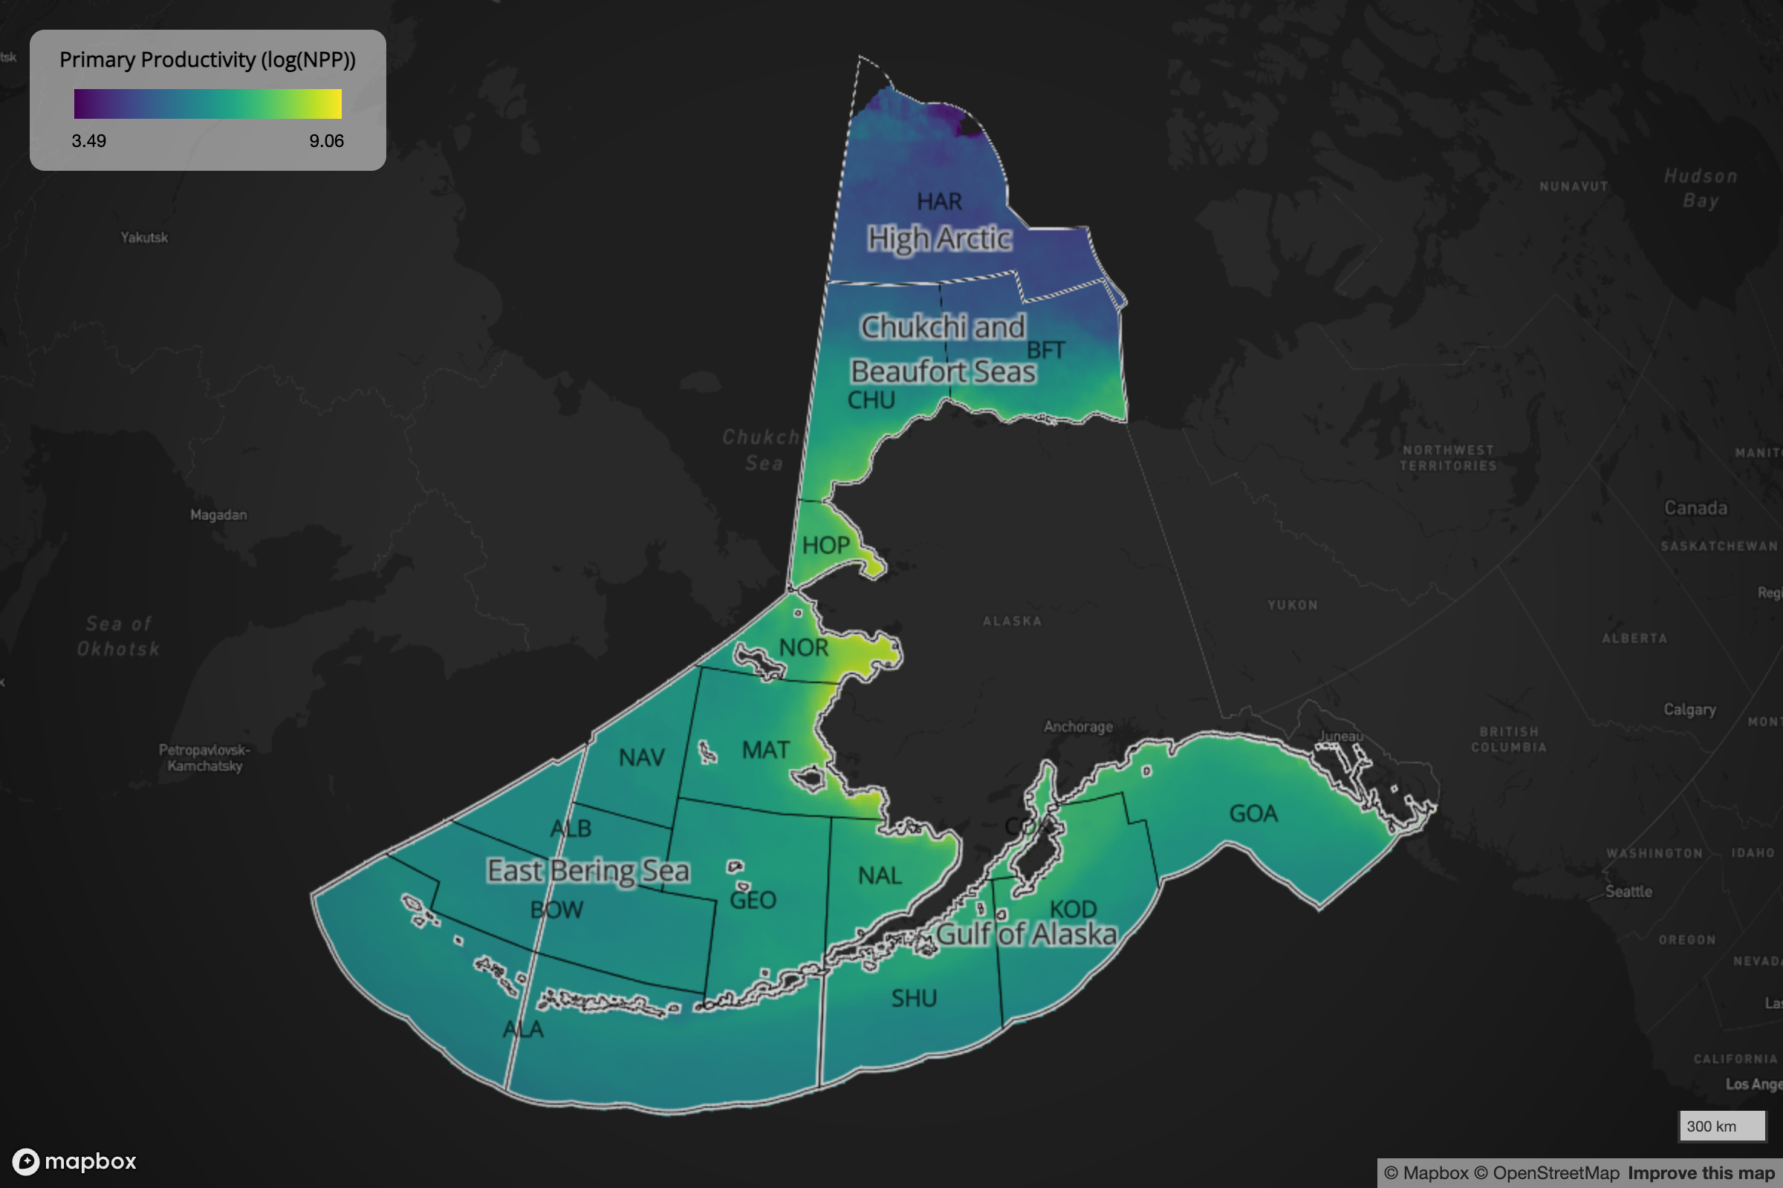
Figure 3: Map of Alaska Primary Productivity by pixel.

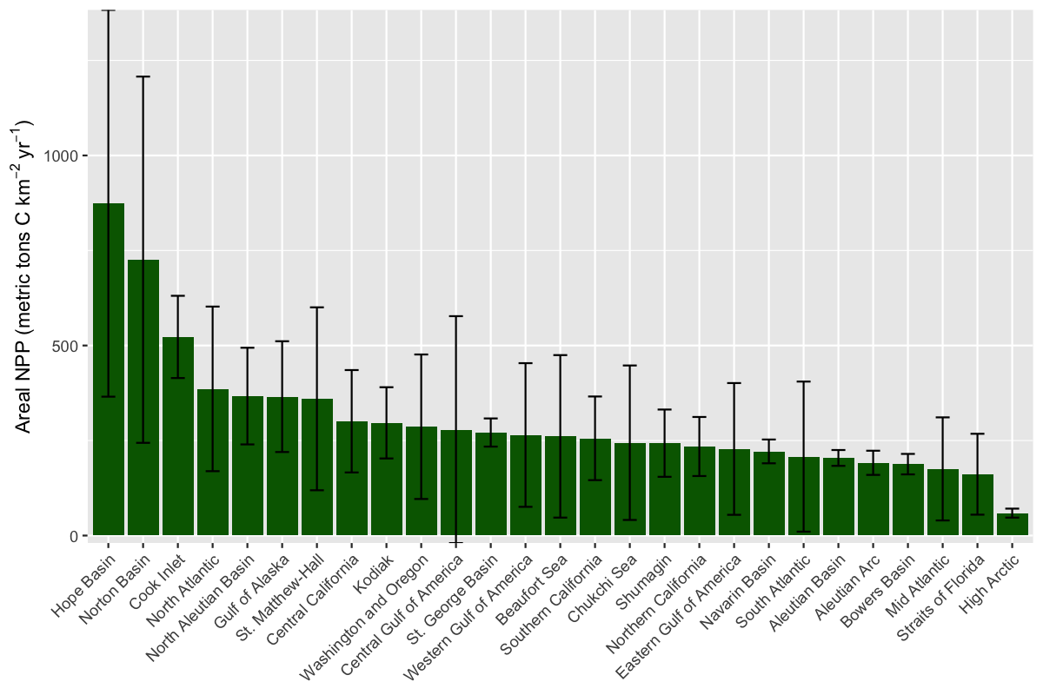
Figure 4: Plot of net primary production (NPP) per Planning Area. Values represent the mean and the standard deviation of 10 annual values for the 2014–2023 period, standardized per unit area.

Maps of Environmental Sensitivity by Pixel
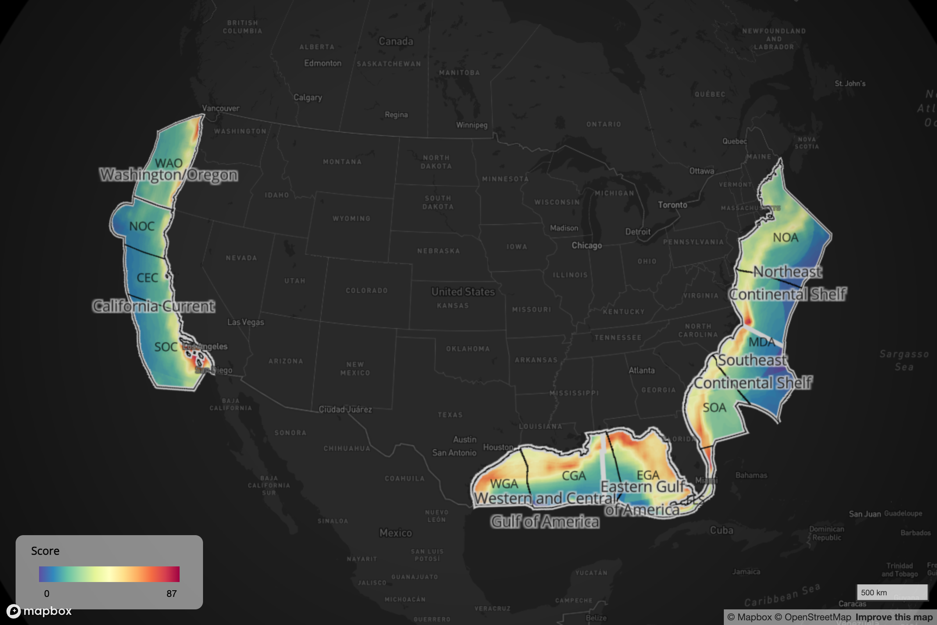
Figure 5: Map of Contiguous US scores by pixel.

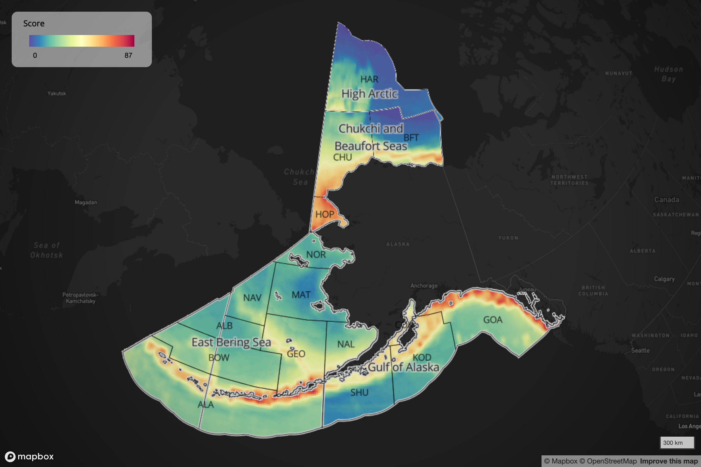
Figure 6: Map of Alaska scores by pixel.

Maps of Environmental Sensitivity by Planning Area
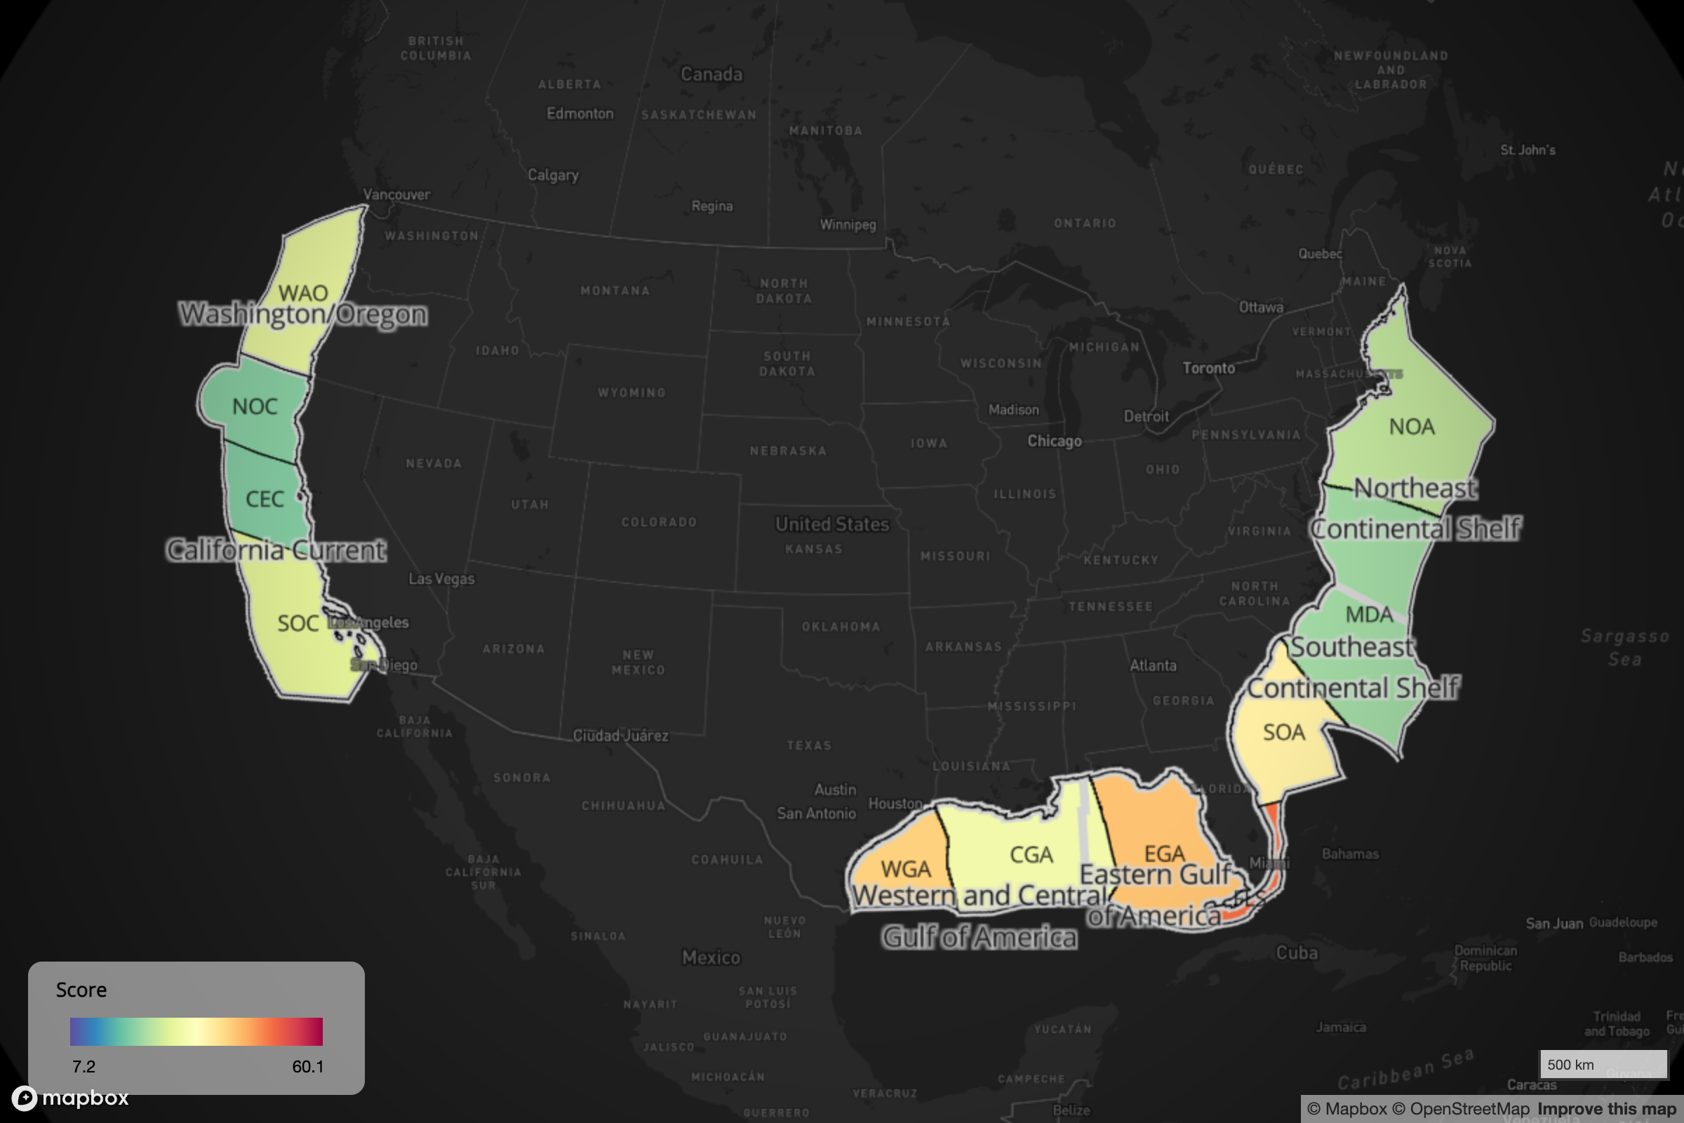
Figure 7: Map of Contiguous US scores by Planning Area.

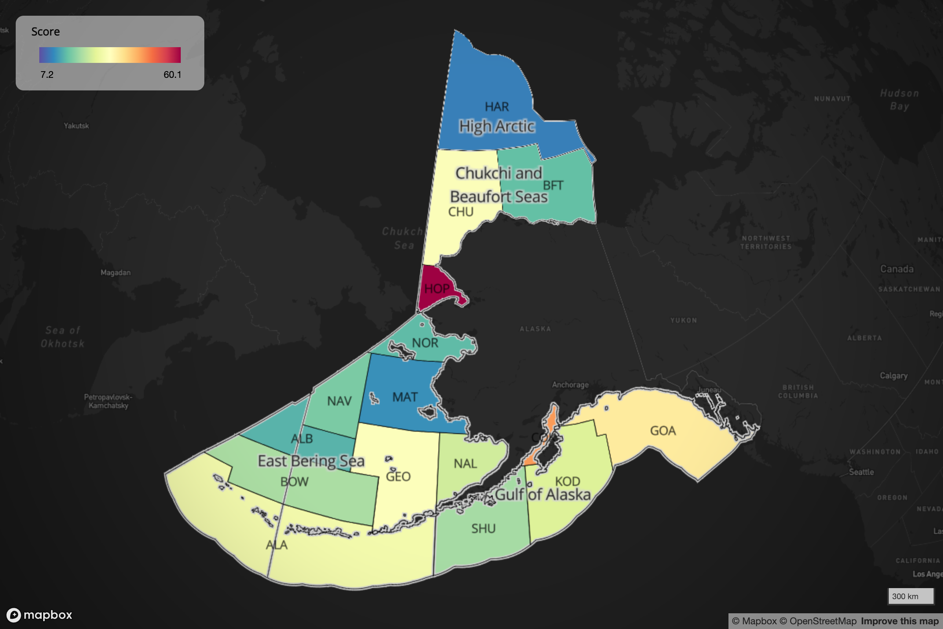
Figure 8: Map of Alaska scores by Planning Area.

Flower Plot Scores of Environmental Sensitivity by Planning Area
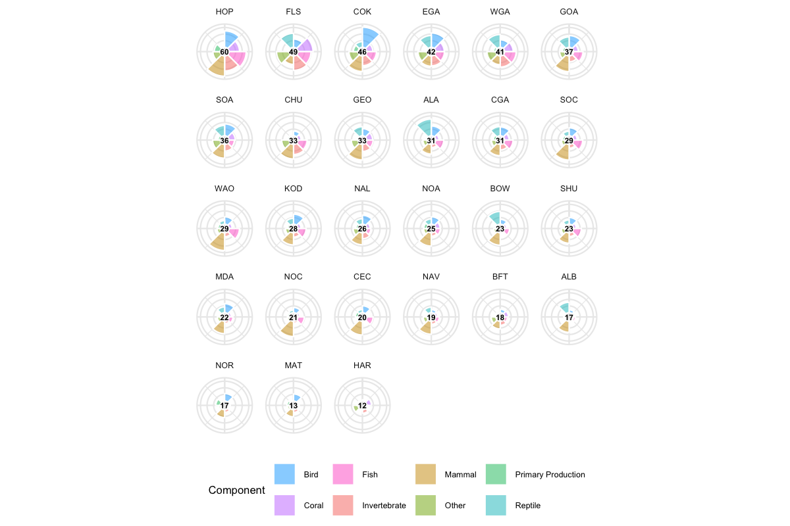
Figure 9: Component and aggregate scores of Marine Environmental Sensitivity in each BOEM Planning Area summarized across taxonomic groups and Primary Productivity. The “petals” of the flower plot represent the component scores and the overall score is given by average number in the middle.

Online Mapping Application
The MST includes an interactive web application that allows users to explore the sensitivity scores across different planning areas and taxonomic groups. This tool provides a user-friendly interface for visualizing the data and understanding the spatial distribution of marine sensitivity.
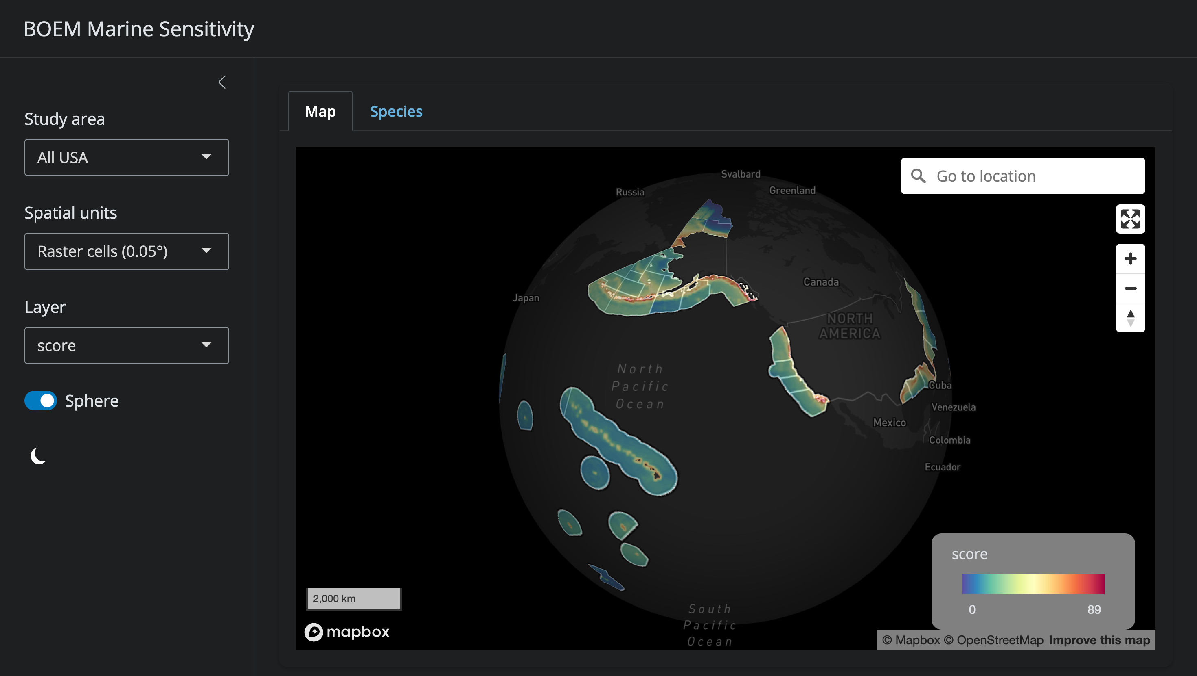
Figure 10: Screenshot of the main app: mapgl showing the raster score for all USA waters.

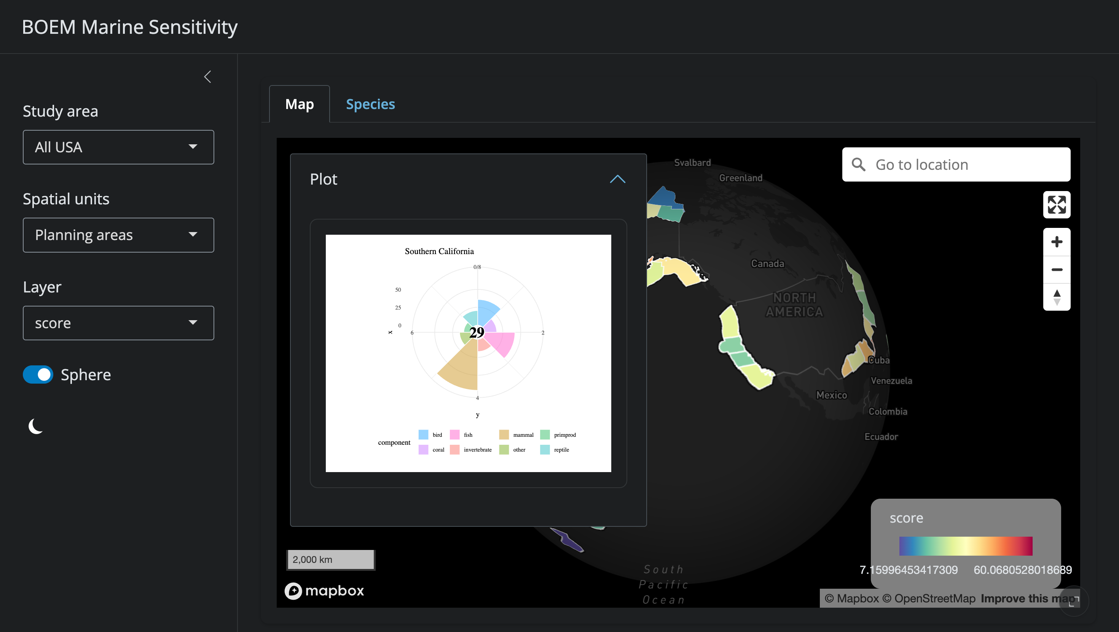
Figure 11: Screenshot of the main app: mapgl showing the Planning Area with flower plot containing component scores as petals and overall score in the middle.

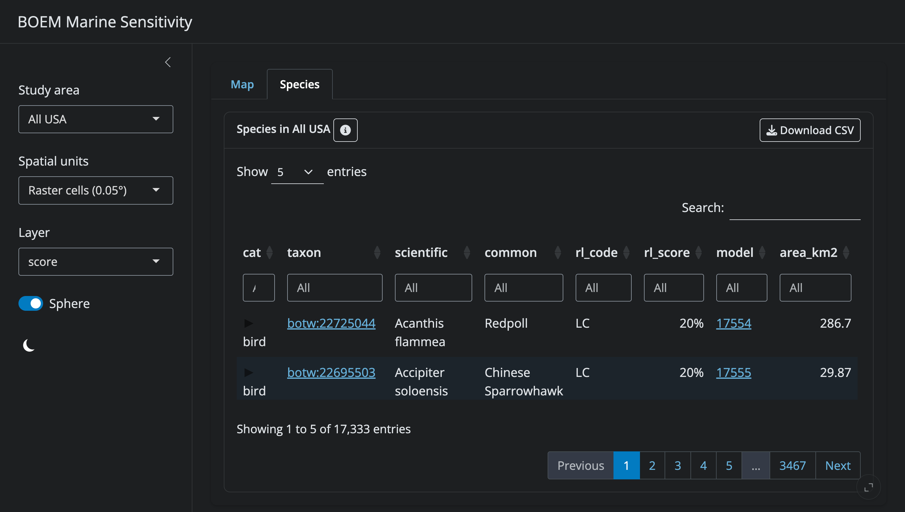
Figure 12: Screenshot of the main app: mapgl showing the Species table. Clicking on the information icon explains the columns and how to interpret the values.

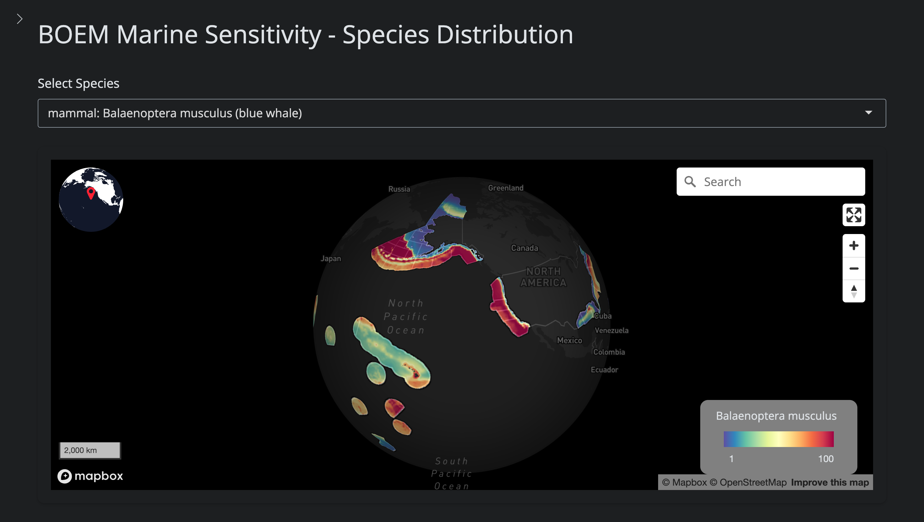
Figure 13: Screenshot of the species distribution app: mapsp showing the species distribution, in this case for the blue whale which is globally distributed.
The main app mapgl app (Figure 10; Figure 11; Figure 12) shows the overall scores and any underlying components by 0.05° raster cell or Planning Area, all masked by the chosen Study area. The model link in the Species table (Figure 12) links to the species distribution app mapsp (Figure 13), which shows the distribution of the species, in this case for the blue whale, which is globally distributed.

Reproducible Infrastructure
The MST is built using open-source tools and is designed for transparency and reproducibility. The entire workflow, from data acquisition to sensitivity scoring, is documented and available for review. This ensures that the analysis can be updated as new data becomes available or as methodologies evolve.
The tasks and full scope of this work is iterative in nature. In Phase 1, the project iterated on 6 core infrastucture components corresponding to the Github repositories that demonstrated work towards the project goals. In Phase 2, we are adding Database and Website as infrastucture components.

Server
Server
All server software is setup using containerized open-source software with Docker to readily spin up the necessary services (particularly: Shiny, RStudio, R Plumber, PostGIS, caddy and pg_tileserv, titiler).

Database
A spatially enabled Postgres database serves the vector data, while being supplemented by the performance and portability of DuckDB for generating on-the-fly rasters of biodiversity metrics.

Workflows
Workflows
The scientific workflows comprise of notebooks that perform exploration, creation and ingestion processes while rendering markdown and chunks of scientific languages (R or Python) into rendered html for inspection and archive.

APIs
APIs
The application programming interfaces (API) enable standardized retrieval of data products from the server with simple parameters for visualization and analytics, such as the vector tile API at tile.marinesensitivity.org (via pg_tileserv), raster tile API at titiler.marinesensitivity.org (via TiTiler) or the custom API at api.marinesensitivity.org (via Plumber).

Libraries
Libraries
Packaging functions with documentation enables reusability across analysis and visualization for simplifying existing applications while extending functionality to outside projects. Phase 2 will build upon the existing msens for analyzing biodiversity data on the desktop, while adding another library for internally ingesting and maintaining the database.

Apps
Apps
The applications have all been built with the R Shiny framework. From Phase 1, the core application is at shiny.marinesensitivity.org/mapgl, and links out to the individual species mapper shiny.marinesensitivity.org/mapsp. Other experimental applications can be found at marinesensitivity.org/docs/apps.html. We anticipate expanding upon the core applications and continuing to experiment with others in Phase 2. The apps actively use functions from the libraries, APIs and direct database calls.

Docs
Docs
The documentation is principally a book (rendered from Quarto) oriented for scientific and technical audiences, but also applies to documentation throughout the project for reproducibility and usability.

Website
Website
The website marinesensitivity.org provides the project landing page with the general public as the initial audience, with content and links (such as to the docs) for deeper understanding.

Conclusions
The Marine Sensitivity Toolkit represents a transformative advancement in BOEM’s capability to fulfill its statutory mandate under Section 18(a)(2)(G) of the Outer Continental Shelf Lands Act to consider “the relative environmental sensitivity and marine productivity of different areas of the OCS.” By integrating 17,333 species distribution models, comprehensive extinction risk data, and decade-averaged primary productivity across 6.2 million high-resolution grid cells, the MST delivers unprecedented spatial detail and taxonomic coverage for environmental decision-making.

Alignment with FAIR Data Principles
The MST fully embodies FAIR (Findable, Accessible, Interoperable, Reusable) data principles, ensuring long-term utility and scientific integrity:
Findable: All data products, code repositories, and documentation are indexed through persistent URLs at marinesensitivity.org with comprehensive metadata. Species distributions are linked to authoritative taxonomic identifiers (WoRMS AphiaID, GBIF taxonID, ITIS TSN, IUCN taxon ID), enabling unambiguous species lookup across databases. DOIs will be assigned to major data releases for permanent scholarly citation.
Accessible: Interactive web applications (https://shiny.marinesensitivity.org/mapgl/) provide immediate public access to sensitivity scores and underlying data without requiring specialized software. Programmatic access through RESTful APIs (tile.marinesensitivity.org, api.marinesensitivity.org) enables automated data retrieval for research and operational applications. All source code is publicly available through GitHub under open-source licenses.
Interoperable: Data products adhere to Open Geospatial Consortium (OGC) standards including GeoTIFF, GeoJSON, and vector tiles. DuckDB analytical database enables SQL-based querying with spatial extensions. Future deployment of STAC (SpatioTemporal Asset Catalog) catalogs will enable seamless integration with cloud-native geospatial workflows. Species taxonomies are cross-referenced to ensure interoperability with OBIS, GBIF, IUCN, and other biodiversity platforms.
Reusable: Complete analytical workflows are documented in executable Quarto notebooks (e.g., ingest_aquamaps_to_sdm_duckdb.qmd, ingest_productivity.qmd, calc_scores.qmd) with explicit provenance from raw data to final products. Modular R packages (msens) provide reusable functions for sensitivity analysis beyond BOEM applications. Comprehensive metadata describe data quality, uncertainty, and appropriate use limitations.

Meeting Executive Order 14303 Requirements
In direct response to Executive Order 14303: Restoring Gold Standard Science (May 29, 2025), the MST exemplifies scientific integrity through:
Best Available Science: Integration of the most current, peer-reviewed data sources including AquaMaps 2019, BirdLife BOTW 2024.2, IUCN Red List 2025, VIIRS-VGPM 2023, and ESA critical habitat as of 2025. Regular update cycles ensure incorporation of new species assessments, range shifts, and improved distribution models.
Transparency: Every analytical step is documented with source code and intermediate outputs publicly accessible. Sensitivity scoring algorithms are mathematically explicit with clear justification for weighting schemes. Quality control procedures are documented, including handling of data conflicts and uncertainty.
Reproducibility: Complete computational environment specified through Docker containers and R package versions. Workflows use directed acyclic graphs (DAGs) to track data dependencies, ensuring any component can be regenerated from source data. Version control through GitHub enables tracking of methodological evolution.
Peer Review: Methods build upon established ecological risk assessment frameworks (e.g., IUCN spatial data standards, VGPM productivity model validation literature) with transparent adaptation for BOEM’s decision context.

Rapid Species-at-Risk Assessment
The MST provides unprecedented capability for rapid identification and characterization of species at elevated risk within proposed lease areas:
Fine-Scale Spatial Resolution: 0.05° grid cells (2-5.5 km) capture habitat heterogeneity and localized species hotspots often missed by coarser assessments. This resolution enables differentiation of sensitivity within planning areas, supporting site-specific lease stipulations.
Taxonomic Comprehensiveness: Coverage of 17,333 species across all major marine taxa (6,682 fishes, 8,525 invertebrates, 505 birds, 819 corals, 99 mammals, 42 turtles) ensures no major taxonomic group is overlooked. Critical Habitat and ESA range maps provide legally-mandated coverage of federally-listed species.
Extinction Risk Integration: Direct linkage of species distributions to IUCN Red List and ESA status enables immediate identification of threatened and endangered species within any area of interest. The precautionary principle (using maximum risk category when multiple assessments exist) ensures conservative risk characterization.
Dynamic Query Capability: Interactive applications enable real-time exploration of sensitivity drivers. Users can identify which specific species, taxonomic groups, or risk categories contribute most to a location’s sensitivity score, facilitating targeted impact assessment and mitigation design.
Ecoregional Context: Rescaling within ecoregions provides ecologically meaningful comparisons. A “moderate” sensitivity score in the species-rich Gulf of America represents fundamentally different ecological conditions than the same score in the Arctic, enabling region-appropriate decision-making.

Foundation for Mitigation and Adaptive Management
Sensitivity scores directly inform multiple stages of offshore energy development planning and mitigation:
Lease Area Identification: High-resolution sensitivity maps (Figure 5, Figure 6) enable identification of lower-sensitivity areas for priority leasing while avoiding biodiversity hotspots and endangered species habitat. Flower plots (Figure 9) reveal which taxonomic groups drive sensitivity, informing taxonomic-specific avoidance.
Temporal Restrictions: Integration of seasonal species distribution models (future Phase 2 enhancement) will support temporal lease stipulations (e.g., avoiding construction during seabird breeding seasons, marine mammal calving periods, or sea turtle nesting migrations).
Site-Specific Stipulations: Cell-level sensitivity scores enable graduated mitigation requirements scaled to local ecological importance. Areas with CR (Critically Endangered) species presence may require enhanced monitoring, operational restrictions, or exclusion zones beyond standard best management practices.
Cumulative Impact Assessment: Standardized sensitivity metrics enable quantitative evaluation of cumulative effects across multiple projects. Summing impacted cell scores provides objective basis for determining when cumulative thresholds warrant enhanced mitigation or alternative analysis.
Adaptive Management Triggers: Baseline sensitivity characterization establishes quantitative monitoring targets. Post-construction monitoring can assess whether observed impacts remain within predicted sensitivity envelopes, triggering adaptive management when thresholds are exceeded.
Mitigation Hierarchy Application: The MST supports systematic application of the mitigation hierarchy (avoid > minimize > restore > offset). High sensitivity areas inform avoidance strategies. Moderate sensitivity areas guide minimization measures. Quantified sensitivity losses inform compensatory mitigation scaling.
Climate Adaptation: As species distributions shift with changing ocean conditions, updateable models ensure mitigation strategies remain effective. Comparison of current versus projected future sensitivity enables climate-informed long-term planning.

Scientific and Policy Implications
The MST methodology is readily transferable to other ocean planning contexts including marine protected area design, essential fish habitat designation, shipping route optimization, and marine spatial planning. The open-source, cloud-native architecture enables adoption by other agencies and nations with minimal technical barriers. As species distribution models improve, extinction risk assessments update, and new data sources emerge, the MST provides a stable framework for incorporating best available science into iterative planning cycles, fully realizing the vision of Executive Order 14303 for transparent, reproducible, science-based environmental decision-making.

Next Steps
The MST is designed to be a living system that can be updated as new data becomes available or as methodologies evolve. Future enhancements may include incorporating additional data sources and refining sensitivity scoring methods.

Refinement and Expansion of Environmental Sensitivity Models
Currently, some models produce biologically unrealistic outputs (e.g., the Pacific Walrus model reflecting outdated historical extents). Therefore, we will revise and constrain species ranges using corroborating evidence from contemporary datasets, such as OBIS and GBIF occurrences. This will ensure all model outputs are based on validated, present-day species data.
The AquaMaps dataset, although numerous with species distributions, sometimes includes historic extents and not present-day extents for which the species are currently found. In Phase 1, we did not have the resources to validate all species distributions, but in Phase 2, we will use the OBIS and GBIF occurrence data to validate the AquaMaps distributions. For instance, we will experiment with applying occurrence filters across different time windows (e.g. 10, 20 and 50 years) and to different areas (e.g., Ecoregions and Planning Areas). We will also compare results with other independent distributional datasets (e.g., IUCN Spatial range maps). This will help us identify and correct aberrant species distributions within the models, such as the Pacific Walrus model reflecting outdated historical extents.

Enhancement and Utilization of the Marine Sensitivity Toolkit (MST) and Geospatial Tools
In Phase 1, we ended up using a DuckDB database to ingest, store and render all the distributions and biodiversity metrics. In Phase 2, we will export these to cloud-optimized GeoTIFFs (COGs) and organize them into spatio-temporal asset catalogs (STACs). This will enable faster rendering in the applications (e.g., see app: sdm-cog, which uses COGs and the TiTiler API) and easier reuse by the general public (e.g., stackstac example). We will also explore customizing our own TiTiler endpoint to generating raster outputs based on various input parameters, such as taxa and stressor. Besides the pixel, we will explore using Uber’s H3 hexagons, which are hierachical in nature, and play well with our existing mapping software (mapgl) in that only the hexagon identifier needs to be transmitted to the client and the client library can render the hexagon geometry (e.g., H3 Tutorial: Suitability Analysis | Observable). We will also explore using PMTiles, which also work with our mapping software, to provide easily stored vector tiles (i.e., on S3 or any web server and do not require the PostGIS + pg_tileserv stack or similar) and the ability to join them with arbitrary attribute data for rendering as choropleths. This will be useful for summarizing to any area of interest, as well as visualizing any set of polygons. Finally, we will keep abreast of the ever-changing technical landscape with regards to Cloud-Optimized Geospatial Formats, and take advantage of new technical possibilities.

Production of Updated Environmental Sensitivity Products
In Phase 1, these products were communicated through an app (app: mapgl) or outputs from various workflows (workflows: calc_scores, msens-summary). In Phase 2, functions will be documented into the msens library and outputs will be updated and output as needed based on dependency changes (i.e., a directed acyclic graph (DAG); probably using targets library) formulating a true data pipeline. Formats will be made available in preferred geographic format for vector (e.g., shapefile, geopackage, or geojson), raster (e.g., GeoTIFF, COG) and image format (png, gif, pdf). Masking by Study area will be an option for any spatial output.

Development of Decision Support Dashboard and Interactive Application
The main app mapgl app (Figure 10; Figure 11; Figure 12) shows the overall scores and any underlying components by 0.05° raster cell or Planning Area, all masked by the chosen Study area. The model link in the Species table (Figure 12) links to the species distribution app mapsp (Figure 13), which shows the distribution of the species, in this case for the blue whale, which is globally distributed.
In Phase 2, the app will be further enhanced to allow for selecting arbitrary areas from a drawn polygon, uploaded shapefile or gazetteer identifier. We will further build out the entire taxonomic tree for each species and allow selection at higher taxonomic classifications for merged products. Other features will be acquired from internal and external user feedback.

Creation of Comprehensive Data Products
“We shall create and deliver a range of data products for users, from technical outputs like an API (using R plumber) for technical users to accessible reports detailing the status and trends of key environmental indicators. Model outputs, such as shapefiles and/or geopackages, shall also be provided to BOEM.”
These data products will include reports that are generated from the latest data and bundled with the latest model outputs in various desired formats. These and archived versions of past iterations will be made available directly through the website. This will be in addition to the programmatic level APIs, made easier to use through functions documented in R libraries with explanatory vignettes.

Reproducibility and Transparency
We will continue to ensure that all code are stored in publicly accessible GitHub repositories under github.com/MarineSensitivity built in Phase 1. In Phase 2, the README in each repository will be cleaned up with clearer instructions. Github tags for specific version histories will be added to each repository corresponding with the overall Marine Sensitivity model iteration. Each iteration will be fully reproducible from source data using the DAG approach (see Section 7.3).

Visualization and Analytical Support for the National Oil and Gas Program
In Phase 1, map figures were generated largely from screenshots of the web interface. In Phase 2, we will implement automatic generation of high quality static figures, including crisp vector graphics suitable for PDF. Another feature we look forward to implementing in Phase 2 is the story-maps feature. For instance, we can build little explainer apps that scrollytell through map layers to explain model inputs and construction. These explainer apps can be standalone or embedded in the website in a broader context.

Data and Tool Transfer to BOEM Server
In Phase 1, we established a server for project use, but technical hurdles prevented its ready use. In Phase 2, we will work through those technical hurdles to make all code and data entirely maintainable internally to BOEM.

Study Products
[text]
Additional Products Resulting from this Study (peer-reviewed articles, conference presentations, videos, etc.)
[list of published or in press at the time of report submission]

Map of Study Area
[include here if appropriate and if not already shown in the report]

References
Behrenfeld, Michael J, and Paul G Falkowski. 1997. “Photosynthetic Rates Derived from Satellite-Based Chlorophyll Concentration.” Limnology and Oceanography 42 (1): 1–20.
Elith, J., and J. Leathwick. 2009. “Conservation Prioritisation Using Species Distribution Modelling.” Spatial Conservation Prioritization: Quantitative Methods and Computational Tools, 70–93.
Niedoroda, A, S Davis, M Bowen, E Nestler, J Rowe, R Balouskus, M Schroeder, B Gallaway, and R Fechhelm. 2014. “A Method for the Evaluation of the Relative Environmental Sensitivity and Marine Productivity of the Outer Continental Shelf.”

