Marine Sensitivity
  - Project Documentation
Benjamin D. Best
Timothy P. White
2026-10-16
Table of contents

Preface
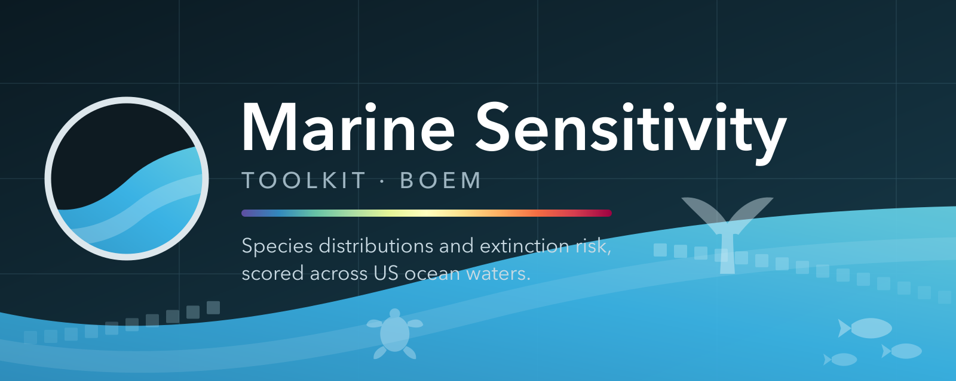
The Marine Sensitivity Toolkit (MST) is a cloud-native system developed for the Bureau of Ocean Energy Management (BOEM) to assess the sensitivity of marine ecosystems to offshore energy development.
It integrates 9,795 species distribution models with extinction risk assessments across US waters (9,597 of which fall within the 20 BOEM Program Areas of the current program cycle).
 What changed in v4, relative to v3
SWOT sea turtles
Datasets — SWOT sea turtle ranges and NOAA Distinct Population Segment polygons added, replacing the IUCN range as the global mask for all six sea turtle species. Their role is unusual: the DPS polygons carry ESA listing status spatially (Endangered vs Threatened by region), rather than as one scalar per species — the first input to vary extinction risk within a species’ range.
Reported units — Scores are reported on 20 programarea — unchanged from the previous release.
Scope — Turtle distributions become substantially more restrictive, since the IUCN and AquaMaps ranges both extended well beyond where the species actually occur.
Measured against v3: datasets added: rng_turtle_swot_dps; valid species 9,795 → 9,795.

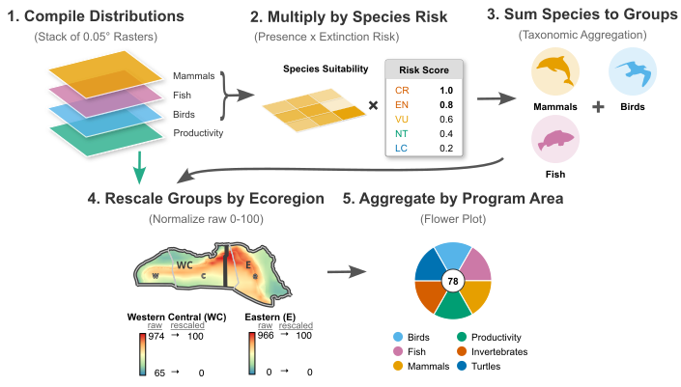
Figure 1: Overview of the MST methodology: species distribution models from the source datasets are merged, weighted by extinction risk scores (incorporating ESA, MMPA, MBTA, and IUCN protections), rescaled by ecoregion, and aggregated to management zones for visualization.

Interactive Apps
- Composite scores — sensitivity scores by zone, with flower-plot summaries
- Individual species — individual species distribution models and habitat suitability
- Your area — outline any place in the Atlas (Places) for the same scores and a downloadable report
All three are the Atlas, which renders any published release: substitute the version in the ?ver= query parameter (e.g. ?ver=v3) to view that one (a restricted pre-release is reached only on the review host, at /{version}/atlas/). Links to the former Scores and Species Shiny apps redirect to it.
- Scoring walkthrough — step through the scoring pipeline interactively, from input rasters to final scores

Documentation
This book documents the scientific methodology, software infrastructure, and interactive applications that comprise the MST. It is organized in two parts:
- Chapter 5 — data sources, taxonomic integration, extinction risk scoring, model merging, and sensitivity scoring methodology
- Chapter 13 — server architecture, databases, workflows, APIs, R libraries, and interactive applications

How to Cite
Best, B.D., T.P. White (2026). Marine Sensitivity Toolkit: Project Documentation. Bureau of Ocean Energy Management, Environmental Studies Program. https://marinesensitivity.org/docs/

Acknowledgments
This work is funded by the BOEM Environmental Studies Program (BOEM-ESP). We thank the data providers whose open datasets make this work possible: AquaMaps, BirdLife International, IUCN Red List, NOAA Fisheries, and U.S. Fish & Wildlife Service.

1. Introduction
The Marine Sensitivity Toolkit (MST) is a cloud-native system developed for BOEM (Bureau of Ocean Energy Management) to assess the sensitivity of marine species to offshore energy development, whether oil & gas or wind. The Outer Continental Shelf Lands Act (OCSLA), Section 18(a)(2)(G), mandates that BOEM consider “the relative environmental sensitivity and marine productivity of different areas of the OCS” when planning the timing and location of offshore energy activities. The MST operationalizes this mandate by combining the best available species distribution data with extinction risk assessments to map areas of the ocean that are most sensitive to human activities.
The MST marks a significant advancement over prior RESA methodologies (Morandi et al. 2018). Earlier approaches often relied on aggregated data from a limited set of broad species groups and surrogate species, lacking spatially explicit information for individual organisms. As a result, previous assessments were typically coarse and areawide, frequently missing critical ecological variation and fine-scale patterns across the OCS. In contrast, the MST uses a high-resolution 0.05° grid (~4 km per cell) on a species level to capture fine-scale conservation concerns and ecological patterns across US waters.
This book documents release v4, which integrates 9,795 valid marine species across 8 source datasets on a 0.05° grid (~4 km cells) covering the US Exclusive Economic Zone study area; of these, 9,597 have modeled distributions inside the 20 BOEM Program Areas of the current program cycle. Every figure on these pages is read from that release’s own published tables, so a page never reports another version’s numbers — see Releases for how the releases differ.
Species distributions are weighted by extinction risk scores that incorporate protections under the Endangered Species Act (ESA), Marine Mammal Protection Act (MMPA), and Migratory Bird Treaty Act (MBTA), as well as IUCN Red List assessments. The merged distribution of sensitivity per species is masked to expert ranges where available — species whose global range maps fall entirely outside the US EEZ are excluded, ensuring that only species with expert-confirmed presence in US waters contribute to scores.
This is a process, not a product. Information is imperfect, especially given the large expanse of US waters. Distributions and abundance of species change, modified increasingly by climate change and human activities. Knowledge on species sensitivities continues to expand with more research. Methods for both modeling and distributing this information continue to improve. In alignment with Executive Order 14303, we aim to provide a transparent and reproducible process that can be regularly updated as new data and methods become available.

1.1 Overview
The MST analytical pipeline proceeds through the following stages (Figure 1.1):
- Data sources (Chapter 6): 8 datasets of species distributions — continuous suitability models, regulatory habitat designations and expert range maps
- Taxonomy matching (Chapter 7): source names resolved to one canonical identity — BirdLife for birds, WoRMS for everything else — so models of the same species merge instead of double-counting it
- Model merging (Chapter 9): one surface per taxon, with the expert range constraining suitability predictions and the governing extinction risk applied to the range cells
- Cell scoring (Chapter 10): extinction-risk-weighted species presence, summed within each scored species category
- Ecoregional rescaling: scores normalized to 0–100 within each BOEM Ecoregion, so richness alone does not decide the ranking
- Zone aggregation: area-weighted means to the spatial units the release scored
- Visualization (Chapter 19): flower plots, treemaps and the interactive map applications
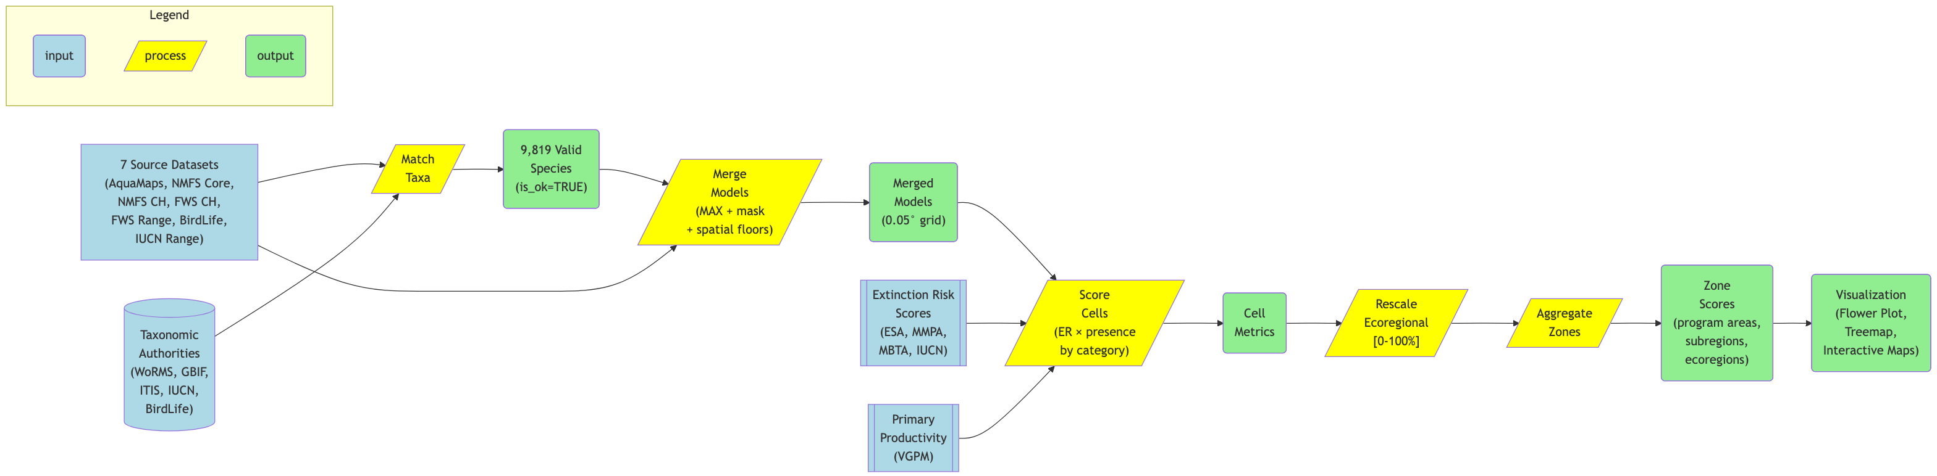
Figure 1.1: Flowchart of the MST analytical pipeline: from source datasets and taxonomic matching through model merging, scoring, and visualization.
Figure 1.2 illustrates the full methodology at a glance. On the left, species distribution data flows in from the source datasets and the taxonomic authorities. In the center, models are merged per species and weighted by extinction risk scores derived from ESA, MMPA, MBTA, and IUCN regulatory frameworks. On the right, cell-level scores are rescaled within BOEM ecoregions and aggregated to program areas for visualization in the interactive mapping applications.
Figure 1.2: Overview of the Marine Sensitivity Toolkit methodology showing the integration of species distribution models, extinction risk scoring, ecoregional rescaling, and spatial aggregation into interactive visualizations.

2. Releases
This book is published once per release. The page you are reading documents v4, and every figure in it comes from that release’s own published tables — so a v3 page reports v3’s numbers, not the newest ones. Use the version switcher in the sidebar to move between builds.
This page is the exception: it reads all releases, because the comparison is exactly what a single-version page cannot show.
v4 — SWOT sea turtles
Released 2026-03-01. This is retired — superseded, but still published and still readable.

2.1 Every release at a glance
Table 2.1: Published releases. Species counts are read from each release’s own taxon table and are not comparable across releases, because the definition of a valid species changed at v3 and again at v7 (see below).
Version | Released | Status | Title | Datasets | Valid species | In Program Areas | Grid
v7c | 2026-10-14 | prerelease | v7.2: record-based ranges for sea turtles and the North Atlantic right whale | 8 | 16,153 | 9,229 | usa05
v7b | 2026-09-20 | prerelease | v7.1: turtle core habitat + coverage floor | 8 | 16,153 | 9,230 | usa05
v9 | 2026-08-27 | prerelease | AquaX supersedes AquaMaps in US waters | 10 | 17,130 | 9,576 | global05
v8 | 2026-07-28 | prerelease | Marine Atlas | 8 | 17,112 | 9,632 | global05
v7 | 2026-06-12 | released | Validity decoupled from Program Areas | 8 | 16,153 | 9,230 | usa05
v6 | 2026-04-09 | retired | IUCN range outside US EEZ | 8 | 9,424 | 9,226 | usa05
v5 | 2026-03-24 | retired | MMPA spatial floor | 8 | 9,795 | 9,597 | usa05
v4b | 2026-03-19 | retired | Turtle multiplicative merge | 8 | 9,795 | 9,597 | usa05
v4 | 2026-03-01 | retired | SWOT sea turtles | 8 | 9,795 | 9,597 | usa05
v3 | 2026-02-01 | retired | Merged models + extinction risk | 7 | 9,795 | 9,621 | usa05
v2 | 2026-01-01 | retired | Program Areas | 6 | 17,353 | 9,792 | usa05
v1 | 2023-09-01 | retired | Planning Areas | 5 | 17,379 | — | usa05

 Why the species count is not a trend line
The count moves for three different reasons, only one of which is “more data”:
- v3 tightened the taxonomy — resolving every source name to a canonical identity, dropping non-marine and extinct taxa — which cut the count roughly in half.
- v6 removed species whose expert range lies entirely outside US waters, whose apparent US presence was an artifact of environmental-envelope prediction.
- v7 stopped requiring Program-Area overlap for validity. Nothing was added; the definition changed, and the count went up accordingly.
Read the column as “what this release considered valid”, never as a measurement of biodiversity that changed between releases.

Table 2.2: What each release published, read from its manifest.
Version | Model id | Metrics | Spatial units
v7c | mdl_seq | 17 | Ecoregions (12), Planning Areas (36), Program Areas (20), Subregions (5)
v7b | mdl_seq | 17 | Ecoregions (12), Planning Areas (36), Program Areas (20), Subregions (5)
v9 | mdl_key | 17 | Ecoregions (12), Program Areas (20), Subregions (5)
v8 | mdl_key | 17 | Ecoregions (12), Program Areas (20), Subregions (5)
v7 | mdl_seq | 17 | Ecoregions (12), Planning Areas (36), Program Areas (20), Subregions (5)
v6 | mdl_seq | 17 | Ecoregions (12), Planning Areas (36), Program Areas (20), Subregions (4)
v5 | mdl_seq | 17 | Ecoregions (12), Planning Areas (36), Program Areas (20), Subregions (4)
v4b | mdl_seq | 17 | Ecoregions (12), Planning Areas (36), Program Areas (20), Subregions (4)
v4 | mdl_seq | 17 | Ecoregions (12), Planning Areas (36), Program Areas (20), Subregions (4)
v3 | mdl_seq | 17 | Ecoregions (12), Planning Areas (36), Program Areas (20), Subregions (4)
v2 | mdl_seq | 19 | Ecoregions (12), Planning Areas (36), Program Areas (20), Subregions (4)
v1 | mdl_seq | 19 | Ecoregions (12), Planning Areas (36), Subregions (4)

2.2 History
Each release is summarized under the same four headings, so two versions can be read line for line. The same summary heads that version’s own landing page.
- Datasets — inputs added or changed, and the role each plays (contributing a value, masking a range, or carrying extinction risk spatially).
- Methods — the scientific rules: how models merge, how extinction risk is scored, which statutory floors apply.
- Scope — what counts and where: the definition of a valid species, the spatial units, the study area, which taxa are eligible.
- Technology — formats, identifiers, serving and applications.
Scope changes move the count without any data changing
The distinction between Methods and Scope is the one to watch. v3 tightened the taxonomy, v6 excluded ranges outside the EEZ, and v7 decoupled validity from Program Areas — each moved the headline species count substantially, and none of them added or removed a single input. Reading those jumps as growth or loss is the single easiest mistake to make with this table.

What changed in v7c, relative to v7
v7.2: record-based ranges for sea turtles and the North Atlantic right whale
Methods — A second surgical patch of v7, superseding v7b for review: three method changes, everything else re-executes v7’s own scoring verbatim, and turning all three off reproduces v7 exactly. (1) The turtle record rule replaces v7b’s suitability threshold. A sea-turtle species is dropped from an Alaska ecoregion where it has never been recorded in any observational channel (NOAA Alaska sightings, strandings and bycatch since 1963, fishery observers, OBIS, GBIF, iNaturalist, and the Washington and Gulf/Atlantic stranding networks), and kept at its v7 value everywhere else. On v7’s data that drops loggerhead, green, leatherback and olive ridley from the East Bering Sea; the Gulf of Alaska, where all four have been recorded, keeps them — v7b’s threshold had removed three of them there. AquaMaps suitability is no longer thresholded and the floor-of-1 range fill is back as in v7. (2) The North Atlantic right whale leaves the Gulf of America: it is dropped from both Gulf ecoregions, which lie outside its range — a handful of vagrant records against thousands in the Atlantic, and no critical habitat, density model or distribution-model ensemble placing it there. Both drops are rows of one evidence table, and critical habitat is never dropped. (3) The coverage floor stays at 5%, as in v7b; here it removes the last sliver of turtle cells from the Aleutian Arc and St. George Basin, so the two rules together leave both Program Areas without a turtle component. A down-weight in place of a drop was worked through and set aside: under ecoregion-relative rescaling a weight common to a species group cancels, and stored values are floored at 1, so only a drop reaches the score. Productivity is untouched — every productivity value equals v7’s; the year-integration fix still lands with v10.
Reported units — Scores are reported on 20 programarea, 1 subregion — unchanged from the previous release.
Scope — Which taxa count where, not which taxa count: no species is added or removed, and the definition of a valid species is v7’s. Four sea turtles no longer occur in the East Bering Sea, and the North Atlantic right whale no longer occurs in the Gulf of America, so the Aleutian Arc and St. George Basin Program Areas lose their turtle component and the Gulf of America Program Areas’ mammal component is rescaled without the right whale. Every other Program Area scores as in v7.
Measured against v7: valid species 16,153 → 16,153.

What changed in v7b, relative to v7
v7.1: turtle core habitat + coverage floor
Methods — A surgical patch of v7, not a new build: two method changes, everything else re-executes v7’s own scoring verbatim, and turning both changes off reproduces v7 exactly. (1) Sea-turtle core habitat — AquaMaps suitability now enters the turtle merge only where it is at least 0.5 (AquaMaps’ own core-habitat default); a range cell with no suitability at or above that threshold is dropped rather than filled at a nominal value of 1. Critical habitat still overrides by taking the higher value, so no designated cell is ever lost to the threshold. (2) Coverage floor. A scored component is reportable in a Program Area only where its scored cells cover at least 5% of the area; on v7’s data this removes exactly one component (St. George Basin’s turtles, at 1.5% coverage) rather than publishing it as a misleadingly precise near-zero. One side effect worth reading carefully: with its turtle component gone, Cook Inlet’s average of its remaining components (53.2) edges past Hope Basin’s (52.7) for the top Program-Area rank — a reordering caused by removing a below-average component, not by anything improving. The year-integrated productivity fix that an earlier review flagged is not part of this patch — productivity is unchanged from v7 here, because under this release’s ecoregion-relative rescaling the year-integration barely moves scores (and moves some the wrong way); it lands with v10, whose national reference is where the correction actually counts.
Reported units — Scores are reported on 20 programarea, 1 subregion — unchanged from the previous release.
Measured against v7: valid species 16,153 → 16,153.

What changed in v9, relative to v8
AquaX supersedes AquaMaps in US waters
Datasets — AquaX (ax) joins as a ninth contributing input — an enhanced and revised AquaMaps framework (Reygondeau et al. 2026): 10,536 ensemble habitat-suitability models delivered on the analysis grid itself and masked to US waters. For the same species it supersedes AquaMaps wherever AquaX was modeled (10,517 species, 10,703 AquaMaps models); AquaMaps continues for the ~6,000 species AquaX did not model and everywhere outside AquaX’s mask. A further 2,742 species AquaX modeled but found absent in US waters keep their AquaMaps surface in this pre-release, pending review.
Methods — Extinction risk becomes spatial for species listed by Distinct Population Segment: 18 species whose ESA listing applies to some populations only (humpback and Southern Resident killer whales, Cook Inlet beluga, the salmonid ESUs, both sturgeons, …) take each listed entity’s status inside its designated critical habitat, from NOAA Fisheries’ authoritative service, and the baseline every unlisted species of its kind gets (the MMPA floor for a marine mammal, the IUCN category otherwise) across the rest of their range. Their merged model stays the habitat suitability; the per-cell risk is carried beside it and multiplied in at scoring, and is offered in the species app as its own layer. Before this the humpback carried the Endangered status of DPSs that breed outside US waters everywhere it occurs, a flat maximum across its entire range. Supersession is a filter on the merge input, not a per-cell blend: inside the AquaX mask a superseded species’ AquaMaps cells are dropped before the merge, so an AquaX absence is an absence. Values are AquaX’s 0–1000 ensemble mean ÷ 10, on AquaMaps’ 0–100 scale; the model’s TSS cutoff is recorded but not applied. Every other rule — range constraint, governing extinction risk, turtle multiplication — is unchanged, and a control run with supersession switched off reproduces v8’s Program-Area scores exactly.
Reported units — Scores are reported on 20 programarea, 12 ecoregion, 5 subregion — unchanged from the previous release.
Scope — Scoring extent and species definition are unchanged from v8; what changes is which model supplies suitability for two thirds of the scored species inside US waters.
Technology — A same-grid version bump now reuses the previous release’s unchanged ingests (copy-on-write clone, verified against their content checkpoints) instead of re-running them, and every reader of the previous release resolves its schema by introspection.
Measured against v8: datasets added: ax, dps_nmfs; valid species 17,112 → 17,130.

What changed in v8, relative to v7
Marine Atlas
Datasets — The same eight contributing inputs. NOAA SEFSC and NCCOS density models are ingested and catalogued but deliberately excluded from the merge, because their units (individuals per km²) have no agreed mapping onto the 0–100 suitability scale — they are flagged is_scored = FALSE so no published count includes them.
Methods — The expert range constrains AquaMaps rather than merely competing with it, and whether a taxon has a range is decided globally — so a species whose range lies wholly outside US waters contributes no US cells. Governing extinction risk is applied at merge time, to the range cells. A BirdLife↔WoRMS crosswalk de-duplicates seabirds that earlier releases split across two taxa. Species categories come from taxonomy rather than keyword matching, removing the catch-all other and surfacing primary_producer; birds are additionally culled to marine/coastal families with at least 5% of their global range over ocean.
Reported units — Scores are reported on the 20 Program Areas, and ecoregion and subregion rollups are restored alongside them — so the release covers every spatial unit it defines, rather than Program Areas alone. (measured: 20 programarea, 12 ecoregion, 5 subregion scored on the composite metric.)
Scope — Ingest becomes global and whole-range — no land mask, no Program-Area gate — while scoring stays over US waters. A species map now shows the species rather than the analysis extent. Non-turtle reptiles and amphibians remain excluded from scoring.
Technology — Releases are published as partitioned Parquet on S3 with a STAC catalog and a searchable STAC API, readable directly by DuckDB including in a browser. Score surfaces become pre-rendered COGs, retiring the tile factory that ran SQL per request. A stable mdl_key replaces the auto-increment mdl_seq, which renumbered on every rebuild and broke saved links. One application renders every release from a ?ver= parameter, so the per-version forks are retired.
Measured against v7: valid species 16,153 → 17,112; grid changed (usa05 → global05), so cell_id denotes a different place; public model id mdl_seq → mdl_key; spatial units changed.

What changed in v7, relative to v6
Validity decoupled from Program Areas
Methods — Scores are recomputed over the full set, with negligible effect: 18 of 20 Program Areas are unchanged.
Reported units — Scores are reported on the 20 Program Areas. A single subregion also carries a composite score, which is a by-product of the study-area rollup rather than a reporting unit. (measured: 20 programarea, 1 subregion scored on the composite metric.)
Scope — Validity is decoupled from Program Areas. Earlier releases silently required a species to overlap a current Program Area to count as valid, which hid biodiversity outside the program cycle’s footprint. Validity now means a taxonomically valid species with a modeled distribution anywhere in the study area, and Program-Area membership becomes a spatial query answered afterwards. The count rises sharply without a single species being added.
Measured against v6: valid species 9,424 → 16,153; spatial units changed.

What changed in v6, relative to v5
IUCN range outside US EEZ
Datasets — Three missing marine-mammal IUCN ranges ingested from a more complete download.
Reported units — Scores are reported on 20 programarea — unchanged from the previous release.
Scope — Species whose IUCN expert range lies entirely outside the US EEZ are excluded. Their apparent presence in US waters was an edge-of-range artifact of environmental-envelope prediction, with near-zero suitability, so the effect on scores is negligible even though the species count drops.
Measured against v5: valid species 9,795 → 9,424.

What changed in v5, relative to v4b
MMPA spatial floor
Methods — The MMPA floor is corrected for FWS-managed marine mammals — walrus, polar bear, sea otter, manatee and dugong — which had been missed because the protection flag was derived from the NMFS Species Directory alone.
Reported units — Scores are reported on 20 programarea — unchanged from the previous release.
Measured against v4b: valid species 9,795 → 9,795.

What changed in v4b, relative to v4
Turtle multiplicative merge
Methods — The multiplicative turtle merge: for sea turtles the DPS extinction-risk surface is multiplied into the suitability surface during merging, with critical habitat overriding by maximum. Risk therefore varies spatially within a species. These taxa pass er_score = 100 through at scoring so the risk already embedded in their values is not counted twice. From here the toolkit has two merge strategies rather than one.
Reported units — Scores are reported on 20 programarea — unchanged from the previous release.
Measured against v4: valid species 9,795 → 9,795.

What changed in v4, relative to v3
SWOT sea turtles
Datasets — SWOT sea turtle ranges and NOAA Distinct Population Segment polygons added, replacing the IUCN range as the global mask for all six sea turtle species. Their role is unusual: the DPS polygons carry ESA listing status spatially (Endangered vs Threatened by region), rather than as one scalar per species — the first input to vary extinction risk within a species’ range.
Reported units — Scores are reported on 20 programarea — unchanged from the previous release.
Scope — Turtle distributions become substantially more restrictive, since the IUCN and AquaMaps ranges both extended well beyond where the species actually occur.
Measured against v3: datasets added: rng_turtle_swot_dps; valid species 9,795 → 9,795.

What changed in v3, relative to v2
Merged models + extinction risk
Datasets — NMFS core areas added — designated regions of concentrated use, a targeted high-confidence habitat indicator rather than a broad-coverage model.
Methods — Extinction risk is reworked into a single governing er_score per taxon, taken as the most protective across its datasets with a US national listing overriding the international IUCN category, plus statutory floors for the MMPA (marine mammals) and MBTA (migratory birds). Merging now runs for every taxon, masked to the IUCN range where one exists.
Reported units — Scores are reported on the 20 Program Areas only. The Planning Area geometry is still carried in the database, and a couple of non-composite metrics with it, but no composite score is computed for it — from here on, Planning Areas are history rather than a reporting unit. (measured: 20 programarea scored on the composite metric.)
Scope — Taxonomy is tightened: every source name resolves to a canonical WoRMS or BirdLife identity, and non-marine and extinct taxa are dropped. Sea turtles become their own category, and non-turtle reptiles stop being scored. This roughly halves the valid-species count — a change in definition, not a loss of data.
Measured against v2: datasets added: ca_nmfs; valid species 17,353 → 9,795.

What changed in v2, relative to v1
Program Areas
Datasets — IUCN Red List range maps added, and used as the global mask — constraining AquaMaps predictions to the expert-assessed range rather than contributing a value of their own.
Methods — A model-merging pipeline is introduced, producing one merged surface per taxon where a taxon has more than one source.
Reported units — The transitional release: scores are reported on both the 36 Planning Areas and the new 20 Program Areas, so the two can be compared directly on the same underlying data. This is the only release that scores both. (measured: 36 planarea, 20 programarea scored on the composite metric.)
Scope — The BOEM Program Areas of the 2026 program cycle are introduced. They do not yet replace the Planning Areas — this release scores both, and the changeover completes at v3.
Technology — Individual model layers are published, and distributions are stored as cloud-optimized GeoTIFFs.
Measured against v1: datasets added: rng_iucn; valid species 17,379 → 17,353; spatial units changed.

v1 — the basis everything since builds on
Planning Areas
Datasets — AquaMaps global environmental-envelope models supply the distribution of nearly every species, with BirdLife expert ranges for birds. NMFS/FWS critical habitat and FWS ranges are present only as a small pilot. Continuous suitability is used as published; expert range polygons take a 50% presence value by convention, since an extent-of-occurrence boundary asserts presence somewhere within it rather than throughout.
Methods — A cell’s score is the sum, over the species present, of presence × extinction-risk weight, computed separately per species category. Weights are the IUCN equal-steps scale used by the Red List Index and the STAR metric, rescaled so Least Concern keeps a non-zero weight — so overall biological richness stays part of the signal rather than the score being driven entirely by the few threatened species. Cell scores are then rescaled within each BOEM Ecoregion and aggregated by area-weighted mean.
Reported units — Scores are reported on the 36 OCS Planning Areas and the 12 BOEM Ecoregions. v1 predates the Program Areas entirely — its database contains none, which is why a Program Area view of v1 is empty rather than merely uninteresting. (measured: 36 planarea, 12 ecoregion scored on the composite metric.)
Scope — Marine relevance is decided spatially — any model whose distribution reaches the study area is included — with no independent test of whether the species is marine. Models are merged only for the handful of taxa that have more than one source; every other species is scored directly from its single source model.
Technology — A 0.05° geographic (WGS84) grid, chosen because every input arrives on a latitude/longitude grid: analysing in geographic coordinates resamples each input once rather than twice. Area distortion is corrected arithmetically rather than by projection.

2.3 Reading an older release
Every release remains published and readable:
- Documentation — this book, at /{version}/; the sidebar switcher moves between builds and marks any version whose docs are not built.
- Applications — the Atlas, substituting any published version in ?ver= (a restricted pre-release is reached only on the preview host, at /{version}/atlas/). The Scores and Species Shiny apps and their per-version forks are retired; their old URLs (/v3/scores/, /v3/species/, an older ?ver=v3 deep link) redirect to the equivalent Atlas view, so links printed in earlier reports still resolve to the release they always showed.
- Data — marine-atlas/{version}/tables/*.parquet on S3, readable directly by DuckDB (including in a browser) without downloading a database.
Promotion is deliberate and separate from publishing. Writing data does not make a release current: the pointer that applications follow by default is only rewritten under an explicit flag, and may only name a released — never a pre-release — version. It currently names v7.

3. v1 — Planning Areas
v1 was the first delivered version of the Marine Sensitivity Toolkit, reported to BOEM’s Environmental Studies Program under contract 140M0123P0018 as the Marine Sensitivity Toolkit final report (2025).
It is documented here in its own right because several of its choices — the conceptual framing, the extinction-risk weighting and its justification, and the honest account of what ecoregional rescaling does and does not preserve — remain the foundation of every later release, and because reports and decisions cite it.
What this page is, and is not
This is the methodology of v1. Numbers are deliberately omitted: the counts in the 2025 report are snapshots of a build that has since been superseded, and reprinting them here would set them beside computed figures elsewhere in this book as if the two were equally current. For v1’s counts as published, see the Releases table, which reads them from the v1 release itself.
The report also retains, as a matter of record, figures it identifies as incorrect. Those are not carried forward.

3.1 Conceptual framework
Vulnerability ($V$) is a function of exposure ($E$), sensitivity ($S$) and adaptive capacity ($A$):
$$V=f(E,S,A) (3.1)$$
This decomposition is the standard framing in ecological risk and climate-vulnerability assessment (Intergovernmental Panel on Climate Change 2014; Halpern et al. 2007; Hare et al. 2016). The more exposed and sensitive an area is — and the less able it is to recover — the more vulnerable it is to impacts from offshore activities.
For spatial implementation, the vulnerability of a cell $v_{c}$ is the sum across all species in a taxonomic group $S_{g}$ of the product of the species’ presence in the cell $p_{sc}$ and a species weight $w_{s}$, the risk of that species going extinct:
$$v_{c}=\sum_{s=1}^{S_{g}}{p_{sc}}⋅w_{s} (3.2)$$
where $p_{sc}$ is presence probability or suitability (0–1) and $w_{s}$ is how at-risk that species is of going extinct (0–1, ranging from Least Concern at 0.2 to Critically Endangered at 1).
In plain terms: if a cell has many species that are both likely to be present and at high risk of extinction, it gets a higher sensitivity score. This is how places where rare or threatened species concentrate are found.

3.1.1 Where exposure and adaptive capacity sit
The implemented score resolves the sensitivity and adaptive-capacity terms jointly, and leaves exposure to be supplied by the decision being evaluated.
Extinction risk serves as an integrated proxy for both because the IUCN and ESA listing criteria assess population size, rate of decline, range restriction and fragmentation — the same properties that govern whether a population can absorb an added impact and recover from it.
This is a deliberate simplification, and the principal structural limitation of v1: adaptive capacity cannot be varied independently of sensitivity, and traits that distinguish recovery potential within a risk category — generation time, fecundity, dispersal, habitat specialization — are not represented. Separating the terms would mean adding activity-specific exposure layers (spill-trajectory probability, lease-block footprints, modeled noise fields) and letting them interact with trait-based adaptive-capacity attributes drawn from established marine vulnerability protocols (Hare et al. 2016).

3.2 Extinction-risk weighting, and why these numbers
IUCN Red List categories and ESA status codes were standardized to numeric risk weights: CR = 1.0, EN = 0.8, VU and ESA Threatened = 0.6, NT = 0.4, LC = 0.2. Where a species had several assessments the most recent was used; where statuses conflicted across regions the precautionary principle applied, taking the higher risk category.
These weights are a rescaling of the IUCN equal-steps weighting used for the Red List Index (Butchart et al. 2004, 2007) and for the Species Threat Abatement and Restoration (STAR) metric (Mair et al. 2021), which maps LC = 0, NT = 1, VU = 2, EN = 3, CR = 4. Dividing by five and shifting Least Concern from 0 to 0.2 yields the multipliers above.
STAR is the closest published analogue to the MST score: an additive, spatially explicit sum of species presence weighted by extinction risk.
Least Concern is deliberately given non-zero weight so that overall biological richness remains part of the sensitivity signal — consistent with the statutory language — rather than the score being driven entirely by the small fraction of species that are threatened. A Critically Endangered species still carries five times the weight of a Least Concern one.
Equal-steps weighting is the most widely used convention but not the only defensible one. Extinction-probability weightings (Butchart et al. 2007; Mooers et al. 2008) are strongly convex and would concentrate nearly all weight on CR and EN species. Because the transformation can affect rank order (Mooers et al. 2008), a sensitivity analysis comparing area rankings under equal-steps, extinction-probability and equal (richness-only) weightings is a recommended next step.

3.3 Scoring
Step 1 — cell-level scoring. For each 0.05° cell the raw score $v_{c}$ is the sum of presence × extinction-risk weight across the species in a taxonomic group.
Step 2 — ecoregional rescaling. Raw cell scores are rescaled to 0–100 within each BOEM Ecoregion, using the minimum and maximum observed inside that ecoregion for the component being scored.
Step 3 — Planning Area aggregation. Rescaled cell scores are aggregated by area-weighted average: each cell contributes in proportion to the fraction of its area falling inside the Planning Area, so larger low-latitude cells do not outweigh smaller high-latitude ones.

3.3.1 Worked example
A simplified Planning Area with three equal-area cells in an ecoregion whose fish scores run from 65 to 974:
Cell | Raw fish score | Rescaled | Cell area (km²) | Weight
A | 200 | $(200−65)/(974−65)×100=15$​ | 25 | 0.33
B | 600 | $(600−65)/(974−65)×100=59$​ | 25 | 0.33
C | 400 | $(400−65)/(974−65)×100=37$​ | 25 | 0.33
The Planning Area fish score is $15×0.33+59×0.33+37×0.33=37$ — meaning the Planning Area sits 37% of the way between the lowest and highest fish scores observed in its ecoregion.

3.3.2 What ecoregional rescaling does and does not preserve
Rescaling within ecoregions is a deliberate analytical choice with a cost that should be explicit.
Because min–max rescaling is monotonic, it preserves the complete ordering of cells and Planning Areas within an ecoregion: no within-region comparison is affected. What it removes is the difference in absolute magnitude between ecoregions. A score of 80 in the Gulf of America and a score of 80 in the Arctic both denote “high relative to that region”, not equal absolute sensitivity, and the difference in raw species richness between those regions is by design not visible in the rescaled value.
The rationale is that the raw score is count-like — it increases with the number of species modeled in a cell — and is therefore governed by the latitudinal richness gradient. Without rescaling, nearly every subtropical Planning Area would outrank nearly every Arctic one, and the result would approximate a map of model density rather than of conservation concern. Within-region normalization is also consistent with the prior RESA methodology (Niedoroda 2014).
Two consequences follow for interpretation:
- Rescaled scores are not a national ranking. Comparing areas across ecoregions compares each to its own regional context.
- The endpoints are observed extrema, so a single outlier cell can set the 100 for an entire ecoregion and compress every other score in it. Robust percentile endpoints (1st/99th) are recommended in their place.
Because absolute magnitude is management-relevant information, reporting raw scores alongside the rescaled ones — together with a nationally rescaled variant and the rank correlation between the two rankings — would let the effect of the normalization on rank order be assessed directly rather than assumed.

3.4 Grid and projection
The analysis grid is geographic (WGS84) rather than projected, because every input dataset — AquaMaps half-degree cells, Bio-ORACLE reference layers, the VIIRS productivity grid, and IUCN/BirdLife range polygons — is distributed on a regular latitude/longitude grid. Analyzing in geographic coordinates resamples each input once rather than twice, avoiding blurred suitability surfaces and displaced range boundaries; and no single equal-area projection serves both the Gulf of America and the Aleutians well.
Area distortion is therefore corrected arithmetically rather than by projection: cell area is computed on the sphere, and every cell-to-area aggregation is weighted by that true area and by the cell’s fractional overlap with the Planning Area — making the reported statistics equal-area in effect. Maps are drawn in region-appropriate equal-area projections for display only; no analysis is performed in a display projection.

3.5 Marine relevance in v1
In v1 a spatial inclusion rule was applied — every model whose distribution intersected the study area was ingested — without an independent test of whether the species is marine.
This admits a small number of non-marine species with coastal range polygons; the introduced White-winged Parakeet (Brotogeris versicolurus) in southern Florida is one. Because such species are almost always Least Concern and occupy few cells, the effect on scores is negligible, but their presence in the species viewer is not defensible.
Subsequent versions apply an explicit marine-relevance filter: birds are scored only if they belong to a marine or coastal family and at least 5% of their whole global range falls over ocean, with a curated include/exclude list for edge cases.
 Important
The standard WoRMS isMarine flag cannot be used for this purpose, because seabirds are largely absent from that register. This is the reason the later filter is built from family membership and a measured percentage rather than from the obvious flag — see Section 7.4.

3.6 Sources in v1
v1’s distributions came principally from AquaMaps global species distribution models, downscaled from their native 0.5° half-degree cells to 0.05° by bilinear interpolation, together with BirdLife range maps for birds.
AquaMaps vintage
The 2025 report cites AquaMaps in two ways — a retrieval date in the Methods and “AquaMaps 2019” in the conclusions — which reads as a contradiction. It is not.
The model release is AquaMaps Version 10/2019, which is what the release registry records and what the data itself carries; the later date is when that release was retrieved. No newer AquaMaps release has been ingested, and the suitability surfaces have not changed.

Presence values follow external convention where one exists and are assigned by the study where one does not. Continuous suitability models are used as published, without modification. Expert range maps take a 50% presence value, following the convention for extent-of-occurrence polygons, which assert presence somewhere within the boundary rather than throughout it. Designated Critical Habitat takes a higher value reflecting the stronger occupancy evidence implied by a legal designation — an assumption of the study rather than an external standard, and identified as such.

3.7 Primary productivity
Net primary productivity was computed with the Vertically Generalized Production Model (Behrenfeld and Falkowski 1997) from VIIRS satellite data for the most recently completed decade. Monthly NPP was averaged annually, then a ten-year mean and standard deviation computed, downsampled to the analysis grid by bilinear interpolation, and converted to metric tons C km⁻² yr⁻¹.

3.8 Successor releases
v1 scored Planning Areas; the 2026 program cycle introduced Program Areas, which v2 adopted. Later releases changed the taxonomy, the merge and the definition of a valid species — see Releases for what changed and when, and read this page as the record of what v1 did.

4. v7c — sea turtles and the North Atlantic right whale where the record places them
A release under review
v7c (titled v7.2) is a pre-release under review. It patches v7’s sea-turtle and North Atlantic right whale distributions where the observational record places them. Its chapter (the rules, the evidence behind them and what moved in the scores) is published with the v7c documentation on the signed-in review host, and appears in every version of this book once v7c is released.

5. Science
 Interactive Walkthrough
New to the MST scoring pipeline? The Scoring Walkthrough provides a step-by-step interactive visualization of how input rasters are merged, rescaled by ecoregion, and averaged into final sensitivity scores.

5.1 Conceptual Framework
The term vulnerability ($V$) is a function of exposure ($E$), sensitivity ($S$) and adaptive capacity ($A$) (Equation 5.1).
$$V=f(E,S,A) (5.1)$$
The more exposed and sensitive an area is—and the less able it is to recover—the more vulnerable it is to impacts from offshore human activities. The MST currently focuses on the sensitivity component, quantifying the intrinsic biological sensitivity of marine ecosystems based on the species present and their conservation status. Exposure and adaptive capacity components are planned for future phases (see Chapter 12).

5.2 Cell Vulnerability
For a given cell $c$, the vulnerability score for a species group $g$ is the sum across all $S_{g}$ species of the product of species presence probability $p_{sc}$ and extinction risk weight $w_{s}$ (Equation 5.2):
$$v_{c}=\sum_{s=1}^{S_{g}}{p_{sc}}⋅w_{s} (5.2)$$
where:
- $v_{c}$ = vulnerability score of cell $c$ for species group $g$
- $p_{sc}$ = probability of species $s$ presence in cell $c$ (0–1 scale, from merged species distribution models)
- $w_{s}$ = extinction risk weight for species $s$ (0–1 scale, derived from ESA/MMPA/MBTA/IUCN status; see Chapter 8)
- $S_{g}$ = total number of species in taxonomic group $g$ (e.g., bird, fish, mammal, coral, invertebrate, reptile/turtle)
In other words, if a cell has many species that are both likely to be present and at high risk of extinction, it gets a higher sensitivity score. This helps identify places where rare or threatened species are concentrated.

5.3 Sensitivity Components
The MST assesses sensitivity through three components:
- Species — by taxonomic category (bird, coral, fish, invertebrate, mammal, reptile/turtle): extinction risk weighted species distribution models across 9,795 valid species (see Chapter 6, Chapter 8)
- Habitats — benthic habitats such as coral reefs, seamounts, and hydrothermal vents (planned for future phases)
- Primary Productivity — satellite-derived net primary productivity from the Vertically Generalized Production Model (VGPM), measured as metric tons C km⁻² yr⁻¹ (see Chapter 6)

5.4 Ecoregional Rescaling
Raw cell scores vary naturally across regions due to differences in species richness and oceanographic conditions. To enable meaningful comparison, scores are rescaled to a [0–100] range within each BOEM Ecoregion using min-max normalization (Equation 5.3):
$$v_{c}^{′}=\frac{v_{c}−v_{min}}{v_{max}−v_{min}}×100 (5.3)$$
where $v_{min}$ and $v_{max}$ are the minimum and maximum cell scores for a given component within the Ecoregion.
Scores are relative within Ecoregions, not absolute. A score of 100 represents the most sensitive 0.05° cell for a given component (e.g., fish, marine mammals, or primary productivity) within a given BOEM Ecoregion—not globally. The final score is an equally weighted average of these ecoregionally rescaled components. This means that a score of 30 in Alaska reflects a different ecological context than a score of 30 in the Pacific.
Why rescale by Ecoregion? Without this step, areas with naturally higher numbers of species (like upwelling zones in the Pacific) would almost always get the highest scores, simply because they have more species. While more species may indicate greater ecological importance, it could also be argued that the fewer species in an ecosystem, the more important each is to its function and resilience. Rescaling by Ecoregion prevents scores from being overwhelmed by species-rich areas. However, comparing across Ecoregions would require developing a mathematical relationship between these competing arguments for sensitivity—one that is still a source of earnest academic debate. For this reason, scores are directly comparable among Program Areas within the same Ecoregion, but should not be compared across Ecoregions.

5.4.1 Geographic Scope
The current analysis covers 20 BOEM Program Areas from the 11th National Draft Proposed Program (2025) spanning Alaska, the Pacific, and the Gulf of America (Figure 5.1). The Atlantic OCS region is not included in this program cycle, so ecoregions without Program Areas (e.g., Northeast Continental Shelf, Southeast Continental Shelf, Washington/Oregon) are excluded from the analysis. Species whose distributions do not overlap with any Program Area will not appear in the interactive mapping applications.
The Gulf of America Program Areas—GOA Program Area A (GAA) and GOA Program Area B (GAB)—were derived from the larger Gulf of America Planning Areas and span parts of two Ecoregions: Western and Central Gulf of America (WCGOA) and Eastern Gulf of America (EGOA). Because cell scores are rescaled within each Ecoregion before aggregation, cells in GAA that fall within the WCGOA Ecoregion are rescaled relative to WCGOA min/max values, while cells within EGOA use EGOA min/max values. The aggregated Program Area score is then the area-weighted average across all constituent cells, regardless of which Ecoregion they belong to. This approach ensures that the rescaling reflects local ecological context even when a Program Area spans Ecoregion boundaries. See Chapter 10 for implementation details.
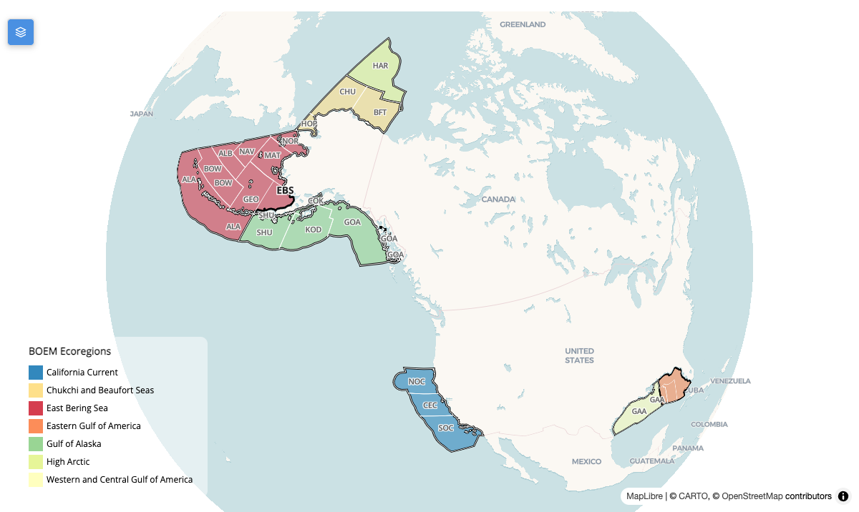
Figure 5.1: BOEM Ecoregions (colored) and Program Area outlines. Ecoregion keys: CAC = California Current; CBS = Chukchi and Beaufort Seas; EBS = East Bering Sea; EGOA = Eastern Gulf of America; GOA = Gulf of Alaska; HAR = High Arctic; NECS = Northeast Continental Shelf; PIS = Pacific Island Territories; PUR = Puerto Rico and U.S. Virgin Islands; SECS = Southeast Continental Shelf; WAOR = Washington/Oregon; WCGOA = Western and Central Gulf of America. Program Area keys: ALA = Aleutian Arc; ALB = Aleutian Basin; BFT = Beaufort Sea; BOW = Bowers Basin; CEC = Central California; CHU = Chukchi Sea; COK = Cook Inlet; GAA = GOA Program Area A; GAB = GOA Program Area B; GEO = St. George Basin; GOA = Gulf of Alaska; HAR = High Arctic; HOP = Hope Basin; KOD = Kodiak; MAT = St. Matthew-Hall; NAV = Navarin Basin; NOC = Northern California; NOR = Norton Basin; SHU = Shumagin; SOC = Southern California.
See subsequent chapters for detailed descriptions of: data sources (Chapter 6), taxonomic integration (Chapter 7), extinction risk scoring (Chapter 8), model merging (Chapter 9), and scoring methodology (Chapter 10).

6. Data Sources
The MST integrates species distributions from 8 source datasets, though not in equal measure — am_0.05 alone supplies the distribution of 98% of this release’s valid species. Each source predicts where a species occurs, and they differ in kind: continuous suitability models, habitats tied to a core area, critical habitat or distinct population segment, and expert range maps.
Note
The counts and citations on this page are read from v4’s own published dataset table, so they describe that release rather than the current one. Earlier releases integrated fewer sources: the table below is the answer for this version.

6.1 Dataset overview
Table 6.1: Source datasets in v4, ordered by merge priority. Mask datasets constrain a taxon’s merged distribution to its known range as well as contributing values. Taxa is how many of this release’s valid species the dataset actually supplied a model for — not how many models it registered.
Dataset key | Name | Cell values | Mask | Taxa | Share
am_0.05 | AquaMaps SDM |  | No | 9,584 | 97.8%
ca_nmfs | NMFS Core Area | Core: 100 | Yes | 1 | <0.1%
ch_nmfs | NMFS Critical Habitat | EN:100, TN:50 | Yes | 26 | 0.3%
ch_fws | FWS Critical Habitat | EN:100, TN:50 | Yes | 17 | 0.2%
rng_fws | FWS Range | EN:100, TN:50, LC:1 | Yes | 45 | 0.5%
bl | BirdLife Range | CR:50, EN:25, VU:5, NT:2, LC:1, DD:1 | Yes | 193 | 2.0%
rng_iucn | IUCN Range | CR:50, EN:25, VU:5, NT:2, LC:1, DD:1 | Yes | 743 | 7.6%
rng_turtle_swot_dps | SWOT+DPS Turtle Range | EN:100, TN:50 | Yes | 6 | <0.1%

Coverage is very uneven — read the Taxa column, not the row count
Broad coverage. am_0.05 (9,584), bl (193), rng_iucn (743) — between them these account for the distribution of essentially every scored species.
Targeted designations. ca_nmfs (1), ch_nmfs (26), ch_fws (17), rng_fws (45), rng_turtle_swot_dps (6) — each under 1% of valid species. These are legal designations and expert ranges for specific taxa (critical habitat, core areas, sea turtle ranges), so they are small by nature rather than incomplete; they raise the value of the cells they cover rather than extending coverage to new species.

The merged model (ms_merge) is the derived output rather than a source, so it is excluded from the table above: for each taxon it takes the maximum value across that taxon’s source datasets in each cell, constrained to the taxon’s expert range where one exists (see Chapter 9).
In v4 the merged model covers 9,795 of the 9,795 valid species (100%). Every scored species goes through the merge, so the scored surface is the merged model throughout.

6.2 The sources

6.2.1 AquaMaps SDM (am_0.05)
AquaMaps species distribution models downscaled from 0.5° to 0.05° cells
- Models: 17,550
- Response: suitability
- Coverage: Global
- Taxa: all taxa, except birds
- Role: contributes values
Kaschner, K., K. Kesner-Reyes, C. Garilao, J. Segschneider, J. Rius-Barile, T. Rees, and R. Froese. 2019. AquaMaps: Predicted range maps for aquatic species. World wide web electronic publication, www.aquamaps.org, Version 10/2019. Content from AquaMaps as provided in this R package is licensed under a Creative Commons Attribution-NonCommercial 3.0 UnportedLicense, please see http://creativecommons.org/licenses/by-nc/3.0/
Source · Download · Metadata

6.2.2 NMFS Core Area (ca_nmfs)
Core distribution areas designated by NOAA Fisheries for species with restricted ranges, used as high-confidence habitat indicators.
- Models: 1
- Response: binary
- Cell values: Core: 100
- Coverage: USA
- Taxa: cetaceans
- Role: contributes values and constrains the merged range
Source · Download

6.2.3 NMFS Critical Habitat (ch_nmfs)
The National Marine Fisheries Service (NMFS) developed this geodatabase to standardize its Endangered Species Act (ESA) critical habitat spatial data.
- Models: 34
- Response: binary
- Cell values: EN:100, TN:50
- Coverage: USA
- Taxa: all taxa
- Role: contributes values and constrains the merged range
Source · Download · Metadata

6.2.4 FWS Critical Habitat (ch_fws)
This page contains the spatial data for active proposed and final critical habitat for FWS only and Joint FWS/NMFS threatened and endangered species. ECOS is a FWS-sponsored platform for FWS data. The ECOS critical habitat on-line mapper includes (some, not all of the) proposed and final critical habitat for species listed as Threatened and Endangered by the FWS, or that are jointly managed by FWS/NMFS. The on-line mapper does not include species which are under the sole jurisdiction of NMFS.
- Models: 29
- Response: binary
- Cell values: EN:100, TN:50
- Coverage: USA
- Taxa: all taxa
- Role: contributes values and constrains the merged range
Source · Download · Metadata

6.2.5 FWS Range (rng_fws)
This is a dataset representing the polygonal boundaries for species as understood by the United States Fish and Wildlife Service.
- Models: 106
- Response: binary
- Cell values: EN:100, TN:50, LC:1
- Coverage: USA
- Taxa: all taxa
- Role: contributes values and constrains the merged range
Source · Download

6.2.6 BirdLife Range (bl)
This dataset contains digital distribution information for the world’s birds. It is a joint product of BirdLife International and Handbook of the Birds of the World.
- Models: 573
- Response: binary
- Cell values: CR:50, EN:25, VU:5, NT:2, LC:1, DD:1
- Coverage: Global
- Taxa: birds
- Role: contributes values and constrains the merged range
Source · Download · Metadata

6.2.7 IUCN Range (rng_iucn)
This dataset contains distribution information on species assessed for The IUCN Red List of Threatened Species™. The maps are developed as part of a comprehensive assessment of global biodiversity in order to highlight taxa threatened with extinction, and thereby promote their conservation.
- Models: 1,516
- Response: binary
- Cell values: CR:50, EN:25, VU:5, NT:2, LC:1, DD:1
- Coverage: Global
- Taxa: all taxa (except birds)
- Role: contributes values and constrains the merged range
IUCN Red List of Threatened Species. Version 2025-2. <www.iucnredlist.org>. Downloaded on 21 January 2026.
Source

6.2.8 SWOT+DPS Turtle Range (rng_turtle_swot_dps)
SWOT sea turtle global distributions overlaid with NMFS Endangered Distinct Population Segments. EN DPS areas coded as Endangered (value=100), remainder as Threatened (value=50).
- Models: 6
- Response: binary
- Cell values: EN:100, TN:50
- Coverage: Global
- Taxa: turtles
- Role: contributes values and constrains the merged range
Wallace BP et al. (2023) Marine turtle regional management units 2.0. Endangered Species Research 52:209-223. DOI:10.3354/esr01243
Source

6.3 Notes on individual sources

6.3.1 AquaMaps vintage
AquaMaps is the foundational dataset for most taxa: environmental-envelope models of habitat suitability as a function of depth, temperature, salinity, primary productivity, ice concentration and distance from land (Kaschner et al. 2019). The model vintage is AquaMaps Version 10/2019 — the release named in the citation above, and the one the registry records as its environmental end date. Later dates that appear alongside AquaMaps in project records are retrieval dates for that same 2019 release, not a newer one; the underlying suitability surfaces have not changed.
Models are native to a 0.5° grid (c-squares) and are interpolated onto the analysis grid bilinearly, implemented as a precomputed weight join rather than a per-species raster resample. Source cells that are absent contribute zero, so a distribution fades to zero within about one cell of its edge rather than ending on a hard step.

6.3.2 Where each representation lives
Several inputs are published in two representations: the Original, at the source’s own resolution (AquaMaps’ 0.5° grid, or a vector range as delivered), and the Interpolated surface on the 0.05° analysis grid that scoring used. The originals are stored under native/{ds_key}/ and the gridded surfaces under cog/{grid_id}/ in the shared, content-addressed store (Section 15.3), and each release’s native_asset table points at both. Because the file name is derived from the source content, a dataset that is unchanged between releases is stored once and pointed at by each release that uses it, rather than copied into every release. An input delivered directly on the analysis grid has nothing to interpolate, but may still have two representations that differ in content rather than resolution: AquaX (v9) publishes the band as delivered beside the surface as ingested (the thresholded, integer values the merge consumed), and the Atlas labels that pair Delivered / As ingested. An input that is gridded from the start with nothing else to show (the NMFS DPS extinction-risk surfaces, and the v7 ranges whose original could not be matched) has a single representation.

6.3.3 Sea turtles: why a dedicated range dataset
Sea turtle distributions from AquaMaps and from IUCN range maps were both too broad, extending well beyond where the species actually occur. Several species also carry different ESA protection in different parts of their range, through NOAA Fisheries Distinct Population Segments (DPS) — which a single global range map cannot express.
The SWOT+DPS dataset replaces the IUCN range as the global mask for all six sea turtle species, combining SWOT Global Distributions (Wallace et al. 2023) for realistic range polygons with the NOAA Fisheries ESA Species Range Geodatabase (NOAA Fisheries 2025) for DPS listing status. Where DPS data exist (Loggerhead, Green, Olive Ridley), Endangered DPS areas take the Endangered value and the remainder of the SWOT range the Threatened value; for species Endangered throughout (Leatherback, Hawksbill, Kemp’s Ridley) the entire range takes the Endangered value.

6.3.4 Range maps as masks
Datasets marked Mask do double duty: they contribute cell values and define the spatial extent a taxon’s merged distribution may occupy. This is what stops an environmental-envelope model from asserting presence far outside a species’ known range — see Chapter 9.

6.4 Standard grid
All datasets are aligned to the usa05 grid (US study area, 0.05 deg (0-360 frame)): 3,103 × 2,006 cells of 0.05° at 0–360 longitudes. At mid-latitudes a cell is roughly 4 × 4 km (~16 km²). Every cell carries a cell_id, which is what joins spatial data to every table in the database.
This release carries 661,372 cells.
cell_id means a different place on different grids
The grid changed at v8, from a regional grid on 0–360 longitudes to a global grid on −180 to 180. A given cell_id therefore denotes an entirely different location in v7 and in v8. Cell ids are meaningful only together with the grid_id the manifest declares, and the cell-id rasters are lookup images — a grid’s geometry cannot be inferred from one.

6.5 Primary productivity
Primary productivity is an explicit statutory consideration: Section 18(a)(2) of the 1978 OCSLA Amendments requires the Department of the Interior to weigh “the relative environmental sensitivity and marine productivity of different areas of the OCS” in the timing and location of OCS activities.
We use satellite-derived net primary productivity (NPP) from the Vertically Generalized Production Model [VGPM; Behrenfeld and Falkowski (1997)] produced by Oregon State’s Ocean Productivity Lab, based on VIIRS data for 2014–2023. Values are converted to metric tons C km⁻² yr⁻¹ and averaged over the period. NPP enters scoring as its own metric, without extinction-risk weighting (see Chapter 10).
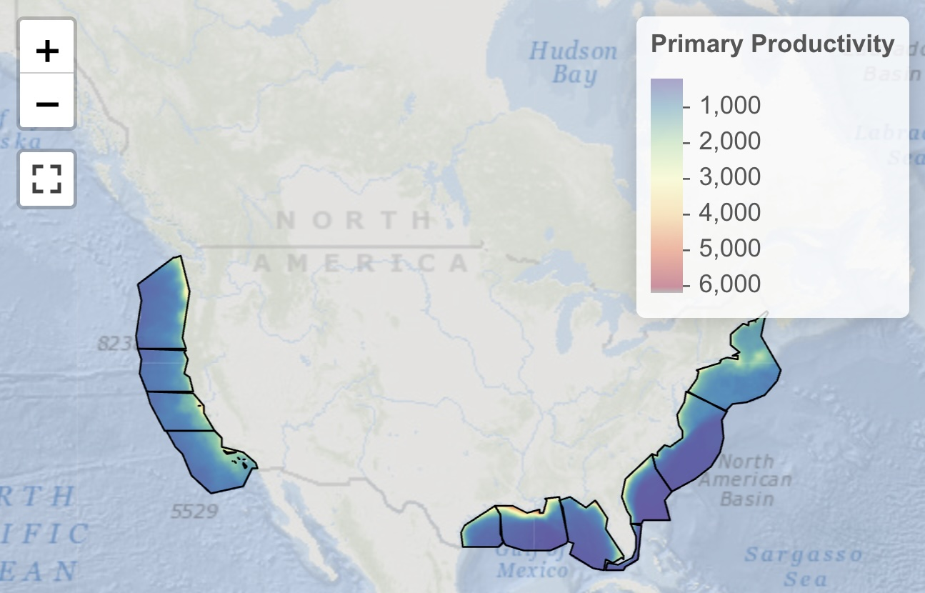
Figure 6.1: Primary productivity throughout the continental United States averaged across months of 2021, as measured by Oregon State’s Vertically Generalized Production Model (VGPM).

7. Taxonomy
Integrating distribution data from several providers requires resolving taxonomic identity across naming systems, so that models of the same species merge rather than being counted as different species. The MST uses a multi-authority matching pipeline in which every source name resolves to one canonical identifier.

7.1 Two taxonomic namespaces
Taxa resolve into one of two authorities, not one:
- Birds → BirdLife (BOTW:{sisid}). WoRMS coverage of birds is poor and its isMarine flag is unreliable for seabirds, so birds are not resolved through WoRMS.
- Everything else → WoRMS (WORMS:{aphia_id}), resolved from the scientific name via the ITIS↔WoRMS crosswalk, then exact WoRMS matching, then the WoRMS REST API for the remainder.
A merged model is keyed by that identity — ms_merge|WORMS:137209, ms_merge|BOTW:22694927 — which is also why species must be counted on the (authority, id) pair: the two namespaces number independently, so counting bare ids collides birds with invertebrates.

7.2 Taxonomic authorities
Table 7.1: Taxonomic authorities used for name resolution.
Authority | Role | Key
WoRMS | World Register of Marine Species — canonical identity for all non-bird marine taxa, and the source of the class/phylum used to assign a species category | worms_id (AphiaID)
BirdLife BOTW | Birds of the World — canonical identity and ranges for birds | botw_id (SIS ID)
GBIF | Backbone taxonomy, used as a crosswalk into WoRMS | gbif_id
ITIS | US federal standard; the first match attempted where a source supplies a TSN | itis_tsn
IUCN Red List | Conservation status, and expert range maps | iucn_id

At each stage deprecated names resolve to their accepted synonyms, with the original source name kept alongside the accepted one.

7.3 Species categories
Table 7.2: Species categories in v4. Scored is read from the metric registry — a category is scored only where the release published an extrisk_{cat} metric for it. Valid counts the taxa eligible for scoring.
Category | Taxa | Valid | Scored
invertebrate | 8,243 | 5,208 | Yes
fish | 6,679 | 3,065 | Yes
other | 1,129 | 910 | Yes
coral | 775 | 333 | Yes
bird | 614 | 203 | Yes
mammal | 89 | 70 | Yes
turtle | 6 | 6 | Yes
reptile | 26 | 0 | No

Categories present in the taxonomy but not scored in v4: reptile. They are carried in the taxon table — the identity is real — but no metric aggregates them, so they contribute nothing to any score.
How categories are assigned
- Sea turtles are their own category (turtle), separated from reptile so that the multiplicative turtle merge and the turtle metric have somewhere to live (see Chapter 9). Non-turtle reptiles — sea snakes, marine iguanas — remain in the taxonomy but are not scored.
- other collects taxa this release’s assignment could not place. It is a symptom rather than a category, and later releases removed the need for it by assigning from the taxonomic hierarchy instead — see Releases.

7.4 Marine relevance
Not every taxon in the source data belongs in a marine sensitivity analysis, and the obvious test does not work.
WoRMS isMarine fails for birds. Birds are resolved through BirdLife, so most have no WoRMS record at all, and those that do are inconsistently flagged; relying on it would drop nearly every seabird. Earlier releases sidestepped this with a purely spatial test — a taxon counted as marine if its distribution overlapped the study area — which admits any coastal or inland bird whose range happens to reach the coast.
This release predates the explicit marine-relevance cull. Marine status comes from WoRMS isMarine, with birds admitted through BirdLife instead, so the bird counts on this page are broader than in later releases.

7.5 From source taxa to valid species
Table 7.3: Validity gates applied cumulatively to v4’s published taxon table. The final row applies the release’s own validity flag to the whole table — it is the authoritative count, and not simply the conjunction of the diagnostic gates above it.
Filter step | Removed | Taxa remaining
Source taxa (all datasets) | — | 17,561
Resolved to a taxon id | — | 17,561
Has a merged distribution | −802 | 16,759
Not extinct | −21 | 16,738
Marine (WoRMS, or a BirdLife bird) | −48 | 16,690
Valid for scoring (the release’s is_ok) | −6,895 | 9,795

This yields 9,795 valid species across the study area.
Of those, 9,597 have modeled distributions inside the 20 BOEM Program Areas of the current program cycle. That is a spatial result, obtained by asking the zone tables which species occur there — not a property of the validity flag.
Validity is not the same question as “occurs in a Program Area”
Through v6 the validity flag silently required overlap with a BOEM Program Area, conflating “this is a real, mapped marine species” with “this species happens to fall inside the areas of the current program cycle” — and so hiding biodiversity outside that cycle. From v7 the two are separate: validity means the taxon has a modeled distribution in the study area, and Program-Area membership is a zone query answered afterwards.
This is why the headline count is not comparable across releases: it rose sharply at v7 without a single species being added, because the definition changed. Per-release counts are on the Releases page.

7.6 Data quality

7.6.1 Duplicate resolution
Several datasets may supply a model for the same species. Resolving every source name to one canonical identifier is what makes those models merge — taking the maximum per cell — instead of appearing as separate species and counting the taxon more than once in every score.

7.6.2 Synonym handling
Names change as taxa are reclassified. The pipeline resolves through acceptedNameUsageID in each authority, keeps the original source name alongside the accepted one, and updates deprecated identifiers to their current accepted form.

7.7 Implementation
Name resolution is msens::match_taxa(), which runs the identifier cascade and returns the unified taxon table. Category assignment, the marine cull and the validity flags are applied in the merge_taxon workflow (see Chapter 16).

8. Extinction Risk
Extinction-risk scoring turns a species’ conservation status into a numeric weight, so that a cell holding rare or threatened species scores higher than one holding common ones. The MST combines three US federal frameworks with the international IUCN Red List into a single score from 1 to 100.

8.1 Regulatory framework

8.1.1 Endangered Species Act (ESA)
The Endangered Species Act (1973) protects species listed as Endangered (EN) or Threatened (TN) by NMFS (marine species) or FWS (terrestrial and coastal species). ESA listing is the strongest signal available and drives the score for US-listed species.

8.1.2 Marine Mammal Protection Act (MMPA) — assigned by taxonomy
The Marine Mammal Protection Act (1972) protects all marine mammals in US waters regardless of ESA status, so the MST assigns it by taxonomy: every taxon in WoRMS class Mammalia, matched on AphiaID.
This is deliberate. Deriving the flag from the NMFS Species Directory instead — as earlier releases did — captures only the managed stocks listed there, roughly 70 against the ~137 marine-mammal taxa the analysis actually carries, and it silently omitted the FWS-managed species entirely (walrus, polar bear, sea otter, manatee, dugong). Taxonomy is the complete test because the statute is written in taxonomic terms.
The floor is 20, higher than the MBTA’s, because the MMPA imposes a stronger statutory standard: it affirmatively requires marine mammal populations to be maintained at Optimum Sustainable Population levels and mandates recovery, whereas the MBTA is primarily a prohibitive take statute. Marine mammals also tend to have lower reproductive rates and longer recovery times than most seabirds.

8.1.3 Migratory Bird Treaty Act (MBTA) — an explicit species list, not all birds
The Migratory Bird Treaty Act (1918) protects migratory birds native to the United States and its territories — which is an explicit list, not a taxonomic class.
The MBTA floor is the FWS CFR 50 §10.13 list, not all Aves
A bird absent from 10.13 — a non-US or non-migratory species — receives no MBTA floor. Treating “bird” as equivalent to “MBTA-protected” would apply a US statutory floor to species the statute does not cover, inflating their weight in US waters.
Note also that most 10.13 birds are terrestrial. The list sets the value of the birds that reach scoring; what keeps terrestrial birds out of the score in the first place is the marine-relevance cull (see Section 7.4).

8.1.4 IUCN Red List
For species with no US federal listing, the score falls back to the IUCN Red List category: Critically Endangered (CR), Endangered (EN), Vulnerable (VU), Near Threatened (NT), Least Concern (LC) and Data Deficient (DD).
Note
TN is an ESA status (Threatened), not an IUCN one — IUCN uses NT for Near Threatened. msens::compute_er_score() errors on a code such as IUCN:TN rather than scoring it through a default, because a silently-defaulted code is a wrong weight that nothing surfaces.

8.2 Scoring
Scores are computed by msens::compute_er_score(), on two tracks.

8.2.1 US-listed species
For a species with an ESA listing, or MMPA or MBTA protection, the score is the maximum of the applicable components:
$$\text{er_score}=max(\text{ESA base}, \text{MMPA floor}, \text{MBTA floor}) (8.1)$$
Table 8.1: Components for a US-listed species; the final score is the maximum across those that apply.
Component | Score
ESA Endangered (EN) | 100
ESA Threatened (TN) | 50
ESA not listed (LC) | 1
MMPA protected (all Mammalia) | 20
MBTA protected (CFR 50 §10.13) | 10

Worked examples:
- ESA Endangered whale (also MMPA): $max(100,20)=100$
- ESA Threatened seabird on the 10.13 list: $max(50,10)=50$
- Marine mammal with no ESA listing: $max(1,20)=20$
- 10.13 migratory bird with no ESA listing: $max(1,10)=10$
A species carrying an MMPA or MBTA floor is routed onto this track even when it has no ESA listing, which is what guarantees the floor is actually applied rather than being lost to the IUCN track.

8.2.2 Species with no US listing
Table 8.2: IUCN-based scores for species not listed by NMFS or FWS.
IUCN category | Score
Critically Endangered (CR) | 50
Endangered (EN) | 25
Vulnerable (VU) | 5
Near Threatened (NT) | 2
Least Concern / Data Deficient / other | 1

The IUCN scale is deliberately lower than the ESA one: a US statutory listing is a stronger, jurisdiction-specific statement about a species in US waters than an international assessment.
Species with no matching code at all receive the baseline of 1.

8.2.3 The governing score, and where it is applied
A taxon may carry several conservation codes at once — one per contributing dataset — and they can disagree, or be stale. The pipeline therefore computes one governing score per taxon: the most protective across its datasets, with a US national listing overriding the IUCN category, plus the statutory floors.
That governing score is applied at merge time, to the range cells — the point at which a species’ presence in a cell should carry its governing risk rather than whatever code the source dataset happened to record. Scoring then reads values that already reflect it.

8.2.4 When the listing is not the whole species: spatial extinction risk
A single governing score assumes the species is listed as a species. Under the ESA the listed entity can instead be a Distinct Population Segment, an ESU or a subspecies, and for some species only certain populations are listed: the humpback whale has six listed DPSs and eight that are not at risk — including the ones that breed in US waters — so its species page, flattened to the highest domestic status, read Endangered everywhere. For every species whose listed entities are scoped below the species (the list is in Chapter 6 under NMFS Distinct Population Segments), risk is therefore a surface, not a scalar: each listed entity’s designated critical habitat, from NOAA Fisheries’ authoritative service, carries that entity’s status (Endangered 100 / Threatened 50), and the rest of the species’ IUCN range carries the baseline every unlisted species of its kind gets — the MMPA floor of 20 for a marine mammal, the IUCN category otherwise. Sea turtles have long had the same treatment through their own SWOT + DPS dataset. How that surface reaches the score differs between the two groups and is described in Chapter 9.
Table 8.3: Distribution of the governing er_score across v4’s valid species.
er_score | Species | Share
100 | 41 | 0.4%
50 | 46 | 0.5%
25 | 37 | 0.4%
20 | 41 | 0.4%
10 | 81 | 0.8%
5 | 64 | 0.7%
2 | 73 | 0.7%
1 | 9,412 | 96.1%

Of v4’s 9,795 valid species, 59 carry the MMPA floor and 91 the MBTA floor.

8.3 Scale
Scores run from 1 to 100 and represent a percentage-like weight — 100 being maximum risk and 1 the baseline. Integers are used for storage efficiency; conceptually the scale is a 0–1 weight multiplied by 100.

8.4 Implementation
msens::compute_er_score(
extrisk_code, # "NMFS:EN", "FWS:TN", "IUCN:CR", ...
is_mmpa = FALSE, # MMPA protection (all WoRMS Mammalia)
is_mbta = FALSE) # MBTA protection (FWS CFR 50 §10.13)
extrisk_code is AUTHORITY:STATUS, where the authority is NMFS, FWS or IUCN, and the status is an ESA code (EN, TN, LC) or an IUCN code (CR, EN, VU, NT, LC, DD). Any other combination is an error, not a default.

9. Model Merging
A taxon may have distribution data in several source datasets. Merging combines them into one surface per taxon, applying the taxon’s governing extinction risk and constraining the result to where experts say the species actually occurs.
Interactive walkthrough
The Scoring Walkthrough animates this — maximum merge, range masking and the regulatory floors, step by step from input rasters.

9.1 The rule, in one place
The merge rules are msens::merge_sql(), msens::turtle_sql() and msens::dps_sql() — SQL held in the package rather than inside a notebook. The merge notebook executes them and the unit tests assert them against synthetic fixtures, one per taxon category, so the pipeline and its tests cannot drift apart. Changing a rule in a way that breaks a documented case fails the tests.

9.2 Pipeline
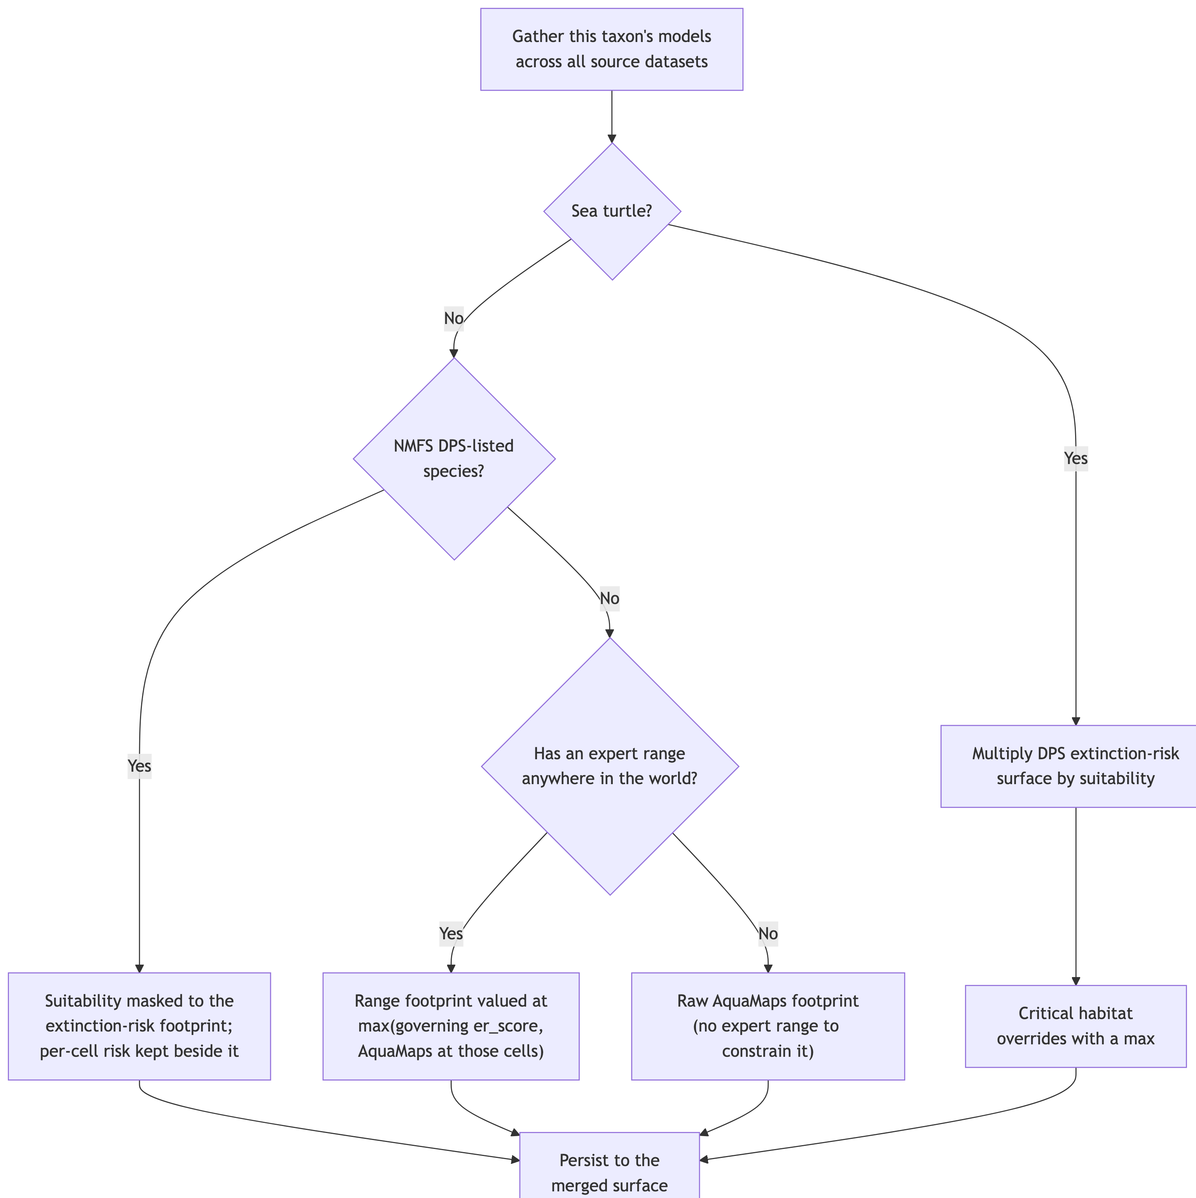
Figure 9.1: Merging one taxon’s source models into a single surface.

9.2.1 Step 1 — gather the taxon’s models
Every model resolving to the same taxon is collected: an AquaMaps suitability surface, any regulatory habitat or range designation (NMFS, FWS), a BirdLife or IUCN range map, and for sea turtles a SWOT+DPS range.

9.2.2 Step 2 — the expert range constrains AquaMaps
This is the heart of the merge, and it is not a plain maximum.
Where a taxon has an expert range, the merged surface is the range footprint, valued at the maximum of the taxon’s governing er_score and the AquaMaps value at those cells:
$$v_{c}=max​\left(\text{er_score}, v_{am,c}\right) c∈\text{range} (9.1)$$
AquaMaps values beyond the range are masked away. An environmental-envelope model will happily predict suitable habitat far outside where a species is known to occur; the expert range is what stops that prediction becoming an assertion of presence.
Where a taxon has no expert range anywhere, there is nothing to constrain it against, so its raw AquaMaps footprint is kept as-is.
“Has a range” is a global question, not a local one
Whether a taxon counts as range-constrained is decided on its range anywhere in the world, not on whether that range reaches the study area.
That distinction is the entire mechanism for excluding species whose expert range lies wholly outside US waters. Such a species has an expert range, so it takes the range-constrained path; its range ∩ US is empty, so it contributes no US cells. Deciding instead on “has a range in the US” would push those same species onto the unconstrained AquaMaps path and re-admit roughly 750 of them — river dolphins such as Sotalia guianensis among them — on the strength of edge-of-range model artifacts that expert assessment places nowhere near the US.
This was a v6 fix, lost in the v8 rewrite and since restored. It is now a named regression test.

9.2.3 Step 3 — two surfaces, not one

9.2.4 Step 4 — sea turtles multiply instead of taking a maximum
For the six sea turtle species, extinction risk varies across the range: NOAA Fisheries lists Distinct Population Segments separately, so the same species can be Endangered in one region and Threatened in another. A single scalar weight cannot express that.
So the turtle merge multiplies the DPS extinction-risk surface by the suitability surface:
$$v_{c}=max​\left(1, round\left(\frac{v_{er,c}×v_{suit,c}}{100}\right)\right) (9.2)$$
Critical-habitat designations then override with a maximum, so a designated cell is never scored below its designation.
Because risk is already inside the merged values, turtles receive er_score = 100 at scoring time as a pass-through multiplier (flagged is_er_spatial), which cancels in the division by 100 rather than double-counting.

9.2.5 Step 5 — NMFS DPS-listed species: the model stays the distribution, risk varies by cell
A second group of species carries extinction risk that varies across the range without being sea turtles: those whose ESA listed entity is a Distinct Population Segment, an ESU or a subspecies rather than the whole species — the humpback whale, the Southern Resident killer whale, Cook Inlet beluga, the salmon and steelhead ESUs, both sturgeons, and the others listed under NMFS Distinct Population Segments in Chapter 6. For them the pipeline builds a per-cell extinction-risk surface (dps_nmfs): each listed entity’s designated critical habitat at that entity’s status, and the species’ baseline everywhere else in its IUCN range (the MMPA floor of 20 for a marine mammal; the IUCN category otherwise).
These species do not use the turtle multiplication. Their merged value is the distribution — the suitability surface (AquaX, or AquaMaps where AquaX did not model the species) masked to the extinction-risk footprint, exactly the range mask every other taxon receives, with a cell that no suitability model covers valued at its risk, as in the plain rule — and the per-cell risk is carried beside the value rather than inside it:
$$v_{c}=\left\{\begin{matrix}v_{suit,c} & \text{where a suitability model covers }c \\ v_{er,c} & \text{otherwise}\end{matrix}\right. er_{c}=v_{er,c} (9.3)$$
Scoring then multiplies the two (Chapter 10), so the score is the same extinction-risk-weighted suitability the turtle rule produces — computed one step later. What changes is what the merged model shows: under the turtle rule the humpback, whose risk is the MMPA baseline across 99.8 % of its range, collapsed to a near-flat minimum everywhere outside critical habitat — the map drew the weight, not the whale. Now the merged model is the whale’s habitat suitability, and its risk is a separate layer (NMFS DPS extinction risk in the species app).
Critical-habitat datasets are not an input for these species: dps_nmfs already carries every designation at its own entity’s status, whereas the generic critical-habitat layers carry the species-level status (Endangered for the humpback) and would override the Threatened Mexico DPS habitat back to Endangered.
Three merge strategies
- Most taxa — range-constrained maximum, then a scalar extinction-risk weight at scoring time.
- Sea turtles — an extinction-risk raster multiplied into the merged model, so risk varies spatially within the species.
- NMFS DPS-listed species — the merged model is the suitability; an extinction-risk raster is kept beside it and multiplied in at scoring time.

9.3 Where extinction risk enters
The governing er_score (Chapter 8) is applied at merge time, valuing the range cells — the point at which a species’ presence in a cell should carry its governing risk rather than whatever code the contributing dataset happened to record. Applying it later, at scoring, would lose that: the merged surface would carry source-specific codes that may be stale or out of jurisdiction. The NMFS DPS-listed species are the deliberate exception: their risk is a per-cell surface built from the listings themselves, so it is carried beside the merged value and applied at scoring, where the per-cell weight replaces the scalar one.

9.4 The statutory floors
The MMPA (20) and MBTA (10) floors are part of the governing er_score, not a separate pass over the cells. A marine mammal’s range cells therefore carry at least 20 wherever it is present, and a CFR 50 §10.13 migratory bird at least 10 — see Chapter 8 for how each flag is assigned, and why the MBTA one is a species list rather than “all birds”.

9.5 Persisted output
The merged result is stored as:
- model — one row per merged model, keyed by mdl_seq.
- model_cell — one row per model × cell, holding the merged value in val.

9.6 Validity after merging
A taxon is flagged valid once merging has run, on the criteria in Chapter 7 — chiefly that it resolved to a taxon, is marine and not extinct, and has at least one merged cell in the study area. Program-Area overlap is not among them from v7 onward; it is a spatial question answered later.
In v4 this yields 9,795 valid species across the study area, of which 9,597 contribute to scores within the 20 BOEM Program Areas of the current program cycle.

9.7 Guarding the rules
Every merge category has a synthetic fixture in the msens test suite asserting its exact expected output: range-only, both-masked, range-outside-the-US excluded, AquaMaps-only single-model, AquaMaps-only multi-model (which must not deduplicate), and the multiplicative turtle case.
This is deliberate. Whole-pipeline checks — the version-equivalence gate on Program-Area scores, and the content-hash checkpoints — catch aggregate drift, but they hide rule-level breakage: the ~750 wrongly-included species above moved aggregate scores almost not at all while being scientifically wrong. A category with no fixture is a category that can break silently.

10. Scoring
Scoring turns merged species distributions and extinction-risk weights into per-cell sensitivity metrics, which are then rescaled within ecoregions and aggregated to management zones.
Interactive walkthrough
The Scoring Walkthrough animates this pipeline — input rasters, merge, ecoregional rescaling and component averaging, step by step.

10.1 Cell-level scoring
For each cell, sensitivity is the extinction-risk-weighted sum of species presence within a species category:
$${\text{score}}_{c,g}=\sum_{s=1}^{S_{g}}{\frac{{\text{er_score}}_{s}×v_{s,c}}{100}} (10.1)$$
where ${\text{score}}_{c,g}$ is the score for cell $c$ and category $g$; ${\text{er_score}}_{s}$ is species $s$’s extinction-risk weight (1–100, Chapter 8); $v_{s,c}$ is the merged model value for that species in that cell (0–100, Chapter 9); and $S_{g}$ is the number of valid species in the category. Dividing by 100 returns the product to a 0–100 scale.
In plain terms: for every cell the MST adds up the contributions of the species found there. A cell holding many species that are both likely present and at high risk scores higher — which is how places where rare or threatened species concentrate are identified.

10.1.1 Two exceptions: species whose risk varies across the range
For sea turtles, extinction risk is already inside the merged values via the multiplicative merge (Chapter 9), so the formula collapses to a plain sum:
$${\text{score}}_{c,g}=\sum_{s=1}^{S_{g}}{v_{merged,s,c}} (10.2)$$
er_score = 100 acts as a pass-through multiplier that cancels against the division. Cells inside an Endangered DPS therefore contribute more than cells inside a Threatened one, for the same species at the same suitability.
For the NMFS DPS-listed species (the humpback whale, Southern Resident killer whale, salmonid ESUs, …) the merged value is the suitability alone and the risk is a per-cell weight carried beside it, so the species-level er_score is replaced by the cell’s:
$${\text{score}}_{c,g}=\frac{1}{100}\sum_{s=1}^{S_{g}}{e}r_{s,c}×v_{s,c} (10.3)$$
Numerically this is the turtle product taken one step later; the difference is that the merged model these species publish is their distribution, not their risk-weighted distribution. Each taxon’s rule is recorded as er_mode in the scoring taxon table (taxon — the scalar weight; premultiplied — sea turtles; cell — DPS-listed species).

10.2 Metrics
Table 10.1: Cell-level metrics published by v4. Each has an ecoregionally rescaled counterpart, and the composite is their equally weighted mean.
Metric | Description
extrisk_bird | Extinction risk for bird
extrisk_bird_ecoregion_rescaled | Extinction risk for bird, rescaled to [0,100] based on Ecoregional min/max values
extrisk_coral | Extinction risk for coral
extrisk_coral_ecoregion_rescaled | Extinction risk for coral, rescaled to [0,100] based on Ecoregional min/max values
extrisk_fish | Extinction risk for fish
extrisk_fish_ecoregion_rescaled | Extinction risk for fish, rescaled to [0,100] based on Ecoregional min/max values
extrisk_invertebrate | Extinction risk for invertebrate
extrisk_invertebrate_ecoregion_rescaled | Extinction risk for invertebrate, rescaled to [0,100] based on Ecoregional min/max values
extrisk_mammal | Extinction risk for mammal
extrisk_mammal_ecoregion_rescaled | Extinction risk for mammal, rescaled to [0,100] based on Ecoregional min/max values
extrisk_other | Extinction risk for other
extrisk_other_ecoregion_rescaled | Extinction risk for other, rescaled to [0,100] based on Ecoregional min/max values
extrisk_turtle | Extinction risk for turtle
extrisk_turtle_ecoregion_rescaled | Extinction risk for turtle, rescaled to [0,100] based on Ecoregional min/max values
primprod | Primary productivity: Oregon State Vertically Generalized Production Model (VGPM) from Visible Infrared Imaging Radiometer Suite (VIIRS) satellite data (mg C / m^2 / day) from daily averages available as monthly averaged to annual and averaged to overall for the most recently available full years of data 2014 to 2023
primprod_ecoregion_rescaled | Primary productivity rescaled to [0,100] based on Ecoregional min/max values
score_extriskspcat_primprod_ecoregionrescaled_equalweights | Combined score of extinction risk per species category and primary productivity, equally weighted (and each previously rescaled [0,100] based on Ecoregional min/max values)

One extinction-risk metric exists per scored species category — invertebrate, fish, other, coral, bird, mammal, turtle — plus primary productivity, which carries no extinction-risk weighting.

10.3 Ecoregional rescaling
Raw cell scores vary naturally between ecoregions, through differences in species richness, oceanography and biogeography. Each metric is therefore rescaled to 0–100 within each BOEM Ecoregion:
$${\text{score}}_{c}^{′}=\frac{{\text{score}}_{c}−{\text{score}}_{min}}{{\text{score}}_{max}−{\text{score}}_{min}}×100 (10.4)$$
with the minimum and maximum taken over that metric’s cells within the ecoregion.
Scores are relative within an ecoregion, never absolute
A score of 100 marks the most sensitive cell for that metric within that ecoregion — not globally. A 30 in Alaska and a 30 in the Pacific describe different ecological contexts.
Scores are therefore directly comparable among Program Areas within one ecoregion, and should not be compared across ecoregions.

Why rescale at all? Without it, naturally species-rich areas would almost always score highest simply for holding more species. More species may well indicate greater ecological importance — but it can equally be argued that the fewer species an ecosystem has, the more each one matters to its function and resilience. Rescaling within ecoregions keeps scores from being dominated by richness. Comparing across ecoregions would require settling that argument with a mathematical relationship between the two views, which remains a live academic debate.

10.4 Spatial units
Table 10.2: Spatial units v4 scored, with the geometry vintage each used.
Unit | Field | Count | Vintage
BOEM Ecoregion | ecoregion_key | 12 | ecoregion_2025-06
BOEM Planning Area | planarea_key | 36 | planarea_2025-06
BOEM Program Area | programarea_key | 20 | programarea_2026-01
Subregion | subregion_key | 4 | subregion_2025-06

Geometry is versioned by its own vintage rather than by release, so several releases legitimately share one boundary set — one Program Area geometry covers v2 through v8, and one ecoregion geometry covers every release. Each release’s manifest names the vintage it used, which is what lets this book draw the correct outlines for the version it documents instead of the newest ones.

10.4.1 Geographic scope
The analysis covers 20 BOEM Program Areas from the 11th National Draft Proposed Program (2025), spanning Alaska, the Pacific and the Gulf of America. The Atlantic OCS is not part of this program cycle, so ecoregions containing no Program Area are outside the scored footprint.
The Gulf of America Program Areas (GAA and GAB) each span two ecoregions — Western and Central Gulf of America, and Eastern Gulf of America. Because rescaling happens before aggregation, cells are rescaled against their own ecoregion’s range, and the Program Area score is then the area-weighted mean across all its cells regardless of ecoregion. Local ecological context is preserved even where a Program Area crosses a boundary.
Figure 10.1: BOEM Ecoregions (colored) and Program Area outlines. Ecoregion keys: CAC = California Current; CBS = Chukchi and Beaufort Seas; EBS = East Bering Sea; EGOA = Eastern Gulf of America; GOA = Gulf of Alaska; HAR = High Arctic; NECS = Northeast Continental Shelf; PIS = Pacific Island Territories; PUR = Puerto Rico and U.S. Virgin Islands; SECS = Southeast Continental Shelf; WAOR = Washington/Oregon; WCGOA = Western and Central Gulf of America. Program Area keys: ALA = Aleutian Arc; ALB = Aleutian Basin; BFT = Beaufort Sea; BOW = Bowers Basin; CEC = Central California; CHU = Chukchi Sea; COK = Cook Inlet; GAA = GOA Program Area A; GAB = GOA Program Area B; GEO = St. George Basin; GOA = Gulf of Alaska; HAR = High Arctic; HOP = Hope Basin; KOD = Kodiak; MAT = St. Matthew-Hall; NAV = Navarin Basin; NOC = Northern California; NOR = Norton Basin; SHU = Shumagin; SOC = Southern California.

10.5 Primary productivity
Net primary productivity from the VGPM satellite model enters as its own metric (primprod), without extinction-risk weighting. The raw values (metric tons C km⁻² yr⁻¹) are rescaled within each ecoregion on the same 0–100 basis as everything else.

10.6 Zone aggregation
Rescaled cell scores are aggregated to each spatial unit by area-weighted mean:
scorezone=c∈zone​scorec′×Acc∈zone​Ac (10.5)
where $A_{c}$ is the area of cell $c$ — which is latitude-dependent on a 0.05° grid, so the weighting is not cosmetic.

10.7 Visualization

10.7.1 Flower plot
The flower plot summarizes a zone’s sensitivity profile by category, after the Ocean Health Index (Halpern et al. 2012):
- petal length — the rescaled score (0–100) for that category; longer means more sensitive
- petal width — that category’s weight in the composite; wider means more influence
- centre — the weighted mean across categories
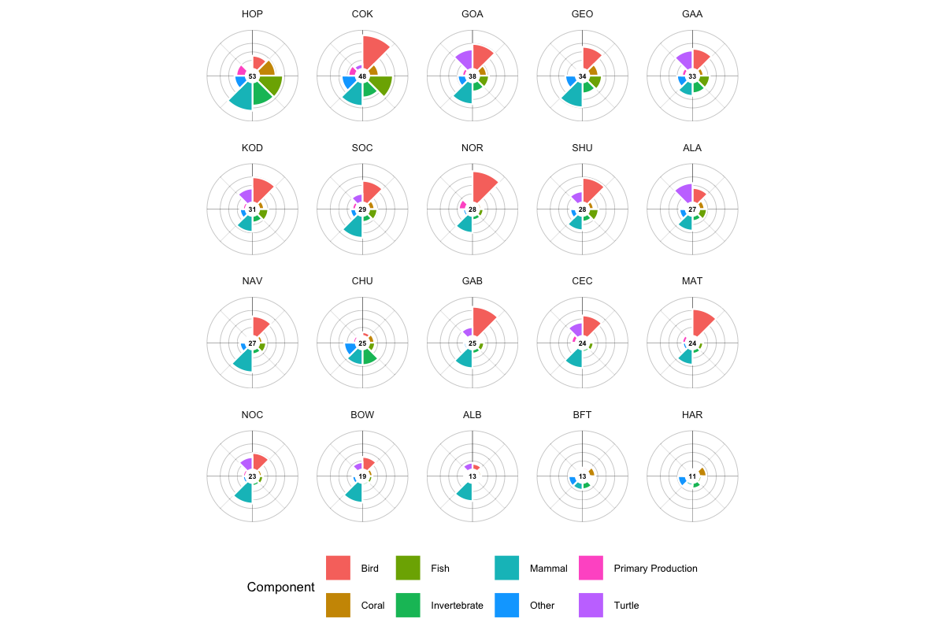
Figure 10.2: Flower plots for the BOEM Program Areas, showing ecoregionally rescaled sensitivity scores by species category.
It lets a reader see at a glance which ecological elements drive sensitivity in an area. The scores app implements an interactive version.

10.7.2 Treemap
The treemap shows how individual species contribute to a score, nested first by extinction-risk category and then by taxonomy, with zoom down to single species.
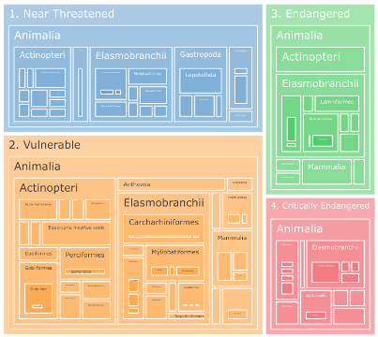
Figure 10.3: Treemap of species contributions to extinction-risk scores, organized by risk category and taxonomy.

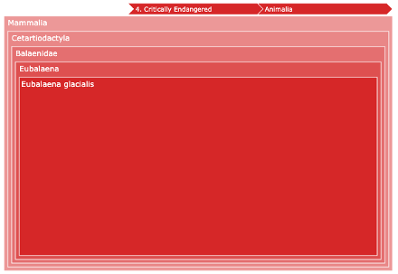
Figure 10.4: Zoomed treemap showing individual species within a risk category and taxonomic group.

10.7.3 Score rasters
Cell-level scores are published as Cloud-Optimized GeoTIFFs, one per metric x subregion, with the manifest carrying each raster’s URL and its build-time rescale range. The map reads those directly.
This replaced a tile factory that ran SQL against the database on every tile request. The rasters were verified byte-identical to the factory’s output before the switch. They are stored without overviews deliberately: the renderer decimates from full resolution per request, so a pre-built pyramid would disagree with it at low zoom.

10.7.4 Interactive maps
The Atlas presents the results, rendering any published release rather than being frozen to one. It has two lenses:
- Scores — composite and per-category sensitivity by zone, with flower plots and component tables (see Chapter 21)
- Species — individual and merged distribution models with regulatory status (see Chapter 21)
Substitute the version in the ?ver= query parameter (e.g. ?ver=v3) to view that release (a restricted pre-release is reached only on the review host, at /{version}/atlas/). The separate Scores and Species Shiny apps that earlier editions of this book described are retired, and their links redirect to the Atlas. See Chapter 19.

10.8 Implementation
Scoring runs in the score_zones, score_cell_metrics and score_zone_metrics workflows (Chapter 16). Whole-pipeline equivalence between releases is checked by msens::pra_score_delta, which compares Program-Area scores on the species the two releases share.

11. Scoring Walkthrough
Interactive step-by-step visualization of the sensitivity scoring pipeline

This interactive walkthrough demonstrates how the Marine Sensitivity Toolkit calculates sensitivity scores, from input rasters through model merging, ecoregional rescaling, and final aggregation. Use the arrow keys or navigation buttons to step through the pipeline. Click any step in the top bar to jump directly to it.
For the underlying methodology, see Scoring and Model Merging. For source code, see the workflows index, which lists every notebook in the pipeline with its current dependency graph.

12. Stressors
The stressor component of the vulnerability framework (see Chapter 5) addresses the human activities that may impact marine ecosystems. This section is a placeholder for future phases of the MST, which will incorporate stressor-receptor interaction matrices to complete the full vulnerability assessment.

12.1 Offshore Wind Energy
Evaluation of stressors from the offshore wind industry needs to be evaluated based on human activities given the phase of development, whether pre-construction, construction, operation or decommissioning (Figure 12.1).
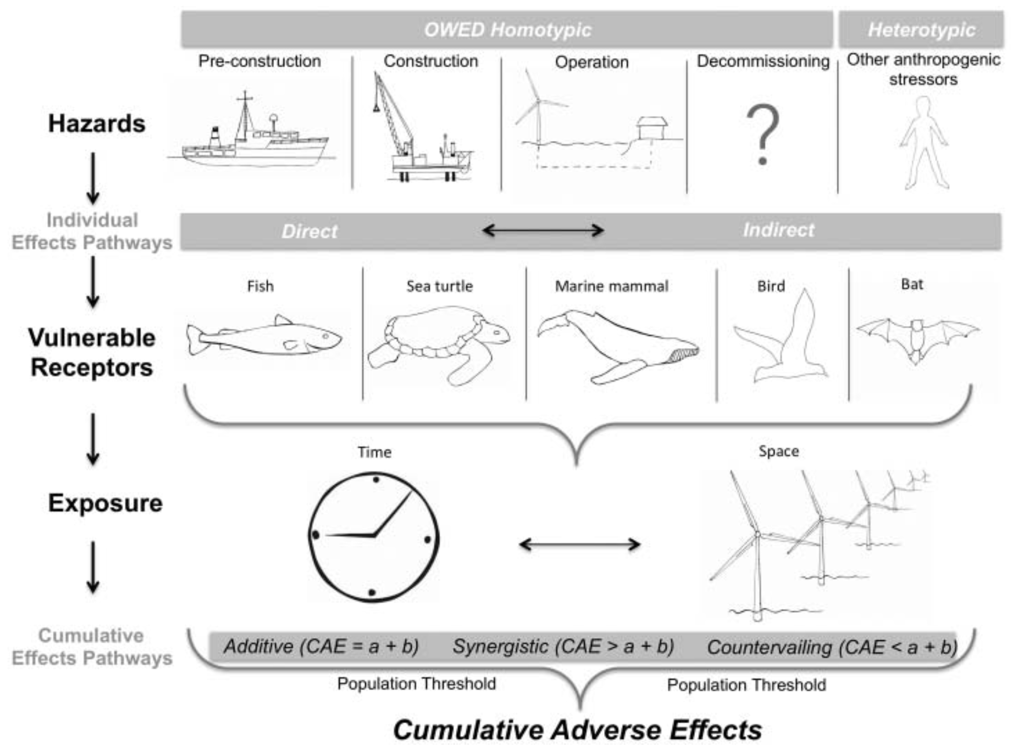
Figure 12.1: Cumulative adverse effects of offshore wind energy development on wildlife (Goodale and Milman 2016).

12.2 Oil & Gas

13. Software

13.1 Software Overview
The Marine Sensitivity Toolkit (MST) is a stack of software components for reproducibly, interactively and hierarchically generating environmental vulnerability maps and scores. Tabular data is collated across studies evaluating sensitivity of species to oil & gas and offshore wind energy development. The best available species and benthic habitat distributions are being mosaicked across the US EEZ. Scores are summarized according to subgroups within Species, Benthic Habitats and Primary Productivity, averaged into an overall score, and visualized as a flower plot, applicable to various levels of BOEM relevancy: regional, ecoregions, protraction diagrams, blocks and aliquots.
The software components for achieving this interactively are:
- server — a Docker Compose configuration orchestrating the reverse proxy, Shiny server, APIs, TiTiler raster serving and file server;
- database — a columnar, embedded analytic database (DuckDB) as the single source of truth for species distributions, per-cell scores and derived per-zone metrics;
- workflows — Quarto notebooks to ingest source datasets (AquaMaps, IUCN, NMFS/FWS, BirdLife, WoRMS, BOEM zones), merge taxonomic authorities, and compute scores that are written back to DuckDB;
- APIs — a custom R plumber API for data requests, TiTiler serving the published COGs, and a searchable STAC API with one Item per model;
- libraries — re-usable documented functions as the msens R package, including the version/manifest registry that lets one application render any release, and the tile-URL helpers the applications use;
- applications — the static, in-browser Atlas, which combines COG raster layers with static PMTiles vector layers and per-zone choropleth fills computed in the browser, rendering any published release (it replaced the earlier scores and species Shiny apps);
- documentation — this Quarto book with figures, tables, glossary and references in interactive HTML or static DOCX / PDF output.
This toolbox is intended to primarily serve BOEM needs internally, but by being open-source and fully reproducible the hope is to enlist buy-in and even contributions from external partners, whether from other government agencies, academia, NGOs or industry.
We ascribe to the philosophy of sharing all code for the sake of reproducibility, transparency and efficiency (Maitner et al. 2024; Lowndes et al. 2017); i.e. the FAIR principles of Findability, Accessibility, Interoperability, and Reusability (Wilkinson et al. 2016).
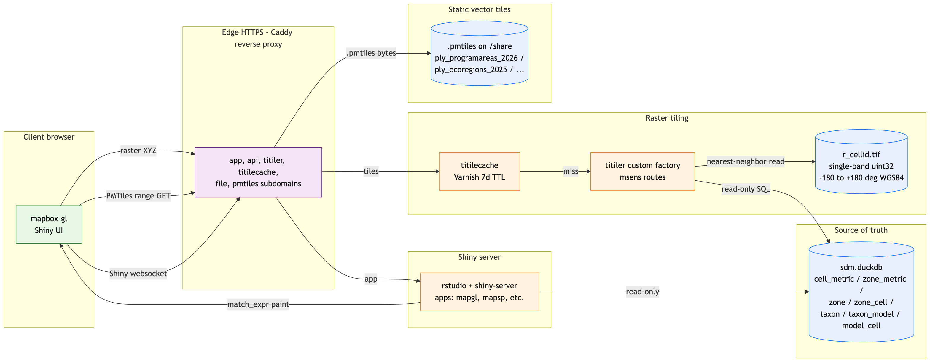
Figure 13.1: System architecture: a release is published as partitioned Parquet plus pre-rendered COGs. TiTiler serves the score rasters; zone polygons are served as static PMTiles through Caddy; the Shiny apps combine both layer types and push per-zone scores live into the polygon paint spec.

13.1.1 Interactive Applications
The project’s interactive application, the Atlas (Chapter 19), lets users visualize the data, explore the results, and interact with the data in a more intuitive way. It is a static web app that computes scores, tables and reports in the browser. Earlier editions of the MST were instead served by two applications built with the shiny package in R (Chang et al. 2024), now retired; the diagrams in this chapter were drawn for that design, so where they show a Shiny server, the Atlas does that work in the browser, with the same COG, PMTiles and Parquet data underneath.

13.1.2 Overcoming Challenges with Large Spatial Data
The MST project incorporates many large spatial datasets that are problematic to render in a typical interactive application. For instance, the most common interactive mapping R package leaflet has a 4 MB limitation for displaying rasters (see “Large Raster Warning” in Raster Images • leaflet). Vectors (points, lines and polygons) get smoothed when containing many vertices, but contiguity between polygons is lost and rendering degrades depending on the user’s connection speed.
To work around these limitations we use a “cloud native” stack (see also the Cloud-Optimized Geospatial Formats Guide) that transfers only the pixels / features visible in the current viewport:
- Raster cell values are published as pre-rendered Cloud-Optimized GeoTIFFs and delivered as small 256×256 PNG tiles by TiTiler’s stock /cog routes, which range-read only the part of the COG a tile needs.
- Vector polygons (Program Areas, Ecoregions, Planning Areas, …) are served as static PMTiles archives by the Caddy file server — a single archive per layer, range-read by the browser.
- Choropleth values (per-Program-Area scores) are pushed live from DuckDB into the PMTiles paint spec via a mapbox-gl match expression, so geometry stays static but color updates as the user changes metric / subregion.
Let’s take a closer look at each.

13.1.2.1 Raster: pre-rendered COGs
Each metric (e.g. extrisk_mammal) resolves, in DuckDB’s cell_metric table, to a list of (cell_id, val) rows — one per grid cell. Materializing the full raster and shipping it to the browser is not viable (several GiB), so only the tiles in view are transferred.
Scores are published as one COG per metric × subregion, written by a publishing workflow into a content-addressed store. Each release’s manifest carries the href and the build-time rescale range, so the application reads them and hands the URL to TiTiler’s stock /cog endpoints — no custom endpoint, and no database query in the tile path (Figure 13.2).
Two details are load-bearing:
- No overviews. The renderer decimates from full resolution on each request, so a pre-built pyramid would disagree with it at low zoom.
- The object key includes the encoding, not just the payload. Rewriting an object at a stable URL once left GDAL’s /vsicurl serving a cached header describing bytes that no longer existed: fine at z5+, HTTP 500 at z2–z4.
This replaced a custom TiTiler factory that rendered each tile by executing a validated SELECT against DuckDB and looking the result up against a pre-baked cell-id COG, with Varnish caching each tile URL for seven days. That path is retired but kept behind a flag (see Chapter 17); the two were verified to produce the same picture before the switch.
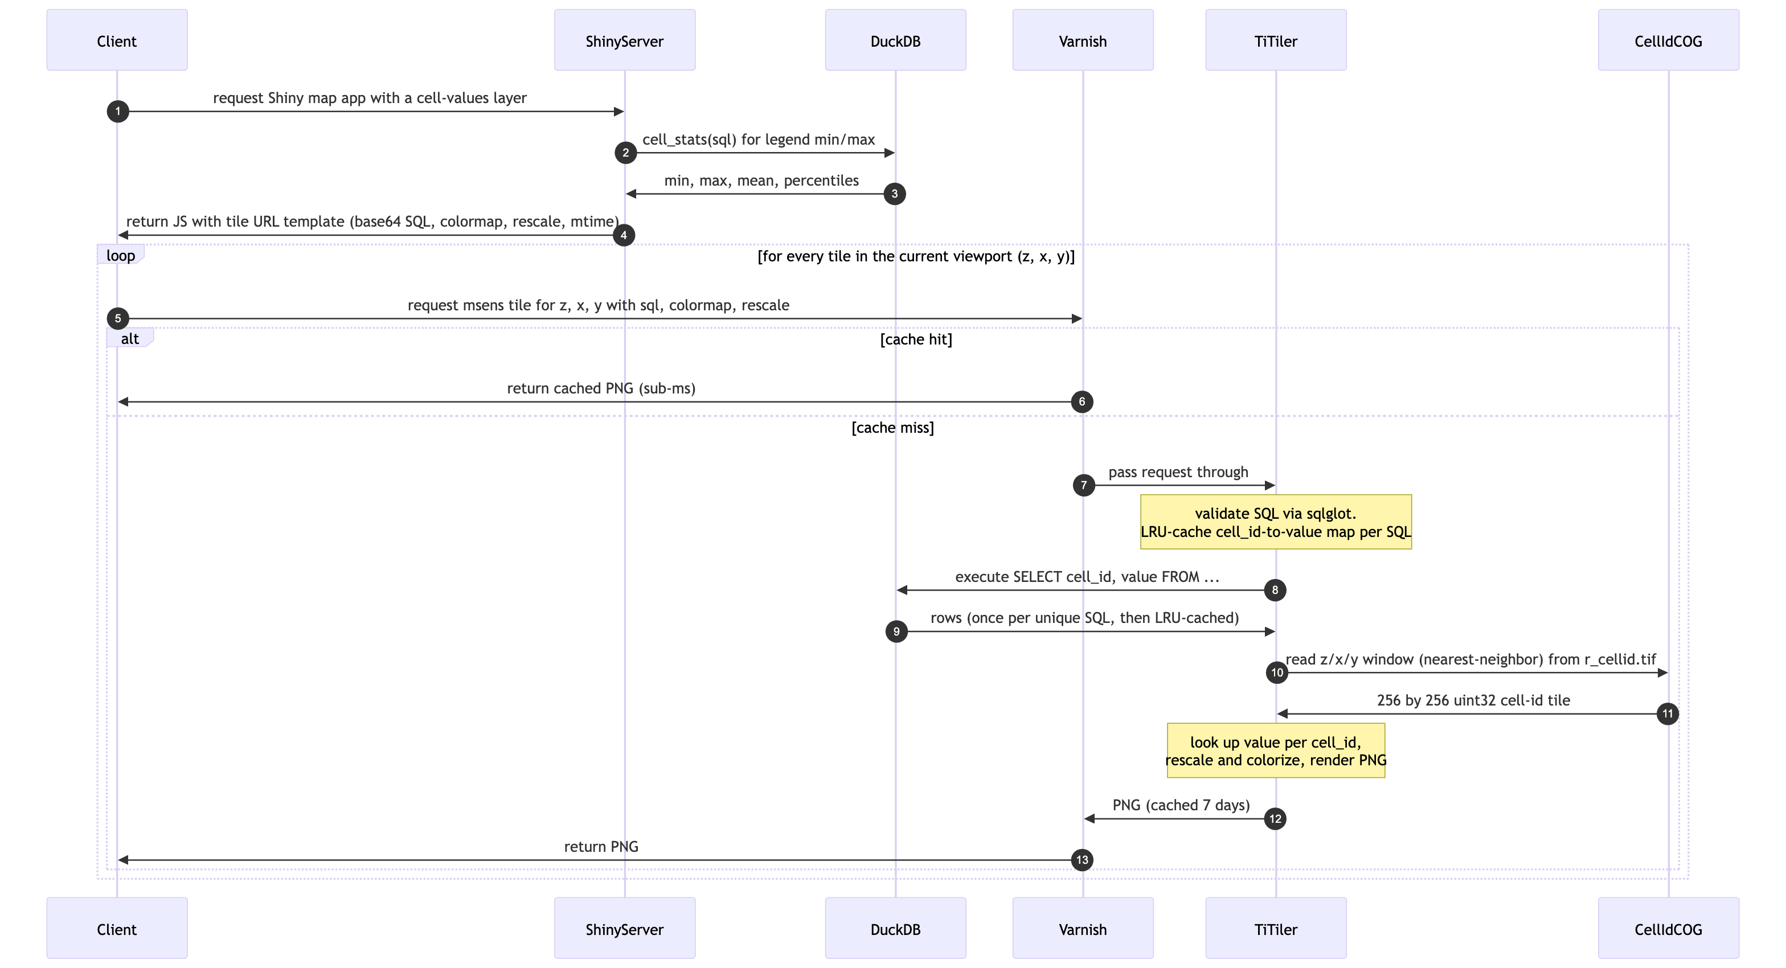
Figure 13.2: Sequence diagram: a cell-values raster layer is rendered on-the-fly by the custom msens TiTiler factory from the DuckDB source of truth. Varnish caches identical tile URLs for 7 days.
Binary overlays — the “cells outside Program Areas” mask — are published the same way, as their own single-color rasters rather than as a query.

13.1.2.2 Vector: static PMTiles served by Caddy
For polygon layers (Program Areas, Ecoregions, Planning Areas, protractions, blocks, aliquots) we build PMTiles archives offline via tippecanoe and publish them as static files on the server. A PMTiles archive is a single file with an internal directory structure that lets any HTTP client issue small range requests for individual tiles; no tile server process is required — Caddy’s static file handler is all we need (Figure 13.3).
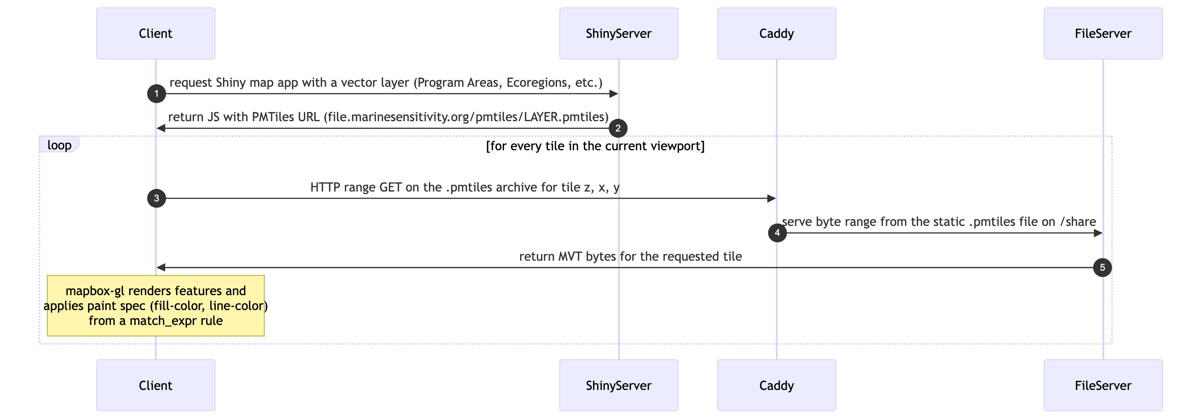
Figure 13.3: Sequence diagram: vector layers are served as static PMTiles archives through Caddy. Each tile is a byte-range read of the archive — no tile server process is in the path.
This is a deliberate simplification from the prior architecture which used PostgreSQL + PostGIS + pg_tileserv. For our workload — polygon layers that change only when the data is rebuilt — a compiled tile server and live database query engine add latency and operational complexity for no benefit over byte-range reads of a pre-baked archive. (PostgreSQL and pg_tileserv are now commented out of docker-compose.yml entirely and are not running; see Chapter 14.)

13.1.2.3 Choropleth: live DuckDB values + static PMTiles geometry
The Program Area choropleth is the interesting hybrid case. The geometry (Program Area polygons keyed by programarea_key) is static — it comes from the same PMTiles file as the polygon outlines. But the fill color depends on the currently-selected metric + subregion, which means the per-Program-Area score has to come live from DuckDB.
(This describes the retired Shiny design; the Atlas applies the same idea in the browser, coloring the static PMTiles geometry from per-zone scores it reads for the release.) The Shiny server handled this by querying zone_metric (pre-aggregated per-zone values), building a mapbox-gl match expression that mapped programarea_key → fill_color, and pushing that paint rule to the map through mapgl’s Shiny proxy. No tiles are re-rendered; only the paint specification changes (Figure 13.4).
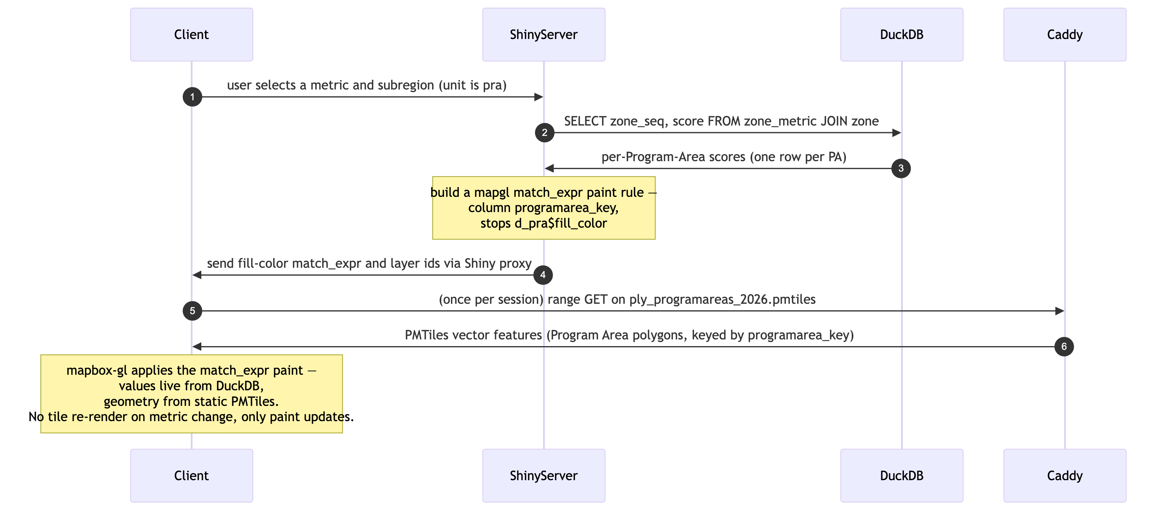
Figure 13.4: Sequence diagram: the Program Area choropleth. Polygon geometry is static (PMTiles from Caddy file server); per-area fill values come live from DuckDB’s zone_metric table and are pushed into mapbox-gl’s paint spec via a match expression. Switching metrics updates only the paint rule, not the tiles.

13.1.2.4 Data pipeline — how the source of truth is built
The serving paths above all sit downstream of one pipeline: ingest workflows write per-dataset distributions, the merge workflows combine them into one surface per taxon, the scoring workflows compute cell_metric and zone_metric, and the release workflow publishes the result as partitioned Parquet plus COGs, PMTiles and a STAC catalog. The whole thing is a targets graph generated from each notebook’s own metadata, so adding a dataset means adding a notebook (Figure 13.5). See Chapter 16.
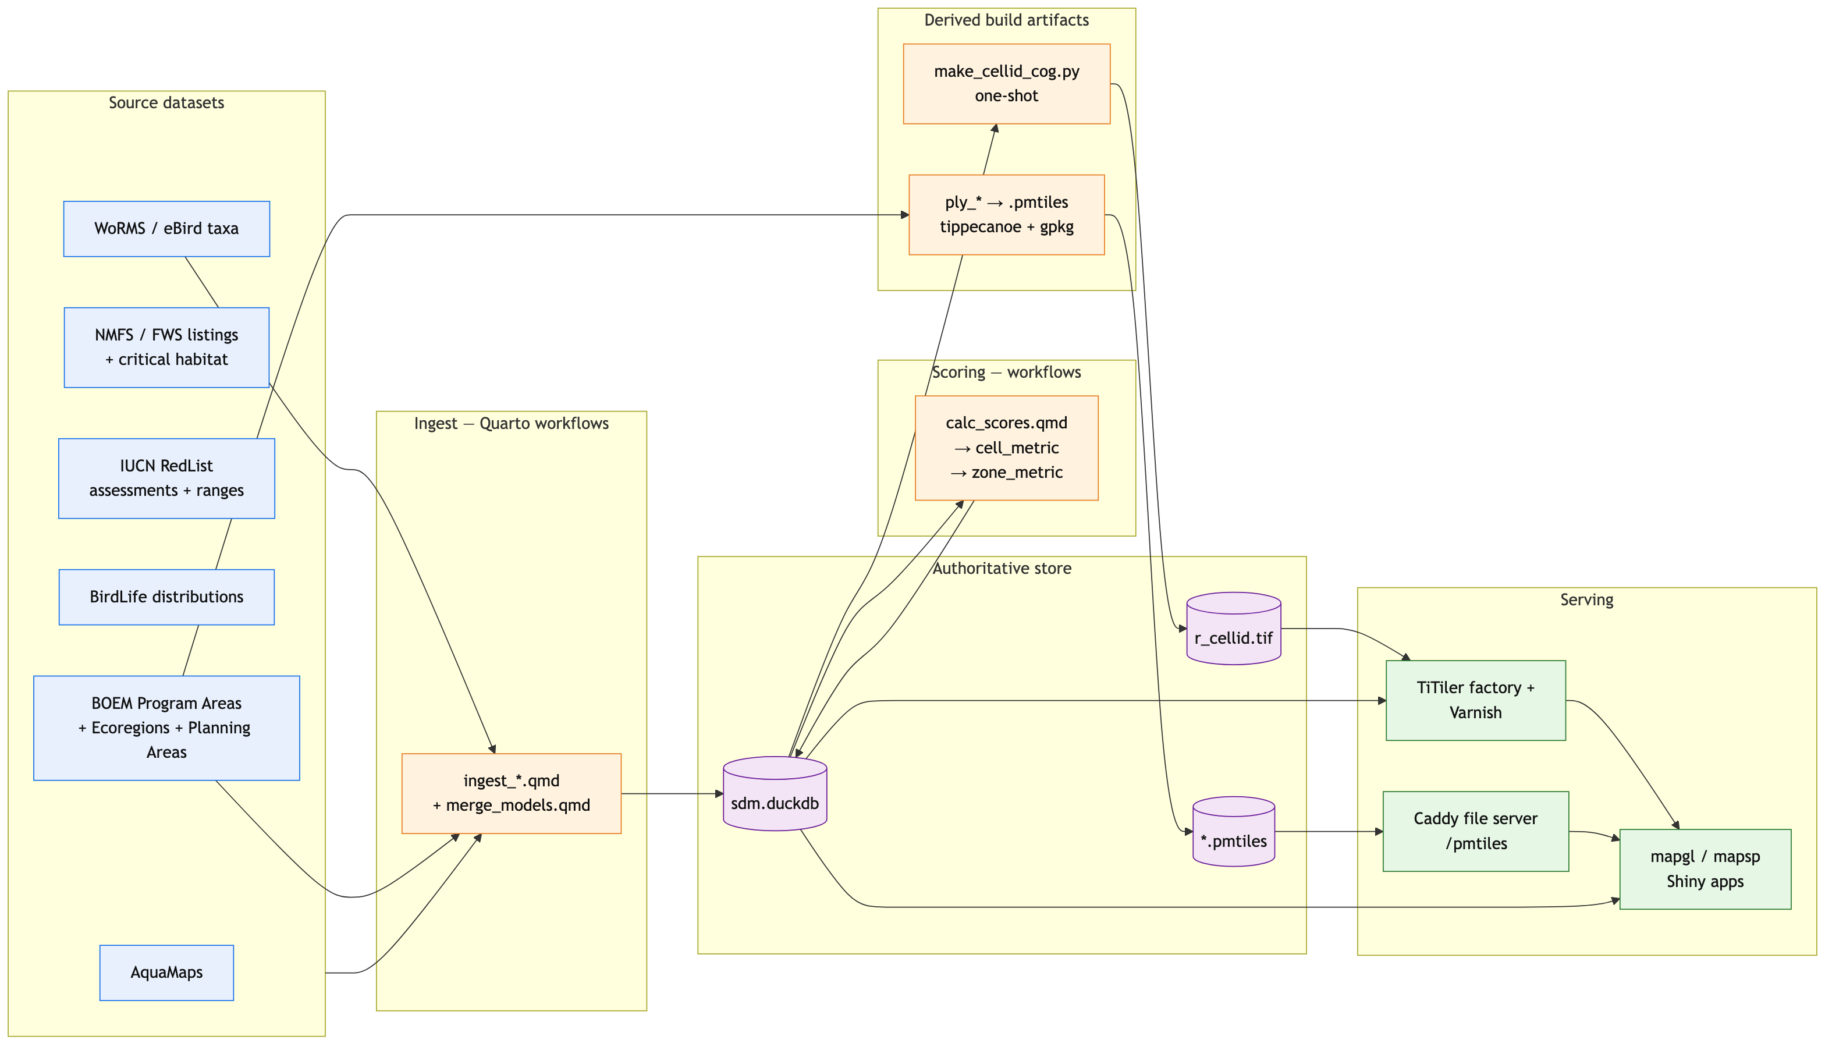
Figure 13.5: Data pipeline: ingest workflows populate DuckDB; scoring workflows compute cell_metric and zone_metric back into DuckDB; a one-shot COG regen and offline PMTiles build produce the derived artifacts the serving tier reads.

13.1.3 Github Repositories
repo | description
.github | organization README
analytics | NA
api | application programming interface (API) using R Plumber package
app | app for viewing and summarizing MST composite scores and individual species distributions
apps | Shiny applications
atlas | Marine Sensitivity Atlas: one static browser app for scores, species, places and reports, reading the published marine-atlas release
docs | documentation for BOEM’s offshore environmental sensitivity index products
manuscripts | Manuscripts with review of sensitivities by industry and receptors (species, habitats, human uses)
MarineSensitivity.github.io | default website
msens | R library of functions for mapping marine sensitivities, sponsored by BOEM
objectives | repository for issues spanning multiple repositories and doing big picture roadmapping
server | server setup for R Shiny apps, RStudio IDE, Caddy web server, h3 TiTiler service and Varnish cache
stac-sdm | STAC extension for Species Distribution Models (SDMs)
workflows | scripts for testing data analytics and visualization as well as production workflows

13.1.4 Software Components
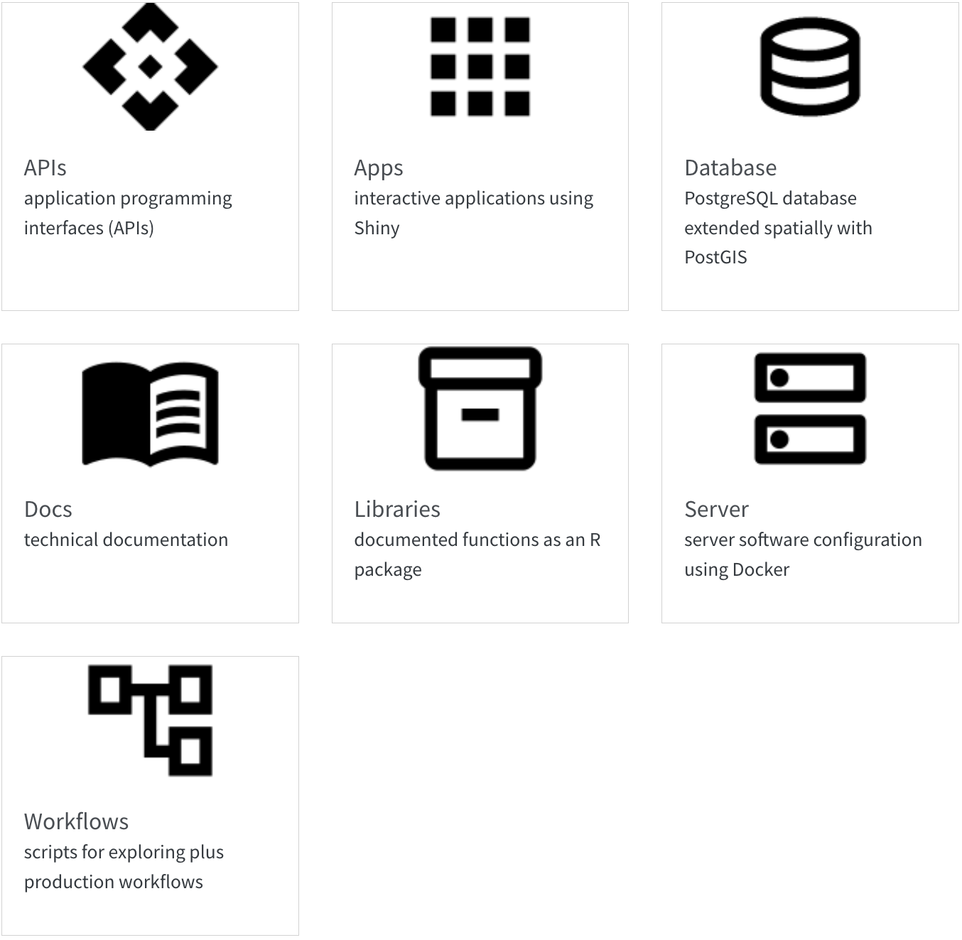

14. Server
The server is for serving up any web services outside those of Github (e.g., website, docs and R package msens) using Docker (see the docker-compose.yml; with reverse proxying from subdomains to ports by Caddy).
The full architecture is summarized in the Software overview. This chapter documents the concrete services running on the host and how Caddy maps subdomains to container ports.

14.1 Setup
For the latest instructions on launching an Amazon instance and installing the server software, see Server Setup · MarineSensitivity/server Wiki, which is pasted below for convenience…
on AWS as EC2 instance using Docker

14.1.1 launch instance
name: msens1:
- Software Image (AMI)
Canonical, Ubuntu, 22.04 LTS, amd64 jammy image build on 2023-09-19 ami-0fc5d935ebf8bc3bc
- Virtual server type (instance type)
t2.xlarge (4 vCPU, 16 GB memory)
- Firewall (security group)
New security group
- Storage (volumes)
2 volume(s)
  - 20 GB
/ server software, disposable
  - 60 GB
/share for all data, persistent and to be backed up

14.1.1.1 allocate IP address
- Elastic IP addresses | EC2 | us-east-1 for persistent IP address
- Allocated IPv4 address: 100.25.173.0
- Associate Elastic IP address

14.1.2 ssh to server
pem='/Users/bbest/My Drive/private/msens_key_pair.pem'
ssh -i $pem ubuntu@msens1.marinesensitivity.org

14.1.2.1 set hostname
- Change the hostname of your Amazon Linux instance - Amazon Elastic Compute Cloud
sudo vi /etc/cloud/cloud.cfg
# preserve_hostname: true
sudo hostnamectl set-hostname msens1.marinesensitivity.org
sudo reboot

14.1.2.2 mount volume
The extra volume (60 GB for /share) was added during EC2 launch instance wizard, but needs to be mounted before available for use.
- Make an Amazon EBS volume available for use on Linux - Amazon Elastic Compute Cloud
df -H
Filesystem Size Used Avail Use% Mounted on
/dev/root 21G 2.3G 19G 11% /
tmpfs 8.4G 0 8.4G 0% /dev/shm
tmpfs 3.4G 898k 3.4G 1% /run
tmpfs 5.3M 0 5.3M 0% /run/lock
/dev/xvda15 110M 6.4M 104M 6% /boot/efi
tmpfs 1.7G 4.1k 1.7G 1% /run/user/1000
lsblk
NAME MAJ:MIN RM SIZE RO TYPE MOUNTPOINTS
loop0 7:0 0 24.6M 1 loop /snap/amazon-ssm-agent/7528
loop1 7:1 0 55.7M 1 loop /snap/core18/2790
loop2 7:2 0 63.5M 1 loop /snap/core20/2015
loop3 7:3 0 111.9M 1 loop /snap/lxd/24322
loop4 7:4 0 40.8M 1 loop /snap/snapd/20092
xvda 202:0 0 20G 0 disk
├─xvda1 202:1 0 19.9G 0 part /
├─xvda14 202:14 0 4M 0 part
└─xvda15 202:15 0 106M 0 part /boot/efi
xvdb 202:16 0 60G 0 disk
sudo file -s /dev/xvdb
# /dev/xvdb: data
So no file system on /dev/xvdb yet.
sudo mkfs -t xfs /dev/xvdb
sudo mkdir /share
sudo mount /dev/xvdb /share
sudo cp /etc/fstab /etc/fstab.orig
sudo blkid
# /dev/xvdb: UUID="bc766dfb-1c42-49cf-9320-2242a2d48a2e" BLOCK_SIZE="512" TYPE="xfs"
sudo vim /etc/fstab
# UUID=bc766dfb-1c42-49cf-9320-2242a2d48a2e /share xfs defaults,nofail 0 2
df -h
sudo umount /share ; df -h
sudo mount -a ; df -h

14.1.3 install docker
Following:
- Step-by-Step Guide to Install Docker on Ubuntu in AWS | by Srija Anaparthy | Medium
sudo apt-get update
#OLD: sudo apt-get install docker.io -y
NEW: [[Migrate to docker compose]]
sudo systemctl start docker
sudo docker run hello-world
sudo systemctl enable docker
docker --version
# Docker version 24.0.6, build ed223bc
sudo usermod -a -G docker $(whoami)

14.1.3.1 run docker compose
- /Users/bbest/My Drive/private/msens_server_env-password.txt
sudo chown -R ubuntu:ubuntu /share
mkdir -p /share/github/MarineSensitivity
cd /share/github/MarineSensitivity
# clone server repo
git clone https://github.com/MarineSensitivity/server.git
cd server
# add password, used as $PASSWORD in docker-compose.yml
echo 'PASSWORD=******' > .env
# launch docker instances
sudo docker-compose up -d

14.1.4 Backup /share with snapshots
Per Automate snapshot lifecycles - Amazon Elastic Compute Cloud, created two policies:
- bkup_msens-share_daily every 24 hrs at 09:00 UTC, max of 7
- bkup_msens-share_weekly every Monday 09:00 UTC, max of 8

14.2 Docker compose
The Docker compose file is used to define and run multi-container Docker applications. Here is the docker-compose.yml file for the server pasted for convenience …
version: "3.9"
services:
caddy:
container_name: caddy
build: ./caddy
ports:
- 80:80
- 443:443
restart: unless-stopped
environment:
# Cloudflare Access team domain + application AUD tag for the signed-in
# preview.marinesensitivity.org vhost (caddy/Caddyfile jwtauth). Set both
# in the server .env once the Access application exists
# (server/cloudflare/). Unset, the vhost fails CLOSED: the defaults match
# no real JWT, so every request there gets 401 rather than the app.
CF_ACCESS_TEAM: ${CF_ACCESS_TEAM:-unconfigured}
CF_ACCESS_AUD: ${CF_ACCESS_AUD:-unconfigured}
# the restricted releases, as a regex alternation ("v8|v9"): the PUBLIC app
# vhost 302s /{ver}/scores|species|atlas (and the retired aliases / ?ver=
# spellings) for these straight to the review host's Atlas, ONE hop (Atlas
# cutover B2, caddy/atlas_cutover_public.caddy), instead of the public Atlas.
# Kept in the server .env beside PREVIEW_REVIEWERS_<VER>; DEPLOY_CADDY asserts
# it against versions.json BEFORE it restarts anything. UNSET (or empty) it
# defaults to the no-match value `__none__`, and then restricted versions are
# sent to the PUBLIC Atlas instead of the review host: that fails closed (the
# app says "under review") but is the wrong door, and the deploy check refuses
# it. Use `__none__` explicitly only while no release is restricted.
PREVIEW_RESTRICTED_VERSIONS: ${PREVIEW_RESTRICTED_VERSIONS:-__none__}
volumes:
- ./caddy/Caddyfile:/etc/caddy/Caddyfile
# the preview host's routes, in their own file so caddy/test/run.sh can
# exercise the very same file behind a test jwtauth (single-file bind
# mount, same restart rule as the Caddyfile)
- ./caddy/preview_routes.caddy:/etc/caddy/preview_routes.caddy
# the version-path routes, shared by BOTH app vhosts (see the Caddyfile)
- ./caddy/app_version_routes.caddy:/etc/caddy/app_version_routes.caddy
# the PUBLIC app host's Atlas cutover redirects (B2, 2026-10-16), imported by
# the app.marinesensitivity.org vhost (single-file bind mount, same restart
# rule). A NEW mount: `up -d --no-deps caddy` recreates the container for it.
- ./caddy/atlas_cutover_public.caddy:/etc/caddy/atlas_cutover_public.caddy
# the atlas app's routes on the preview host, imported from
# preview_routes.caddy (single-file bind mount, same restart rule)
- ./caddy/atlas_preview_routes.caddy:/etc/caddy/atlas_preview_routes.caddy
- /share:/share
# the atlas-preview clone, explicitly read-only: caddy only ever serves
# from it, atlas-preview (below) is the only writer
- /share/atlas_preview:/share/atlas_preview:ro
- /share/caddy/data:/data
- /share/caddy/config:/config
rstudio:
container_name: rstudio
build:
context: ./rstudio
args:
# which msens the IMAGE carries. Default `main` = never stale; the deploy
# (rstudio/build.sh) passes the resolved commit instead, which both
# records what was built and busts Docker's layer cache. The running
# container additionally reconciles with the /share checkout at start
# (rstudio/cont-init/03_msens_from_share).
MSENS_REF: ${MSENS_REF:-main}
environment:
ROOT: 'true'
# The login is `rstudio`, and DEFAULT_USER must say so.
#
# rocker's /rocker_scripts/init_userconf.sh sets USER=${DEFAULT_USER}, but it
# only ever CREATES that account inside `if [ "$USERID" -ne 1000 ]` (or the
# rootless branch). At the default USERID=1000 neither runs, so the image's
# built-in `rstudio` user is all that exists — and line 167,
# echo "$USER:$PASSWORD" | chpasswd
# then targets an account that was never created.
#
# With DEFAULT_USER: admin that failed silently on every recreate: no `admin`
# to log in as, and `rstudio` still carrying whatever password the image was
# built with, so BOTH logins were rejected while .env looked perfectly
# correct. Verified by comparing the .env value against the shadow hash: NO
# MATCH.
#
# Do NOT "fix" this by setting USERID to force the rename — uid 1000 is what
# matches host `ubuntu`, and scripts/srv_render.sh renders as `-u 1000:1000`
# precisely because of it.
DEFAULT_USER: rstudio
PASSWORD: ${PASSWORD}
ADD: shiny
# usage-log Sheet endpoint (Apps Script /exec) for the Shiny apps'
# msens::ga_js() beacon. Set MSENS_LOG_URL in the server .env alongside
# PASSWORD; if unset the Sheet leg is a silent no-op and only GA4 receives
# events. The apps hold no credential — the endpoint is the whole secret,
# so it belongs in .env (untracked), never in the app source.
MSENS_LOG_URL: ${MSENS_LOG_URL:-}
# signs the version token a Shiny page embeds so the session renders the
# version its page was served for (msens::ver_token_*). Set in .env
# (`openssl rand -hex 32`); reaches the app processes via rocker's
# Renviron.site. Unset, msens uses a per-process random secret, which is
# still correct -- only a session straddling a process restart is asked
# to reload.
MS_TOKEN_SECRET: ${MS_TOKEN_SECRET:-}
# shared secret the PREVIEW app instance sends to the API as
# X-MS-Preview-Token, so /report will render a restricted (under-review)
# release for a signed-in reviewer and for nobody else. Same value in the
# plumber service below; unset = restricted reports refused everywhere.
MSENS_PREVIEW_TOKEN: ${MSENS_PREVIEW_TOKEN:-}
ports:
- 8787:8787 # rstudio
- 3838:3838 # shiny
restart: unless-stopped
# MEMORY CEILING (2026-09-24 outage): a Shiny Server app worker (uid 996 `shiny`) grew to
# 7.8 GB resident inside this container; with no cgroup limit and no swap the host spent an
# hour reclaiming page cache (ssh, apps, STAC, API all unreachable) before the OOM killer
# fired, and only an EC2 reboot ended it. With a ceiling, a runaway worker is killed INSIDE
# this container (its Shiny session errors; everything else keeps serving). 9 GB leaves
# ~6 GB for erddap/titiler/plumber/stac-api/caddy on the 16 GB host at their measured idle
# (~3.2 GB). memswap_limit == mem_limit: this container never spills into the host swap
# (host/swap.sh); swap exists so the REST of the host degrades instead of wedging.
mem_limit: 9g
memswap_limit: 9g
volumes:
- /share:/share
- /share/shiny_apps:/srv/shiny-server
# Shiny Server config with a SECOND server block (:3839) for the preview
# instance -- same app code, MS_PREVIEW=1 -- that only Caddy's signed-in
# preview.marinesensitivity.org vhost proxies to. Single-file bind mount:
# a change needs `docker compose restart rstudio` (inode rule, as Caddyfile).
- ./rstudio/shiny-server.conf:/etc/shiny-server/shiny-server.conf:ro
# the preview instance's site_dir: 3-line wrapper app.R per app that sets
# MS_PREVIEW=1 and shinyAppDir()s the real app; `touch restart.txt` here
# reloads it (DEPLOY_APPS does). Not published as a port on purpose.
- ./rstudio/shiny_apps_preview:/srv/shiny-server-preview
# Release notebooks rendered INSIDE this container publish to S3. The image
# carries the AWS CLI, but a CLI with no credentials just fails later and
# louder: `NoCredentials` at the publish step, after the build work is done.
# Read-only, and the container already runs as uid 1000 = host `ubuntu`,
# which owns these.
- /home/ubuntu/.aws:/home/rstudio/.aws:ro
# warm: keep the versions people actually open already built, so the first
# visitor after a deploy or a quiet night does not pay the ~13-17 s cold start
# (app_idle_timeout can only keep alive what someone already started). Reads
# the registry for WHICH versions — promoted + restricted — and hits the
# container ports directly, so no Cloudflare round trip and no Access token.
# See warm/warm.sh.
warm:
container_name: warm
image: alpine:3.22
restart: unless-stopped
depends_on: [rstudio]
entrypoint: ["/bin/sh", "-c"]
command: ["apk add --no-cache curl jq >/dev/null && exec /warm.sh"]
volumes:
- ./warm/warm.sh:/warm.sh:ro
# docs-preview: the rendered books of RESTRICTED docs releases. GitHub Pages
# cannot be gated, so the docs CI publishes restricted versions to the
# `gh-pages-preview` branch (public versions go to gh-pages as always) and
# Caddy's signed-in preview vhost serves this clone at /docs/{ver}/. The
# sidecar keeps the clone current by polling -- no inbound secret, no manual
# step; a docs push shows up within 5 min. Runs as uid 1000 (= host `ubuntu`)
# so nothing under /share ends up root-owned. The branch may not exist yet on
# a fresh install: the loop just retries.
docs-preview:
container_name: docs-preview
image: alpine/git:v2.49.1
restart: unless-stopped
user: "1000:1000"
environment:
HOME: /tmp
GIT_TERMINAL_PROMPT: "0"
entrypoint: ["/bin/sh", "-c"]
command:
- |
REPO=https://github.com/MarineSensitivity/docs.git
while true; do
if [ ! -d /repo/.git ]; then
git clone --quiet --branch gh-pages-preview --single-branch "$$REPO" /repo \
&& echo "cloned gh-pages-preview" \
|| echo "clone failed (gh-pages-preview may not exist yet); retrying in 5 min"
else
git -C /repo pull --ff-only --quiet || echo "pull failed; retrying in 5 min"
fi
sleep 300
done
volumes:
# HOST STATE: this directory must be owned by uid 1000 (`sudo chown
# 1000:1000 /share/docs_preview`). Docker auto-creates a missing bind-mount
# source as root:root, and the sidecar then cannot write its clone.
- /share/docs_preview:/repo
# atlas-preview: the STATIC BUILD of the atlas app, for RESTRICTED releases.
# GitHub Pages serves `gh-pages` publicly and cannot be gated, so the preview
# host's Caddy vhost (caddy/atlas_preview_routes.caddy) serves this clone at
# /{ver}/atlas/ instead -- the SAME dist/, the SAME commit, just a different
# door (atlas/CLAUDE.md: the build is base-relative and router-free, so it
# runs unmodified under either mount point). This sidecar keeps the clone
# current by polling the same `gh-pages` branch the public host reads -- no
# inbound secret, no manual step; an atlas push shows up within 5 min. Runs as
# uid 1000 (= host `ubuntu`) so nothing under /share ends up root-owned. The
# branch may not exist yet before atlas-0's first CI publish: the loop just
# retries.
atlas-preview:
container_name: atlas-preview
image: alpine/git:v2.49.1
restart: unless-stopped
user: "1000:1000"
environment:
HOME: /tmp
GIT_TERMINAL_PROMPT: "0"
entrypoint: ["/bin/sh", "-c"]
command:
- |
REPO=https://github.com/MarineSensitivity/atlas.git
while true; do
if [ ! -d /repo/.git ]; then
git clone --quiet --branch gh-pages --single-branch "$$REPO" /repo \
&& echo "cloned gh-pages" \
|| echo "clone failed (gh-pages may not exist yet); retrying in 5 min"
else
git -C /repo pull --ff-only --quiet || echo "pull failed; retrying in 5 min"
fi
sleep 300
done
volumes:
# HOST STATE: this directory must be owned by uid 1000 (`sudo chown
# 1000:1000 /share/atlas_preview`). Docker auto-creates a missing
# bind-mount source as root:root, and the sidecar then cannot write its
# clone.
- /share/atlas_preview:/repo
# plumber: DuckDB-backed custom API (postgres stack retired 2026-06). Serves
# the OBIS H3 summary endpoint /h3 (obisindicators::obis_h3t_sql) from the same
# store as the h3t tile service. Caddy already routes
# api.marinesensitivity.org -> plumber:8888. No postgis dependency: the
# postgres-backed endpoints degrade (see api/plumber.R lazy `con`).
plumber:
container_name: plumber
build: ./plumber
environment:
MSENS_OBIS_DUCKDB: /share/data/obis/obis_h3.duckdb
# the other half of the review gate's report check: /report renders a
# restricted (under-review) release only for a caller presenting this
# secret in X-MS-Preview-Token -- i.e. the preview Shiny instance. Must
# match the rstudio service's value; unset = restricted reports refused.
MSENS_PREVIEW_TOKEN: ${MSENS_PREVIEW_TOKEN:-}
ports:
- 8888:8888 # api
volumes:
- /share:/share
restart: unless-stopped
# --- postgres stack retired (2026-06) to free resources for OBIS h3 build ---
# plumber:
# container_name: plumber
# build: ./plumber
# ports:
# - 8888:8888 # api
# restart: unless-stopped
# volumes:
# - /share:/share
# depends_on:
# - postgis
# postgis:
# container_name: postgis
# image: postgis/postgis:latest
# environment:
# POSTGRES_DB: msens
# POSTGRES_USER: admin
# POSTGRES_PASSWORD: ${PASSWORD}
# ANON_PASSWORD: ${ANON_PASSWORD}
# PGDATA: /share/postgis/data
# volumes:
# - ./postgis/init.sh:/docker-entrypoint-initdb.d/init.sh
# - /share:/share
# - /share/postgis:/var/lib/postgresql
# restart: unless-stopped
# healthcheck:
# test: 'exit 0'
# ports:
# - 5432:5432
# pgadmin:
# container_name: pgadmin
# image: dpage/pgadmin4:8.14
# restart: always
# environment:
# PGADMIN_DEFAULT_EMAIL: ben@ecoquants.com
# PGADMIN_DEFAULT_PASSWORD: ${PASSWORD}
# PGADMIN_LISTEN_PORT: 8088
# ports:
# - 8088:8088
# volumes:
# - /share/pgadmin:/var/lib/pgadmin
# depends_on:
# - postgis
# pgbkups:
# container_name: pgbkups
# image: prodrigestivill/postgres-backup-local
# restart: always
# user: postgres:postgres
# volumes:
# - /share/postgis_backups:/backups
# links:
# - postgis
# depends_on:
# - postgis
# environment:
# - POSTGRES_HOST=postgis
# - POSTGRES_DB=msens
# - POSTGRES_USER=admin
# - POSTGRES_PASSWORD=${PASSWORD}
# - POSTGRES_EXTRA_OPTS=-Z6 --blobs
# - SCHEDULE=@daily
# - HEALTHCHECK_PORT=8088
# - BACKUP_KEEP_DAYS=2
# - BACKUP_KEEP_WEEKS=1
# - BACKUP_KEEP_MONTHS=2
# tile:
# container_name: tile
# environment:
# DATABASE_URL: 'postgresql://admin:${PASSWORD}@postgis:5432/msens'
# image: pramsey/pg_tileserv:latest
# depends_on:
# - postgis
# ports:
# - 7800:7800
# tilecache:
# container_name: tilecache
# image: varnish:latest
# volumes:
# - /share:/share
# ports:
# - 6081:6081
# environment:
# VARNISH_BACKEND_HOST: tile
# VARNISH_BACKEND_PORT: 7800
# VARNISH_HTTP_PORT: 6081
# restart: always
# depends_on:
# - "tile"
# --- end postgres stack ---
# rest:
# container_name: rest
# environment:
# PGRST_DB_URI: 'postgresql://anon:${ANON_PASSWORD}@postgis:5432/msens'
# PGRST_OPENAPI_SERVER_PROXY_URI: http://127.0.0.1:3000
# PGRST_DB_ANON_ROLE: anon
# image: postgrest/postgrest
# depends_on:
# - postgis
# ports:
# - "3000:3000"
# swagger:
# container_name: swagger
# image: swaggerapi/swagger-ui
# depends_on:
# - rest
# ports:
# - "8080:8080"
# expose:
# - "8080"
# environment:
# API_URL: https://rest.MarineSensitivity.org/
titiler:
container_name: titiler
build: ./titiler
environment:
PORT: 8000
# WORKERS_PER_CORE: 1
# CORS: the atlas POSTs a GeoJSON geometry to /cog/statistics for place summaries (2026-10-14)
TITILER_API_CORS_ALLOW_METHODS: "GET,POST,OPTIONS"
MSENS_CELLID_COG: /share/data/derived/r_cellid.tif
MSENS_DUCKDB: /share/data/big/latest/sdm.duckdb
MSENS_MAX_ROWS: "1000000"
MSENS_LRU_SIZE: "128"
volumes:
- /share:/share
ports:
- "8000:8000"
restart: always
# v8 parallel serving: a tiny view-only DuckDB whose model_cell is a VIEW over the
# partitioned Parquet on S3 (marine-atlas/v8), rendered on the global [-180,180] cell COG.
# v7 titiler above stays fully live (A/B). serve.duckdb is KB — no multi-GB rsync.
# Stock titiler: /cog serves the precomputed COGs every app layer now uses.
#
# The custom /msens cells factory (DuckDB query -> tile) is RETIRED but KEPT:
# set MSENS_FACTORY=1 to mount it for exploratory on-the-fly queries. It is off
# by default because nothing reaches it — the scores app's SQL fallback cannot
# fire (every metric on v1-v8 has a COG) and the species app's needed only the
# 192 taxa that now have merged COGs. Verified equivalent first: 100/105 tiles
# byte-identical, the rest differing by 3-6 px of 262,144 from float32 storage.
#
# Deliberately NOT proxied through titilecache (Varnish): a query-driven tile
# is not cache-friendly the way an immutable COG is, and caching an exploratory
# endpoint mostly serves stale answers to whoever is iterating on the query.
# The MSENS_* vars below stay so enabling the factory needs no other change.
titiler-v8:
container_name: titiler-v8
build: ./titiler
environment:
PORT: 8000
# CORS: the atlas POSTs a GeoJSON geometry to /cog/statistics for place summaries (2026-10-14)
TITILER_API_CORS_ALLOW_METHODS: "GET,POST,OPTIONS"
MSENS_CELLID_COG: /share/data/derived/r_cellid_global.tif
MSENS_DUCKDB: /share/data/big/v8/serve.duckdb
MSENS_MAX_ROWS: "1000000"
MSENS_LRU_SIZE: "128"
volumes:
- /share:/share
ports:
- "8001:8000"
restart: always
# stac-api: a SEARCHABLE STAC API with one Item per model, complementing (not
# replacing) the static catalog at file.marinesensitivity.org/stac.
#
# The static catalog is dataset-level: one Item per collection whose assets are
# S3 PREFIXES (…/native/am_native/, which 403s) and whose bbox is the whole
# dataset envelope — so it can answer neither "the asset for this model" nor
# "which models cover this area". This serves 25,643 per-model Items with real
# asset hrefs and real footprints.
#
# Backend reads stac-geoparquet via DuckDB — the same Parquet-on-DuckDB shape as
# the rest of this stack. Items and collection.json come from the tree that
# workflows/publish_stac_api.qmd builds and rsyncs; PARQUET_URLS_JSON (collection
# id -> parquet path) is passed by that notebook from parquet_urls.json, so
# adding a dataset needs no edit here.
#
# Pinned to an exact upstream commit built straight from GitHub — the project is
# marked EXPERIMENTAL by both its repo and the stac-fastapi docs (pgstac and
# Elasticsearch are the production-ready backends), so a moving default branch
# is not something to serve from. Treat this as a trial surface, not load-bearing.
stac-api:
container_name: stac-api
build: ./stac-api # upstream pinned + ST_Intersects(WKB) patch; see its Dockerfile
environment:
APP_HOST: 0.0.0.0
APP_PORT: "8084"
ENVIRONMENT: production
WEB_CONCURRENCY: "4"
BACKEND: duckdb
STAC_FILE_PATH: /app/stac_collections
PARQUET_URLS_JSON: ${PARQUET_URLS_JSON:?written to .env by workflows/publish_stac_api.qmd}
volumes:
# read-only: the API must never mutate the published catalog. The version is STAC_API_VER in .env,
# written by publish_stac_api.qmd beside PARQUET_URLS_JSON: a hardcoded v8 here once served v9's
# PARQUET_URLS_JSON against v8's tree, and every collection answered "No Parquet configured" (2026-10-07)
- /share/data/derived/stac-api/${STAC_API_VER:?written to .env by workflows/publish_stac_api.qmd}:/app/stac_collections:ro
ports:
- "8085:8084"
restart: unless-stopped
command: bash -c "python -m stac_fastapi.duckdb.app"
titilecache:
container_name: titilecache
image: varnish:latest # 7.4.2 # last updated: 2023-12-26
volumes:
- /share:/share
- "./varnish/titiler.vcl:/etc/varnish/default.vcl:ro"
ports:
- 6082:6082
environment:
VARNISH_BACKEND_HOST: titiler
VARNISH_BACKEND_PORT: 8000
VARNISH_HTTP_PORT: 6082
command: "-p default_keep=604800" # 7d, matches vcl TTL
restart: always
depends_on:
- "titiler"
# h3t: OBIS biodiversity-by-hex tile factory (DuckDB SELECT -> h3j JSON tiles)
h3t:
container_name: h3t
build: ./h3t
environment:
H3T_DBS: "obis:/share/data/obis/obis_h3.duckdb"
H3T_DEFAULT_DB: obis
H3T_MAX_ROWS: "50000"
# common filtered maps now hit precomputed idx_h3 / idx_h3_taxon layers;
# these caps are the stopgap for the remaining live occ_h3 paths (year
# filters, multi-value / fine-rank taxa). raise the timeout above the
# app-side client timeout in apps/h3-db/app.R.
H3T_STMT_TIMEOUT_MS: "8000"
H3T_THREADS: "4" # cap serving CPU (don't peg all cores)
H3T_MEMORY_LIMIT: "6GB" # cap serving RAM (occ_h3 rollups can spill)
# /h3t/subtree + /h3t/taxon (obis-hex app): own DuckDB instance, capped
# separately; see h3t/README.md "subtree endpoint"
H3T_SUBTREE_THREADS: "2"
H3T_SUBTREE_MEMORY_LIMIT: "1GB"
H3T_SUBTREE_TIMEOUT_S: "60"
H3T_SUBTREE_MAX_CELLS: "200000"
volumes:
- /share:/share
ports:
- "8889:8889"
restart: always
h3tcache:
container_name: h3tcache
image: varnish:latest # 7.4.2 # last updated: 2023-12-26
volumes:
- /share:/share
- "./varnish/h3t.vcl:/etc/varnish/default.vcl:ro"
ports:
- 6083:6083
environment:
VARNISH_BACKEND_HOST: h3t
VARNISH_BACKEND_PORT: 8889
VARNISH_HTTP_PORT: 6083
command: "-p default_keep=604800" # 7d, matches vcl TTL
restart: always
depends_on:
- "h3t"

14.3 DNS
The domain name server (DNS) records are managed by SquareSpace. The subdomains point to the server on Amazon at 100.25.173.0, whereas the main website is hosted by Github servers, per Managing a custom domain for your GitHub Pages site - GitHub Docs.
Host | Type | Data
@ | A | 185.199.111.153
@ | A | 185.199.110.153
@ | A | 185.199.109.153
@ | A | 185.199.108.153
api | A | 100.25.173.0
app | A | 100.25.173.0
file | A | 100.25.173.0
msens1 | A | 100.25.173.0
pgadmin | A | 100.25.173.0
pmtiles | A | 100.25.173.0
rstudio | A | 100.25.173.0
shiny | A | 100.25.173.0
tile | A | 100.25.173.0
tilecache | A | 100.25.173.0
titiler | A | 100.25.173.0
titilecache | A | 100.25.173.0
www | CNAME | marinesensitivity.org

14.4 Caddyfile
The Caddyfile parameterizes the reverse proxying between the external subdomains and the Docker’s internal ports. Here is the Caddyfile pasted for convenience …
# docker exec caddy caddy reload --config /etc/caddy/Caddyfile
{
order pmtiles_proxy before file_server
# jwtauth (ggicci/caddy-jwt, built into caddy/Dockerfile) must run before any
# handler on the vhosts that use it -- see preview.marinesensitivity.org
order jwtauth before basic_auth
}
(cors) {
@origin header Origin *
header @origin {
Access-Control-Allow-Origin "*"
Access-Control-Request-Method GET
}
}
# CORS for the storage.* redirect to S3 (2026-10-08): the 302 itself must carry
# the headers, and OPTIONS must be answered here, because a browser preflights
# before it ever follows the redirect. Not (cors): that one only answers when
# the request has an Origin and adds no Expose/Methods/Max-Age.
(s3_cors) {
header {
Access-Control-Allow-Origin "*"
Access-Control-Allow-Methods "GET, HEAD"
Access-Control-Expose-Headers "Content-Range, Content-Length, Accept-Ranges, ETag"
Access-Control-Max-Age "3600"
}
}
# Every vhost logs (2026-10-02 egress review: only storage/preview/file did, so
# nobody could say who was crawling the other ~17). Every byte served is EC2
# egress, so the log is what turns a surprise bill into a name.
# import access_log <name> -> /share/logs/caddy/<name>.log (JSON, rotated)
(access_log) {
log {
output file /share/logs/caddy/{args[0]}.log {
roll_size 64MiB
roll_keep 14
roll_keep_for 2160h
}
format json
}
}
# Crawler policy for the DATA hosts (tiles, COGs, API, files). These are used by
# browsers through the apps, never meant to be walked: tell well-behaved crawlers
# to stay out, and refuse the AI/SEO scrapers outright.
(robots_none) {
handle /robots.txt {
header Content-Type "text/plain; charset=utf-8"
respond `User-agent: *
Disallow: /
` 200
}
}
# 403 for AI-training / SEO scrapers by User-Agent (case-insensitive substring).
# Deliberately NOT listed: Claude-User, ChatGPT-User -- a person asking an
# assistant to fetch one URL is wanted. Arguments are the paths exempt from the
# block (always /robots.txt; the file host also exempts its small browsable
# trees). This is a `handle`, not a bare `respond`, so that it also runs on a
# vhost made of sibling `handle` blocks (file), where a respond would sort AFTER
# them and never fire.
(no_ai_bots) {
@ai_bots {
header_regexp ai_bot User-Agent (?i)(GPTBot|OAI-SearchBot|ClaudeBot|Claude-SearchBot|anthropic-ai|Amazonbot|Bytespider|CCBot|PerplexityBot|Google-Extended|meta-externalagent|AhrefsBot|SemrushBot|MJ12bot|DotBot)
not path {args[:]}
}
handle @ai_bots {
header Content-Type "text/plain; charset=utf-8"
respond "Automated crawling of these data hosts is not permitted. See https://marinesensitivity.org/ for the catalog." 403
}
}
api.marinesensitivity.org {
import access_log api
import robots_none
import no_ai_bots /robots.txt
reverse_proxy plumber:8888
}
file.marinesensitivity.org {
import cors
# This host had no access log and no robots.txt while it listed ~80 GB of
# data as browsable directories (2026-10-02 egress review). Every byte it
# serves is VM egress, so: log it, tell crawlers to stay out of the data,
# and serve files by exact URL only -- no directory listings on the data
# trees. The browsable front door for data is the S3 index at
# storage.marinesensitivity.org; /stac/ and /branding/ stay browsable (small).
import access_log file
import no_ai_bots /robots.txt /stac/* /branding/*
handle /robots.txt {
header Content-Type "text/plain; charset=utf-8"
respond `# The STAC catalog and the brand set: crawl away. Data files: please do not.
User-agent: *
Crawl-delay: 10
Allow: /stac/
Allow: /branding/
Disallow: /
` 200
}
# the brand set, served straight from the repo checkout: a `git pull` on the
# server publishes it, so there is no copy step to forget. Used by the
# Cloudflare Access login page (which takes a logo URL), the docs, the apps
# and any deck. See server/branding/README.md.
handle_path /branding/* {
root * /share/github/MarineSensitivity/server/branding
header Cache-Control "public, max-age=3600"
file_server browse
}
# raw pmtiles for client-side PMTiles protocol (add_pmtiles_source)
handle_path /pmtiles/* {
root * /share/data/derived/pmtiles
file_server
}
# The per-model PMTiles of v8 and v9 were served from /share/data/pmtiles_native
# (moved out of derived/ on 2026-10-02 after the BOEM mirror's rclone loop re-read
# them hourly, ~150 GB/day) until the asset-store prune of 2026-10-07 removed them:
# every published v8/v9 `native_asset` row names a store object on S3
# (native/{ds_key}/{hash}.pmtiles). The old URLs answer 410 here rather than
# falling through to /share/data/derived/pmtiles, so a stray copy in the old
# place can never be served again (caddy/test/file_host_local.sh proves it).
handle /pmtiles/v8/* {
respond "Gone: per-model PMTiles are served from the asset store; see the release's native_asset table" 410
}
handle /pmtiles/v9/* {
respond "Gone: per-model PMTiles are served from the asset store; see the release's native_asset table" 410
}
# legacy versioned pmtiles routes (backwards compat for old apps)
handle_path /pmtiles/v4/* {
root * /share/data/derived/v4/pmtiles
file_server
}
handle_path /pmtiles/v3/* {
root * /share/data/derived/v3/pmtiles
file_server
}
# stac catalog (sdm extension) — static JSON tree
handle_path /stac/* {
root * /share/data/derived/stac
file_server browse
}
# versioned derived data (geoparquet, cogs, gpkg) referenced by stac assets
handle_path /derived/* {
root * /share/data/derived
file_server
}
# force reports to download (especially HTML which otherwise renders inline)
handle_path /reports/* {
root * /share/public/reports
header Content-Disposition "attachment"
file_server
}
handle {
root * /share/public
file_server {
precompressed zstd br gzip
}
}
}
# Browsable front door for the PUBLIC S3 bucket -- folder PAGES only.
#
# Why this exists: S3 serves OBJECTS, not directories. A URL ending in "/" 404s
# unless an object literally has that key, and anonymous ListBucket is DENIED on
# this bucket (403 AccessDenied), so a browser cannot enumerate anything. The
# workflows notebook publish_storage_index.qmd generates a real index.html per
# directory; this vhost rewrites folder URLs to them:
#
# storage.marinesensitivity.org/marine-atlas/v8/ -> .../v8/index.html (proxied)
# storage.marinesensitivity.org/marine-atlas/latest.txt -> 302 to the object
#
# ONLY the small pages transit this server: folder URLs, */index.html and
# */README.md. EVERY OTHER object is a 302 to the bucket's own HTTPS endpoint,
# so none of its bytes -- Range requests included, a redirect ignores Range --
# is billed as VM egress (it used to be proxied: 18 GB across ~90,000 objects,
# 2026-10-02 egress review). The index pages already link files at that endpoint
# directly. 302, not 301, because the store may move to another provider and a
# cached 301 would pin clients to the old one.
#
# The redirect carries CORS (2026-10-08): the apps' pmtiles / COG / Parquet range
# requests to this host failed with status 0 because the bare 302 (and a bare 302
# on the OPTIONS preflight) had no Access-Control-* headers. The 302 now has
# them (snippet s3_cors) and OPTIONS is a 204 here; the bucket itself answers
# with Access-Control-Allow-Origin: * once the browser lands on it.
#
# Named "storage" rather than "s3" so the URL survives a move to another
# provider.
# storage.oceanmetrics.io is the same bucket under the Ocean Metrics brand (the
# gazetteer/ prefix is published there first; marine-atlas/ keeps its old links).
storage.marinesensitivity.org, storage.oceanmetrics.io {
encode zstd gzip
import access_log storage
# robots.txt inline, BEFORE the bucket handler, so it cannot be lost by an
# index regeneration. The catalog pages are welcome in search results; the
# objects behind them are not (they are now redirected to S3, but a crawler
# that follows the redirect still walks 90,000 of them).
handle /robots.txt {
header Content-Type "text/plain; charset=utf-8"
respond `# Catalog pages: crawl away. Data objects: please do not.
User-agent: *
Crawl-delay: 10
Disallow: /*.tif$
Disallow: /*.parquet$
Disallow: /*.duckdb$
Disallow: /*.pmtiles$
Disallow: /*.gz$
Disallow: /*.zip$
` 200
}
# ONLY the published atlas. The same bucket holds backups/ -- including a
# multi-GB database dump -- which is technically public but must not be
# advertised or reachable here, even by exact path. This allow-list is the
# server-side half of the restriction the index generator applies.
@atlas path_regexp atlas ^/(marine-atlas|gazetteer)(/|$)
handle @atlas {
# CORS preflight, answered here (a redirect on OPTIONS fails the preflight).
# Suffix ranges (bytes=-N, how Parquet readers fetch the footer) and
# If-Match / If-None-Match are not CORS-safelisted, so they DO preflight.
@preflight method OPTIONS
handle @preflight {
import s3_cors
header Access-Control-Allow-Headers "Range, If-Match, If-None-Match, If-Range, Content-Type"
respond 204
}
# folder URL -> the index.html object standing in for a listing
@dir path */
handle @dir {
rewrite * {path}index.html
reverse_proxy https://s3.us-east-1.amazonaws.com {
header_up Host s3.us-east-1.amazonaws.com
rewrite /oceanmetrics.io-public{uri}
}
}
# the pages themselves: small, and what a browser needs on this host
@page path */index.html */README.md
handle @page {
reverse_proxy https://s3.us-east-1.amazonaws.com {
header_up Host s3.us-east-1.amazonaws.com
rewrite /oceanmetrics.io-public{uri}
}
}
# everything else is a data object: hand the client to S3, move no bytes
handle {
import s3_cors
header Cache-Control "public, max-age=86400"
redir https://s3.us-east-1.amazonaws.com/oceanmetrics.io-public{uri} 302
}
}
# the bare host lands on the atlas index
redir / /marine-atlas/ 302
# anything else: refuse, and say where to go
handle {
header Content-Type "text/plain; charset=utf-8"
respond `Not found.
Browsable: /marine-atlas/ and /gazetteer/
Start here: https://storage.marinesensitivity.org/marine-atlas/
` 404
}
}
pgadmin.marinesensitivity.org {
import access_log pgadmin
reverse_proxy pgadmin:8088
}
# rest.marinesensitivity.org {
# reverse_proxy rest:3000
# }
# searchable STAC API (one Item per model) — complements the STATIC catalog served
# from file.marinesensitivity.org/stac, which stays exactly as it is.
stac-api.marinesensitivity.org {
import access_log stac-api
import robots_none
reverse_proxy stac-api:8084
}
rstudio.marinesensitivity.org {
import access_log rstudio
reverse_proxy rstudio:8787
}
shiny.marinesensitivity.org {
import access_log shiny
# the SAME public Shiny Server (:3838, /share/shiny_apps) as app.*, so scores and
# species were reachable here too: the Atlas cutover (B2) redirects them from this host
# as well, or /scores/ and /species/ would bypass it. Only the scores/species shapes
# (and the retired aliases) match; every other app on this host proxies as before.
import atlas_cutover_public.caddy
reverse_proxy rstudio:3838
}
app.marinesensitivity.org {
import access_log app
# ---- MST app cutover -------------------------------------------------
#
# ATLAS CUTOVER B2 (2026-10-16): the Shiny /scores and /species apps are
# replaced by the static Atlas (https://marinesensitivity.org/atlas/), and
# every Shiny URL -- /{ver}/scores|species/, the unversioned /scores/ and
# /species/ (+ ?ver=), and the retired /mapgl /mapsp /mapgl_v{n} /mapsp_v{n}
# /scores_v{n} /species_v{n} aliases -- 302s into it with the query carried
# verbatim (the Atlas rewrites mdl_key / mdl_seq itself). A RESTRICTED version
# (PREVIEW_RESTRICTED_VERSIONS: a regex alternation such as "v8|v9" from the
# server .env -- the same manual step as PREVIEW_REVIEWERS_<VER> and
# CF_ACCESS_AUD, asserted against versions.json by DEPLOY_CADDY before it
# restarts anything) goes straight to https://preview.marinesensitivity.org/
# {ver}/atlas/. If it is UNSET it matches nothing, so restricted versions land
# on the PUBLIC Atlas: that fails closed ("under review"), but it is the wrong
# door and the deploy check exists to catch it. All 302 until B3 flips the
# public ones to 301: a cached 301 would outlive a rollback. The rules, their
# order and why live in atlas_cutover_public.caddy, which
# caddy/test/atlas_cutover_local.sh proves.
#
# Before B2 this block held the `&{query}` aliases and the restricted-version
# 302 (MarineSensitivity/apps#6: a redir target carrying its own query REPLACES
# the incoming one). Rolling back = revert the B2 server merge AND the
# workflows merge (its DEPLOY_CADDY assertions expect the redirects), then
# DEPLOY_CADDY=1.
#
# The bare host root has nothing to show any more: send it to the Atlas.
# (shiny.* roots are left alone: they list that Shiny Server's other apps.)
redir / https://marinesensitivity.org/atlas/ 302
import atlas_cutover_public.caddy
# THE VERSION IS THE PATH here too (2026-08-27). One definition, shared with
# the preview vhost, so the two hosts cannot drift: /v7/scores/ is canonical,
# /scores/?ver=v7 301s to it, and the app reads X-MS-Version. A bare /scores/
# (no version) still resolves the promoted release inside the app -- Caddy
# cannot read latest.txt, and the app canonicalises the URL once it knows.
import app_version_routes.caddy rstudio:3838
# X-MS-User (the signed-in reviewer's identity) and X-MS-Version (the version
# from the preview host's URL path) are set by the PREVIEW vhost from things
# it has verified. Both are meaningful only there; a client must not be able
# to supply either here, where the version comes from ?ver= and the policy
# refuses restricted releases anyway.
request_header -X-MS-User
request_header -X-MS-Version
reverse_proxy rstudio:3838
}
# The signed-in PREVIEW host: restricted (under-review) releases of the apps and
# docs, for SDM data providers and BOEM/NOAA reviewers.
#
# How the gate works (workflows/.claude/plans/2026-08-15 pre-release review gate …):
# 1. DNS for this ONE hostname is proxied through Cloudflare, and a Cloudflare
# Access application in front of it lets a request through only after the
# visitor signs in (emailed one-time PIN, Google). Access then stamps every
# request -- page GETs, static assets, the Shiny websocket upgrade -- with
# Cf-Access-Jwt-Assertion, an RS256 JWT for this app's AUD.
# 2. jwtauth below is the ORIGIN-SIDE check Cloudflare documents: verify that
# JWT against the team's JWKS + issuer + audience. A request that reaches
# this box without going through Access (origin IP, wrong hostname, a
# forged header) has no valid JWT and gets 401 -- so proxying only this
# hostname is safe.
# 3. What is behind it (caddy/preview_routes.caddy): the PREVIEW Shiny Server
# instance (rstudio:3839, the same app code as /scores + /species with
# MS_PREVIEW=1 -- see rstudio/shiny-server.conf) at /{ver}/scores/ and
# /{ver}/species/ -- THE VERSION IS THE PATH, so Access can hold one
# reviewer policy per version -- the rendered books of restricted docs
# versions at /docs/{ver}/ (docs CI publishes those to the gh-pages-preview
# branch, cloned at /share/docs_preview by the docs-preview sidecar), and a
# landing page.
#
# CF_ACCESS_TEAM / CF_ACCESS_AUD come from the server .env. Their DEFAULT is a
# value nothing can match, so an unconfigured deploy fails CLOSED (401 for
# everyone) rather than open. Which versions are restricted is NOT known here:
# that is `access` in versions.json, enforced by the app process's MS_PREVIEW.
preview.marinesensitivity.org {
import access_log preview
jwtauth {
jwk_url https://{$CF_ACCESS_TEAM:unconfigured}.cloudflareaccess.com/cdn-cgi/access/certs
from_header Cf-Access-Jwt-Assertion
from_cookies CF_Authorization
issuer_whitelist https://{$CF_ACCESS_TEAM:unconfigured}.cloudflareaccess.com
audience_whitelist {$CF_ACCESS_AUD:unconfigured}
# A HUMAN's Access JWT carries `email`; a SERVICE TOKEN's carries
# `common_name` (its client id) and no email at all. caddy-jwt needs to
# find one of these or it rejects the request -- which is how the release
# notebook's own check token got a 401 from the ORIGIN after Cloudflare
# had already admitted it. (Cloudflare rewrites `server:` on proxied
# responses, so `server: cloudflare` on that 401 was not evidence that
# Cloudflare produced it; the body was this vhost's own error page.)
user_claims email common_name sub
}
# the routes themselves live in a file the functional test can import too
# (caddy/test/run.sh) -- see it for the URL scheme: the version is the PATH
import /etc/caddy/preview_routes.caddy
# jwtauth answers a bare 401 with an EMPTY body -- a blank page in a browser,
# indistinguishable from "broken". Say what this host is instead. (Cloudflare
# Access intercepts before the origin, so once it is in front a human never
# sees this; it is what a request that BYPASSED Access gets.)
handle_errors {
@unauth expression {http.error.status_code} == 401
handle @unauth {
header Content-Type "text/html; charset=utf-8"
respond <<HTML
<!doctype html><meta charset="utf-8"><meta name="robots" content="noindex">
<title>Marine Sensitivity — preview (sign-in required)</title>
<style>body{font:16px/1.5 system-ui,sans-serif;max-width:40rem;margin:4rem auto;padding:0 1.25rem}</style>
<h1>Marine Sensitivity — preview</h1>
<p>This host serves <b>restricted, pre-release</b> versions of the apps and documentation
to invited reviewers, and requires sign-in through the project's access gateway —
which is not yet in front of this address, so nothing here can be viewed at the moment.</p>
<p>Public releases: <a href="https://marinesensitivity.org/atlas/">the Atlas</a> ·
<a href="https://marinesensitivity.org/docs/">Documentation</a>.</p>
HTML 401
}
}
}
shiny.oceanmetrics.io {
import access_log shiny-oceanmetrics
# same Shiny Server as app.* / shiny.marinesensitivity.org: see the Atlas cutover note there
import atlas_cutover_public.caddy
reverse_proxy rstudio:3838
}
# swagger.marinesensitivity.org {
# reverse_proxy swagger:8080
# }
tile.marinesensitivity.org {
import access_log tile
import robots_none
import no_ai_bots /robots.txt
reverse_proxy tile:7800
}
tilecache.marinesensitivity.org {
import access_log tilecache
import robots_none
import no_ai_bots /robots.txt
reverse_proxy tilecache:6081
}
titiler.marinesensitivity.org {
import access_log titiler
import robots_none
import no_ai_bots /robots.txt
reverse_proxy titiler:8000
}
titiler-v8.marinesensitivity.org {
import access_log titiler-v8
import robots_none
import no_ai_bots /robots.txt
reverse_proxy titiler-v8:8000
}
titilecache.marinesensitivity.org {
import access_log titilecache
import robots_none
import no_ai_bots /robots.txt
reverse_proxy titilecache:6082
}
h3t.marinesensitivity.org {
# JSON (cell species lists up to ~1.8 MB, taxon search, h3j tiles); Parquet is
# zstd inside and not in encode's default content types
encode zstd gzip
import access_log h3t
import robots_none
import no_ai_bots /robots.txt
reverse_proxy h3t:8889
}
h3tcache.marinesensitivity.org {
# JSON (cell species lists up to ~1.8 MB, taxon search, h3j tiles); Parquet is
# zstd inside and not in encode's default content types
encode zstd gzip
import access_log h3tcache
import robots_none
import no_ai_bots /robots.txt
reverse_proxy h3tcache:6083
}
pmtiles.marinesensitivity.org {
import access_log pmtiles
import cors
import robots_none
import no_ai_bots /robots.txt
# server-side tile decoding: ZXY + TileJSON (for QGIS, leaflet, etc.)
handle_path /tiles/* {
pmtiles_proxy {
bucket file:///share/data/derived/v4/pmtiles
# note: v3 pmtiles also available at /share/data/derived/v3/pmtiles
cache_size 256
public_url https://pmtiles.marinesensitivity.org/tiles
}
}
}
# erddap.oceanmetrics.io: the vhost lives in its own repo (oceanmetrics/erddap,
# checked out under /share/github, which this container mounts); the erddap
# compose joins this stack's `server_default` network so `erddap:8080` resolves.
import /share/github/oceanmetrics/erddap/caddy/Caddyfile.erddap

14.5 Services
The server is running the following services. Subdomains with 🔒 are internal (admin / development); others are public.

14.5.1 App + data plane
- app (app.marinesensitivity.org) / shiny
app: retired, redirects to the Atlas — this host formerly served the two interactive Shiny applications, /scores and /species, from the rstudio container’s Shiny Server on internal port 3838, each rendering any published release from the URL path (e.g. /v8/scores/). Since the Atlas became the project’s application (October 2026) Caddy answers every URL those apps ever had with a redirect (HTTP 302 until the retired Shiny blocks are removed; the public ones then become permanent 301s) to the equivalent Atlas view, query carried: /{ver}/scores/ and /{ver}/species/, the older ?ver=, mdl_key and mdl_seq query forms, the retired /mapgl and /mapsp aliases, and the same paths on the preview host (a restricted release’s go to its Atlas on the review host). The bare host root app.marinesensitivity.org/ also goes to the Atlas. So every link printed in a published report keeps working, but the Shiny apps are no longer reachable through the proxy; their source stays in the apps repository. shiny.marinesensitivity.org is the same Shiny Server’s own host; its /scores/ and /species/ paths redirect to the Atlas the same way, and its other apps are unchanged. The Atlas itself is a static site on GitHub Pages (marinesensitivity.org/atlas/) and, for restricted releases, preview.marinesensitivity.org/{ver}/atlas/.
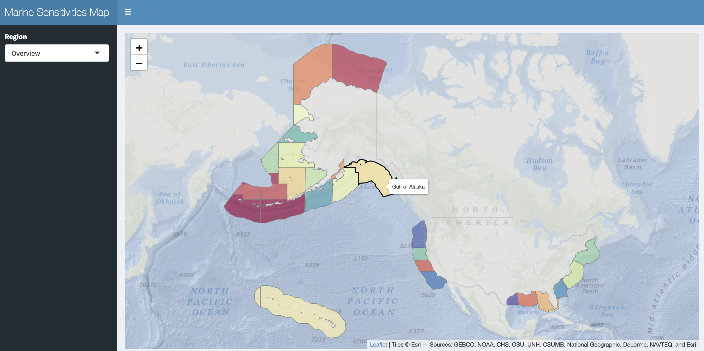
Shiny Server docs
- file
static file server for PMTiles archives, report downloads, reference GeoPackages — served by Caddy’s file_server directive directly from the /share bind-mount. This replaces the old pg_tileserv vector-tile path for Program Areas, Ecoregions, Planning Areas, protractions, blocks and aliquots; each layer is a single .pmtiles file that the browser range-reads for only the tiles it needs. It no longer hosts the per-species range tiles (the pmtiles/{v8,v9}/ copies): from the asset-store migration (2026-10) those are served from the S3 store (native/{ds_key}/{hash}.pmtiles, Section 15.3), which answers range requests with CORS. The file host keeps serving the zone and reference layers, report downloads and reference GeoPackages, and the species copies are retained there until the prune that follows the migration.
- titiler + titiler-v8 🟢
TiTiler serving the published raster assets.
Every map layer the applications draw is now a pre-rendered Cloud-Optimized GeoTIFF read through titiler’s stock /cog routes — score surfaces per metric × subregion, and per-model distributions. titiler-v8 runs in parallel with the v7 instance, reading a kilobyte-sized view-only DuckDB whose model_cell is a view over the partitioned Parquet on S3, so no multi-gigabyte database is copied to the server.
- titilecache (Varnish) 🔒
Fronts the v7 titiler only. The v8 service is deliberately not proxied through it: an immutable COG is already cacheable by URL, and the one endpoint that would benefit is retired (below).
- api
custom R plumber API for programmatic access to DuckDB — see Chapter 17
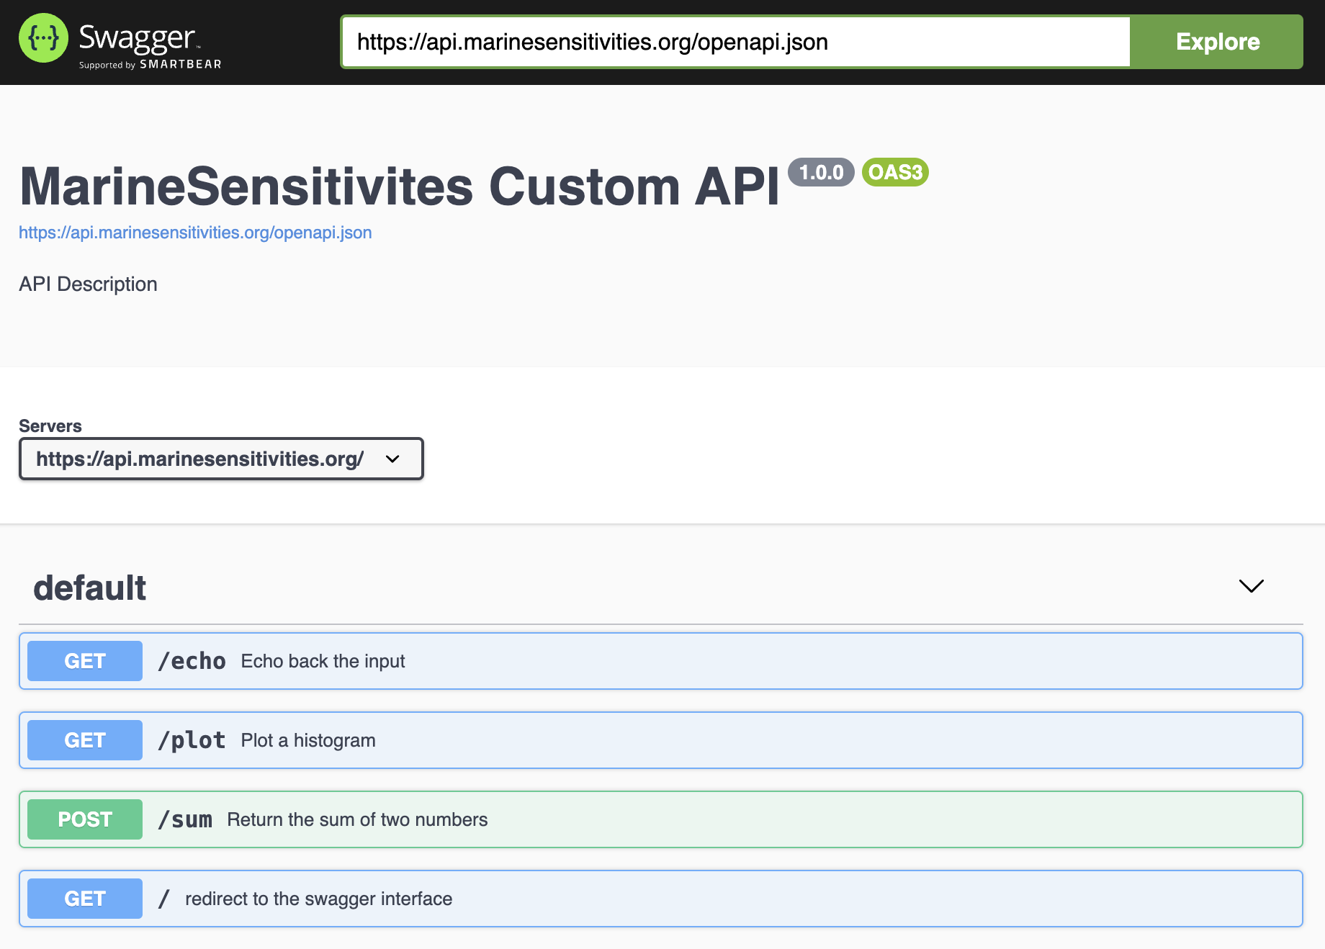

14.5.2 Admin
- rstudio 🔒
integrated development environment (IDE) to code and debug directly on the server.
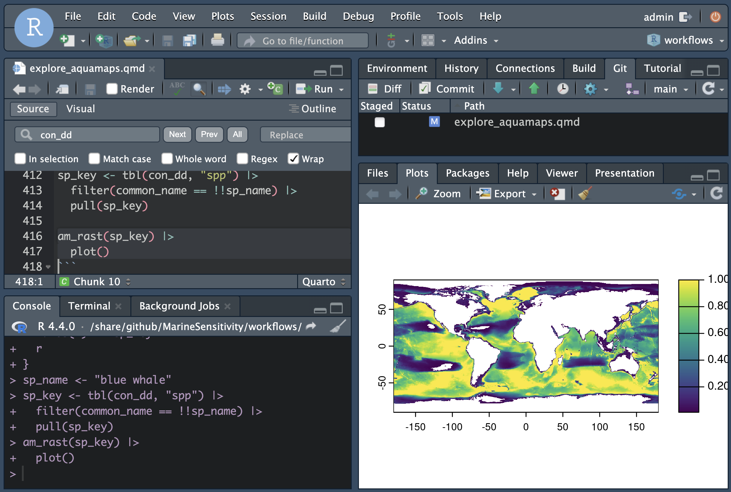
Posit RStudio Server
- pgadmin 🔒 — PostgreSQL administration interface, commented out along with the PostgreSQL services it managed (see Retired, below).

14.5.3 Retired
- The custom /msens tile factory — kept in the image but off by default, behind MSENS_FACTORY=1.
It rendered a tile by executing a validated SELECT against DuckDB and looking the result up against a cell-id COG. Pre-rendered COGs replaced it: nothing reaches it any more, because every metric on every release now has a COG. The two paths were verified equivalent before the switch — 100 of 105 sample tiles byte-identical, the remainder differing by 3–6 pixels out of 262,144 from float32 storage. It remains available for exploratory on-the-fly queries.
- postgis, tile (pg_tileserv), tilecache, rest (PostgREST) and swagger — all commented out in docker-compose.yml and not running. PostgreSQL is no longer part of any serving path; the authoritative store is DuckDB, with the published release as partitioned Parquet on S3. Vector geometry is served as static PMTiles by Caddy’s file subdomain, and the pgadmin entry above is likewise vestigial.

15. Database
The source of truth for the Marine Sensitivity Toolkit is DuckDB — a columnar, embedded analytic database. It is fast enough to answer live per-cell queries while remaining a single-file artifact that can be copied, versioned and served read-only to many processes at once.
The pipeline writes a working database (sdm.duckdb) on the machine that runs it; a release is the published, immutable form of that database’s tables. Since the marine-atlas release format, each version is published as partitioned Parquet on S3 under marine-atlas/{ver}/tables/, and serving reads it through a tiny view-only DuckDB (serve.duckdb, kilobytes) whose tables are views over those files — never a multi-gigabyte copy.
Everything below is read from the release this build documents (v4), so the tables, columns and row counts are those of that version rather than of whichever version happened to be current when the page was written.
Note
Why DuckDB and not PostgreSQL? Earlier versions of the stack used PostgreSQL + PostGIS as the primary store. As the analysis stabilized around a fixed 0.05° cell grid and a small set of zone layers, live geometry operations and concurrent writes stopped being needed — only fast analytic reads. DuckDB scans tens of millions of rows in well under a second with no separate server process. PostGIS is no longer part of the serving path (see Chapter 14).

15.1 Table and column naming conventions
- Table names are singular and lower case.
- Unique identifier columns are suffixed with:
  - *_id for unique integer keys (stable across rebuilds);
  - *_key for unique string keys (human-readable and stable across releases);
  - *_seq for auto-incrementing sequence integer keys (internal join keys, not stable across rebuilds).
- Column names are singular and use snake_case.
- Foreign keys use the singular form of the referenced table, followed by the primary-key suffix (_id, _key, or _seq).
value is a reserved word in DuckDB
Cell values are stored in a column named val, not value. The serving views expose val AS value for backward compatibility with callers written against the older schema.

Table 15.1: Tables published by v4, with row counts read from the release itself.
Table | Rows | Purpose
cell | 661,372 | Grid cells of the study area, with environmental covariates and membership flags.
taxon | 17,561 | One row per taxon: identity, category, extinction risk and validity flags.
model | 30,436 | Registry of every distribution model, keyed by the stable model identifier.
metric | 35 | Metric registry: key and description for each scored quantity.
cell_metric | 21,961,527 | Per-cell score for each metric — the surface the maps draw.
zone | 72 | Zone registry keyed by source table, field and value, so every spatial unit shares one schema.
zone_cell | 4,552,747 | Zone membership: which cells belong to which zone.
zone_metric | 770 | Pre-aggregated per-zone score for each metric — what drives the choropleth.
zone_taxon | 61,063 | Per-zone species list with each species’ contribution to the zone score.
dataset | 9 | Source datasets, with citations, vintages and whether each fed the scores.
taxon_model | 29,811 | Which models fed which taxon — the taxon to model relation.
listing | 718 | US federal listing lookup (ESA status, MMPA and MBTA protection).

Not published by v4
model_asset, native_asset. Sections that depend on these are omitted from this build rather than described from another release.

15.2 Schema
The columns of each published table, read from the release:

15.2.1 cell
Column | Type
cell_id | INTEGER
depth_mean | DOUBLE
depth_min | DOUBLE
depth_max | DOUBLE
oxy_b_mean | DOUBLE
oxy_mean | DOUBLE
prim_prod_mean | DOUBLE
ice_con_ann | DOUBLE
salinity_b_mean | DOUBLE
salinity_mean | DOUBLE
sbt_an_mean | DOUBLE
sst_an_mean | DOUBLE
fao_area_m | DOUBLE
area_km2 | DOUBLE
width_km2 | DOUBLE

15.2.2 taxon
Column | Type
taxon_id | DOUBLE
taxon_authority | VARCHAR
n_ds | INTEGER
ms_merge | INTEGER
sp_cat | VARCHAR
mdl_seq | INTEGER
scientific_name | VARCHAR
common_name | VARCHAR
worms_id | INTEGER
redlist_code | VARCHAR
extrisk_code | VARCHAR
er_score | INTEGER
is_mmpa | BOOLEAN
is_mbta | BOOLEAN
is_bcc | BOOLEAN
worms_is_marine | BOOLEAN
worms_is_extinct | BOOLEAN
esa_code | VARCHAR
esa_source | VARCHAR
is_ok | BOOLEAN
worms_taxonomic_status | VARCHAR

15.2.3 model
Column | Type
mdl_seq | INTEGER
ds_key | VARCHAR
taxa | VARCHAR
time_period | VARCHAR
region | VARCHAR
mdl_type | VARCHAR
description | VARCHAR
date_created | DATE

15.2.4 metric
Column | Type
metric_seq | INTEGER
metric_key | VARCHAR
description | VARCHAR
date_created | DATE
metric_title | VARCHAR
metric_abbrev | VARCHAR

15.2.5 cell_metric
Column | Type
cell_id | INTEGER
metric_seq | INTEGER
value | DOUBLE

15.2.6 zone
Column | Type
zone_seq | INTEGER
tbl | VARCHAR
fld | VARCHAR
value | VARCHAR
date_created | DATE

15.2.7 zone_cell
Column | Type
zone_seq | INTEGER
cell_id | INTEGER
pct_covered | INTEGER

15.2.8 zone_metric
Column | Type
zone_seq | INTEGER
metric_seq | INTEGER
value | DOUBLE

15.2.9 zone_taxon
Column | Type
zone_tbl | VARCHAR
zone_fld | VARCHAR
zone_value | VARCHAR
mdl_seq | INTEGER
sp_cat | VARCHAR
sp_common | VARCHAR
sp_scientific | VARCHAR
taxon_id | DOUBLE
taxon_authority | VARCHAR
rl_code | VARCHAR
er_score | INTEGER
is_mmpa | BOOLEAN
is_mbta | BOOLEAN
is_bcc | BOOLEAN
esa_code | VARCHAR
esa_source | VARCHAR
area_km2 | DOUBLE
avg_suit | DOUBLE
suit_rl | DOUBLE
suit_rl_area | DOUBLE
cat_suit_rl_area | DOUBLE
pct_cat | DOUBLE

15.2.10 dataset
Column | Type
ds_key | VARCHAR
name_short | VARCHAR
name_original | VARCHAR
description | VARCHAR
citation | VARCHAR
source_broad | VARCHAR
source_detail | VARCHAR
regions | VARCHAR
response_type | VARCHAR
taxa_groups | VARCHAR
year_pub | INTEGER
date_obs_beg | DATE
date_obs_end | DATE
date_env_beg | DATE
date_env_end | DATE
link_info | VARCHAR
link_download | VARCHAR
link_metadata | VARCHAR
links_other | VARCHAR
spatial_res_deg | DOUBLE
temporal_res | VARCHAR
date_created | DATE
name_display | VARCHAR
value_info | VARCHAR
is_mask | BOOLEAN
sort_order | INTEGER
global_mask_priority | DOUBLE

15.2.11 taxon_model
Column | Type
taxon_id | DOUBLE
ds_key | VARCHAR
mdl_seq | INTEGER

15.2.12 listing
Column | Type
spp_id | DOUBLE
worms_id | DOUBLE
botw_id | DOUBLE
extrisk_code | VARCHAR
er_score | INTEGER
is_mmpa | BOOLEAN
is_mbta | BOOLEAN
is_bcc | BOOLEAN
common_name | VARCHAR

15.3 Asset store
Old copies remain until the prune
Every published release (v7, v7b, v8, v9) has pointed only into the store since the asset-store migration of 2026-10-02. The copies the v8 and v9 releases carried before it still exist under their release prefixes (v8/native/, v9/native/) and on the file host, unreferenced, until a prune that follows a soak period. The migration’s listing on 2026-10-01 found 145,452 objects (33.08 GB) under those two prefixes, which collapse to 86,421 distinct keys (19.63 GB) in the store, because the two releases carry the same files for most datasets.

A release owns pointers, never distribution files. Every cloud-optimized distribution file lives exactly once in an unversioned, content-addressed store, and each release publishes tables whose rows point into it. Nothing ending in .tif or .pmtiles is written under a release’s {ver}/ prefix. A release prefix holds only its manifest, its tables, its app bundle and its serving files.
There are two stores, both in the project’s public S3 bucket:
Store | Key | Holds
cog/ | cog/{grid_id}/{hash}.tif | rasters on an analysis grid: each input’s gridded surface, merged models and score surfaces
native/ | native/{ds_key}/{hash}.{tif\|pmtiles} | each source dataset’s own resolution original: a raster (.tif) or a vector range (.pmtiles)

15.3.1 The key comes from the content
The hash in a key is computed before any file is built, from the source content of the model plus an encoding tag, and never from the bytes of the file or from the release:
- for a gridded surface, the model’s (cell_id, val) rows;
- for a native raster, the source grid’s (cell_id, val) rows;
- for a native vector range, the normalized geometry and the attributes that reach the tile;
- the encoding tag names how the file is written (data type, nodata, overviews, tile scheme), so a different encoding of the same content is deliberately a different object.
Two consequences follow. A surface that did not change between releases is found in the store by its key, so it costs neither a build nor an upload; a source dataset such as AquaMaps that is unchanged between releases is registered by a new pointer row and nothing else. And a merged model that equals its only input has the same rows, hence the same key, hence is the same object as that input, with no special case. A re-ingested dataset adds objects only for the models whose content changed; the old objects stay for the releases that still point at them. Scores are always new, because they are per-release tables.
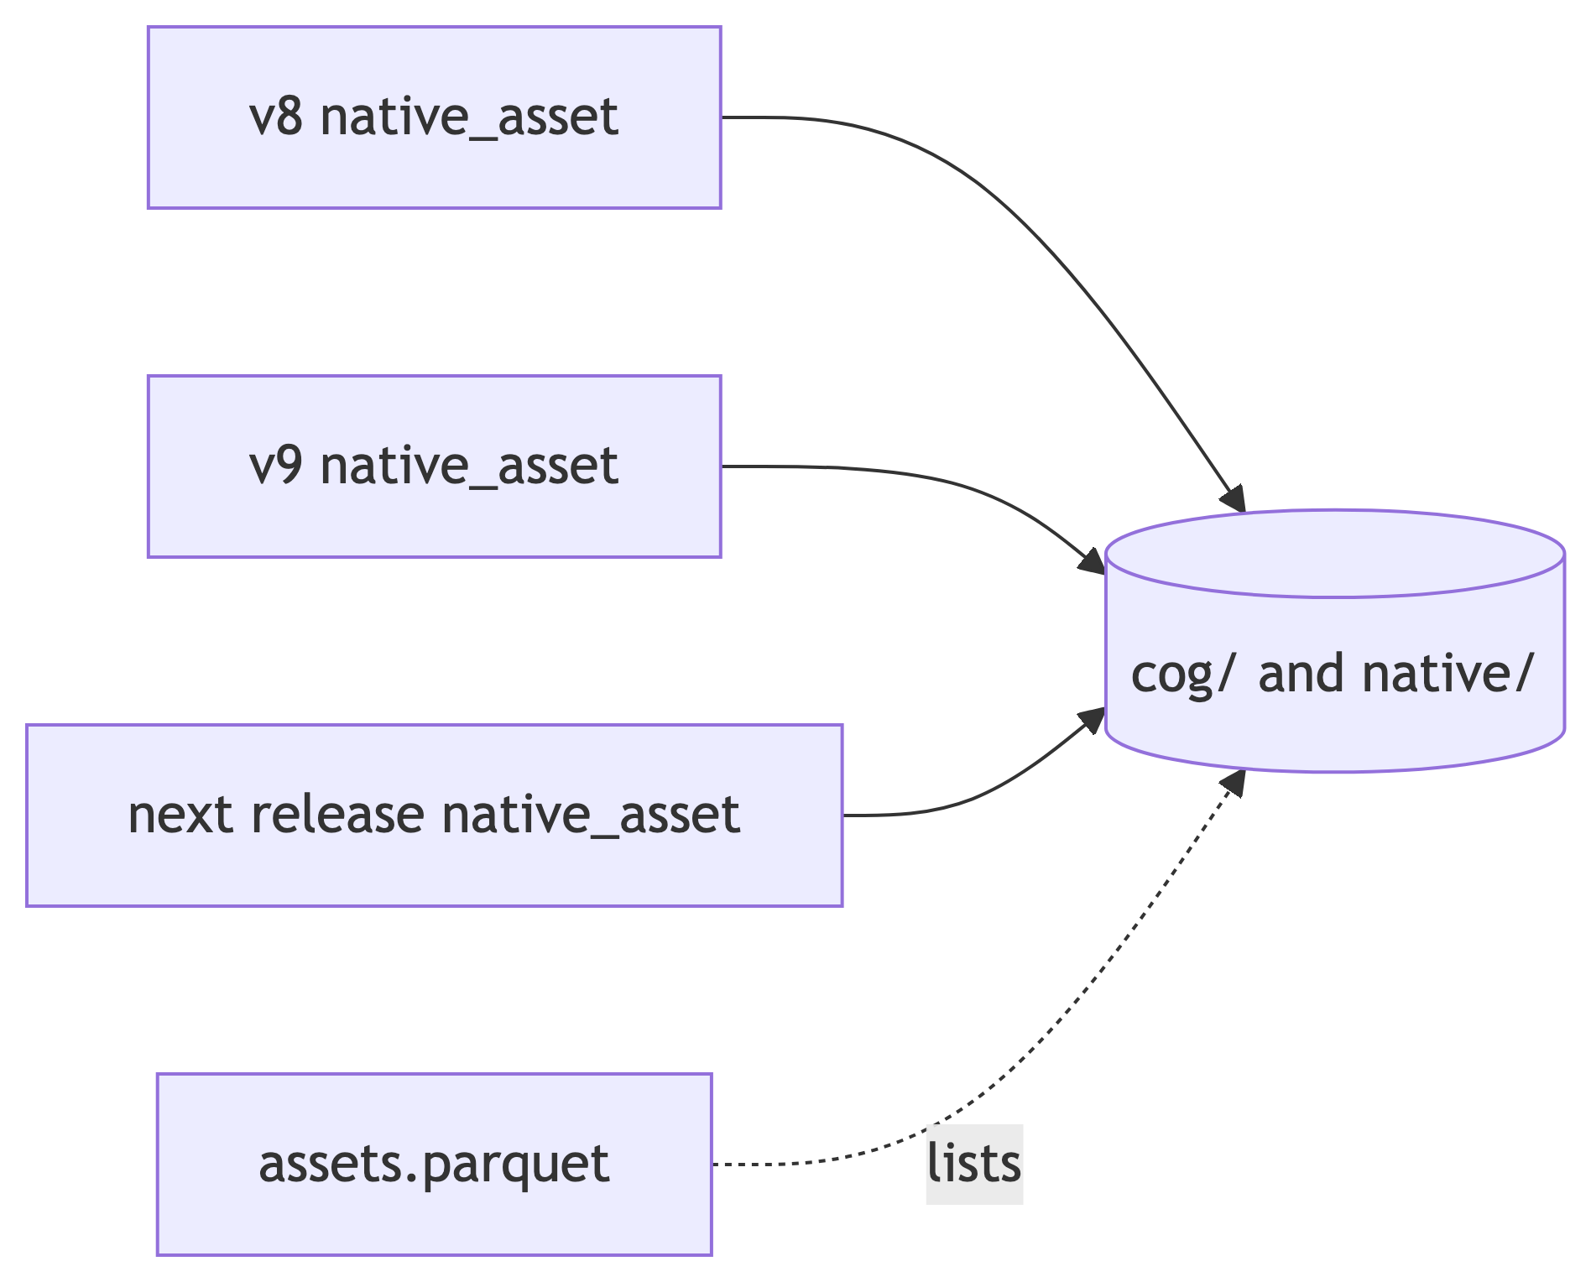
Figure 15.1: A release’s pointer table refers to objects in the shared stores; the catalog lists every stored object.

15.3.2 The catalog and the pointer table
- assets.parquet at the atlas root (beside the cog/ and native/ stores, under the same marine-atlas/ prefix as the releases) is the catalog, with one row per stored object (store, key, content hash, encoding tag, asset type, grid or dataset key, size, MD5, creation time and the first release that used it). “Is it already stored?” is an anti-join against this file, not a bucket listing.
- native_asset is the per-release pointer table (Table 15.1). Its representation = model rows point into cog/, its native rows point into native/, and a merged model is a row with ds_key = ms_merge. Each row carries the content hash and the asset URL; a PMTiles row also carries source_key, the model key the tile’s features are tagged with, which is how a viewer filters one range out of the archive. Every published release has one in this shape; the earlier releases keep model_asset beside it so that old links still resolve.
- An object no release points at is garbage. Nothing is deleted except through a check that joins the catalog against every release’s pointer tables.

15.3.3 Finding a file
The bucket denies anonymous listing, so a file is found through a pointer, not by browsing:
- read the catalog assets.parquet to see what exists and where;
- read a release’s native_asset table ({ver}/tables/native_asset.parquet) to see which objects that release uses for each model;
- or ask STAC: the searchable STAC API is built from the pointer table, so each Item’s model and native assets carry the same store URLs, and the static STAC catalog of a release links them once its tree is rebuilt from the pointer table (every published release today).

15.3.4 Verify before store
An object is admitted to the store under key K only if its decoded pixels equal the rows K was computed from. In the migration, a file that failed the check was repainted from the model’s current rows and uploaded under its key (2,934 of the raster objects; the rest were copied once their pixels had been verified). A publish applies the same check to every new file before it is uploaded. This keeps what a map draws identical to what the scores used.
See Section 16.3 for how a publish writes to the store and what the publish gate checks.

15.4 How the tables feed the serving tier
- Score rasters — per-cell scores are published as Cloud-Optimized GeoTIFFs, one per metric × subregion, and the app reads the href and rescale range straight from the release manifest. Earlier releases rendered them by sending SQL to a tile factory per request; that path is retired (see Chapter 14).
- Per-model distributions — model_cell is published partitioned by a dense integer model id, so a tile request reads exactly one partition as a point read rather than scanning the surface.
- Zone choropleths — zone_metric joined to zone gives the per-zone score; the geometry comes from PMTiles published per zone-set vintage, and the manifest names the vintage each release used. Only the paint specification changes when the reader switches metric.
- Per-cell and per-area species lists — the same rows partitioned by a spatial tile instead (cell_model), because a per-cell question against a model-partitioned surface would scan everything.
See Chapter 16 for the notebooks that build each of these tables.

16. Workflows
Workflows are Quarto notebooks that ingest source datasets, resolve taxonomy, merge models, compute scores and publish a release. They are the only writers of the pipeline database; everything downstream reads published artifacts.
Links:
- marinesensitivity.org/workflows — every notebook, rendered, with the current dependency graph
- github.com/MarineSensitivity/workflows — source
The notebook list is deliberately not reproduced here: it is generated from the pipeline’s own metadata and changes whenever a dataset is added. What is documented here is the contract that generates it.

16.1 The pipeline is a graph, generated from the notebooks
The pipeline is a targets directed acyclic graph, and the graph is not hand-maintained. Each notebook declares its own place in it, in YAML front-matter:
msens:
target_name: ingest_aquamaps
workflow_type: ingest
dependency: [build_cell_grid]
output: data/manifests/ingest_aquamaps.json
dataset: {ds_key: am, response_type: suitability, source_authority: AquaMaps,
temporal_interval: static, native_format: raster}
The target list is built by parsing those blocks, so adding a dataset means adding a notebook — not editing a pipeline definition that could disagree with it. The dataset: block is also the single source of truth from which the dataset registry table is consolidated; a dataset that is ingested without one fails the build loudly rather than appearing in the data with no metadata.

16.2 Stages
Stage | What it does
grid | Builds the global 0.05° cell grid — the sampling unit every model is rasterized onto — with environmental covariates and study-area membership.
ingest | One notebook per source dataset, writing one distribution per model keyed by this release’s model id (mdl_seq). Vector ranges are rasterized by exact area coverage; rasters are interpolated onto the grid.
merge | Resolves every model to a common taxon, computes each taxon’s governing extinction risk, and merges the per-dataset surfaces into one surface per taxon (Chapter 9).
score | Computes per-cell metrics, rescales within ecoregions, and aggregates to each spatial unit (Chapter 10).
schema | Consolidates the registry tables — dataset, model, taxon_model, listing — that describe what the release contains.
release | Publishes the release to S3 as partitioned Parquet, COGs, PMTiles and a STAC catalog, writes the version manifest, and (gated) deploys the serving tier. The COG and PMTiles files are written to the shared store, not to the release (Section 15.3).

16.3 Publishing to the asset store
The publisher of distribution files (publish_native.qmd) writes only to the content-addressed stores (cog/, native/) and to the catalog assets.parquet; a release prefix receives tables, a manifest and an app bundle, never a distribution file (Section 15.3). The order is fixed: the key of every file is computed from its content first, a file whose key is already in the catalog is neither built nor uploaded, each new file is decoded and checked against its key before upload, the uploaded objects are appended to the catalog, and only then is the release’s native_asset table written. A publish gate stops the run before that last step if any URL in the pointer table is not a catalogued store object, or if any .tif or .pmtiles object is listed under {ver}/ (for v8 and v9 that check is a warning rather than a stop until their pre-migration copies are pruned).

16.4 Reproducibility rules
These are load-bearing, not stylistic. Each one exists because its absence caused a specific failure.
Every process is a chunk in a committed notebook, run by rendering to HTML. Including the parts that touch the outside world — the S3 sync, the server deploy, the app reload. Not an ad-hoc shell command. Rendering is what produces the tracked HTML output and the content-hash checkpoint; executing the code without rendering skips both, so it is a diagnostic, never a run.
Side effects are opt-in. Anything expensive or outward-facing sits behind an environment flag that defaults to off, so a routine render cannot publish or restart anything by accident.
The orchestration is part of the process. A notebook parameterized by version is only half reproducible if the loop over versions lives in a throwaway shell script, so the multi-version drivers are committed too. Likewise, forcing a rebuild is a flag — never moving output directories aside by hand, which leaves no record of what was rebuilt or why.
A version number is not proof. A notebook whose logic lives in the msens package is only as current as the installed package. The server once reported the right package version while running an older function, and seven release manifests were regenerated missing their zone tiles as a result — with nothing failing. So every behavior change gets a version bump and a changelog entry, and the container pins move with it.
Reproducibility beats uptime. Where a reproducible fix and a fast in-place workaround are both available, the reproducible one wins even at the cost of brief downtime. Drift between a running container and the image it was built from is a bug to fix immediately, not a reason to avoid rebuilding.

16.5 Content-addressed checkpoints
Each notebook writes a manifest recording a content hash of what it produced. A downstream stage can then tell whether its input actually changed, rather than trusting a timestamp — which is what makes a re-run cheap when nothing moved, and what makes an unexpected change visible.

16.6 Guarding the science
Scientific rules live in the msens package as documented functions, not as SQL strings inside a notebook — so a notebook calls the rule and a unit test asserts it, and the two cannot drift. Every non-trivial rule has a test with a small fixture asserting its exact expected output, and every bug that is found becomes a permanent named assertion.
This matters more than the aggregate checks. Whole-pipeline validation — comparing a release’s zone scores against the previous one — catches broad drift but hides rule-level breakage: one lost exclusion affected ~750 species while barely moving any aggregate score (Chapter 9).
See Chapter 15 for the schema these workflows produce, and Chapter 2 for what each release changed.

17. APIs
Three services sit in front of the published data:
- titiler.marinesensitivity.org — TiTiler, serving the pre-rendered Cloud-Optimized GeoTIFFs that every map layer now draws.
- api.marinesensitivity.org — a custom R plumber API for programmatic (non-tile) data access.
- A searchable STAC API — one Item per model, with real asset hrefs and real footprints, so a client can ask which models cover this area.
Static vector data (PMTiles) is served directly by Caddy’s file server and needs no API — see Chapter 14. The published Parquet tables can also be range-read straight from S3, including by DuckDB-WASM in a browser.

17.1 Raster tiles: COGs, not SQL per request
Score surfaces are published as one COG per metric × subregion, and per-model distributions as one COG per model. A release’s manifest carries each raster’s URL and its build-time rescale range, so an application reads the href and hands it to titiler’s stock /cog routes — no custom endpoint, no query in the tile path.
The COGs are stored without overviews, deliberately: the renderer decimates from full resolution on each request, so a pre-built pyramid would disagree with it at low zoom. Their object keys are content-addressed including the encoding, because rewriting an object at a stable URL once left /vsicurl serving a cached header for bytes that no longer existed — fine at z5+, HTTP 500 at z2–z4.

17.2 The /msens factory (retired, kept)
Important
The custom factory below is no longer in the serving path. It is retained in the image behind MSENS_FACTORY=1 for exploratory on-the-fly queries, and is documented here because published reports reference its endpoints.
It was replaced by pre-rendered COGs after verifying the two produce the same picture: of 105 sample tiles, 100 were byte-identical and the rest differed by 3–6 pixels out of 262,144, from float32 storage. Nothing reaches it now — every metric on every release has a COG.

The factory is a FastAPI subclass of titiler.core.factory.TilerFactory, registered at the /msens prefix on top of the default TiTiler application.
Source: server/titiler/factory.py.

17.2.1 Endpoints
All /msens/* routes accept a sql query parameter: a base64url-encoded SELECT returning exactly two columns, cell_id (integer) and value (numeric). The SQL is parsed with sqlglot (SELECT-only, no write ops, no dynamic I/O like read_* / httpfs / load_*), executed against a read-only DuckDB connection, and the resulting cell_id → value map is cached in-process with an LRU keyed on the canonical SQL string. A mtime parameter can be passed for cache-busting (typically the mtime of sdm.duckdb).
Endpoint | Purpose
GET /msens/bounds | Geographic (EPSG:4326) bounds of the cell-id COG.
GET /msens/statistics?sql=… | {n, min, max, mean, std, p2, p50, p98} of the SQL result — used by clients to set a stable legend rescale without fetching any tiles. Cached by Varnish.
GET /msens/tilejson.json?sql=…&colormap=…&rescale=… | TileJSON 2.2.0 document with the tile URL template — lets any TileJSON-aware client (QGIS, MapLibre, Mapbox GL) consume the layer.
GET /msens/tiles/{z}/{x}/{y}.png?sql=…&colormap=…&rescale=… | The tile endpoint. Renders a 256×256 RGBA PNG by: (a) executing the SQL and LRU-caching the cell_id → value map; (b) reading the z/x/y window of the cell-id COG with nearest-neighbor resampling; (c) looking the value up per pixel, rescaling and colorizing; (d) returning PNG with Cache-Control: public, max-age=604800.
GET /msens/tiles/{z}/{x}/{y}.png?sql=…&color=#rrggbb[aa] | Single-color mask variant: every valid (in-range, finite-value) pixel is painted with the given hex color; colormap and rescale are ignored. Used for binary overlays like “cells outside Program Areas”.
GET /msens/debug/cog | Inspect the underlying cell-id COG (bounds, CRS, dtype, nodata, overviews, rio_tiler / rasterio versions).
GET /msens/debug/tile/{z}/{x}/{y} | Inspect what rio_tiler.Reader.tile() returns for a given tile (cell-id range, mask valid-pixel count, top-10 cell-ids by count).
Tile URLs were composed via msens::cell_tile_url() with stats from msens::cell_stats(); see Chapter 18.

17.2.2 Caching (v7 factory only)
Varnish fronts the factory at titilecache:6082. The custom VCL (server/varnish/titiler.vcl):
- Normalizes query-param order via std.querysort() so semantically-identical URLs share a cache entry.
- Strips Cookie / Authorization (the factory is stateless).
- Caches 2xx responses on /msens/(tiles/|tilejson|bounds|statistics) for 7 days (grace=1h, keep=24h); errors for 60 s to prevent stampede.
- Adds X-Cache: HIT | MISS for debugging.
When the source DuckDB regenerates, the retired Shiny apps bumped the mtime query parameter to invalidate all cached tiles at once.

17.2.3 Derived cell-id COG
The factory looks values up against a single-band uint32 cell-id COG — one per grid, since the grid changed at v8: r_cellid.tif for the v1–v7 regional grid, r_cellid_global.tif for the v8 global one.
Warning
These are lookup images: a pixel’s value is a cell id, not a measurement. A grid’s geometry therefore cannot be inferred from the COG — use the grid registry (msens::grid_spec_for()), which is the authority on extent, size and longitude convention.

17.3 Custom plumber API
The plumber API at api.marinesensitivity.org covers non-tile use cases — CSV exports, species lookups by feature, on-demand PDF/DOCX report generation. Source: MarineSensitivity/api.

17.4 STAC
Each release publishes a SpatioTemporal Asset Catalog describing its distributions and score surfaces, with a project extension for species-distribution-model metadata. Alongside the static catalog there is a searchable STAC API with one Item per model — the static catalog is dataset-level, with assets that are S3 prefixes and a bounding box covering a whole dataset, so it can answer neither “the asset for this model” nor “which models cover this area”.
The API backend reads stac-geoparquet through DuckDB, the same shape as the rest of the stack. It is pinned to an exact upstream commit and marked experimental upstream; treat it as a trial surface rather than load-bearing.

17.5 Retired APIs
Removed from the serving path entirely — the containers are commented out in docker-compose.yml and are not running:
- swagger.marinesensitivity.org — PostgREST over PostgreSQL.
- tile.marinesensitivity.org — pg_tileserv vector tiles from PostGIS, superseded by static PMTiles served by Caddy’s file subdomain (see Chapter 13).

18. Libraries
By creating an R package, we document functions and make them easily available across workflows and apps.
- msens
R library of functions for mapping marine sensitivities, sponsored by BOEM
Functions read data from Chapter 15, analyze it, and visualize results. The retired Shiny apps consumed msens::* helpers exclusively — their code never talked to the tile factory or PMTiles URL templates directly. The Atlas (Chapter 19) is a JavaScript app and reads the release manifest itself; its in-browser score and species queries are checked against msens by the Atlas’s parity tests.

18.1 Map-tile helpers (as of 0.3.4)
The following helpers bridged the retired Shiny apps to the msens TiTiler factory (Chapter 17):
Helper | Purpose
cell_tile_url(sql, colormap, rescale, color, mtime, base) | Compose an XYZ tile URL template for the factory, base64url-encoding sql and omitting colormap/rescale when color= is set (single-color mask).
cell_stats(sql, mtime, base) | GET /msens/statistics — returns list(n, min, max, mean, std, p2, p50, p98) for a stable legend rescale.
add_cell_tiles(m, tile_url, ...) | Wraps mapgl::add_raster_source() + mapgl::add_raster_layer() so the retired Shiny apps added a cell-values (or mask) layer to a map in one call.
add_cells(m, r, colors, ...) (retained) | Legacy image-source path for static report figures that need terra SpatRaster rendering (e.g., Quarto-to-DOCX output that can’t reach the tile server).
The SQL passed to cell_tile_url() and cell_stats() must return exactly two columns, cell_id (integer) and value (numeric) — see the examples in Chapter 15.

19. Apps
The MST has one interactive application, the Atlas (marinesensitivity.org/atlas/?ver=v4). It replaces the two Shiny apps (Scores and Species) that came before it; those are retired and described, for the record, under Section 19.2 below and in the Legacy appendix.
These tools allow stakeholders, scientists, and decision-makers to understand the underlying components contributing to an area’s sensitivity to offshore energy development, supporting better planning and impact assessment.
One application, every release
The Atlas renders any published release rather than shipping a per-version fork. The version is data, settled by the release’s published manifest, so a fix reaches every version at once. On the public host the release is a query parameter (?ver=v3); a restricted pre-release is reached only through the signed-in preview host, where the version is the URL path (/v9/atlas/). The release picker in the app’s top bar moves between them. See Chapter 21.

19.1 The Atlas
The Atlas is a static web app (Svelte and MapLibre) with no application server of its own: the Scores lens’s cell and area clicks, flowers, tables and reports are computed in your browser by a DuckDB-WASM instance that queries the release’s published Parquet directly over HTTPS. What a browser cannot compute itself comes from services that are not Atlas-specific: score and species map tiles from the project’s titiler (which range-reads the release’s Cloud-Optimized GeoTIFFs, and also answers a species click and the legend’s histogram), zone outlines and species range inputs from static PMTiles archives, and the basemap from CARTO.
It has two lenses, switched from the top bar, and four tools on its rail, the same in both lenses — Layers, Details, Table and Report:
- Scores lens — composite and per-category sensitivity, mapped as the 0.05° cell grid or aggregated to BOEM Program Areas (Planning Areas for v1), with a flower plot and a component table (in Details) and a species table for the selected cell or area.
- Species lens — individual and merged distribution models with their contributing input datasets, regulatory status (ESA listing, IUCN Red List category, MMPA and MBTA protection) in the Details tool. Search by common or scientific name.
- Places (the first part of the Report tool) — outline any area of interest (pick a Program Area or a gazetteer place, draw a shape, type coordinates, or upload a file) and get the same scores and species results, shareable entirely through the URL.
- Report — a printable, downloadable document (print, HTML, ZIP or Word) for any place.
Chapter 21 is the full walkthrough, including how a drawn place is encoded in a shareable link, and the Atlas user guide steps through the app’s own guided tour one control at a time.
Deep links carry their state in the URL. lens=species opens the Species lens, sp= selects a species, and the Atlas rewrites the older mdl_key and mdl_seq parameters to sp when it loads, so a link made for either Shiny app, or printed in an earlier report, opens the same species.

19.1.1 How the Atlas draws a release
Three kinds of map layer, each resolved from the release’s manifest rather than hardcoded, make the Scores lens:
- Score raster — a pre-rendered COG per metric × subregion, whose URL and rescale range come straight from the release manifest and which titiler turns into small tiles on request. The browser fetches only the tiles intersecting its viewport; no full raster is transferred on load.
- “Cells outside Program Areas” mask — a single-color overlay published the same way.
- Zone choropleth — polygon geometry from a static PMTiles archive published per geometry vintage, with each zone’s fill color computed in the browser from the release’s per-zone scores.
Because every one of those is resolved from the manifest, switching the release switches all three together, including drawing the boundary vintage that release actually used. Chapter 13 shows the serving architecture these layers sit on, and how COGs and PMTiles are produced and published; its diagrams were drawn when the Shiny apps were the clients, so where they show a Shiny server, the Atlas now does that work in the browser.

19.2 Retired: the Scores and Species Shiny apps
Until October 2026 the MST’s interactive tools were two R Shiny apps, each rendering any published release from the URL path:
- Scores — composite and per-category sensitivity by Program Area or cell, with flower plots, treemaps and species tables (Appendix B).
- Species — individual and merged distribution models with regulatory status (Appendix D).
The Atlas does what both did and adds Places. The Shiny apps are no longer reachable, and every URL they answered at (app.marinesensitivity.org/{ver}/scores/, /{ver}/species/, the older ?ver=, mdl_key and mdl_seq query forms, the retired /mapgl and /mapsp aliases, and the same paths on the preview host) is redirected (HTTP 302 for now; the public redirects become permanent 301s once the Shiny services are removed) to the equivalent Atlas view with its query carried; a restricted release’s URLs go to its Atlas on the preview host. Links in earlier reports, including the URLs printed in the BOEM final report, therefore keep working. The apps’ source remains in the apps repository, and their documentation is kept in the Legacy appendix: Appendix B, Appendix D and their step-by-step guide.

19.3 Legacy Applications
Earlier prototype applications from the research phase are kept in the Appendix under Applications (Legacy) for reference, alongside the retired Shiny apps. They are not part of the current serving path.

20. Atlas — the static, in-browser scores, species and places app

21. Atlas

21.1 Overview
The Atlas (https://marinesensitivity.org/atlas/?ver=v4) is the MST’s interactive application: one static web app, built with Svelte and MapLibre, that runs entirely in the browser. Where the Scores and Species Shiny apps it replaced were server-rendered R processes, the Atlas has no application server of its own: scores, flowers, tables and reports are computed in your browser, by a DuckDB instance compiled to WebAssembly (DuckDB-WASM) querying the release’s published Parquet directly over HTTPS. It still depends on a few other services for what a browser cannot compute itself — score and species map tiles come from the project’s titiler, zone outlines from PMTiles on S3, and the basemap from CARTO — but there is no Atlas-specific backend.
On the public host the release is a query parameter (?ver=v7), resolved client-side against the published versions.json and defaulting to the promoted release when absent. A restricted pre-release is served only through the signed-in preview host, at https://preview.marinesensitivity.org/{ver}/atlas/ (the version as the URL path, since Cloudflare Access scopes its reviewer policies by path, never by query).
This chapter describes the Atlas as of version 0.10.93. Figure 21.1 shows the default Scores view: the 0.05° cell grid colored by a composite sensitivity score across U.S. waters, dark theme (the app’s default). In the current build the four-tool rail is attached to the panel, which opens docked on the left with Layers showing, the map’s legend sits at the bottom right, and the basemap’s attribution is just under it.
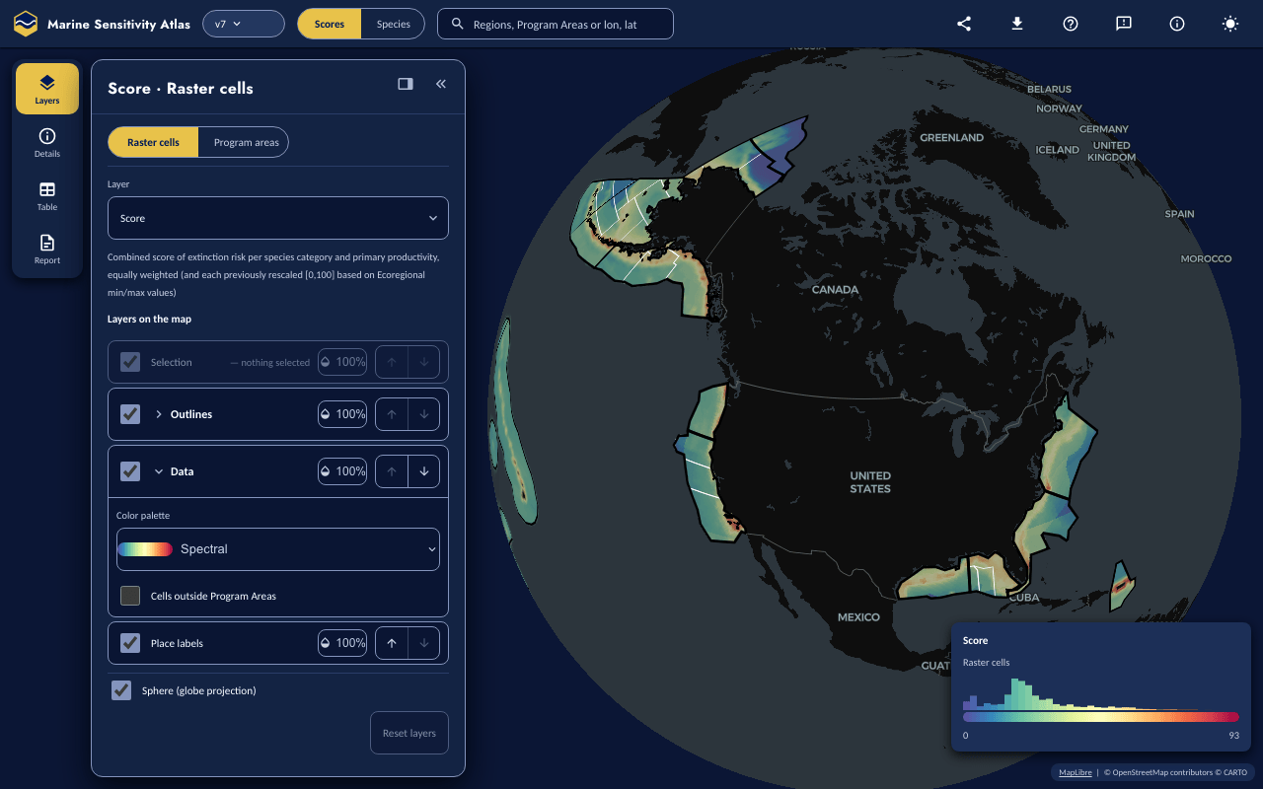
Figure 21.1: The Atlas, Scores lens, default view (desktop, dark theme): the Layers panel and its four-tool rail docked on the left, the score legend at the bottom right. Atlas 0.10.91, release v7, 2026-10-16.
Desktop vs. phone layout. On a wide viewport the four rail tools — Layers, Details, Table, Report, the same in both lenses — open a single panel attached to the rail. It docks on the left by default, one header button moves it (and the rail) to the other side, and Table takes the whole stage instead of the side panel. On a phone the identical four tools sit in a labelled bottom tab bar, and the panel becomes a bottom sheet with three heights (peek, half, full). Figure 21.2 shows the phone layout, and Figure 21.3 its top bar’s More (⋯) menu.
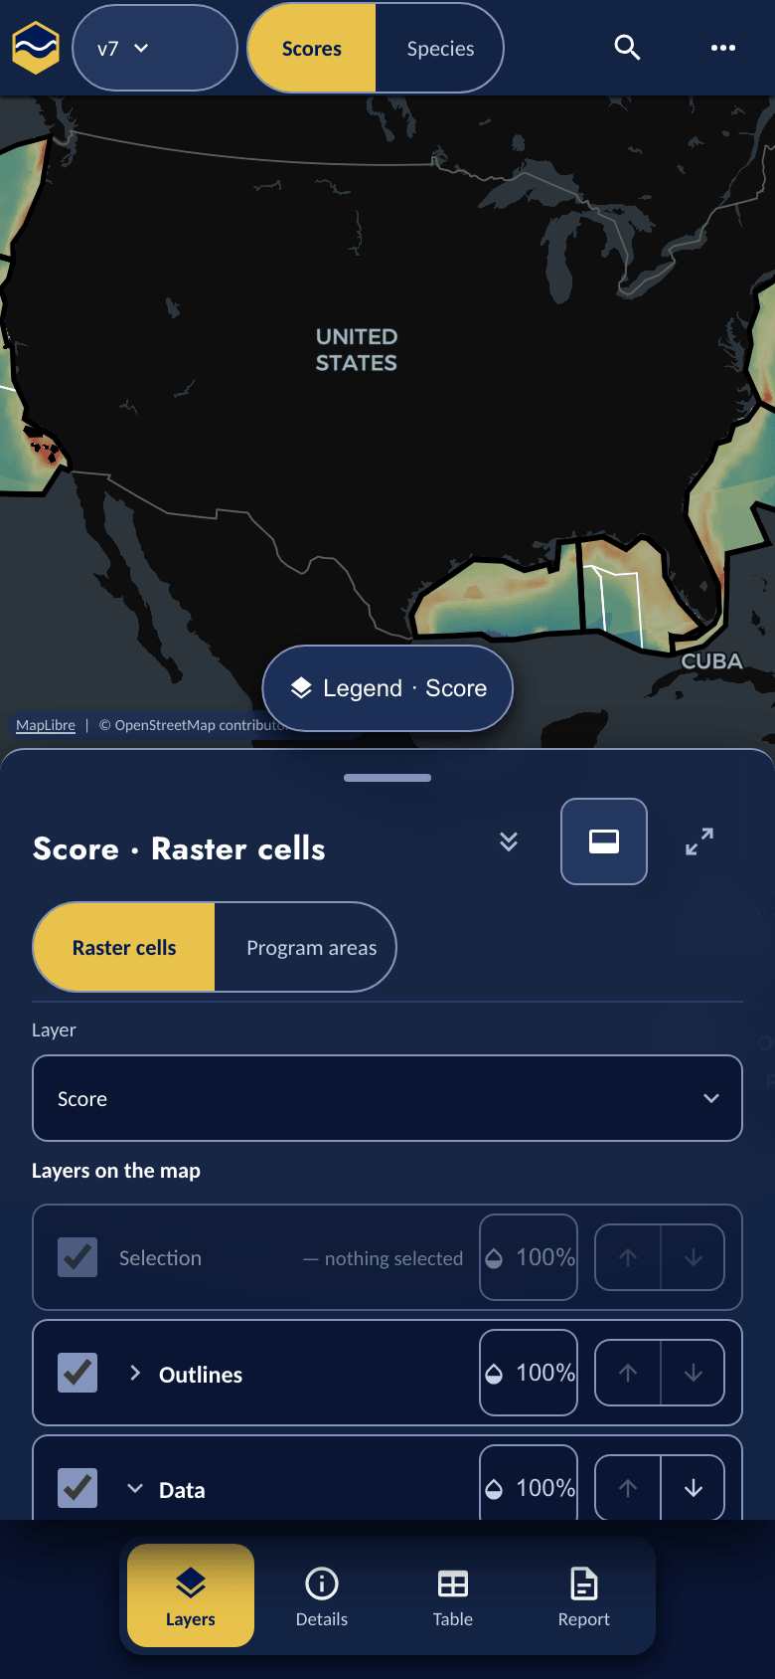
Figure 21.2: Phone: default view, with the Layers sheet at half height above the four-tab bottom bar. Atlas 0.10.91, release v7, 2026-10-16.

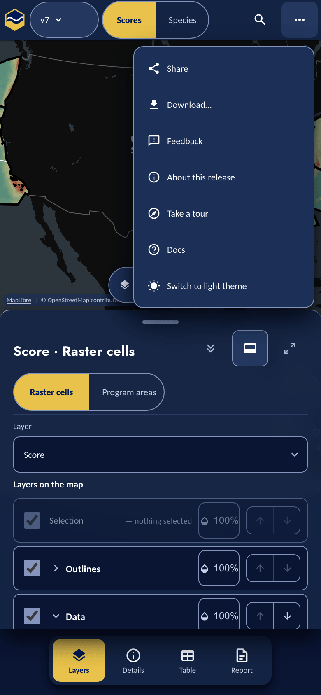
Figure 21.3: Phone: the top bar’s More (⋯) menu, listing Share, Download…, Feedback, About this release, Take a tour, Docs and the theme switch. Atlas 0.10.91, release v7, 2026-10-16.

21.2 Quick start
Desktop:
- Click a cell or a Program Area on the map, then open Details (the rail’s second tool, or the popup’s Details link) for its flower plot; Add to report keeps it as a place, and Open table lists its species.
- Or open Report, and under Add a place choose a Program Area, pick one on the map, draw a Rectangle (click, move, click, then Done), pick from the gazetteer, type coordinates or upload a file.
- Select a place in the list — Program Area or drawn — to see its results: a coverage note (or, for a Program Area, its published cell count, area and composite), a flower and component table, and (on request) its species table. Rename a drawn place inline if you like.
- Share at the foot of the Report tool opens the place-link dialog — the fastest way to hand someone the same place.
- Open report (the gold button at the foot of the Report tool) opens a printable, downloadable document (Print, HTML, ZIP or Word).
Phone: the tool rail is the bottom tab bar; use the Program Area picker or Enter coordinates rather than drawing, and the file picker rather than dropping a file on the map (that gesture needs a desktop pointer).

21.3 Getting around
The top bar, left to right on desktop: the MST mark and title; a release chip that opens the version picker; a Scores | Species lens switch; a search field (Program Areas, regions and coordinates in the Scores lens, Section 21.4; species in the Species lens); then, right-aligned and icon-only (each shows a tooltip on hover or focus), Share, Download (a PNG or SVG of the map view, a GeoTIFF of the current data layer, or a GeoJSON of the current places), a (?) Help menu (Take a tour, keyboard shortcuts, a Docs link), Feedback, About this release, and a sun/moon theme toggle. On a phone (below 900 px) the title collapses to the mark, and Share, Download, Feedback, About, Take a tour, Docs and the theme toggle fold into one More (⋯) menu beside a search button; below 381 px the mark hides too. The keyboard-shortcut list is desktop-only. Report is not a top-bar control on either viewport: it is a rail tool.
The tool rail is four controls, always in the same order, in both lenses and on every viewport: Layers · Details · Table · Report. Layers holds the map’s layer stack and the lens’s own data controls. Details shows what was last clicked — the flower plot in the Scores lens, the species information in the Species lens. Table is the species, zone and composition tables (the model inputs, in the Species lens). Report is the Places flow and the report itself.
The panel that a rail tool opens is attached to the rail and docks on the left by default; one header button moves both to the right, and the choice is remembered per browser. Resize it by dragging its map-facing edge or with arrow keys, or collapse it to a small labelled pill; clicking the active tool collapses the panel, and clicking any tool opens it. Table takes the whole stage beside the rail (its “← Map” button returns). The panel’s header says what is shown — the active layer and unit, the clicked cell or species name, “3 places” — rather than the tool’s name, which it shows only when nothing is selected (“Details”, “Table”, “Report”). The panel arrangement is chrome, not part of the shared view: only the top bar’s Share writes it into a link (as a ui= token), the address bar does not carry it. On a phone the same panel is the bottom sheet, with peek/half/full detents. On a desktop the map’s legend floats at the bottom right (mirroring to the bottom left when the panel is docked on the right), with a histogram of the whole layer’s values above its colour ramp and a marker for the clicked value; on a phone it is a compact Legend chip above the sheet that opens the full legend, moving into the sheet’s own header at full height.

21.4 Scores lens
The Scores lens shows the composite, extinction-risk-weighted score for every 0.05° cell (or, aggregated, every Program Area) of U.S. waters. Layers (Figure 21.4) opens with this lens’s own controls at the top: a Raster cells | Program areas switch for the spatial unit, and a Layer menu (the composite score or one component) with a short description of what it shows. Below them, Layers on the map lists the rows you can change, top to bottom: Selection (pinned at the top), Outlines, Data and Place labels. Expanding Data gives its Color palette and, where the release publishes that overlay, a Cells outside Program Areas switch; a Sphere (globe projection) switch sits under the list. Every row’s visibility and opacity can be changed and most can be reordered, but Data can never move above Outlines, so an opaque score raster can never hide the boundaries it is measured against. The basemap’s land, boundaries and roads are drawn under everything and have no row of their own. Reset layers restores the default stack.
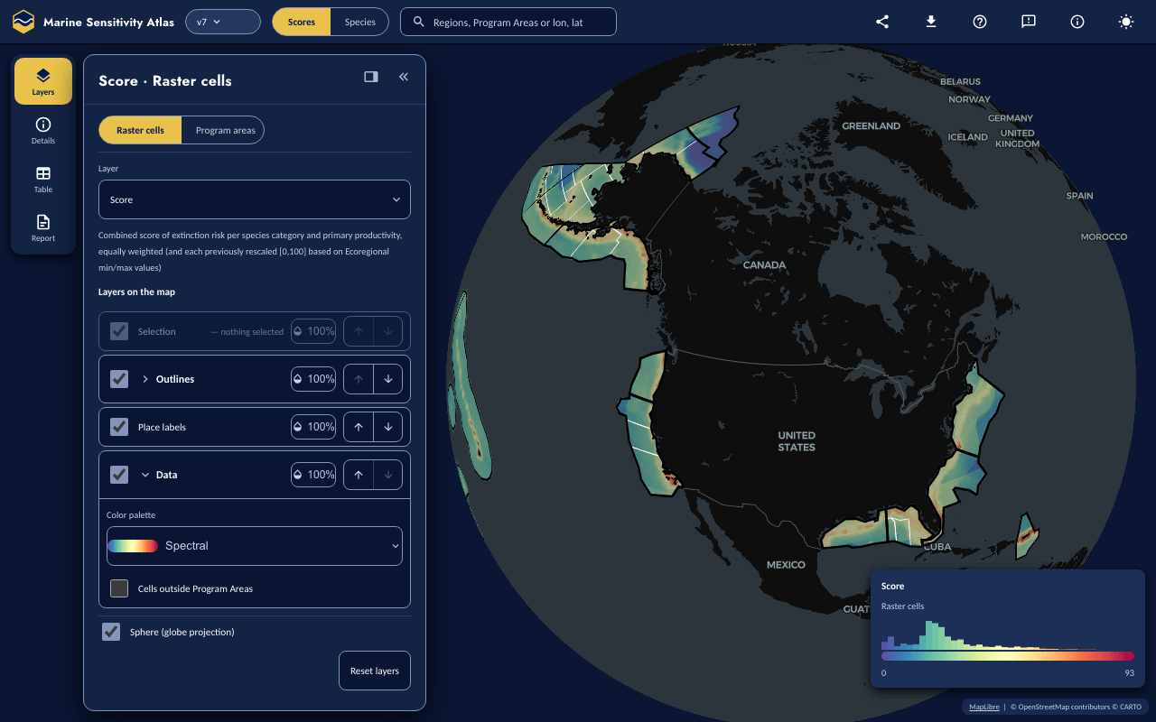
Figure 21.4: The Layers panel with Place labels moved above Data (one “move up” click) to show the reorder feature, and Data expanded to its Color palette menu and the Cells outside Program Areas switch. The panel’s header names what is on the map (“Score · Raster cells”); the Raster cells and Program areas switch, the Layer menu with a short description of the score, and the layer stack sit below it. Atlas 0.10.91, release v7, 2026-10-16.
Clicking a cell or a Program Area selects it: the URL gains a sel=cell:<id> or sel=zone:<unit>:<key> token, which the Details (flower plot) and Table tools then describe (Section 21.8). A click never switches tools: it updates Details in place and adds a “Last clicked” row to the Report tool. A click on land or outside the scored area shows “No scored cell here” with its coordinates and leaves the selection unchanged.
The top-bar search field also works here: it matches Program Areas (and any subregion/ecoregion archive the release happens to publish) by key (“ALA”) or by name (“Aleutian”), and coordinates typed as “lon, lat” (e.g. “-140, 57” — “lat, lon” is read correctly too, either by an explicit lat/lon label or because the default order would be out of range). Matching is entirely offline, against only what the release itself already publishes — no Nominatim, no third-party geocoder, no network call. Choosing a Program Area result selects it exactly as clicking it on the map would, and flies the camera there; choosing a coordinate result flies to the point and selects that cell. Results are a keyboard-navigable list (arrow keys, Enter to select, Esc to close), on both the desktop top-bar field and the phone’s search modal.

21.5 Species lens
Switching to Species turns the top-bar search into a species picker (common or scientific name, with an “Only species in US waters” checkbox). Layers then leads with a Model input picker — a bar headed ✓ Merged Model (maximum of N inputs) (▶ and the input’s name once an input is picked) with a gold left edge, the active layer as a gold-filled pill, plus one pill per contributing input dataset — a Zoom to layer on change checkbox (on by default; picking an input refits the camera to that surface, and zl=0 in the link turns it off), and, where the selected input publishes both, a labelled Show … as switch (“Original” vs. “Interpolated,” or “Delivered” vs. “As ingested” for a dataset already on the scoring grid). Below it the Data row carries the species title with its zoom actions. An input’s raster is found the way the retired Species Shiny app found it — through the release’s model-asset registry, looked up by model key — and an input whose registry row is missing renders as a struck-through, non-interactive pill, never simply omitted. The species’ own information — names, ESA listing, IUCN Red List category, WoRMS id, and the tree of values (the merged model and its inputs, the layer on screen in bold) — is in Details. Selecting a species flies the map to that model’s extent; clicking it then returns that cell’s modelled value, or “No scored cell here” outside the model’s range. The legend floats in a corner of the map (a legend chip on a phone), titled with the species’ common and scientific name, with a subtitle naming the layer and its 1–100 range.
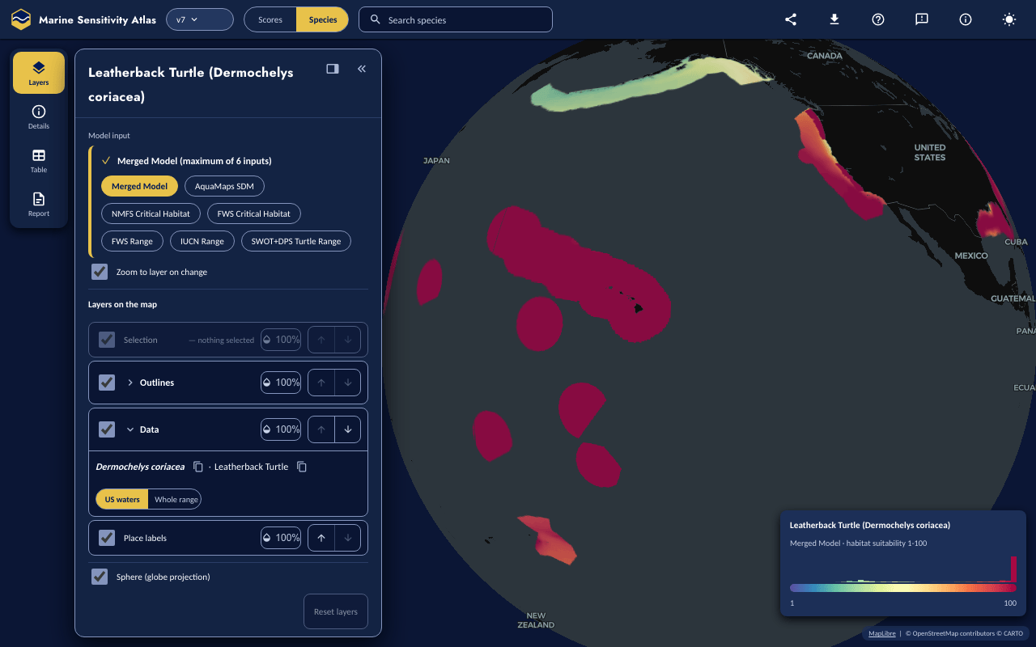
Figure 21.5: The Species lens’ Layers panel for the leatherback turtle (Dermochelys coriacea): the merged model selected, with all six of its inputs available as pills. In the layer stack, the expanded Data row shows the scientific and common names (each with a copy button) and, for a wide-range model, a US waters / Whole range zoom switch. Atlas 0.10.91, release v7, 2026-10-16.

21.6 Places
Places — the first part of the Report tool, listed with its count (“Places 2 / 20”) above an Add a place section — is what the two retired Shiny apps did not have: any area you outline gets the same scores and species results the built-in Program Areas get. The empty state reads exactly: “No places yet. Click the map, or add one below.” A click on the map shows up as a pink Last clicked row with an Add button, which hides once that place is in the list; a click never wipes places you have explicitly added.
- Pick a Program Area. The Add a Program Area chooser plus Add this Program Area needs no pointer and works on a phone. Or turn on Pick mode and click on the map — that only highlights it (Ctrl/Cmd-click, Shift-click or long-press to highlight several) — and “Add to places (n)” is the button that actually adds it; several picks become one place. Program Areas are shown as “Full Name (KEY)” — e.g. “St. George Basin (GEO)” — from an app-side name table generated off the canonical Program-Area geometry (no published release, v6 through v9, actually publishes a full name on its own Program Area rows; a release that does publish one is preferred when present), everywhere: Places, search, the map tooltip, the Details flower’s title, the Table header, the Zones table and the report.
- Pick from the gazetteer. Turn on Pick from gazetteer to show the gazetteer’s polygons on the map and click one to add it. The place is carried in the link by its gazetteer id, not its outline (Section 21.7); other gazetteer collections appear in a Gazetteer layer selector once the gazetteer publishes its layer list, and the map’s credit line names the gazetteer’s data while its polygons or places are shown.
- Draw a Polygon, Rectangle or Circle: click, move, click for each vertex or corner (not a drag), then press Done — a polygon also closes when you click its first vertex again, or press Enter. A circle is stored as a 64-sided polygon. Dragging a finished shape’s corner edits that place in place (same row, same name, re-analysed) rather than adding a new one.
- Enter coordinates — the keyboard/screen-reader alternative to drawing, in a modal dialog: a bounding box (xmin, ymin, xmax, ymax), a list of lon, lat vertices one per line, or pasted WKT/GeoJSON. A refusal is shown verbatim — what went wrong, why, and how to fix it.
- Upload a file, through the picker or by dropping it anywhere on the map: “GeoJSON, zipped shapefile, KML, GPX, FlatGeobuf, WKT or GeoPackage, up to 10 MB.” GeoPackage is now read (polygons only, same as every other format), through the same resident DuckDB-WASM engine the scores boot, via its spatial extension — fetched live, with consent, from extensions.duckdb.org (the one deliberately non-mirrored third-party download, 22.4 MB); each .gpkg upload asks first, not just the first one in a session. A GeoPackage with no vector layer (raster tiles, or a plain attribute table) is refused when ST_Read fails to read it (see Known limitations), not by a dedicated check. Other rules that cause a refusal: polygons only (points and lines are refused, never buffered); a shapefile needs its .prj (projected coordinates are refused); at most 50,000 vertices; a zipped shapefile at most 50 MB uncompressed and 200 entries; and the shape must touch the U.S. study area. A feature’s own name (KML’s <name>, or a name/title/label property on GeoJSON/shapefile/etc., case-insensitive) — auto-detected from the file’s first feature and applied to every feature — names each place; a file with no such property falls back to the file name, numbered. A file with several features becomes one place per feature (up to 20), each named this way, or one merged place, named after the file, your choice.
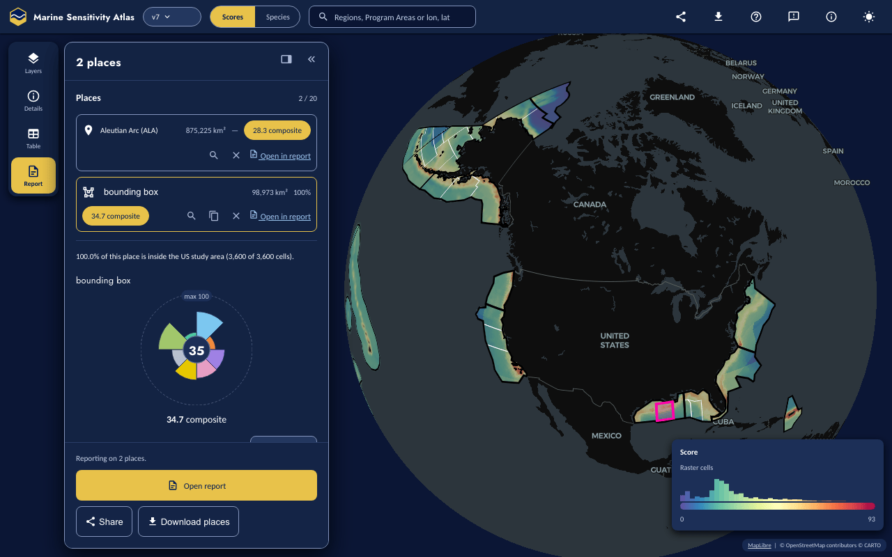
Figure 21.6: The Report tool’s list of places with two places, both analysed: a Program Area (“Aleutian Arc (ALA),” 875,225 km², 28.3 composite) and a selected, entered-coordinates place (“bounding box,” 98,973 km², 100% coverage, 34.7 composite) whose coverage note reads “100.0% of this place is inside the US study area (3,600 of 3,600 cells),” with its flower plot below; the box is outlined in pink over the Gulf of America on the map. The pinned footer below reads “Reporting on 2 places.” above the gold Open report button, Share and Download places. Atlas 0.10.92, release v7, 2026-10-16.

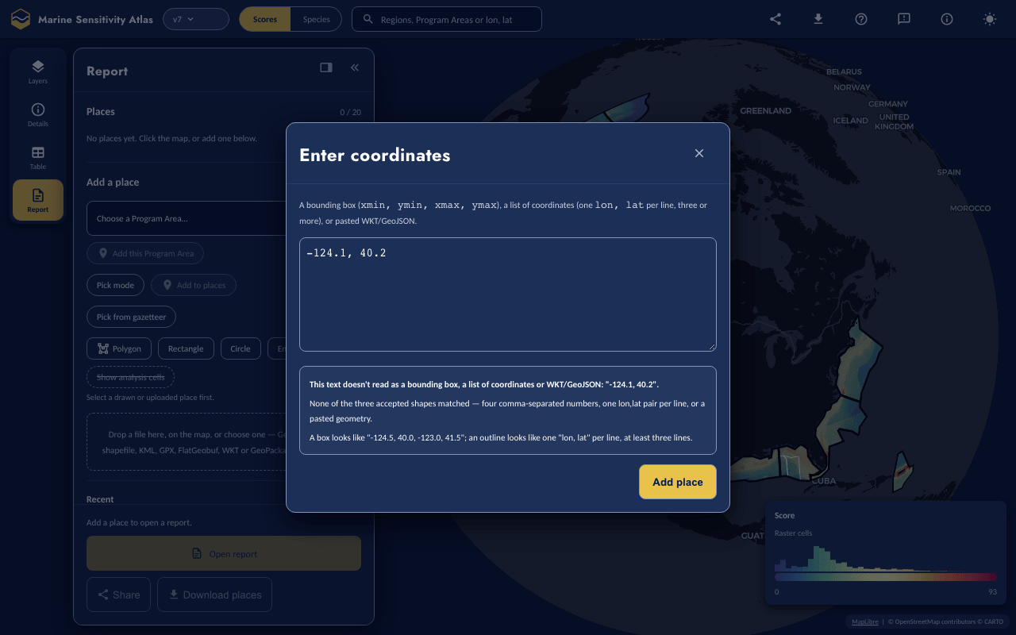
Figure 21.7: The “Enter coordinates” dialog after a single longitude, latitude point (“-124.1, 40.2”) was entered and Add place clicked: it is refused, because the text matches none of the three accepted shapes (a bounding box, a list of coordinates, pasted WKT/GeoJSON). Atlas 0.10.91, release v7, 2026-10-16.
Each row shows its area and, as soon as it is analysed, its data coverage percentage and composite score directly in the row — for a drawn, typed or uploaded place the same analysis runs for every such place in the list, not only the one currently selected; a Program Area row shows its own published composite the same way (e.g. “Aleutian Arc (ALA) … 28.3 composite”). Row actions: an inline rename (≤ 60 characters, drawn/uploaded places only), zoom to, duplicate (drawn/uploaded only), delete, and Open in report. Selecting any place — drawn, typed, uploaded, or a Program Area — expands the same results panel below the list, though the note at its top differs by kind: a drawn, typed or uploaded place shows a coverage note (“N% of this place is inside the US study area (a of b cells)”, or “This place is outside US waters here: no scores can be computed”); a Program Area shows its own note instead (“N cells, A km²; published composite C.”). Both then show a flower plot and a component table, and a species table on request — a drawn/typed/uploaded place behind a “Loading species needs N tiles, about X MB. Continue?” prompt (species come from map tiles), a Program Area behind a plain Load species button with no such prompt (its species table is a precomputed release table, not tiles). A single selected Program Area reads all of this straight off the release (the same path the Scores lens’s Table › Zones tool uses, Section 21.8); a multi-Program-Area selection (several picks added as one place) still sums area and means the composite for the list row, but its flower/component/species panel asks you to select a single Program Area instead of guessing which one’s to draw. Show analysis cells paints the analysed 0.05° cells (up to 20,000 of them) for a drawn, typed or uploaded place; for a Program Area it reads plainly “Show analysis cells: not available for Program Areas yet” — the app bundle the Atlas reads does not yet carry per-zone cells, even though the release’s own tables do (see Known limitations) — rather than showing a disabled control with a misleading reason. The list caps at 20 places (“n / 20 places”); Recent (this browser only) offers to add a removed place back. The Report tool’s footer is pinned to the bottom of the pane: a sentence saying what the report is about (“Reporting on 2 places.”, “Reporting on the last clicked place. Add it to keep it.”, or “Add a place to open a report.”), the gold Open report button (disabled with nothing to report on), then Share and Download places (GeoJSON, with each gazetteer place’s id), the last two disabled with zero places.
Two different Share buttons. The top-bar Share simply copies the current address to the clipboard, plus a ui= token that records the panel arrangement — no dialog, no summary, no length check. The Share at the foot of the Report tool opens the real dialog described next, and is the one to use whenever places are involved.

21.7 How places are stored in the link
A place never lives on a server: it is encoded directly into the URL fragment (#pl=, never the query string, so it is never sent to a server or a referrer), so opening a shared link reproduces the sender’s exact area. Every analysis runs on the decoded geometry, never the geometry as drawn, so the numbers can never diverge between sender and recipient. Places are joined with ~:
#pl=z.pa.GAA~g1.Gulf%20box.EAMBAQSf_grYrQPQDwAA0A_PDwA~p.NMS%3ACINMS.Channel%20Islands
(the decoded form; the address bar itself percent-encodes ~ and other reserved characters)
- z.<set>.<key>[,<key>...] — a reference to a built-in zone (pa Program Area, pl Planning Area, er ecoregion, sr subregion); its geometry comes from the release’s own PMTiles.
- g1.<name>.<base64url bytes> — a drawn, typed or uploaded polygon, carried inline as a compact binary encoding (see “For developers” below).
- p.<place_id>.<name> — a gazetteer place, carried by reference: only the gazetteer’s place_id and a display name travel, e.g. p.NMS%3ACINMS.Channel%20Islands. It is fetched when the link opens and analysed like a drawn place; if the gazetteer cannot be reached the place stays in the list (and the link) with a “couldn’t load” note and a Retry. Links made before 0.10.88 open unchanged, but an older Atlas drops a p. place it cannot read.
- u.<name>.<8-hex-digit digest> — the fallback for a place too large to carry (see below): only a name and a digest travel.
For developers: the g1 byte layout
Each ring is quantized to a fixed precision (3 decimal digits, ~110 m — 4 digits when the place’s bounding box is under 0.5° in both directions), delta-encoded vertex-to-vertex as zigzag varints running across rings and polygons, and base64url-encoded with no general-purpose compression (delta varints are already dense). Longitudes are stored unwrapped, so a place crossing the antimeridian round-trips without a special case. msens::place_decode() is the R decoder; the shared test fixture (tests/fixtures/place_codec.json) matches it byte for byte.

The link’s length is checked only when you open the Report tool’s Share dialog. Adding a place, or copying the top-bar Share link, carries the unsimplified geometry (already quantized to 3–4 decimals) regardless of length. In that dialog: up to 2,000 characters silently; between 2,000 and 8,000 a note reads “This link is over 2,000 characters — some chat apps and older browsers truncate very long links,” with Copy anyway; only above 8,000 does the Douglas-Peucker ladder run — 0.001° doubling to 0.016°, a rung accepted only while the area changes by no more than 1% and every ring stays simple — aiming to bring the link back under 2,000 characters; it stops at the first rung that does, or, if none does, uses the coarsest accepted rung provided that still fits under 8,000. This is never silent: the dialog shows the before/after (vertices, area change, cells, Figure 21.9), and you click “Simplify and update the numbers” to accept it — which is also what rewrites #pl=, so the copied link and the displayed numbers can never disagree. If even the coarsest rung is still too long, Copy link anyway copies every drawn, typed or uploaded place (zone places are unaffected) as a u. token instead — your own address bar and session keep the real shapes; the recipient of that copied link sees a named row with no results and a “not analysed yet” chip, never a prompt. The dialog’s own advice at that point is to download the place as GeoJSON and send that alongside the link. A single small rectangle almost always fits in the silent budget; that is not guaranteed for several places together, or a long base URL.
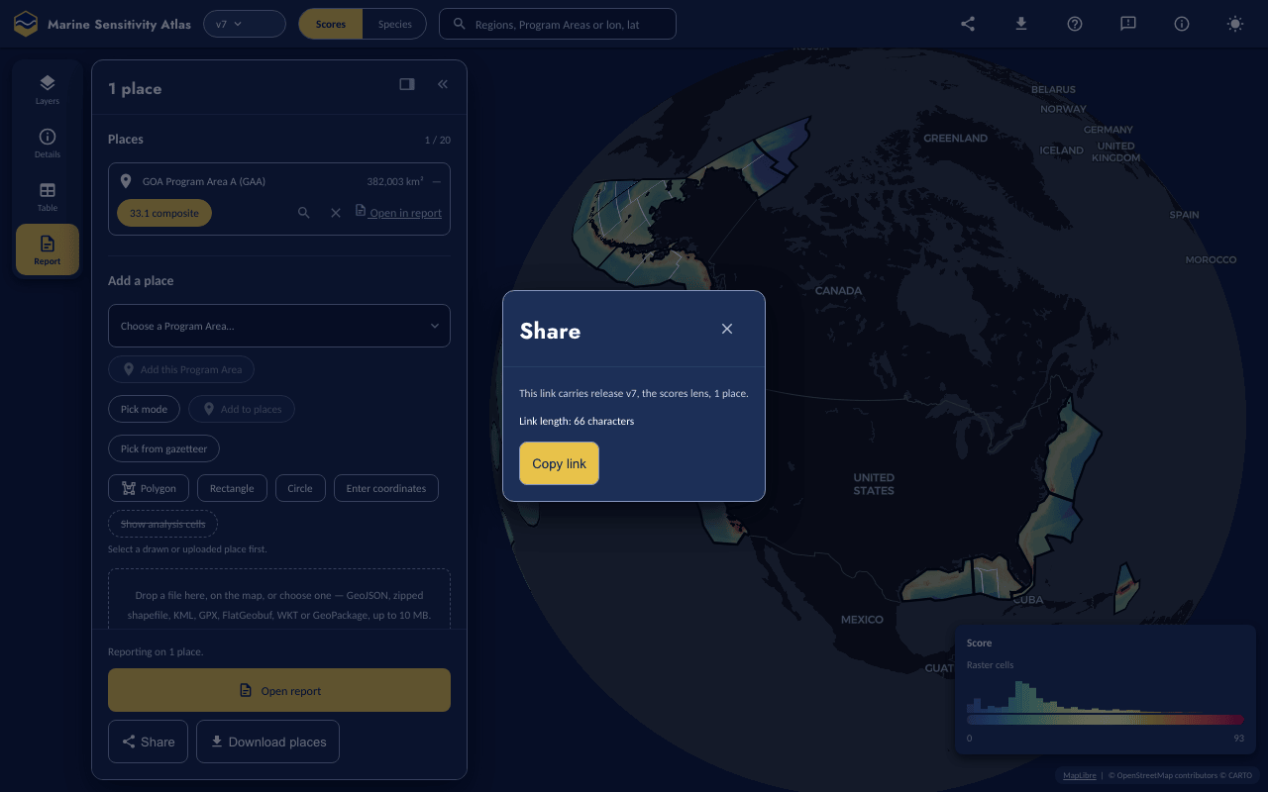
Figure 21.8: The Share dialog for one place (the Program Area GAA): what the link carries and its exact length. The dialog is opened from the Share button at the foot of the Report tool. Atlas 0.10.91, release v7, 2026-10-16.

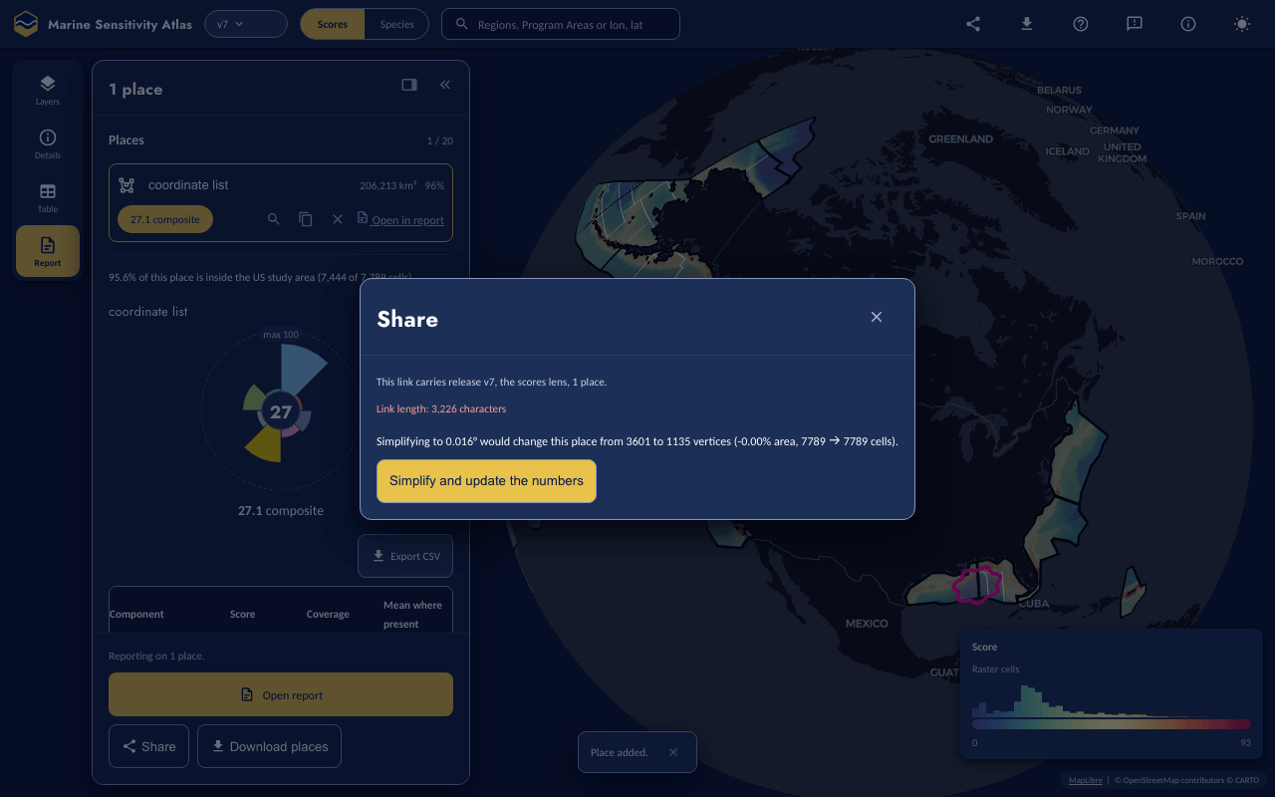
Figure 21.9: The Share dialog’s simplification ladder for an oversized place (a 3,600-point coordinate list in the Gulf of America): the link length shown, the before/after vertex count, area change and cell count of the proposed rung, and the “Simplify and update the numbers” button. Atlas 0.10.92, release v7, 2026-10-16.
The rest of the view travels the same URL-is-the-state way, in the query string: ver, lens, lyr/sp (with in, rep and us for a species’ input, representation and US-waters filter), unit, area, map (camera), pal, sel, layers (the stack deltas from Section 21.4), zl (zoom to layer), theme and tour — each written only when it differs from its default. ?tool=report (or layers, details, table) opens that rail tool and counts as a deep link, so the first-visit welcome does not cover it; the top-bar Share adds a ui= token for the panel arrangement. A link from the retired Shiny apps (mdl_key, mdl_seq) is rewritten to sp (and in when it named an input) when the Atlas loads.

21.8 Details and Table
Details (the rail’s second tool) describes what was last clicked, and is the same tool in both lenses. In the Scores lens it is the Flower plot for the clicked cell or Program Area, headed by its subject (“Cell 3372565 · 28.275° N, 83.575° W” or the Program Area’s full name), with Add to report and Open table buttons; with nothing clicked it shows the flower for All US waters. In the Species lens it is the species’ information (see the Species lens above). A drawn place’s flower and species table live in the Report tool’s results panel instead (Section 21.6).
The flower draws one equal-width annular petal per score component, scaled to its rescaled score; the hub shows the plain mean of the components present (not a weighted mean). Since 0.10.41 the values also list in a real table (swatch, component, score, and a Mean row) below the plot.
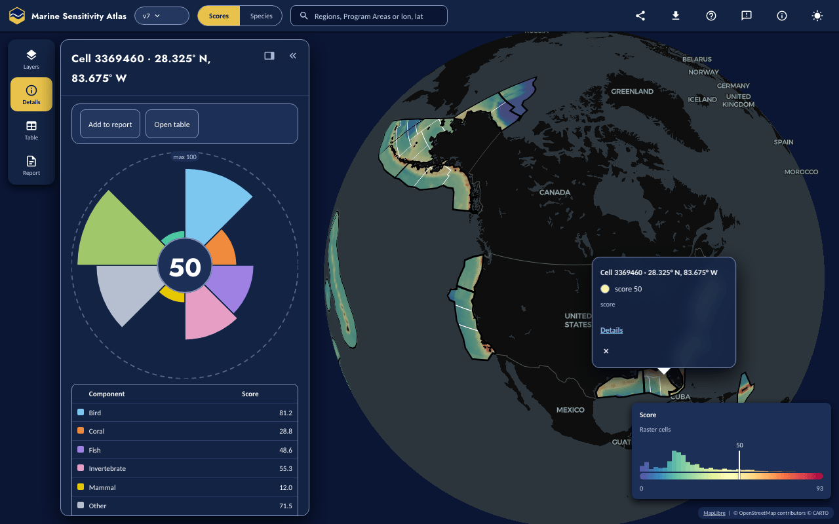
Figure 21.10: The Details tool for a clicked cell in the Gulf of America: one petal per score component, and the values table below it. The panel is headed by the cell’s subject line, with Add to report and Open table buttons above the flower; the map shows the cell’s popup (score 50). The click, aimed at 28.3° N, 83.6° W, landed in cell 3369460 (centre 28.325° N, 83.675° W). Atlas 0.10.91, release v7, 2026-10-16.
Table takes the whole stage beside the rail, with a one-row header: a ← Map button that collapses the panel, what is shown (“Species in Cell …”, “Species in All US waters”, “Species for 2 places”), the column glossary and the CSV download. In the Species lens the Table lists the species’ model inputs instead (with its own CSV download). In the Scores lens it opens three underline tabs: a sortable species table (Category, Taxon, Scientific name, Common name, ER code, ER score, Model, MMPA, MBTA, Area (km²), Avg. suitability, % of category — ESA and IUCN status are folded into ER code), a zones table (every Program Area ranked by the current layer, with “report on selected” once some are ticked), and a composition treemap (one box per species category, sized by suitability × extinction risk × area). Only the species table has the phone’s compact default columns and a Columns control; both tables get sticky headers/first column and horizontal scrolling that never spills the panel. Only the species table’s Download CSV exports it; the zones table and the composition treemap have no export yet. A drawn place’s Components and Species tables in the Places results panel each have their own working Export CSV.
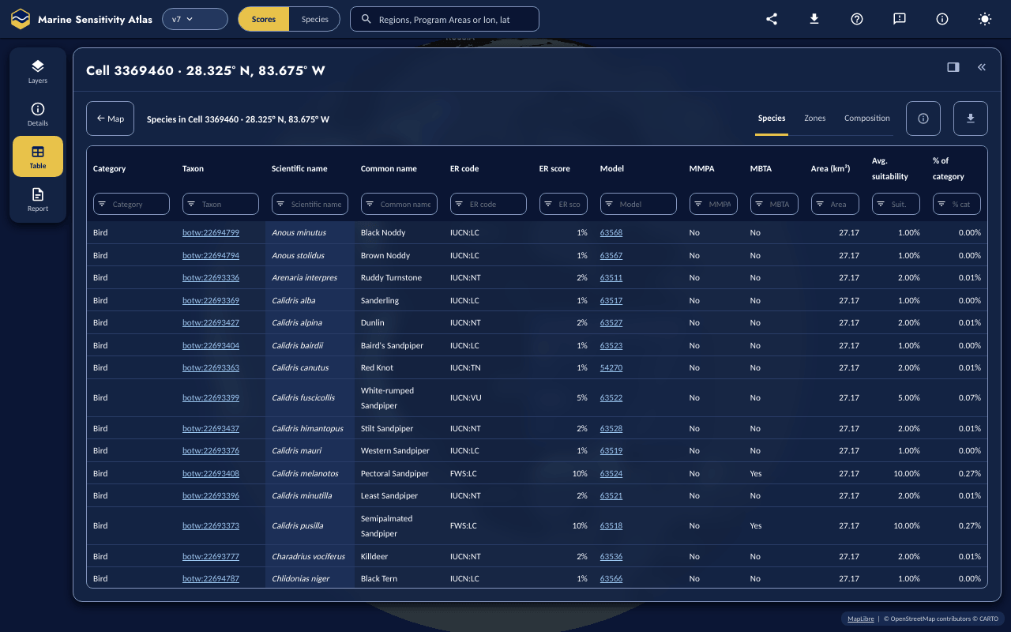
Figure 21.11: The Table tool’s Species tab for the clicked cell in Figure 21.10. The Table fills the whole stage beside the rail, with a single header row (← Map, the subject, Species · Zones · Composition tabs, a glossary button and a CSV download). Atlas 0.10.91, release v7, 2026-10-16.

21.9 Report
The Open report button reports every place currently in the link (#pl=); with no places, it reports the single selected Program Area, or the single clicked cell (its square, the same place Add puts in the list); with none of these, it is disabled and the footer says “Add a place to open a report.” A row’s own Open in report reports just that row’s place. The report opens in a new tab and renders progressively as its data arrives:
- a header band — mark, release chip, generation time, permalink and QR code (a restricted release also gets a PREVIEW banner and print watermark);
- an introduction;
- a collapsible Parameters section (kind, keys or vertices, area, cell count, study-area share, token);
- a map — interactive on screen; a static snapshot only in print and the HTML export;
- one flower plot per place, under “Plot of Scores”;
- a Table of Scores — component and overall scores, with a footnote when a component covers under 99% of the area, or is missing entirely because the release’s own 5% coverage floor dropped it;
- a Summary of Species per place (a category × count cross-tab, plus the top 20 by score);
- Sources and Method, with the release’s own citations — each query behind these numbers is a parity-tested twin (npm run parity, max|Δ| < 1e-9) of an msens R function; “Reproduce in R” prints the exact calls to msens::place_decode(), cells_in_polygon_grid() and scores_for_cells() that reproduce it, needing msens ≥ 0.44.0 and a local copy of the release’s sdm.duckdb;
- a Provenance section (release, status/access, app build SHA, DuckDB-WASM version, tables read, SQL run).
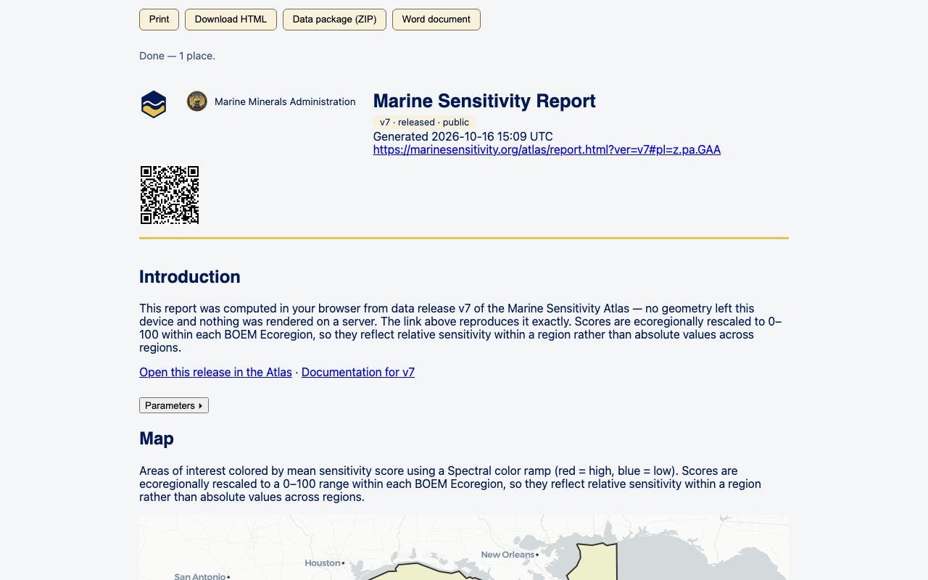
Figure 21.12: The report document for the Program Area GAA, opened from the Report tool’s Open report button in a new tab: the export buttons, the MMA seal, a release chip, a permalink and QR code, the Introduction, a Parameters disclosure and the start of the interactive map. The title is the default “Marine Sensitivity Report” because the link carries no t= title. Atlas 0.10.92, release v7, 2026-10-16.

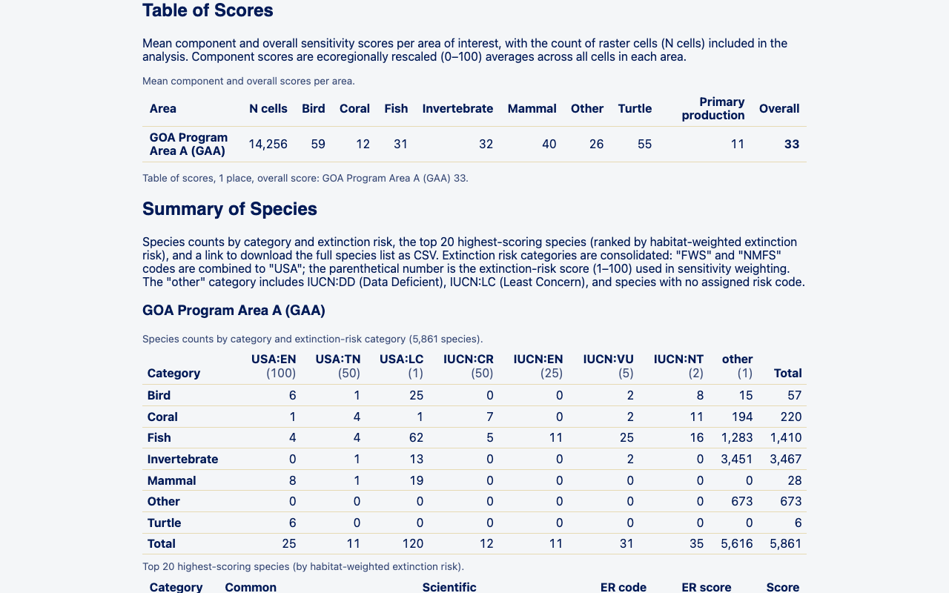
Figure 21.13: The report’s Table of Scores and the start of the Summary of Species, for the same Program Area (GOA Program Area A, GAA). The species-count table’s extinction-risk headings take two lines (code over score) so all of its columns fit the page. Atlas 0.10.92, release v7, 2026-10-16.
Four exports, all built client-side: Print (the browser’s dialog; roughly five Letter pages); Download HTML (one self-contained file — the flowers stay inline SVG, only the map is an embedded PNG); a data package (ZIP) — README.md, CITATION.md, provenance.json, places.geojson (drawn/uploaded places only, not zone places), a scores_*.csv/species_*.csv pair per place, and query/*.sql; and a Word document (.docx) — the same tables as coded Word styles, plus the map and a rasterized flower per place.

21.10 Accessibility and performance notes
The Atlas ships a written WCAG 2.1 conformance note and a performance budget report in its own repository. As of the note’s own 0.10.24 (2026-09-23) evaluation the claim is “partially supports,” not full support, and it states plainly that no screen reader was actually driven in producing it — automated and manual keyboard testing stand in for that. Two skip links sit at the very top of the page: “Skip to the tools” and “Skip to the details panel.” The critical-path JavaScript was measured (0.10.20, 2026-09-23) at ~417 KB gzip against a 450 KB budget (it has been 460 KB since 0.10.89), plus ~140 KB for the MapLibre worker against 150 KB; a separate gate asserted the species lens paints its first data pixel within 2.5 s on a laptop and 4 s on CI. The measured numbers may have moved since; see the linked reports for current ones.

21.11 When a service is down
Since 0.10.58, the Atlas checks two external services it does not control: titiler-v8 (every score and species map tile) and the S3 data origin each release’s own files are fetched from. Both are checked at boot and on a manual Retry; a map tile that actually fails to load for a real reason — a 5xx, a network error, or a timeout, never a normal “this release has no data here” 403/404 — re-checks only the tile server. It never polls in the background while everything is fine.
When either is down, a dismissible banner — since 0.10.62 it sits in the map stage, below the top bar, so it never covers the top bar’s controls — names the failing host, the reason (timeout or HTTP status), and what still works — places, tables and reports already built from data already loaded, just no new tiles or new fetches from the down host; when it is specifically the tile server that is down, the legend also switches to a compact “tiles unavailable” state instead of a bare colour ramp. Built after titiler-v8 and the API were unreachable for an hour and the live app kept rendering a perfectly normal-looking map with no raster and no word to anyone.
What it cannot detect: a partial outage (some tiles or objects failing, others not — only a further real request surfaces it), a degraded-but-200 response (a tile that loads but paints wrong data), or a preview session’s own restricted data prefix (the probe always checks the public bucket origin, not a signed-in override). No release the Atlas reads from calls a separate API today, so there is nothing of that kind to probe; DuckDB-WASM’s own Parquet fetches, PMTiles zone archives and the basemap are likewise outside this check’s scope — a partial CDN problem affecting only one of those would not trip the banner.

21.12 Feedback and versions
Feedback opens a dialog: a kind (bug / idea / question / data), a title, a description, an optional email, an annotatable screenshot, and a privacy checkbox (off by default) for including the current view’s link. Send is live: it posts to a Google Apps Script endpoint that writes a Sheet row, mails the team, and — for a public release — also files a public GitHub issue in MarineSensitivity/atlas with the screenshot attached (your email, if given, is never included in it); a restricted release never gets a public issue either way. An email, if given, is kept only in the team’s Sheet row and mail (plus a copy to you), never in the issue (see docs/feedback.md in the atlas repo for the dialog’s exact privacy wording). The original zero-backend fallback stays alongside Send, not replaced by it: “Open as GitHub issue” opens its own prefilled public issue, labelled by kind, with the screenshot copied to your clipboard to paste in — offered on every public release whether or not Send is configured, and the only option on a build with no endpoint set. Tell an analyst plainly: on a public release, both routes end in a public GitHub issue. A restricted release never offers the GitHub route; on a build with no endpoint configured it says plainly that “feedback cannot be sent from here right now.”
GA4 receives interaction events as well as page views, and the app also logs those same events to the batched usage-log Sheet the retired Shiny scores/species apps also wrote (app = "atlas" distinguishes its rows) — never the URL fragment, which the app’s own analytics code is source-scanned to never read.
Versions follow the same public/restricted split as the rest of the MST (see Chapter 2): a public release opens directly on the public host; a restricted pre-release’s Atlas is reached only through the signed-in preview host, at its own /{ver}/atlas/ path. Requesting a release the current host cannot show opens the version picker automatically: a restricted one reads, for example, “v9 is a pre-release under review and is not shown on this host” and offers “Continue on the preview host” (a link straight to that release’s Atlas there, at https://preview.marinesensitivity.org/v9/atlas/?ver=v9), an unrecognized one reads “is not a version this host recognizes,” and either way the promoted release loads underneath while the picker explains why. In the picker, every public release other than the current one offers Switch.
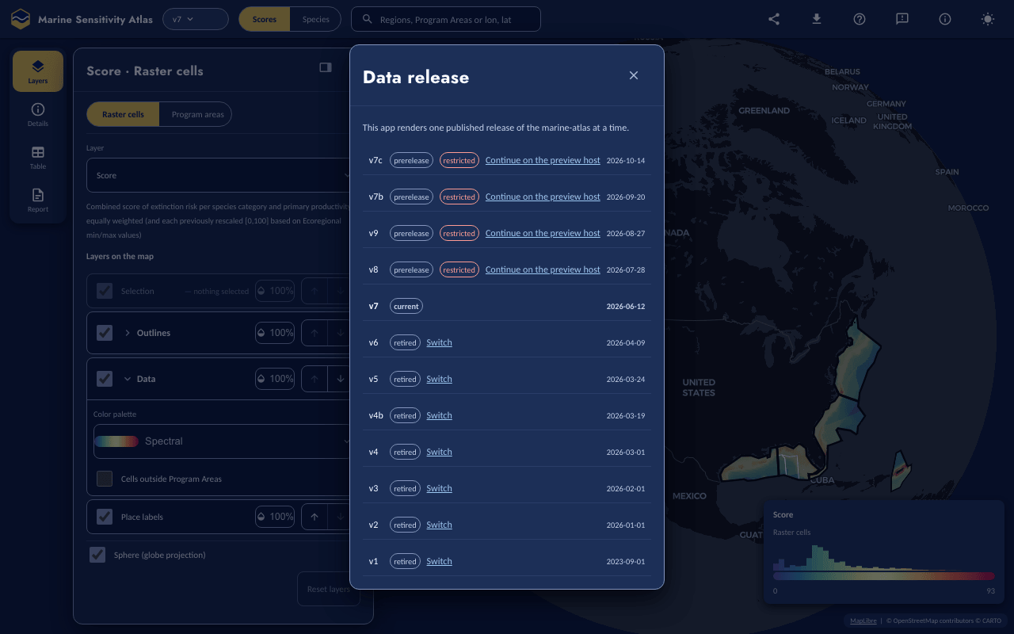
Figure 21.14: The release picker (the release chip’s dialog), listing v7c, v7b, v9 and v8 as restricted pre-releases each with a Continue on the preview host link, v7 as current, and v6 down to v1 as retired, each with a Switch link and a date. Atlas 0.10.91, release v7, 2026-10-16.

21.13 Known limitations (as of 0.10.93)
- In v7, 1,873 of the 2,619 rng_iucn range inputs have no model-asset registry row, so their pills in the Species lens show struck through (as they did in the retired Species Shiny app); every other input of v3, v6 and v7 resolves. The other pre-v8 releases (v1, v2, v4, v4b, v5, v7b, v7c) were not checked for this chapter.
- GeoPackage is refused (see the Places section above) whenever ST_Read fails to parse it, including a file with no vector layer — its declared-CRS and no-feature-table checks cannot actually run against an uploaded file, because DuckDB-WASM’s sqlite_scan() cannot open a file registered only through registerFileBuffer, the way an uploaded GeoPackage is, so both checks silently fall through and ST_Read, or the normal out-of-range magnitude check, is left to catch a projected or empty file instead (still refused, just by a different, honest rule).
- A multi-Program-Area selection (several picks added as one place) sums area and means the composite for its list row, but its flower, component table and species table are not aggregated — the results panel asks you to select a single Program Area for those.
- Show analysis cells is not available for a Program Area place: the app bundle the Atlas reads carries each zone’s count, area and scores but not its cells.
- The Atlas’s report is a print-first document built and exported entirely client-side (HTML/ZIP/DOCX from the same source), not the retired Shiny apps’ report.

21.14 Generating Screenshots
Every figure in this chapter was recaptured on 2026-10-16 from the live Atlas (0.10.91, release v7, dark theme; Figure 21.6, Figure 21.9, Figure 21.12 and Figure 21.13 from 0.10.92 later that day, after its Report fixes) with Playwright’s Chromium: desktop at 1280×800 and 1x, phone at 390×844 and 2x with touch, at https://marinesensitivity.org/atlas/. The atlas repository’s own scripts/eyes-shots.mjs covers the standard states (about 20 numbered shots per viewport) and was run against the live site:
ATLAS_URL=https://marinesensitivity.org/atlas OUT=.tmp/eyes ONLY=map,layers,more node scripts/eyes-shots.mjs
It does not reach every state in this chapter, so the figures were taken by one driver script (figs.mjs, kept outside both repositories) that uses the same helpers (go, explore, tool, and screenPointFor to click a map coordinate by projecting it) and loads each state from a URL or UI steps: ?ver=v7&theme=dark for the map, Layers, the version picker and the phone figures (the release chip opens the picker, More the phone menu); a click at 28.3° N, 83.6° W for the flower and the Table; ?ver=v7&lens=species and a search for “leatherback” for the Species lens; #pl=z.pa.GAA plus Open report (a new tab, then scrolled to the Table of Scores heading) for the two report figures and the Share dialog; Add a Program Area (Aleutian Arc) plus Enter coordinates (-93, 26, -90, 29) for the places list; a single point (-124.1, 40.2) for the refusal; and a 3,600-vertex noisy outline pasted into Enter coordinates, then Share, for the simplification ladder. Each PNG was then reduced with pngquant --quality=85-98. The guided-tour images of the Atlas user guide come from a different script, npm run tour:guide (scripts/tour-guide.mjs, from atlas 0.10.90).

21.15 Source Code
atlas on its own main branch — one static build for every release, the same “one checkout, not one per version” convention the retired Scores and Species apps followed.

22. Atlas User Guide
Step-by-step walkthrough of the Atlas, one control at a time

This guide walks through the Atlas (marinesensitivity.org/atlas/?ver=v4) one control at a time. Each numbered step below mirrors a step in the Atlas’s built-in Take a tour (click (?) Help › Take a tour on a desktop, or ⋯ More › Take a tour on a phone, to walk the same path live), with the relevant control highlighted on the screenshot, and links to open that step’s view in the Atlas itself.
For a feature-by-feature reference instead, see the Atlas chapter (Chapter 21). The Scores and Species Shiny apps that came before the Atlas have their own, frozen step-by-step guide in the Legacy appendix.
How this guide stays in sync
The steps, captions, and highlighted screenshots are generated directly from the Atlas’s own guided tour (the driver.js step data in src/shell/tour.ts of the atlas repository). From the atlas repository, node scripts/tour-guide.mjs --out <docs>/figures/atlas-guide walks the tour on a running build of the Atlas, re-captures a screenshot with each step’s control highlighted, and writes figures/atlas-guide/steps.json into this book. So whenever the tour changes, re-running that one script refreshes this whole page.

Screenshots captured from the live Atlas 0.10.91 (7e6d326), release v7, 2026-10-16.

22.1 Atlas — Scores lens

22.1.1 1. The map
Colour is the combined sensitivity score for each 0.05° cell of US waters (red high, blue low).
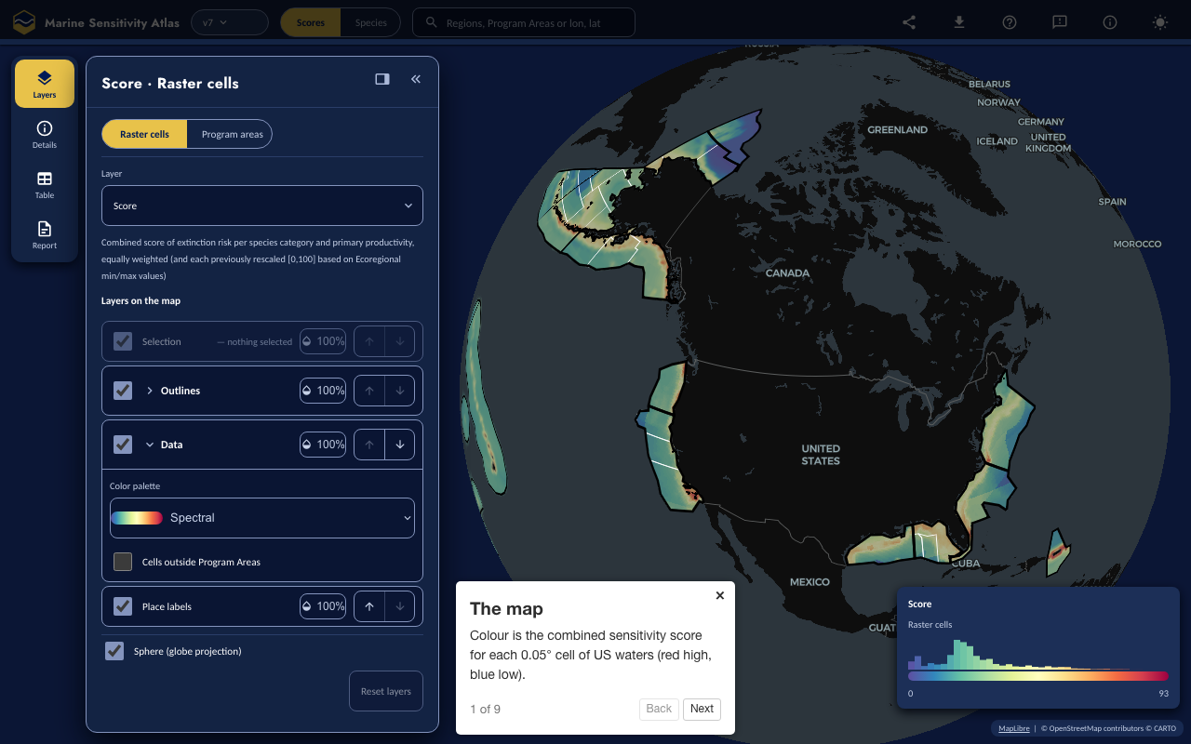
Figure 22.1: The map
Open this step in the Atlas

22.1.2 2. The release
You are looking at this release; every published release is here.
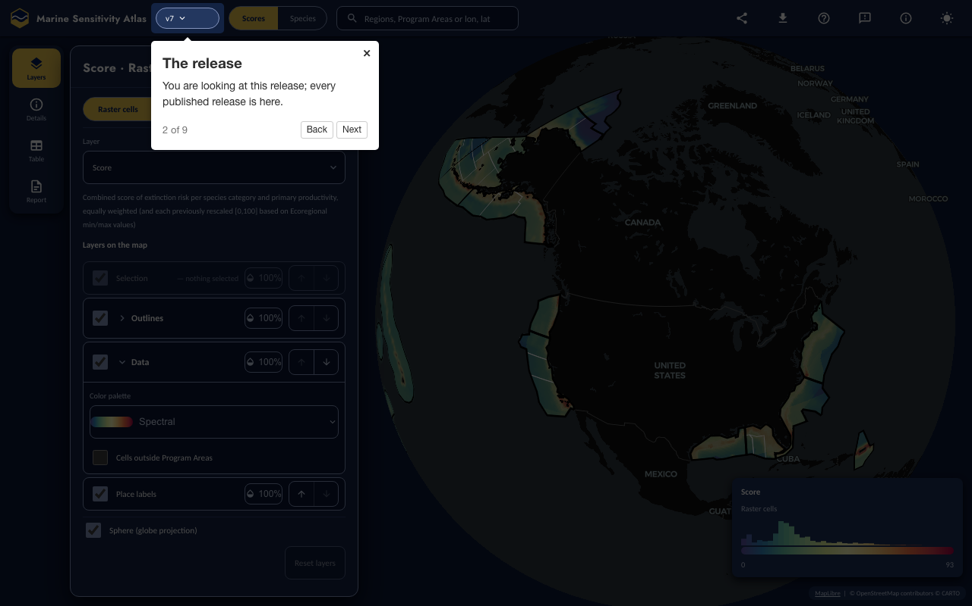
Figure 22.2: The release
Open this step in the Atlas

22.1.3 3. The lenses
Scores ranks places; Species shows one species’ distribution.
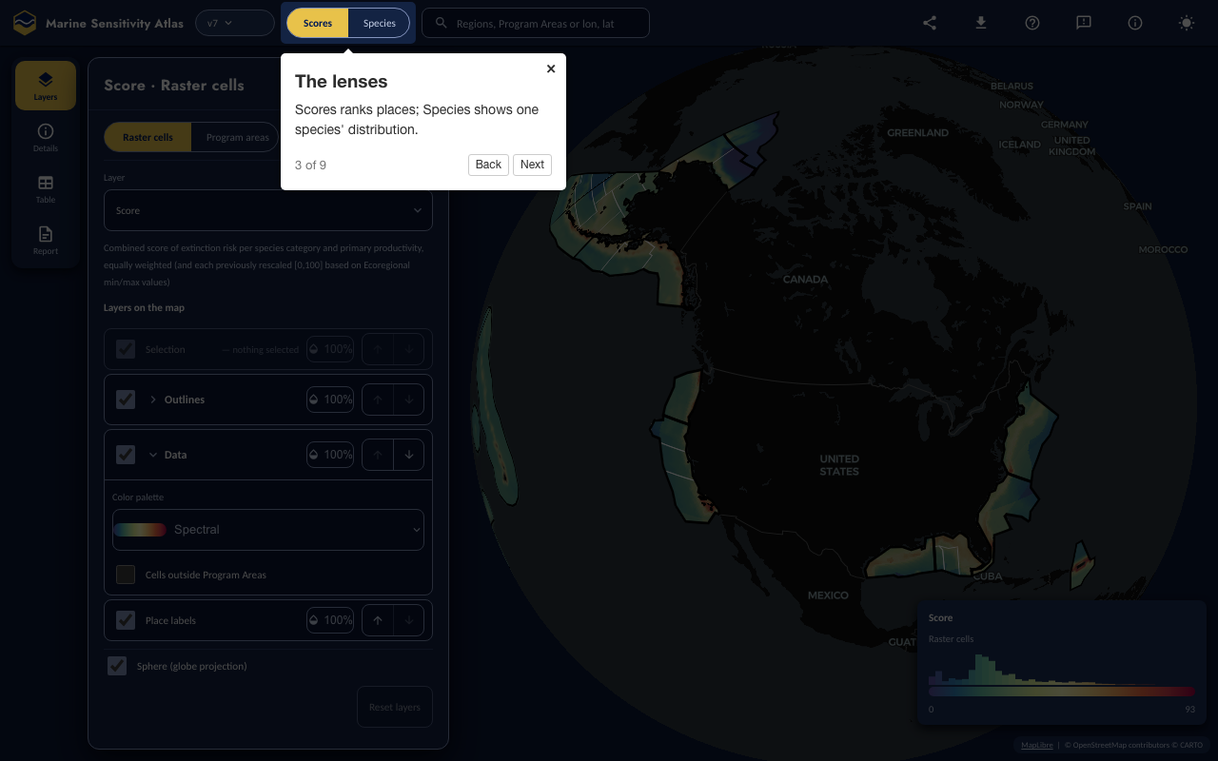
Figure 22.3: The lenses
Open this step in the Atlas

22.1.4 4. Layers
Choose the score layer, Program Areas or cells, and the colour ramp.
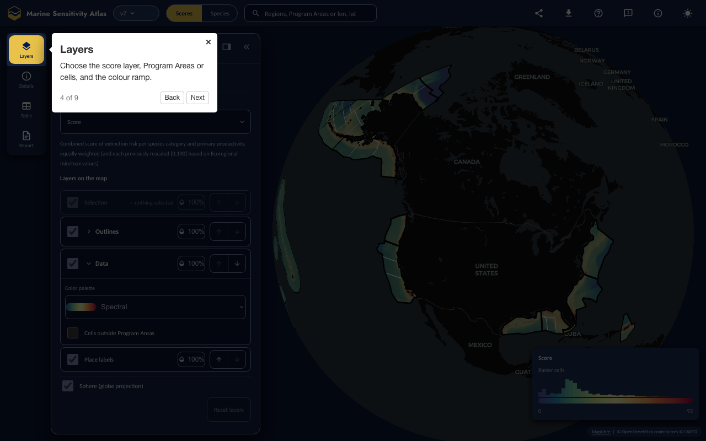
Figure 22.4: Layers
Open this step in the Atlas

22.1.5 5. Click
Click a cell or a Program Area for its score and a link to its details.
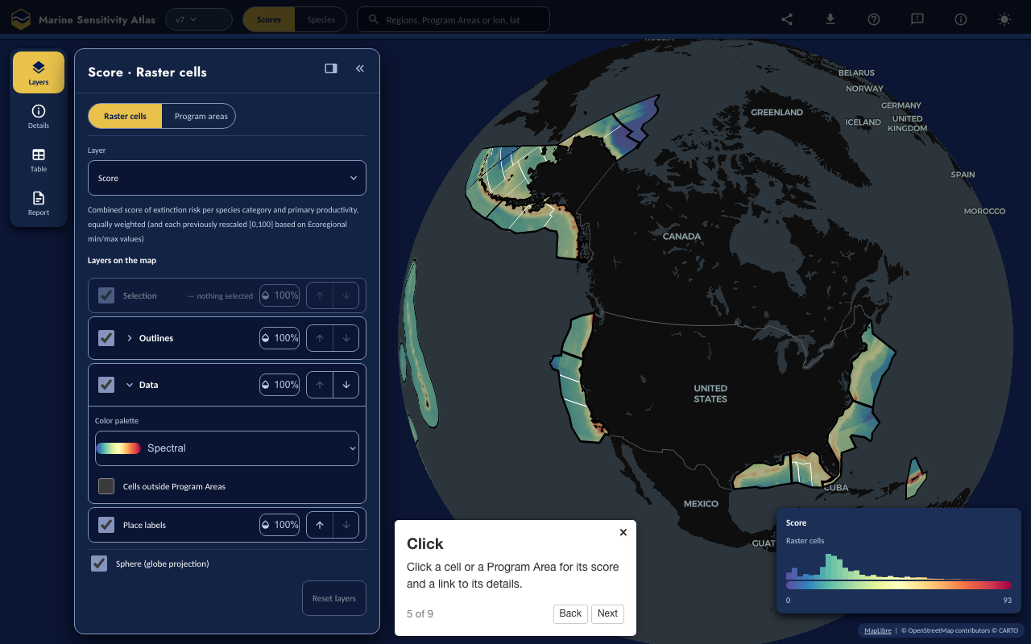
Figure 22.5: Click
Open this step in the Atlas

22.1.6 6. Details
The flower for what you clicked; add it to your report or open its table.
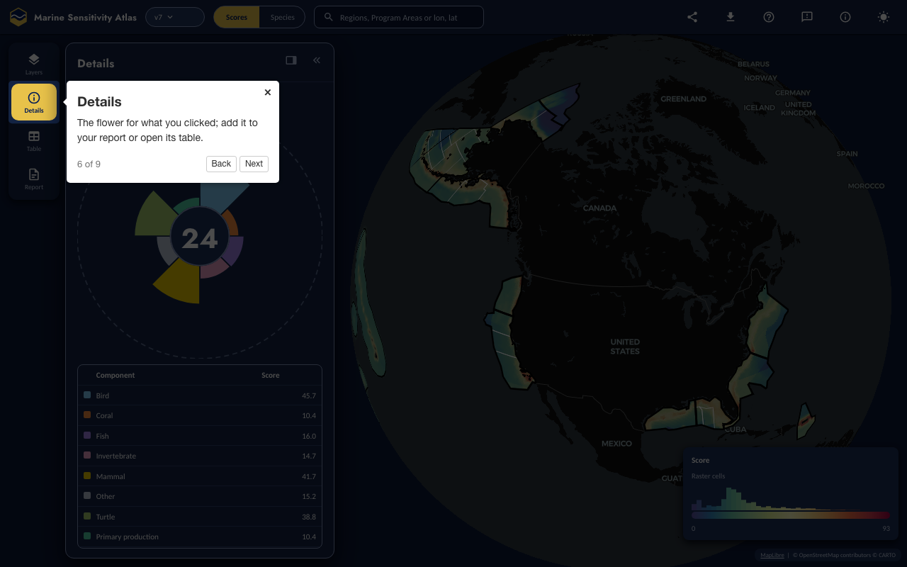
Figure 22.6: Details
Open this step in the Atlas

22.1.7 7. Table
Every Program Area ranked; tick some and report on them.
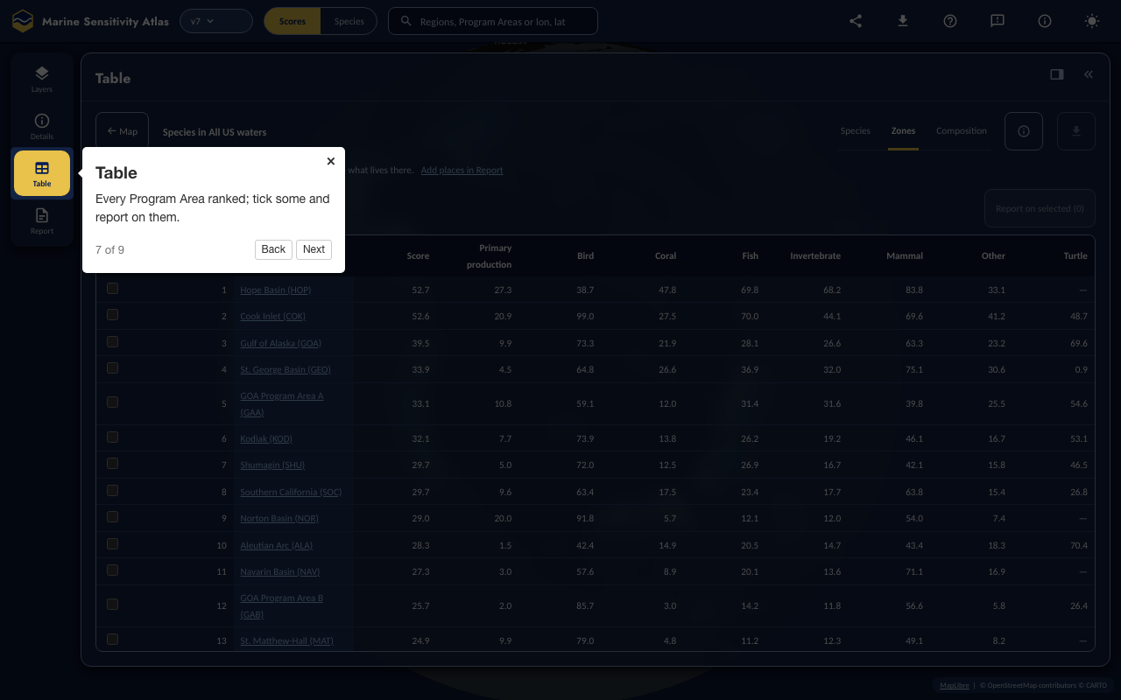
Figure 22.7: Table
Open this step in the Atlas

22.1.8 8. Places
Draw your own area, enter coordinates or upload a file.
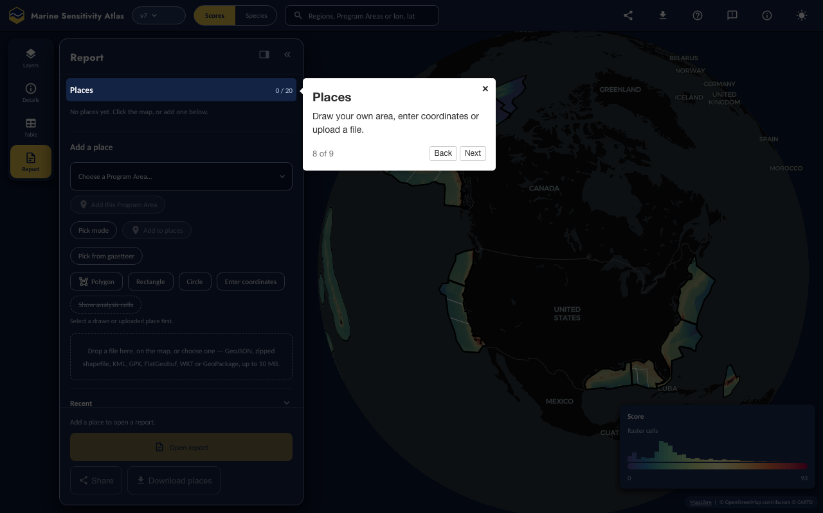
Figure 22.8: Places
Open this step in the Atlas

22.1.9 9. Report
Build a printable, downloadable report for what you selected.
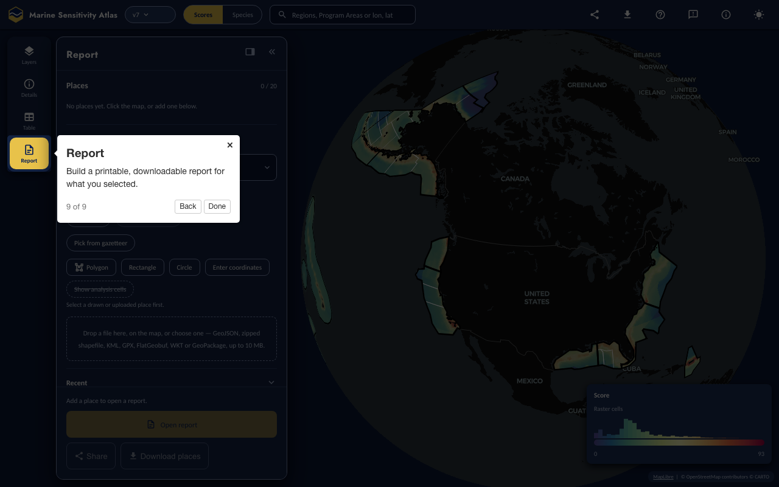
Figure 22.9: Report
Open this step in the Atlas

22.2 Atlas — Species lens

22.2.1 1. Search
Find a species by common or scientific name.
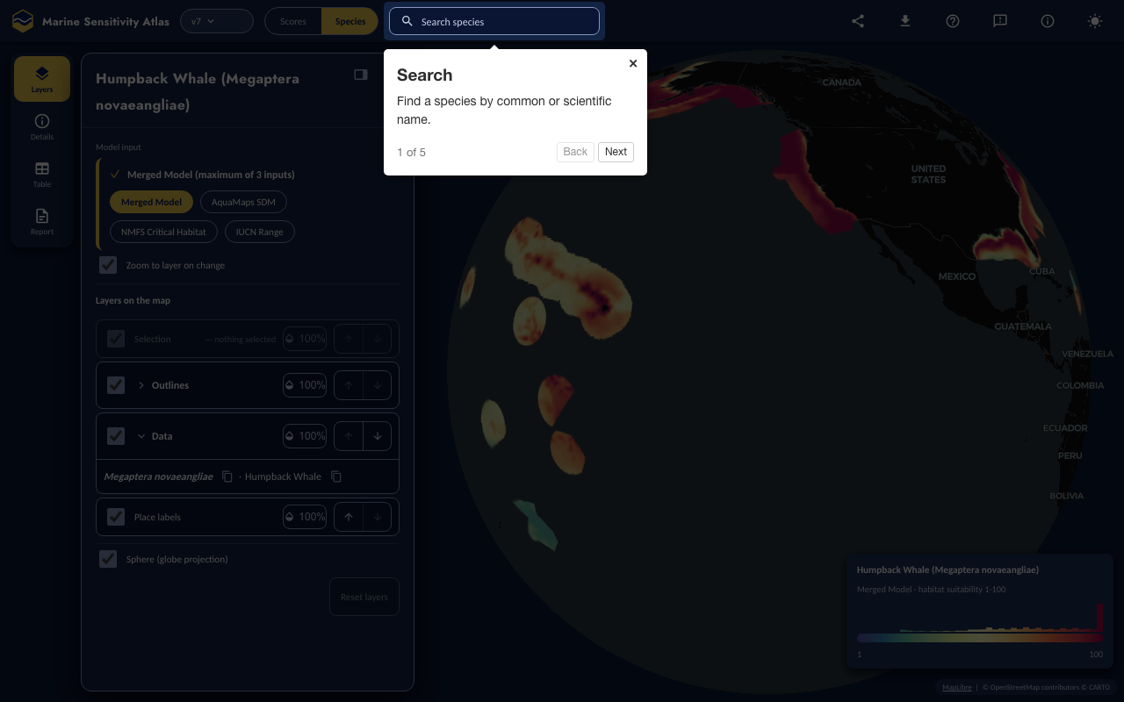
Figure 22.10: Search
Open this step in the Atlas

22.2.2 2. The card
The merged model and the inputs it combines.
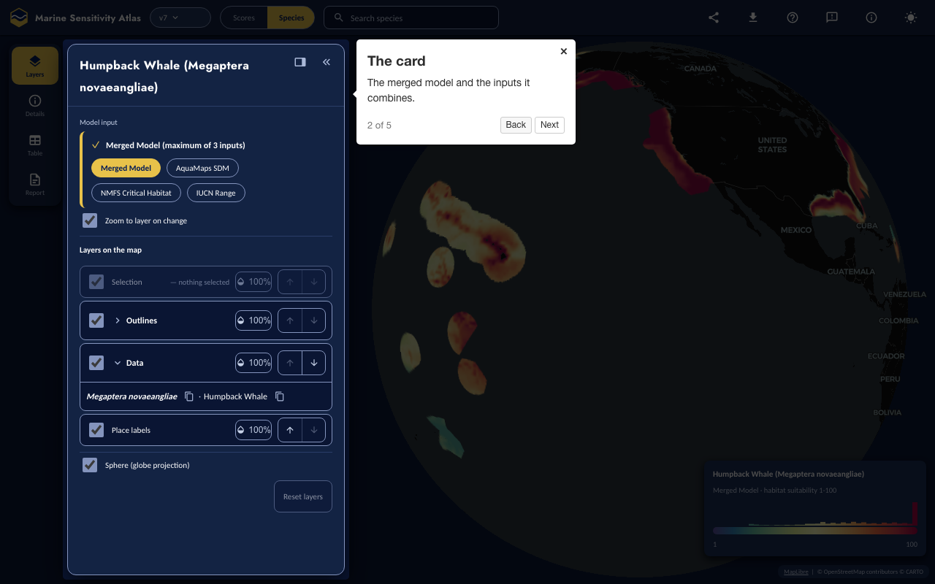
Figure 22.11: The card
Open this step in the Atlas

22.2.3 3. The map
Click anywhere for the modelled value.
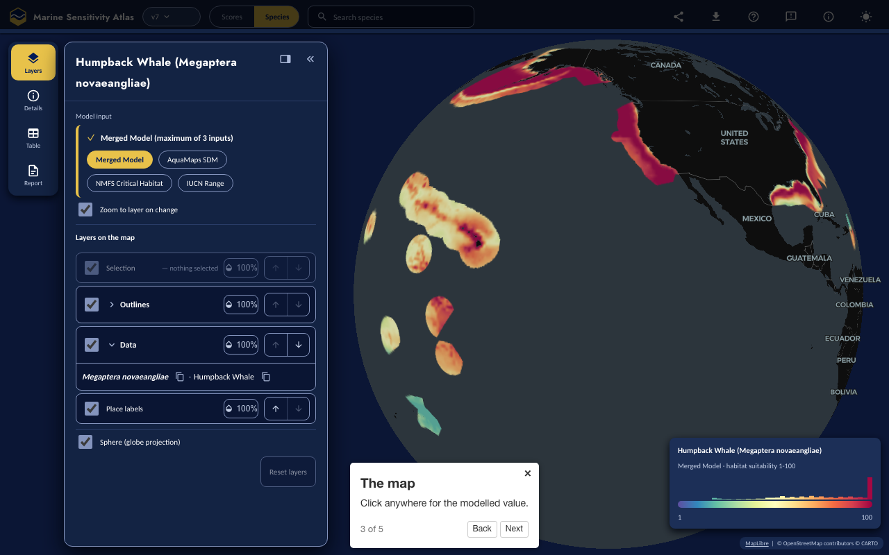
Figure 22.12: The map
Open this step in the Atlas

22.2.4 4. The legend
What 1–100 means.
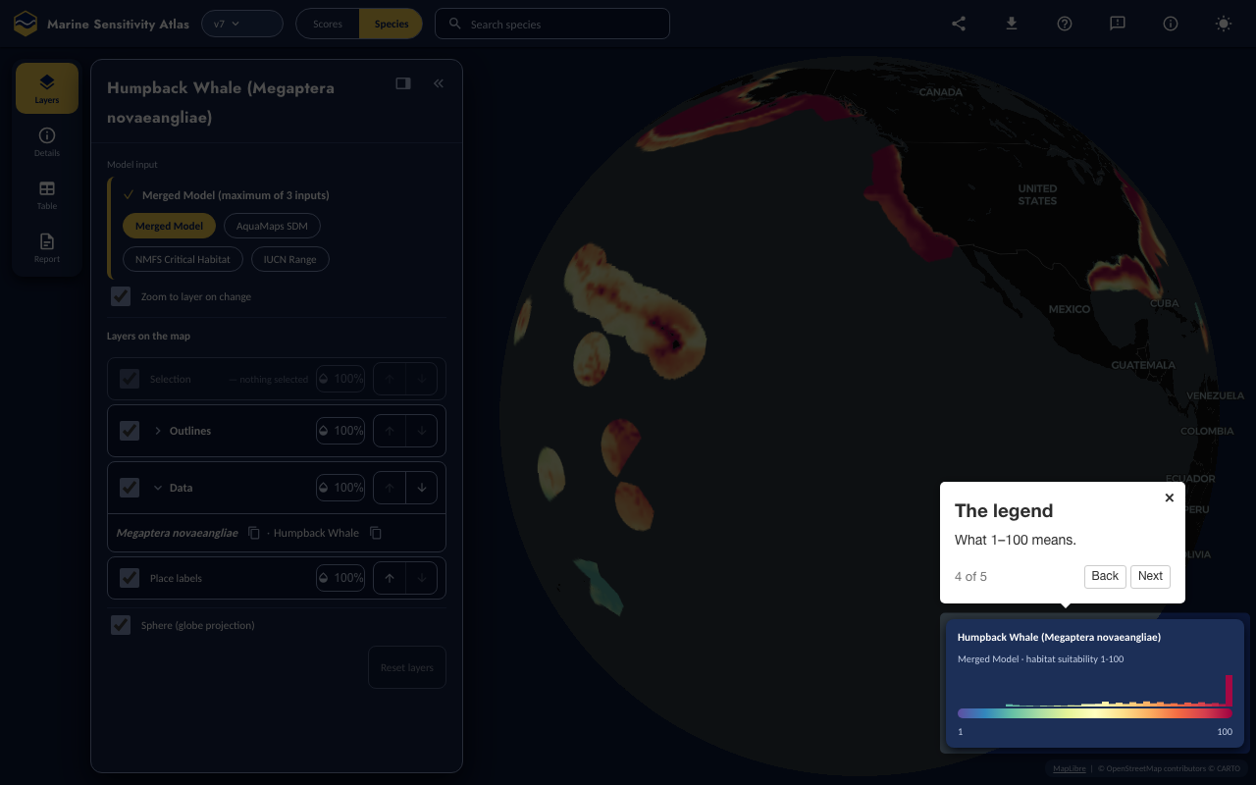
Figure 22.13: The legend
Open this step in the Atlas

22.2.5 5. Back
Switch to Scores to see how this species contributes.
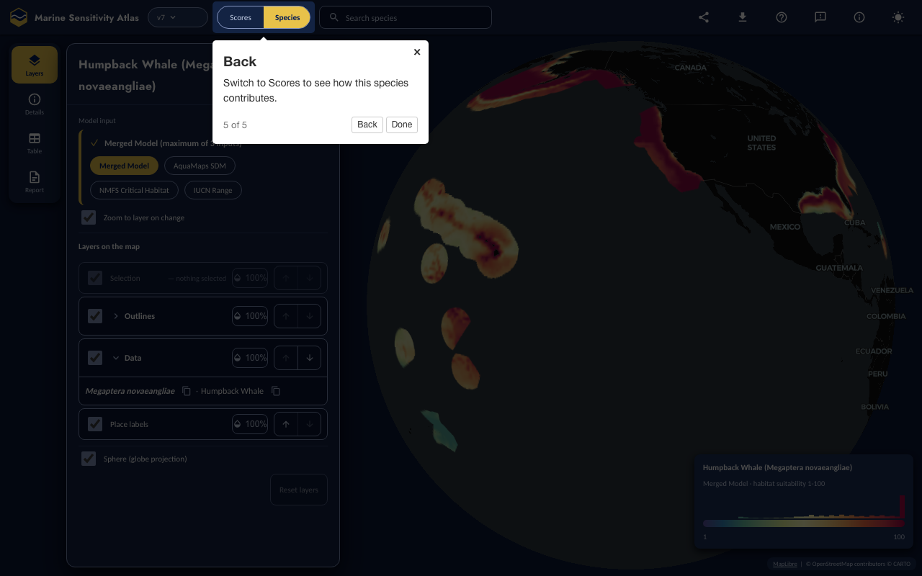
Figure 22.14: Back
Open this step in the Atlas

23. Docs
Technical documentation is principally in this book:
- marinesensitivity.org/docs
the main documentation site
- github.com/MarineSensitivity/docs
source code in the Github repository
But there are also some other self-documenting resources:
- marinesensitivity.org/msens
documented R functions

24. Summary
The Marine Sensitivity Toolkit (MST) provides a reproducible system for assessing the sensitivity of marine ecosystems to offshore energy development across US waters. This summary describes release v4; figures are read from that release.

24.1 What this release delivers
- 9,795 valid marine species on a 0.05° grid (~4 km cells) across the US EEZ study area, of which 9,597 fall inside the 20 BOEM Program Areas, integrating 8 source datasets — continuous suitability models, regulatory habitat designations and expert range maps.
- 7 scored species categories (invertebrate, fish, other, coral, bird, mammal, turtle), assigned from taxonomy rather than from the dataset a model arrived in.
- Extinction-risk scoring (1–100) folds in ESA listing, the MMPA floor (assigned by taxonomy, so no marine mammal is missed) and the MBTA floor (the FWS CFR 50 §10.13 species list, not all birds), falling back to the IUCN Red List where there is no US listing.
- Model merging produces one surface per taxon, with the expert range constraining suitability predictions rather than merely competing with them, and the governing extinction risk applied at the range cells. Sea turtles merge multiplicatively, so risk varies spatially within a species.
- Ecoregional rescaling normalizes each metric to 0–100 within a BOEM Ecoregion, so scores are comparable among Program Areas in one ecoregion without being dominated by naturally species-rich waters.
- The Atlas, the interactive application (Scores and Species lenses, plus Places and Reports), renders any published release (e.g. ?ver=v3; a restricted pre-release only on the review host, at /{version}/atlas/), so a reader can look at the release a report cited rather than only the newest one. The earlier Scores and Species Shiny apps are retired and their links redirect to the Atlas.

24.2 Delivered since the first release
Several capabilities listed as future work in earlier editions of this documentation have since shipped:
- A DAG pipeline. The workflow is a targets graph generated from each notebook’s own metadata, so adding a dataset means adding a notebook, not editing a pipeline definition.
- Cloud-Optimized GeoTIFFs and a STAC catalog. Distributions and score surfaces are published as COGs with STAC metadata, discoverable through a searchable STAC API, and the score rasters replaced an on-demand SQL-per-tile factory.
- Partitioned Parquet releases. Each version is published as Parquet on S3 and read directly, including from the browser, rather than shipped as a monolithic database file.
- One application across all releases. The per-version application forks are retired; version is data, settled by a published manifest, not a code fork.
- Whole-range models. Distributions are captured globally rather than clipped to the study area, so a species map shows the species instead of the analysis extent.
The H3 hexagonal grid proposed earlier was evaluated and not adopted: v8 stays on a 0.05° raster grid, made global rather than regional. Interpolating suitability onto hexes added a resampling step without improving the analysis, and the raster grid aligns directly with the source environmental layers.

24.3 Future directions
- OBIS/GBIF validation — refine distributions against occurrence records, with temporal filters.
- Density models — NOAA SEFSC and NCCOS density surfaces are ingested and catalogued but excluded from scoring, pending an agreed mapping from individuals km⁻² onto the 0–100 suitability scale. They are flagged is_scored = FALSE so no count on these pages includes them.
- Habitat sensitivity — benthic habitats (coral reefs, seamounts, hydrothermal vents) as a component alongside species and productivity.
- Stressor–receptor matrices — extend from sensitivity alone to full vulnerability by adding exposure for offshore wind, oil and gas, and other activities (see Chapter 12).
- Application enhancements — arbitrary area selection, taxonomic-tree browsing, automatic figure generation, and scrollytelling explainers.
- Infrastructure transfer — support moving the data and applications onto BOEM infrastructure for long-term operation.

References
Behrenfeld, Michael J., and Paul G. Falkowski. 1997. “Photosynthetic Rates Derived from Satellite-Based Chlorophyll Concentration.” Limnology and Oceanography 42 (1): 1–20. https://doi.org/10.4319/lo.1997.42.1.0001.
Butchart, Stuart H. M., H. Resit Akçakaya, Janice Chanson, et al. 2007. “Improvements to the Red List Index.” PLoS ONE 2 (1): e140. https://doi.org/10.1371/journal.pone.0000140.
Butchart, Stuart H. M., Alison J. Stattersfield, Leon A. Bennun, et al. 2004. “Measuring Global Trends in the Status of Biodiversity: Red List Indices for Birds.” PLoS Biology 2 (12): e383. https://doi.org/10.1371/journal.pbio.0020383.
Chang, Winston, Joe Cheng, JJ Allaire, et al. 2024. Shiny: Web Application Framework for r. https://CRAN.R-project.org/package=shiny.
Goodale, M. Wing, and Anita Milman. 2016. “Cumulative Adverse Effects of Offshore Wind Energy Development on Wildlife.” Journal of Environmental Planning and Management 0 (0): 1–21. https://doi.org/10.1080/09640568.2014.973483.
Halpern, Benjamin S., Catherine Longo, Darren Hardy, et al. 2012. “An Index to Assess the Health and Benefits of the Global Ocean.” Nature, ahead of print. https://doi.org/10.1038/nature11397.
Halpern, Benjamin S., Kimberly A. Selkoe, Fiorenza Micheli, and Carrie V. Kappel. 2007. “Evaluating and Ranking the Vulnerability of Global Marine Ecosystems to Anthropogenic Threats.” Conservation Biology 21: 1301–15. https://doi.org/10.1111/j.1523-1739.2007.00752.x.
Hare, Jonathan A., Wendy E. Morrison, Mark W. Nelson, et al. 2016. “A Vulnerability Assessment of Fish and Invertebrates to Climate Change on the Northeast u.s. Continental Shelf.” PLoS ONE 11 (2): e0146756. https://doi.org/10.1371/journal.pone.0146756.
Intergovernmental Panel on Climate Change. 2014. Climate Change 2014: Impacts, Adaptation, and Vulnerability. Contribution of Working Group II to the Fifth Assessment Report. Cambridge University Press.
Kaschner, K., K. Kesner-Reyes, C. Garilao, et al. 2019. AquaMaps: Predicted Range Maps for Aquatic Species. https://www.aquamaps.org.
Lowndes, Julia S. Stewart, Benjamin D. Best, Courtney Scarborough, et al. 2017. “Our Path to Better Science in Less Time Using Open Data Science Tools.” Nature Ecology & Evolution 1 (6): 0160. https://doi.org/10.1038/s41559-017-0160.
Mair, Louise, Leon A. Bennun, Thomas M. Brooks, et al. 2021. “A Metric for Spatially Explicit Contributions to Science-Based Species Targets.” Nature Ecology & Evolution 5: 836–44. https://doi.org/10.1038/s41559-021-01432-0.
Maitner, Brian, Paul Efren Santos Andrade, Luna Lei, et al. 2024. “Code Sharing in Ecology and Evolution Increases Citation Rates but Remains Uncommon.” Ecology and Evolution 14 (8): e70030. https://doi.org/10.1002/ece3.70030.
Mooers, Arne Ø., Daniel P. Faith, and Wayne P. Maddison. 2008. “Converting Endangered Species Categories to Probabilities of Extinction for Phylogenetic Conservation Prioritization.” PLoS ONE 3 (11): e3700. https://doi.org/10.1371/journal.pone.0003700.
Morandi, A., S. Berkman, J. Rowe, et al. 2018. Environmental Sensitivity and Associated Risk to Habitats and Species on the Pacific West Coast and Hawaii with Offshore Floating Wind Technologies. OCS Study BOEM 2018-031. US Department of the Interior, Bureau of Ocean Energy Management, Pacific OCS Region. https://www.boem.gov/sites/default/files/environmental-stewardship/Environmental-Studies/Pacific-Region/Studies/BOEM-2018-031-Vol1.pdf.
Niedoroda, Alan W. 2014. Renewable Energy Space Assessment Model (RESA). Bureau of Ocean Energy Management.
NOAA Fisheries. 2025. Endangered Species Act Species Range Geodatabase. National Oceanic; Atmospheric Administration (NOAA), National Marine Fisheries Service (NMFS), Office of Protected Resources (OPR). https://noaa.maps.arcgis.com/home/search.html?searchTerm=turtle+dps.
Ross, Pauline M., Elliot Scanes, Maria Byrne, et al. 2023. Surviving the Anthropocene: The Resilience of Marine Animals to Climate Change. CRC Press.
Wallace, Bryan P., Zachary A. Posnik, Bryan J. Hurley, et al. 2023. “Marine Turtle Regional Management Units 2.0.” Endangered Species Research 52: 209–23. https://doi.org/10.3354/esr01243.
Wilkinson, Mark D., Michel Dumontier, IJsbrand Jan Aalbersberg, et al. 2016. “The FAIR Guiding Principles for Scientific Data Management and Stewardship.” Scientific Data 3 (1): 160018. https://doi.org/10.1038/sdata.2016.18.

Glossary
acclimatisation
the adjustment of an organism to environmental conditions in the field or environment rather than the laboratory without an adjustment in their genetics. Acclimatisation has been used to describe phenotypically plastic responses in natural conditions. Source: Ross et al. (2023).
adaptation
the evolutionary mechanism where natural selection of traits is genetically passed on, typically over many generations, to create an organism suited to the environment. Source: [rossRoss et al. (2023)
adaptive capacity
the capacity of the ecosystem or organism to improve and reorganise in response to stress such as climate change through phenotypic plasticity (acclimation, acclimatisation) or adaptation, distributional shifts, and rapid evolution of traits suited to new conditions. Source: Ross et al. (2023).
BOEM
Bureau of Ocean Energy Management — US federal agency responsible for managing offshore energy and mineral resources on the Outer Continental Shelf.
COG
Cloud-Optimized GeoTIFF — a raster file format optimized for efficient access over HTTP, enabling range requests for partial reads.
DuckDB
an embedded analytical database engine used for storing and querying species distribution models, extinction risk scores, and sensitivity metrics.
ecoregion
a BOEM-defined ecological region used as the spatial unit for rescaling sensitivity scores to enable meaningful cross-region comparison.
epigenetics
the modification of phenotype plasticity of an organism through altered gene expression without an alteration to the DNA sequence. ‘Epi’ means above the DNA and includes DNA methylation, modification of histones, and non-coding RNA. Source: Ross et al. (2023).
ESA
Endangered Species Act (1973) — US federal law providing protections for species listed as Endangered or Threatened by NMFS or FWS.
exposure
the magnitude of the change in the environment
fecundity
the maximum physiological potential reproductive output of an organism to produce offspring (reproductive output). This differs from fertility, which is the number of offspring born. Source: Ross et al. (2023)
MBON
Marine Biodiversity Observation Network; see MarineBON.org
MBTA
Migratory Bird Treaty Act (1918) — US federal law protecting migratory birds, including most seabird species. MBTA-protected species receive a minimum spatial floor score of 10.
MMPA
Marine Mammal Protection Act (1972) — US federal law protecting all marine mammals in US waters. MMPA-protected species receive a minimum spatial floor score of 20.
MST
Marine Sensitivity Toolkit — the cloud-native system developed for BOEM to assess marine ecosystem sensitivity to offshore energy development.
OCSLA
Outer Continental Shelf Lands Act — US federal law governing the management of offshore resources, including the mandate to consider environmental sensitivity and marine productivity.
resilience
the capacity of an ecosystem, society, or organism to absorb disturbance and reorganise while undergoing change so as to retain essentially the same function, structure, identity, and feedbacks. Resilience reflects the degree to which a complex adaptive system is determined by its capacity to reorganise and adapt in order to avoid being disturbed again. Source: Ross et al. (2023).
SDM
Species Distribution Model — a statistical or environmental envelope model predicting the spatial distribution of a species based on environmental variables.
sensitivity
the magnitude of response to the change
stressor
the stimulus that causes stress to an organism
vulnerability
combination of exposure and sensitivity

Appendix A — Scores — mapper of aggregate sensitivity scores

Appendix A — Scores

A.1 Overview
Retired
The Scores Shiny app was retired in October 2026 when the Atlas (Chapter 21) became the project’s application; this page documents it as it was. Its URLs (app.marinesensitivity.org/{ver}/scores/, the older ?ver= form) now redirect to the Atlas’s Scores lens with the query carried, and its source stays in the apps repository.

The Scores application (app.marinesensitivity.org/{ver}/scores/) was the project’s interactive tool for exploring composite marine sensitivity scores. It rendered any published release from the URL path — /v3/scores/ showed v3 — defaulting to the promoted release when none was given. It let users visualize extinction risk weighted species presence at multiple spatial resolutions, with integrated flower plot and treemap summaries.
Figure B.1 shows the global view of cell-level sensitivity scores across all US waters. The sidebar provides controls for study area, spatial units (raster cells or program areas), and layer selection.
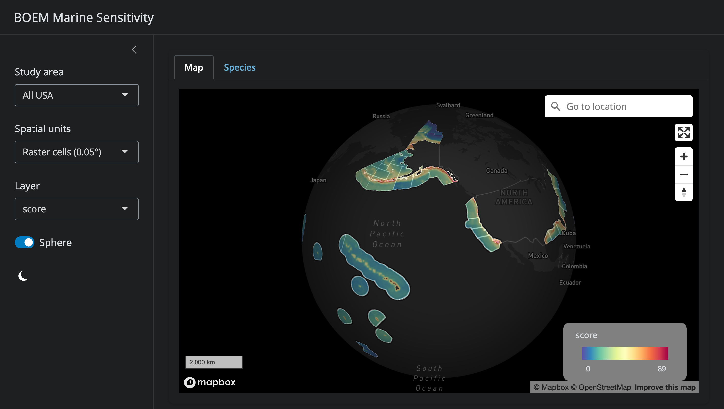
Figure B.1: The Scores application displaying cell-level sensitivity scores across US waters. The sidebar provides controls for study area selection, spatial resolution (raster cells vs. program areas), and layer choice. The globe view shows scores from 0 (blue) to 89 (red) with MapBox basemap.
Figure B.2 shows the flower plot panel that appears when a program area is selected. Here, the Southern California program area displays a weighted mean score of 29, with petals representing species categories (bird, coral, fish, invertebrate, mammal, other, turtle) and primary productivity.
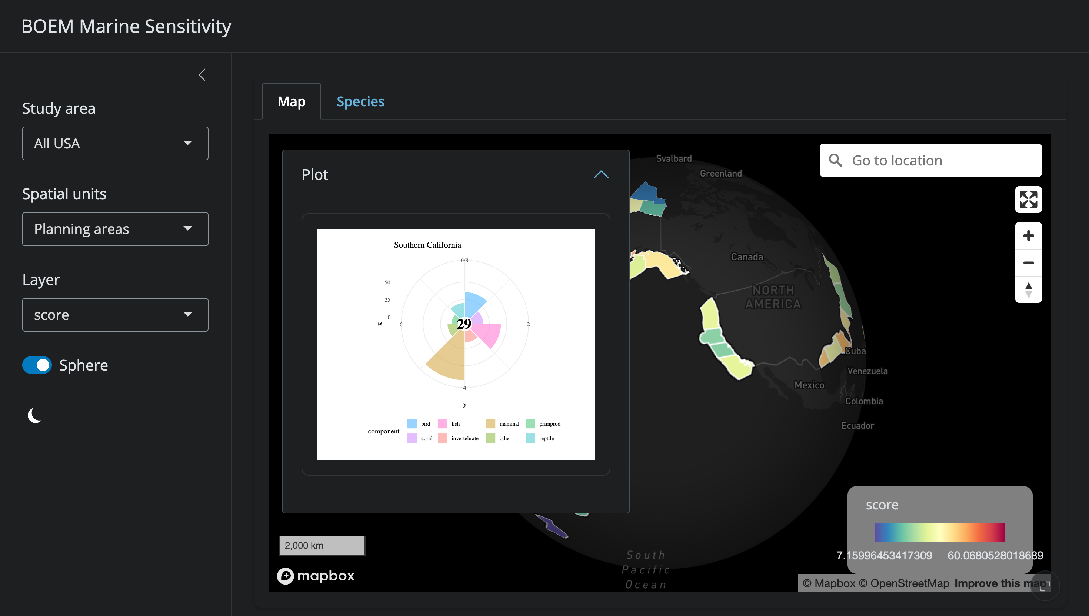
Figure B.2: The Scores application showing the flower plot panel for Southern California. Petal length represents each category’s rescaled sensitivity score; petal width represents its weight. The center value (29) is the weighted mean across all categories.

A.2 Features

A.2.1 Map Display
- Cell-level view: 0.05° grid cells colored by sensitivity score for the selected metric
- Program area view: aggregated scores by BOEM Program Area, with boundaries overlaid
- Base maps: multiple MapBox base layers (satellite, streets, light, dark)
- Study area selection: click a program area to focus the view and update summary panels

A.2.2 Sensitivity Metrics
The map can display any of the following layers:
- Composite extinction risk (weighted sum across all species categories)
- Individual category scores, one per scored species category in the release being viewed
- Primary productivity
All scores are ecoregionally rescaled to [0–100] for meaningful cross-region comparison (see Chapter 10).

A.2.3 Flower Plot
Selecting a program area displays a flower plot summarizing the sensitivity profile:
- Each petal represents a species category
- Petal length = rescaled sensitivity score (0–100)
- Petal width = category weight
- Center value = weighted mean across categories

A.2.4 Species Table
A sortable table of all valid species present in the selected area, showing:
- Scientific and common name
- Species category
- ESA listing, IUCN Red List status
- MMPA/MBTA protection flags
- Extinction risk score

A.2.5 Data Export
Users can download CSV files of scores and species lists for the selected program area or custom area of interest.

A.3 Generating Screenshots

A.4 Source Code
scores/app.R on the apps repository’s main branch. There is one checkout, not one per release: the version is data, resolved from the published manifest, so the per-version forks (mapgl, mapgl_v1…v6, scores_v6, scores_v8) were retired earlier; since the Atlas cutover they, the /v{n}/scores/ path and an older ?ver= deep link all redirect (HTTP 302) straight to the Atlas in one hop, a restricted release’s to its Atlas on the preview host.

Appendix B — Species — mapper of individual species distributions

Appendix B — Species

B.1 Overview
Retired
The Species Shiny app was retired in October 2026 when the Atlas (Chapter 21) became the project’s application; this page documents it as it was. Its URLs (app.marinesensitivity.org/{ver}/species/, the older ?ver=, mdl_key and mdl_seq forms) now redirect to the Atlas’s Species lens with the query carried, and its source stays in the apps repository.

The Species application (app.marinesensitivity.org/{ver}/species/) enabled exploration of individual species distribution models. Like the Scores app it rendered any published release from the URL path — /v3/species/ showed v3. Users could view merged and source-level models, compare masked vs. unmasked distributions, and access detailed species regulatory status information.
Figure D.1 shows the merged distribution model for the blue whale (Balaenoptera musculus). The map displays cell values from 1 (low suitability, blue) to 100 (high suitability, red) across all US program areas where the species occurs.
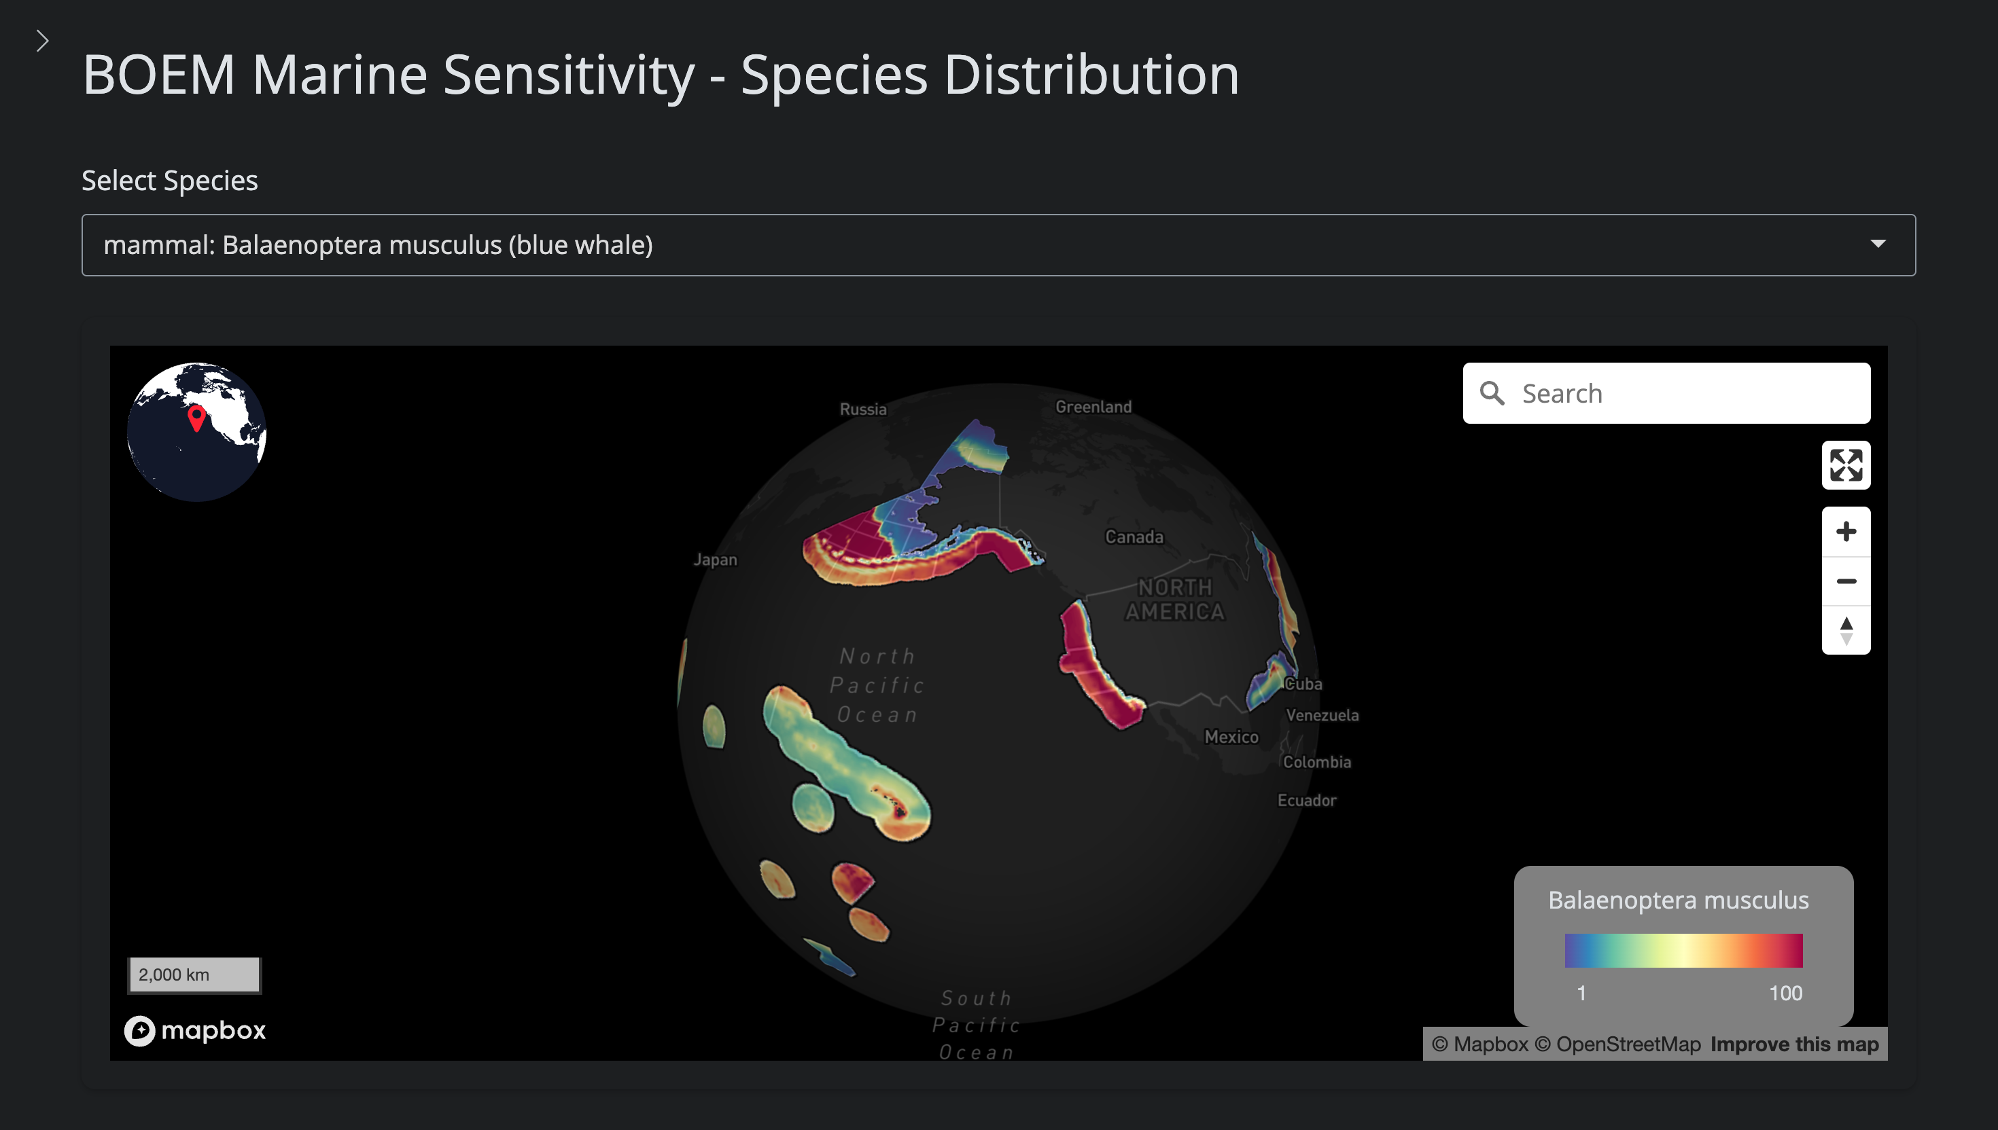
Figure D.1: The Species application showing the merged distribution model for blue whale (Balaenoptera musculus). Cell values range from 1 (low suitability) to 100 (high suitability). The species selector dropdown allows searching by common or scientific name with category prefix.

B.2 Features

B.2.1 Species Selection
- Search: find species by common name or scientific name
- Category filter: narrow results by species category, as defined in the release being viewed
- Alphabetical browsing: scroll through species lists within each category

B.2.2 Model Display
- Merged model: the final merged distribution showing MAX values across all source datasets, with masking and spatial floors applied
- Source datasets: toggle individual source layers (AquaMaps, NMFS CH, FWS CH, FWS Range, BirdLife, IUCN Range) to see each dataset’s contribution
- IUCN masking toggle: compare the unmasked AquaMaps SDM with the masked merged model to visualize the effect of range constraints

B.2.3 Species Info Panel
Detailed information for the selected species:
- Scientific name and common name
- Species category (bird, fish, mammal, etc.)
- ESA listing status (Endangered, Threatened, or not listed)
- IUCN Red List category
- MMPA protection flag
- MBTA protection flag
- Computed extinction risk score (1–100)
- Number of source datasets contributing to the merged model

B.2.4 Deep-Linking
The application supports URL parameters for direct linking to specific species, enabling bookmarking and sharing of specific views:
https://shiny.marinesensitivity.org/species/?species=Balaenoptera+musculus

B.3 Generating Screenshots

B.4 Source Code
species/app.R on the apps repository’s main branch — one checkout serving every release, not one per version.

Appendix C — Shiny Apps User Guide (retired)
Step-by-step walkthrough of the retired Scores and Species Shiny applications

Retired
The Scores and Species Shiny apps this guide walks through were retired in October 2026 when the Atlas became the project’s application; their URLs now redirect to the Atlas. The screenshots below were captured on 2026-06-05; the apps changed after that until their retirement, so they may differ in detail from the last build. They are kept as a record. For the current app see the Atlas user guide.

This guide walked through the two interactive Shiny applications — Scores (app.marinesensitivity.org/{ver}/scores/) and Species (app.marinesensitivity.org/{ver}/species/) — one control at a time. Each numbered step below mirrors a step in that app’s built-in Take a Tour (About → Take a Tour in either app), with the relevant control highlighted on the screenshot.
For a feature-by-feature reference instead, see the Scores and Species pages.
How this guide was generated
The steps, captions, and highlighted screenshots were generated directly from the apps’ in-app tours (the Conductor$new()$step(...) chains in each app.R) by libs/apps-guide-regenerate.R, which wrote figures/apps-guide/steps.json. The apps are retired and unreachable, so that script can no longer run and this page is frozen at the last capture.

C.1 Scores app

C.1.1 1. Study Area
Pick a region to focus on. ‘Full study area’ shows all US federal waters from the Aleutians to the Caribbean and out to the Pacific Island Territories. The other choices zoom into a single subregion.
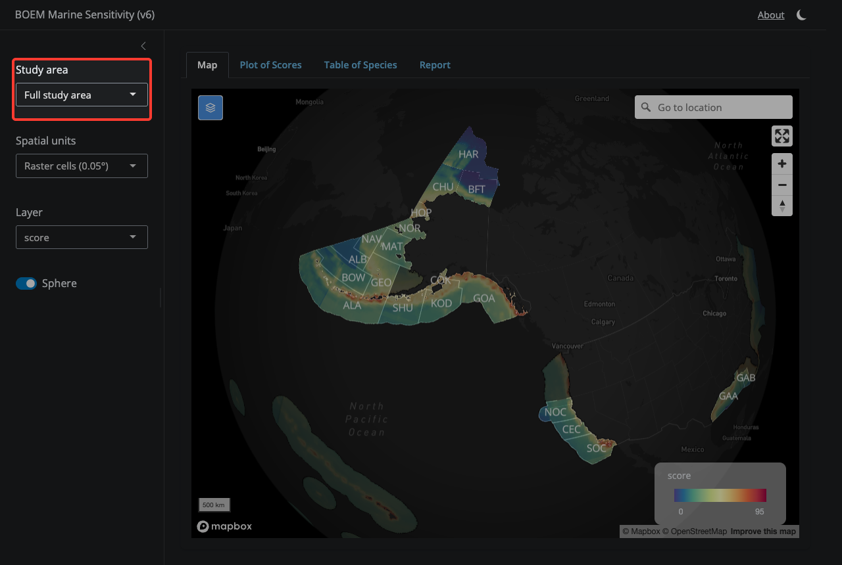
Figure E.1: Study Area

C.1.2 2. Spatial Units
Toggle between fine-grained raster cells (0.05°) and aggregated BOEM Program Area polygons. Cell mode lets you click any pixel; Program Area mode shows pre-aggregated zone scores.
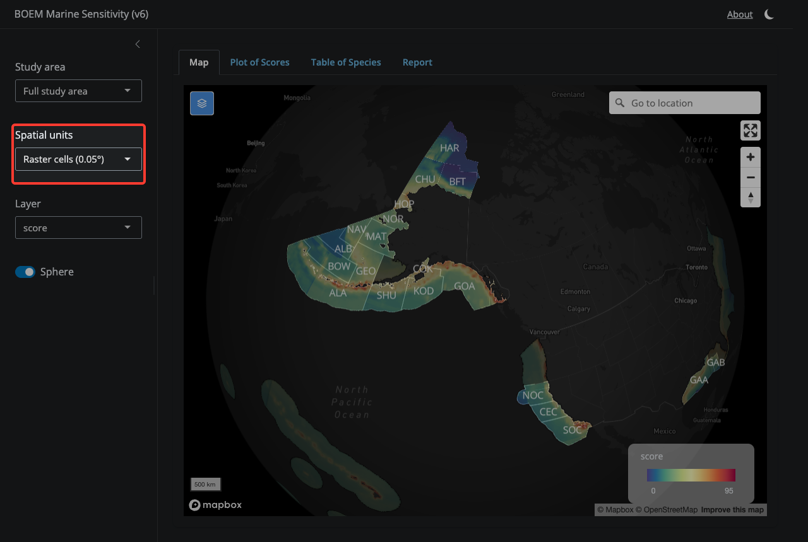
Figure E.2: Spatial Units

C.1.3 3. Layer Selection
Choose which sensitivity metric to display — composite score, individual species categories (bird, fish, mammal, etc.), or primary productivity. Note that some cells (Atlantic, Gulf of America, Hawaii, Puerto Rico, Pacific Islands) have scores but lie outside any v6 BOEM Program Area; they appear dimmed under a ‘Cells outside Program Areas’ overlay.
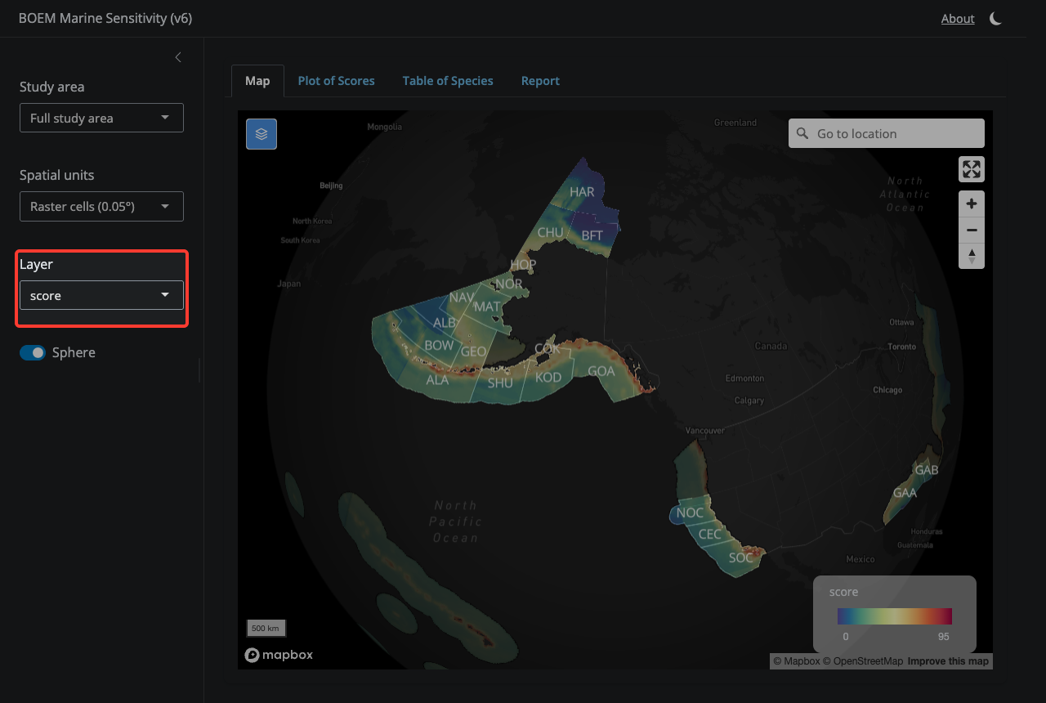
Figure E.3: Layer Selection

C.1.4 4. Map tab
The Map tab is where you explore scores spatially — click cells or click Program Areas to see their scores.
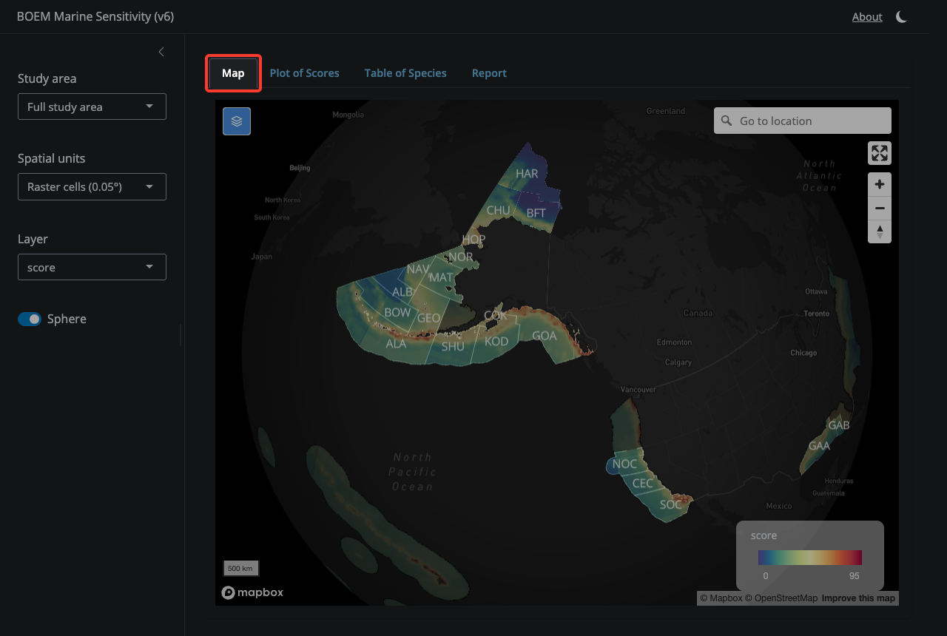
Figure E.4: Map tab

C.1.5 5. Layers control
Toggle individual map layers on and off — program area outlines, ecoregion outlines, raster cells, and the gray ‘Cells outside Program Areas’ overlay.
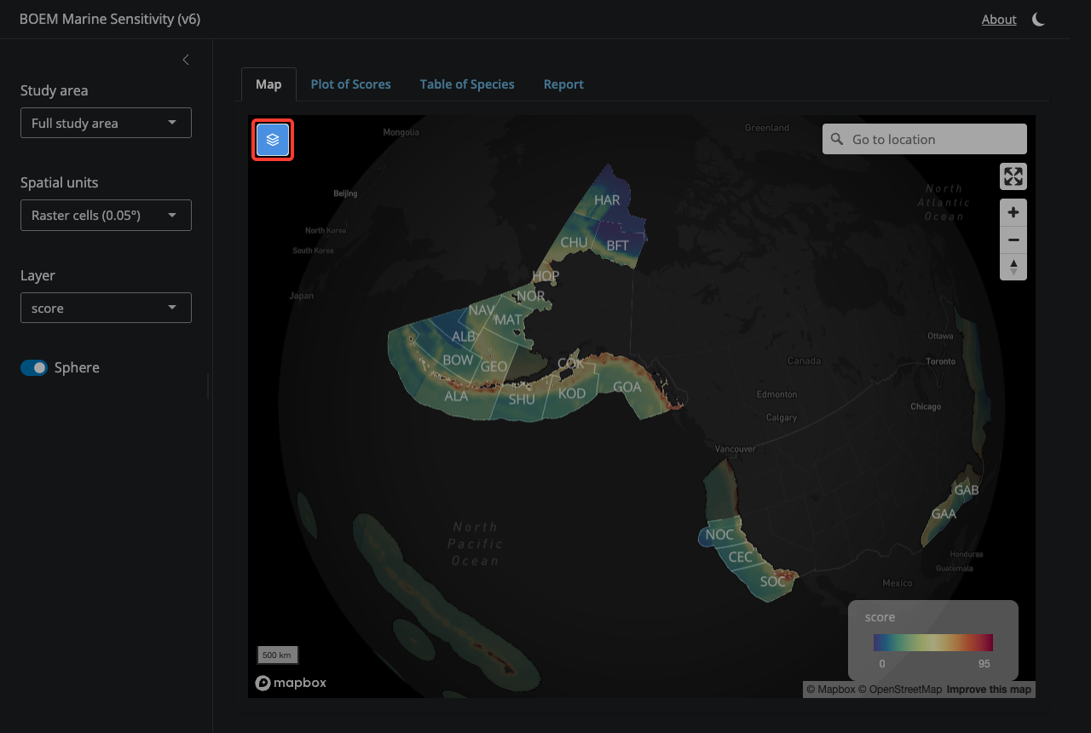
Figure E.5: Layers control

C.1.6 6. Go to location
Search for a place name and the map will fly there — useful for jumping to a specific Program Area, port, or feature.
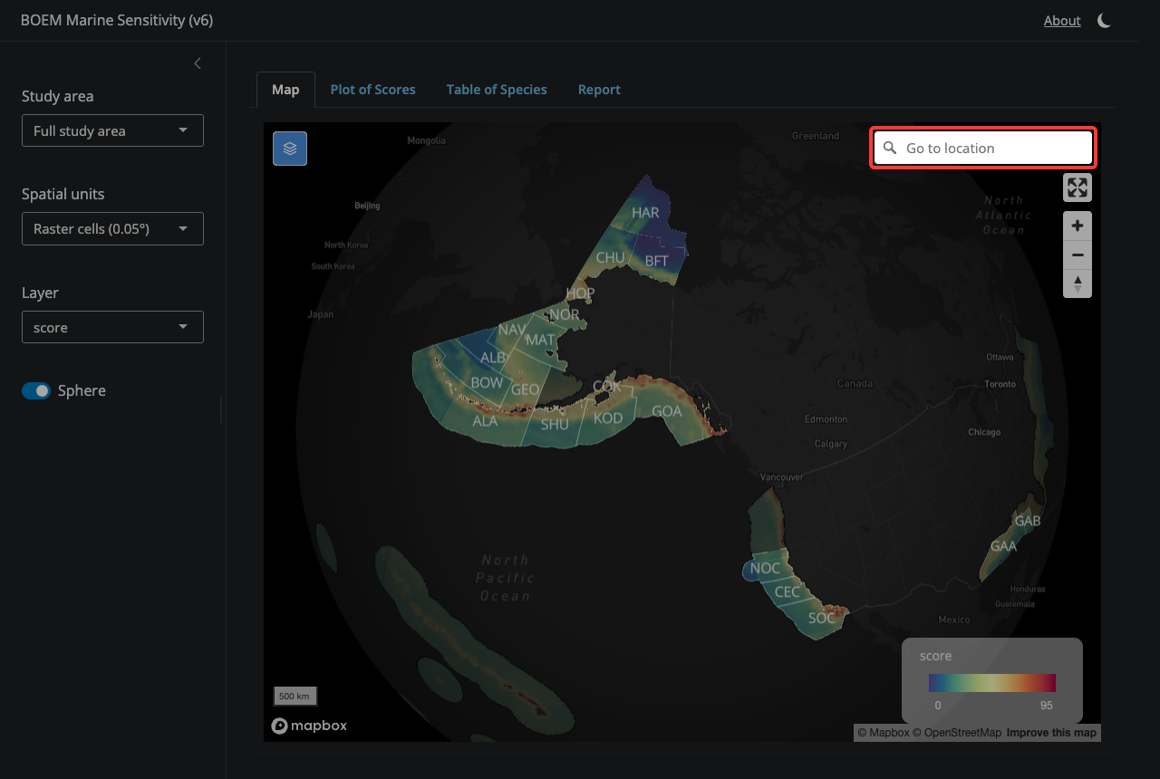
Figure E.6: Go to location

C.1.7 7. Full screen
Expand the map to fill the entire window.
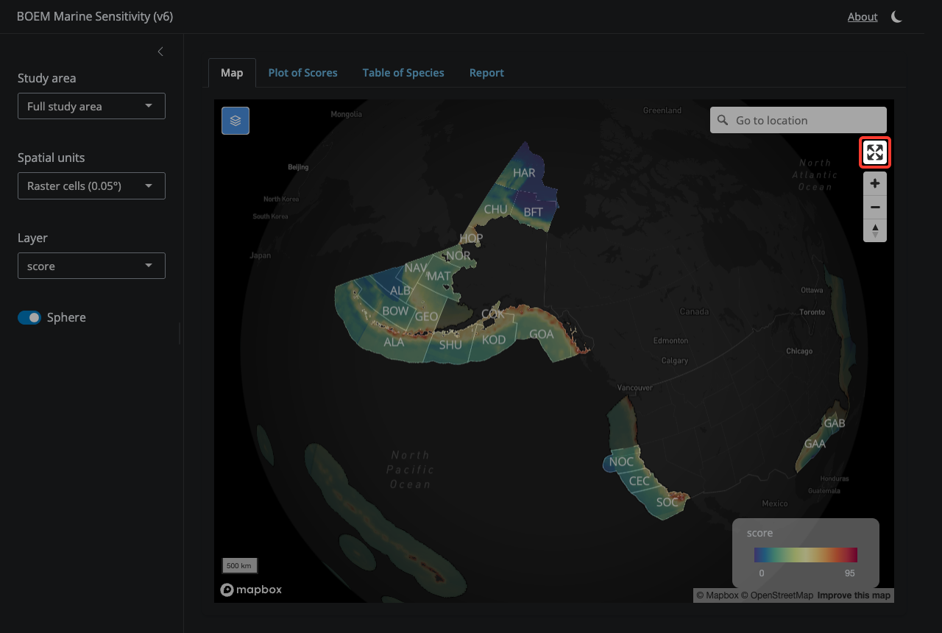
Figure E.7: Full screen

C.1.8 8. Zoom in / out
Zoom and reset the view. You can also use the mouse wheel, pinch gesture, or double-click.
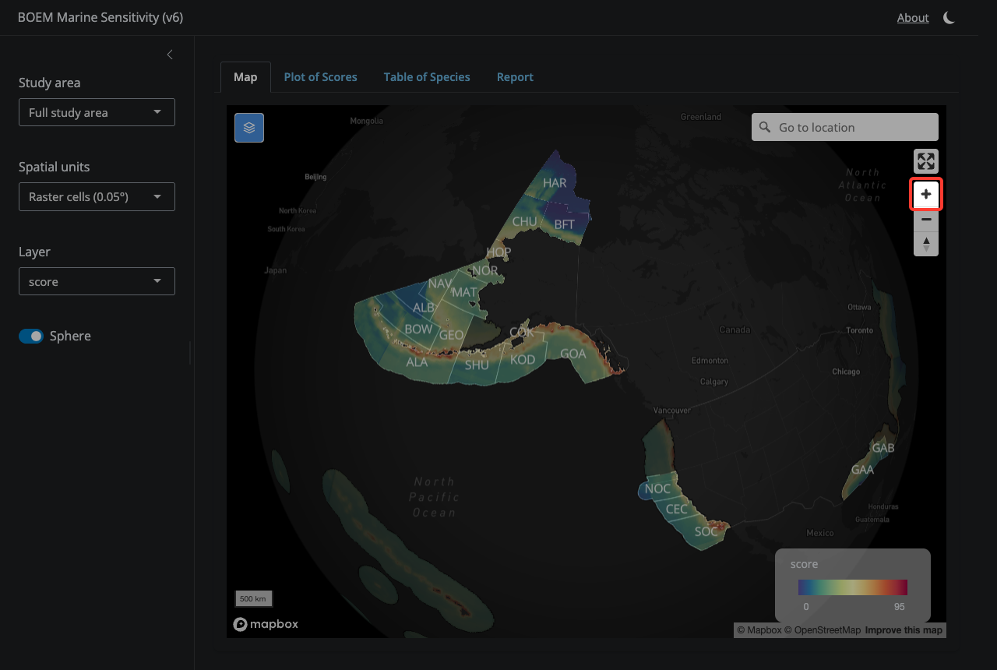
Figure E.8: Zoom in / out

C.1.9 9. Plot of Scores tab
Switch here to see the flower plot of aggregated sensitivity scores for the current selection, broken out by species category. Petal length = score (0–100); center number = weighted mean. Defaults to ‘All USA’ until you click a cell or click a Program Area.
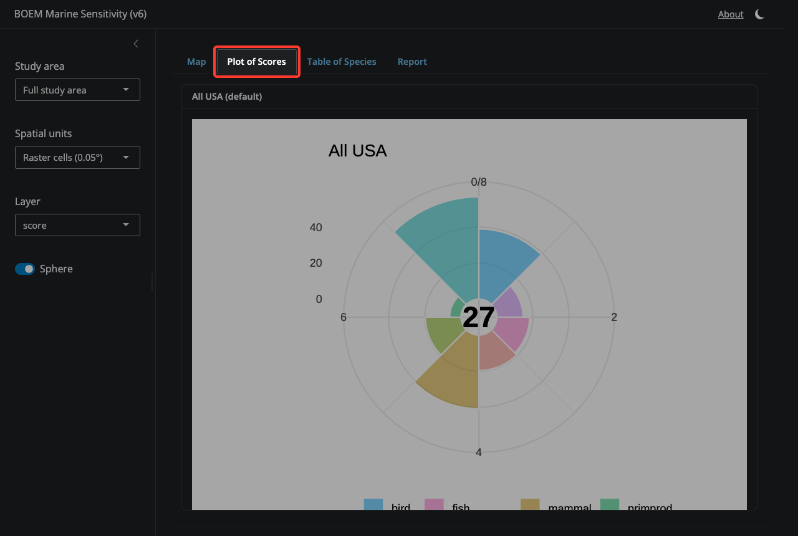
Figure E.9: Plot of Scores tab

C.1.10 10. Table of Species tab
A sortable, downloadable table of every species in the currently selected area, with extinction-risk codes, areas, and per-category contributions.
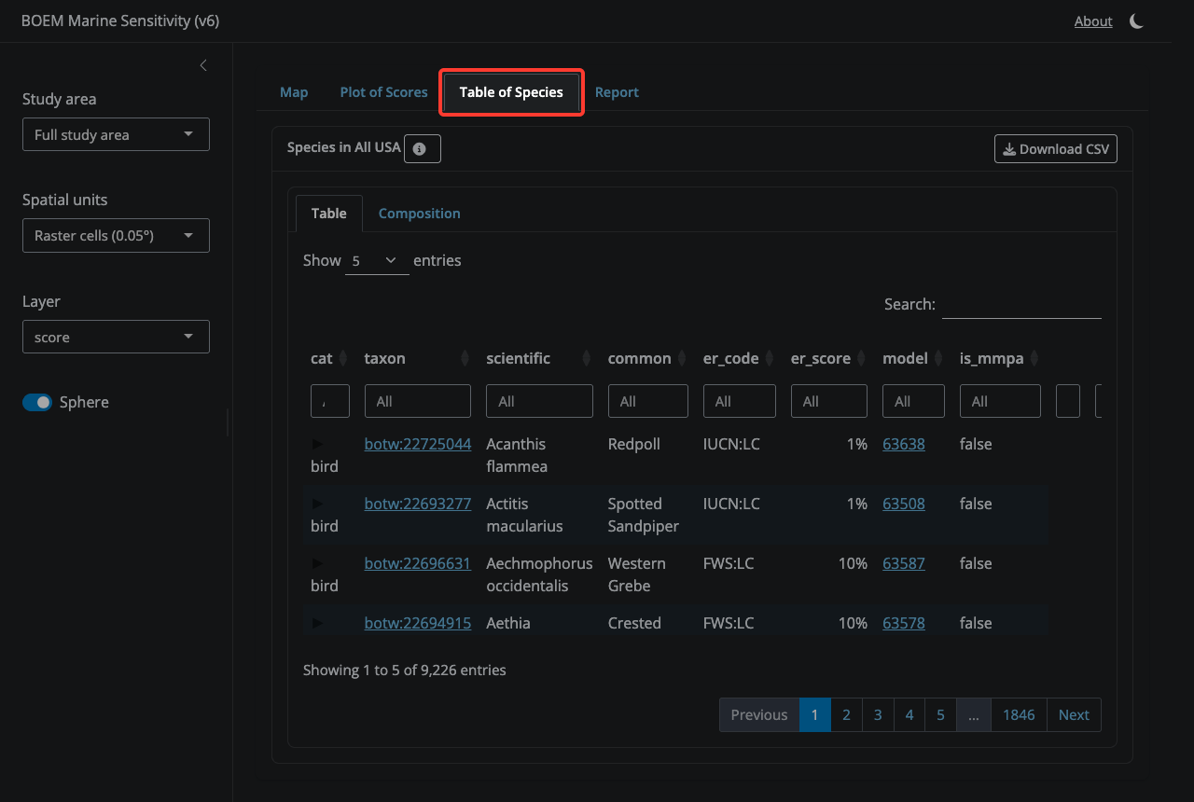
Figure E.10: Table of Species tab

C.1.11 11. Report tab
Generate a sensitivity report for one or more custom areas. Build up a list of labeled areas by drawing a polygon on the map (using the polygon tool) and/or by selecting a Program Area, then clicking ‘Add’ for each. Set a title, data version, and output format (HTML, Word, or PDF), then click ‘Generate report’.
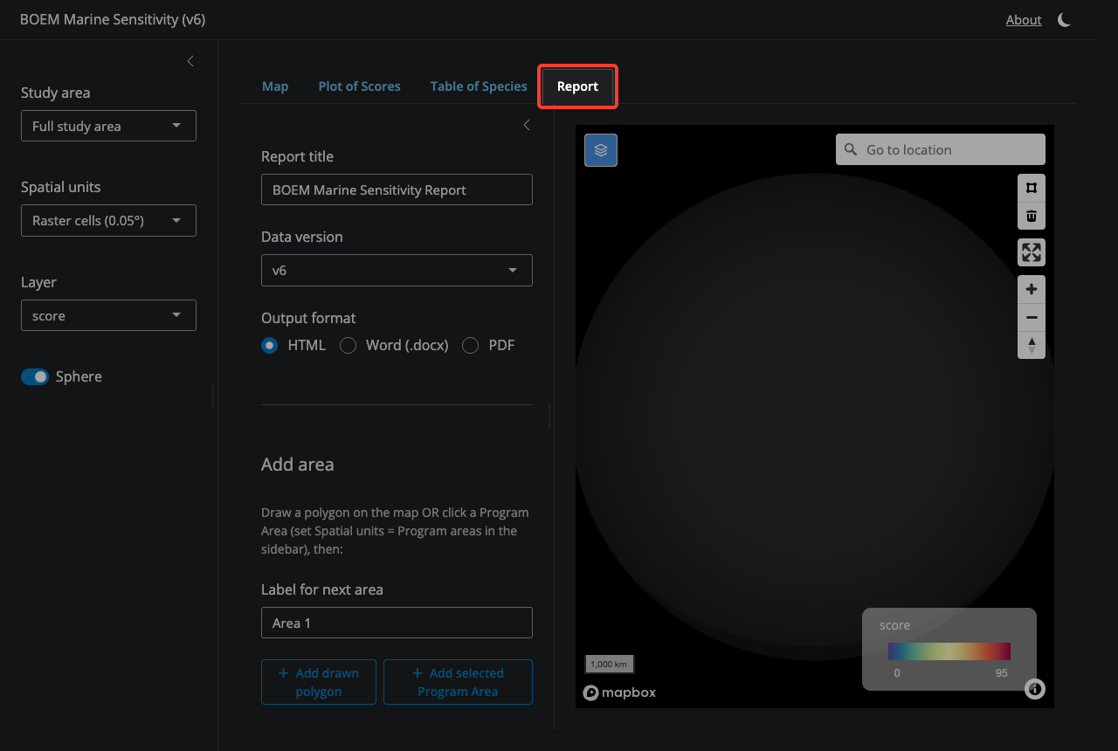
Figure E.11: Report tab

C.2 Species app

C.2.1 1. Select a Species
Search by common or scientific name. Results are grouped by category (bird, fish, mammal, etc.).
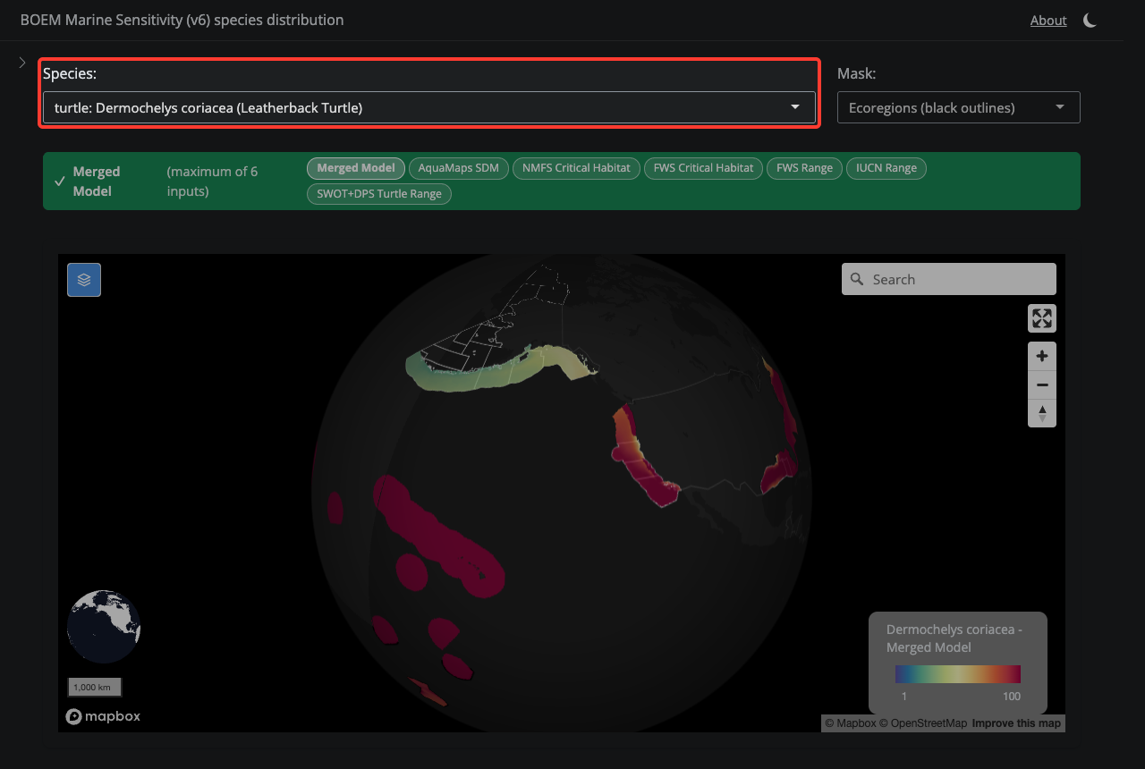
Figure E.12: Select a Species

C.2.2 2. Mask Selection
Choose whether to overlay BOEM Program Area or Ecoregion boundaries on the map.
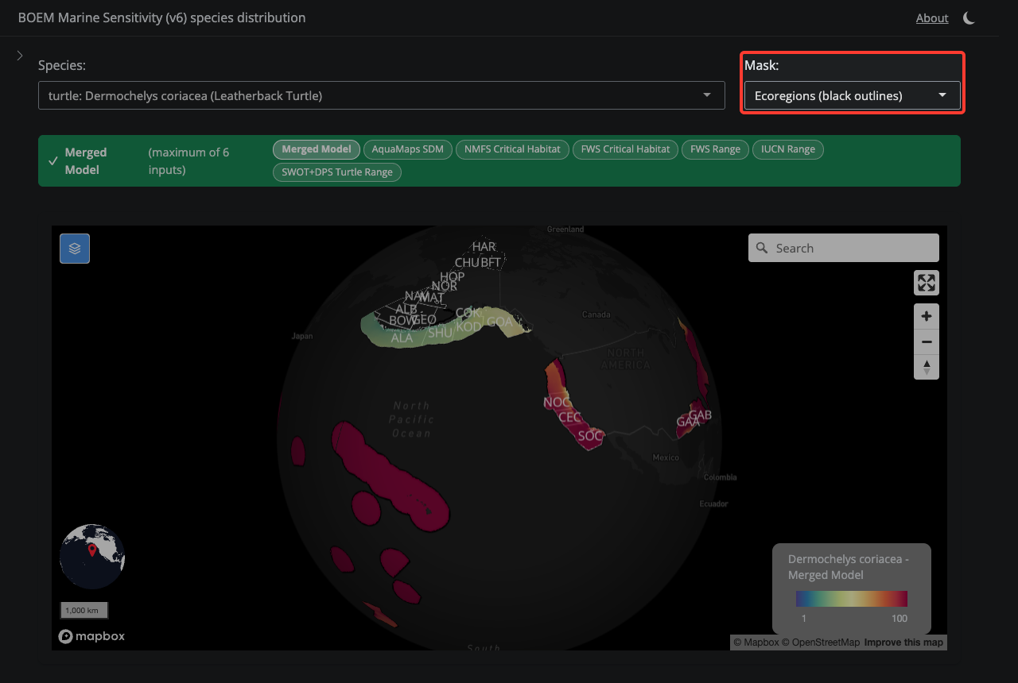
Figure E.13: Mask Selection

C.2.3 3. Layer Selector
The colored bar shows which model layer is displayed. Green means the final Merged Model; orange means you are viewing a single input. Click the pills to switch layers.
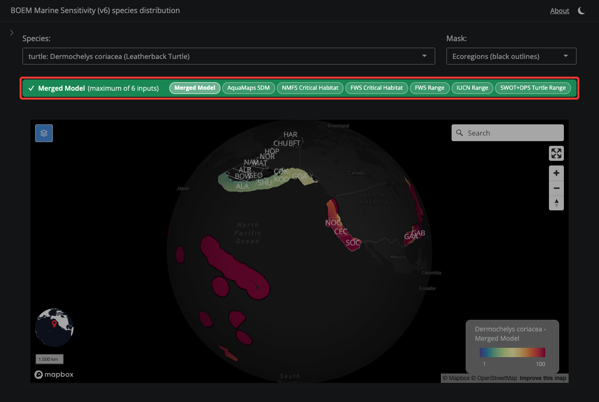
Figure E.14: Layer Selector

C.2.4 4. Species Map
The map shows the species distribution model. Cell values range from 1 (low sensitivity) to 100 (high sensitivity). Click cells for details.
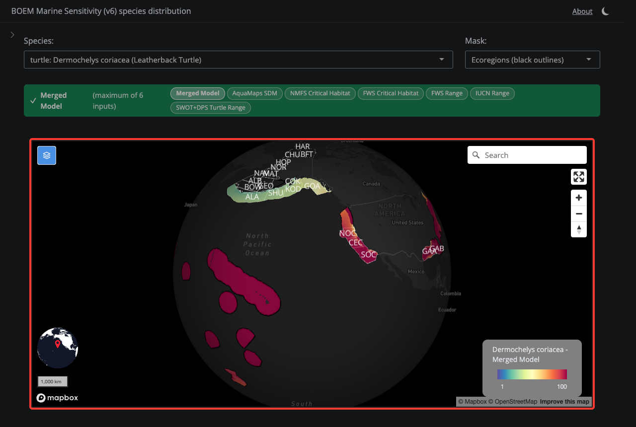
Figure E.15: Species Map

C.2.5 5. Species Info
Open the sidebar to see ESA listing, IUCN status, MMPA/MBTA flags, and extinction risk score for the selected species.
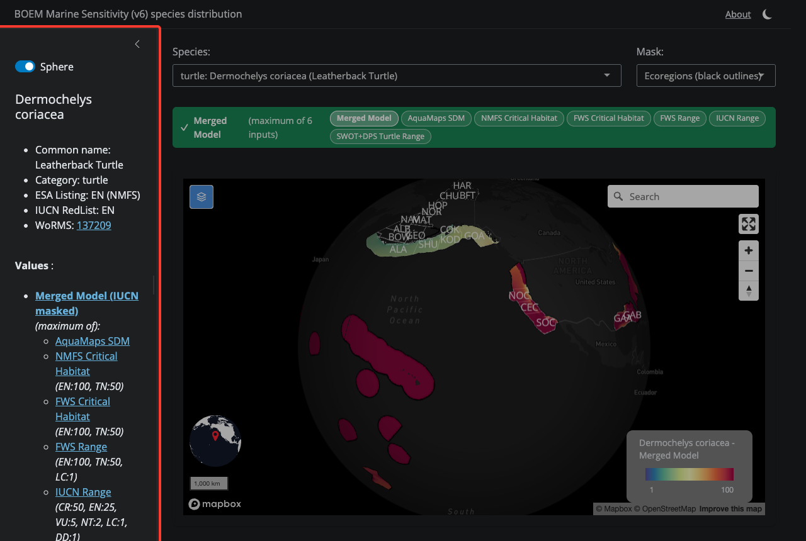
Figure E.16: Species Info

Areas of Interest
Map high resolution Areas of Interest (using vector tiles) for visualization (and later summarization).
- website
- code
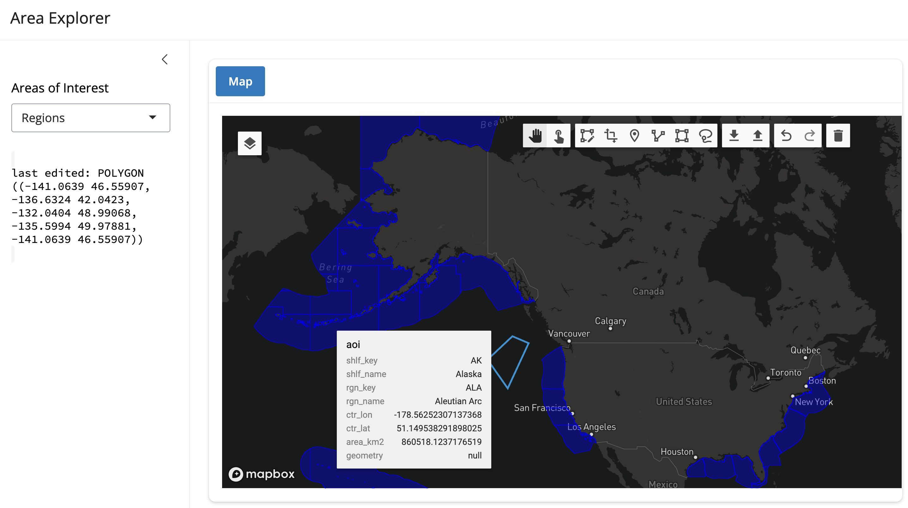

Bird Hotspots
Bird hotspots application showing hotspot probability for species present given drawn Area of Interest.
- website
- code
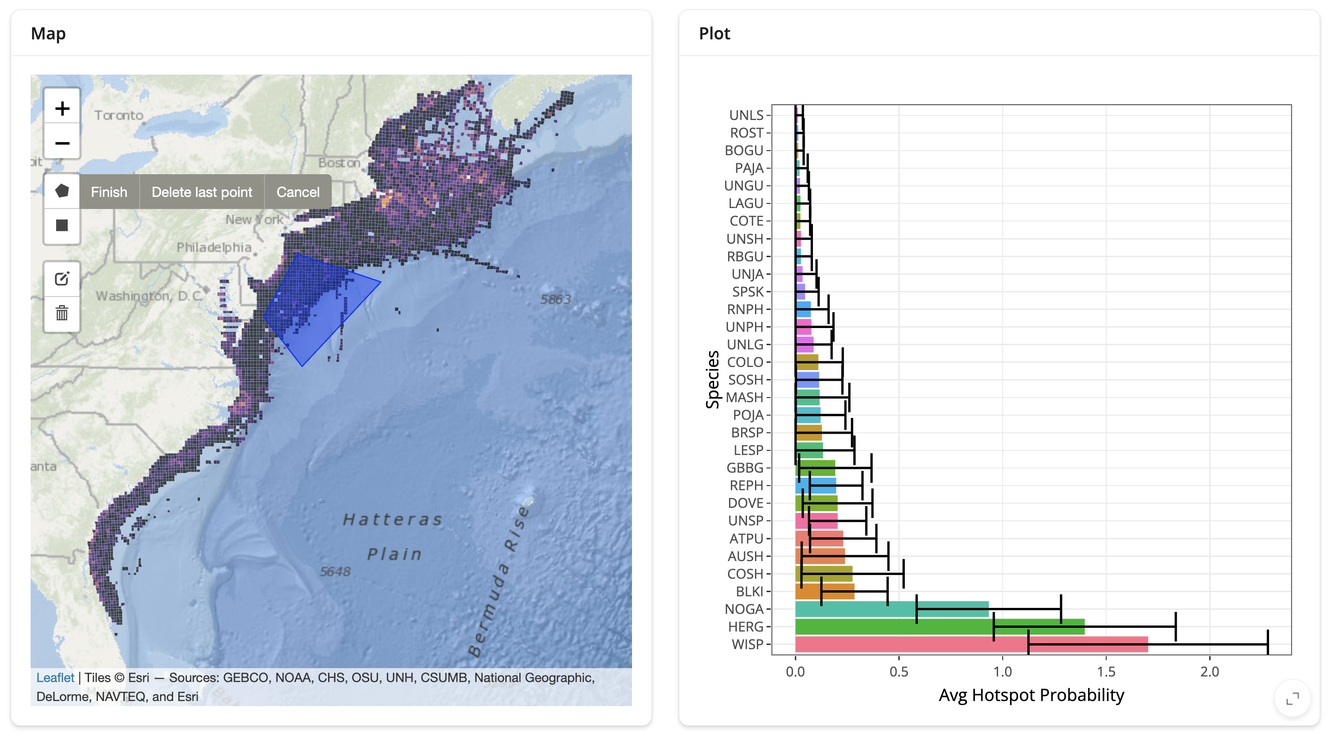

Regional Map
Basic interactive map of BOEM regions.
- website
- code
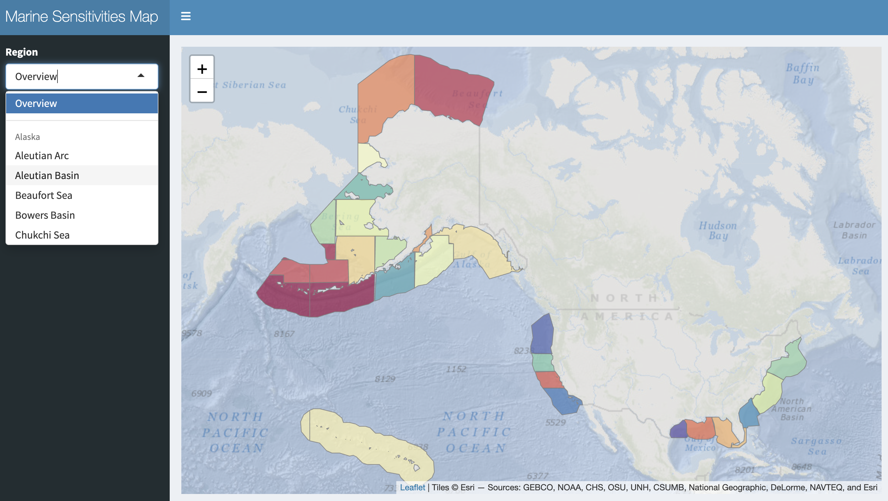

Scores Explorer
Calculate scores based on sensitivity metric – for now, extinction risk across taxonomic groups.
- website
- code
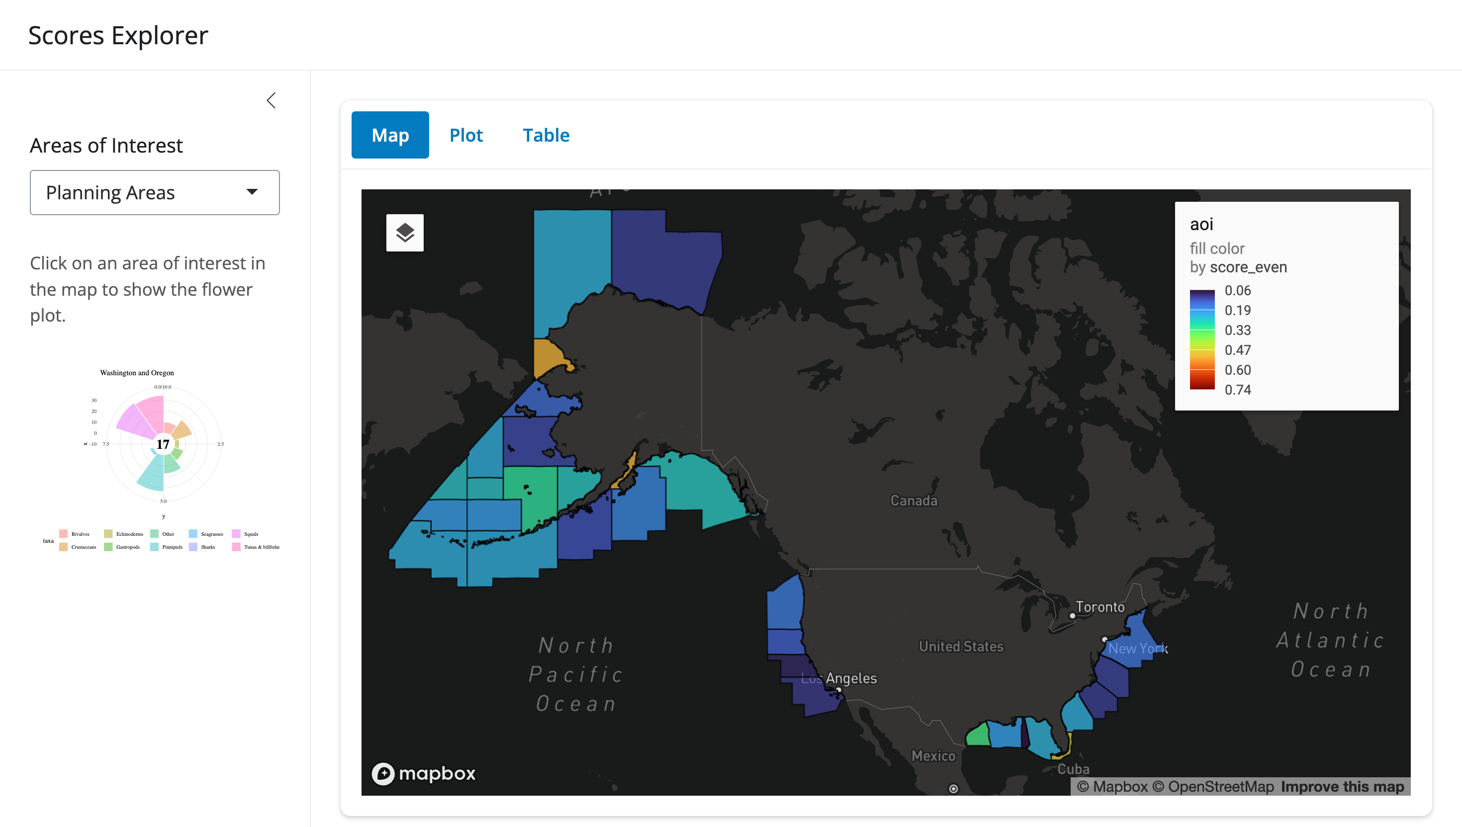

Distributions, Vector
Show species distributions with high resolution vectors (as vector tiles).
- website
- code
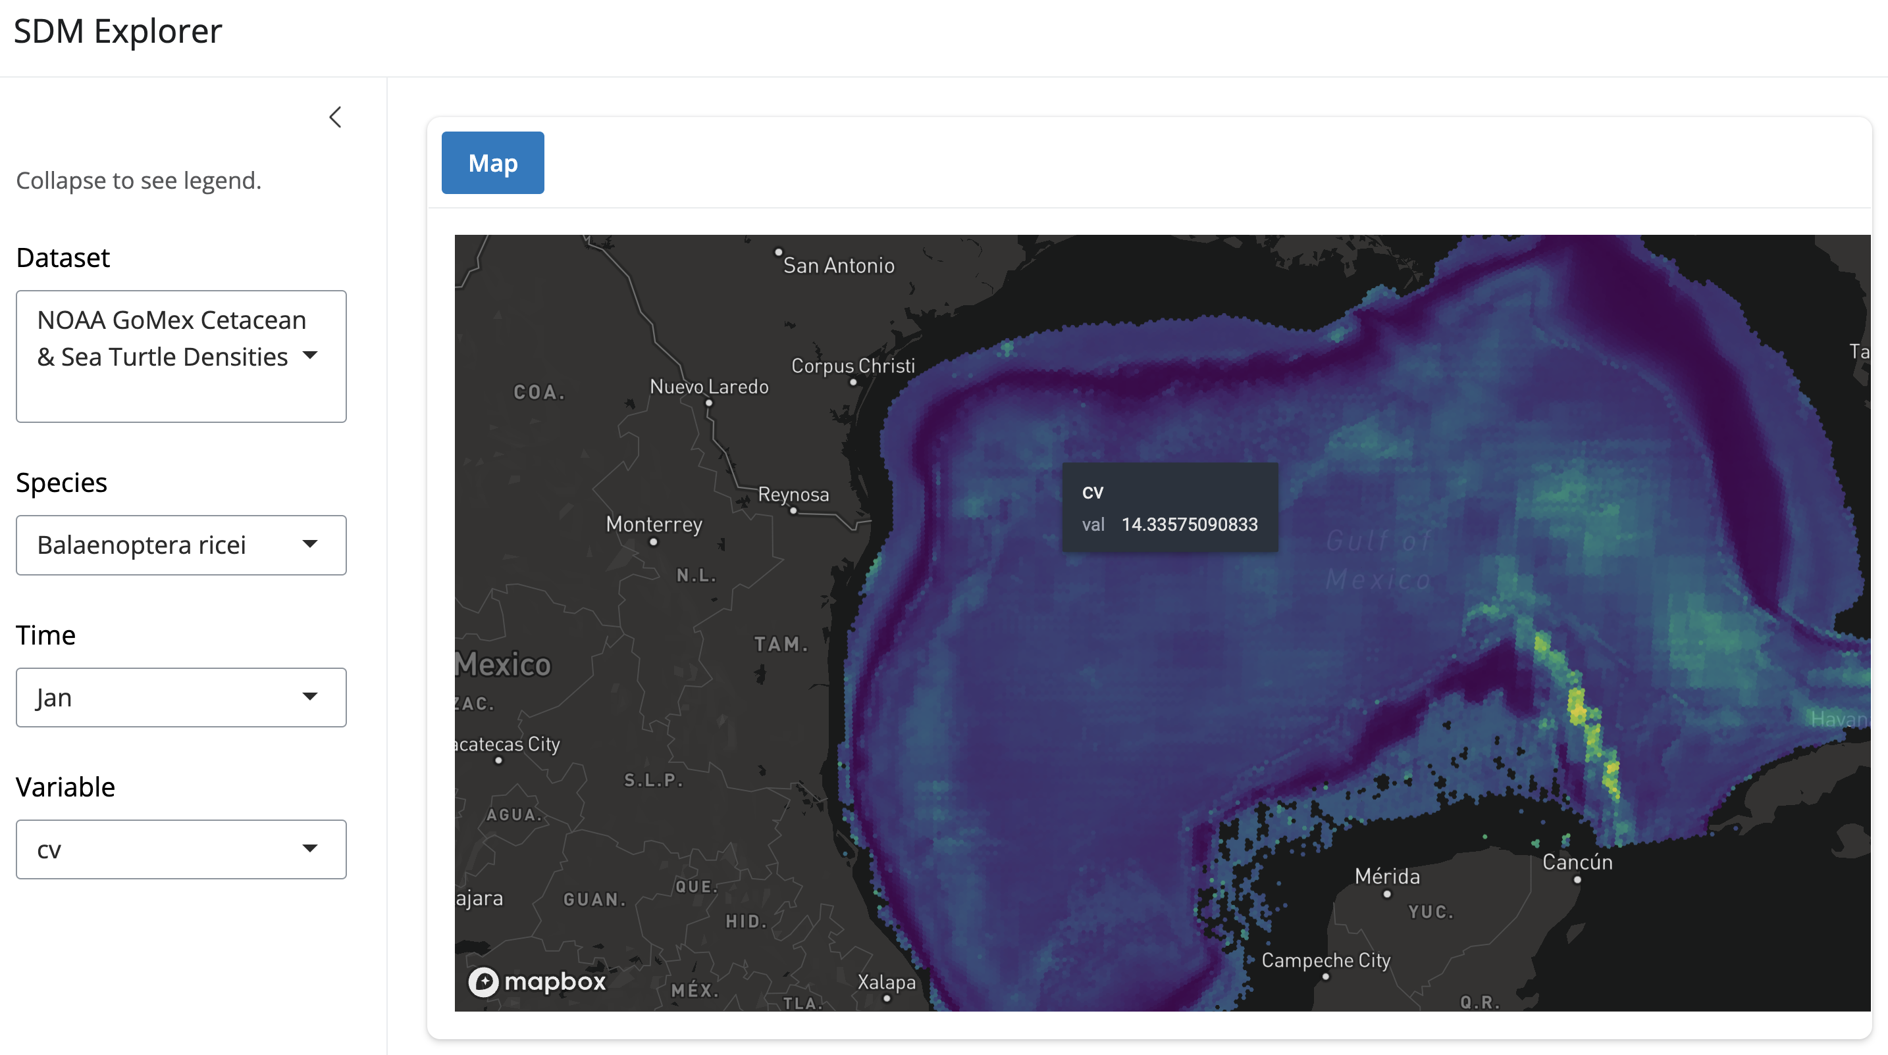

Distributions, Raster
Show species distributions with high resolution rasters as cloud-optimized GeoTIFFs (COGs).
- website
- code
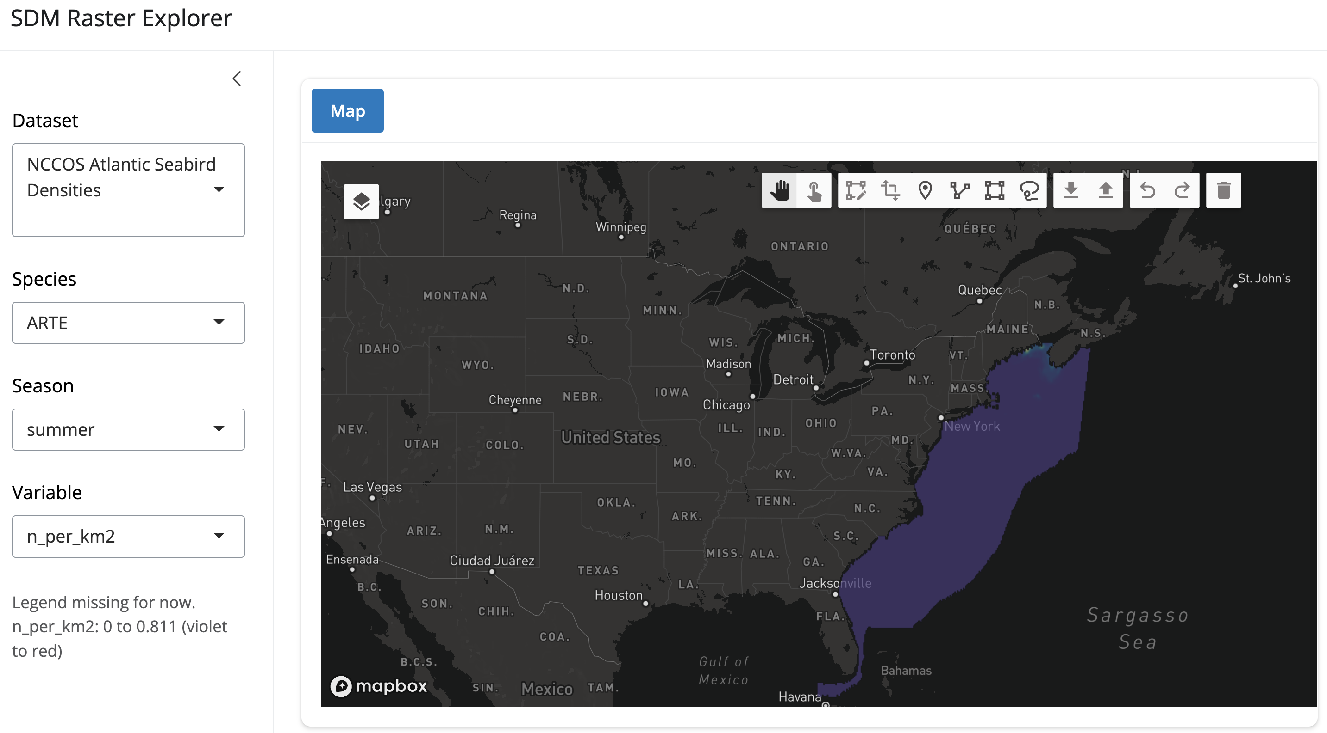

Vulnerability Mapper
Combine species distribution models (raster) and vulnerability metrics (tables) to identify areas of high conservation concern.
- website
- code
