Marine Sensitivity
  - Project Documentation
Ben Best
2024-09-16
Table of contents

Preface
This is a Quarto book.

1. Introduction
This Marine Sensitivity (MS) project of BOEM seeks to assess the sensitivity of marine species to offshore energy development, whether oil & gas or wind. By combining the best available species distributions with known species sensitivities we can map out areas of the ocean that are most vulnerable to human activities. This information can be used to inform decisions about where to place energy infrastructure and/or implement mitigations to minimize impacts on the marine environment.
This is a process, not a product. Information is imperfect, especially given the large expanse of US waters. Distributions and abundance of species change, modified increasingly by climate change and human activities. Knowledge on species sensitivities continues to expand with more research. And finally the methods for both modeling and distributing all this information continue to improve. We aim to provide a transparent and reproducible process that can be regularly updated as new data and methods become available.
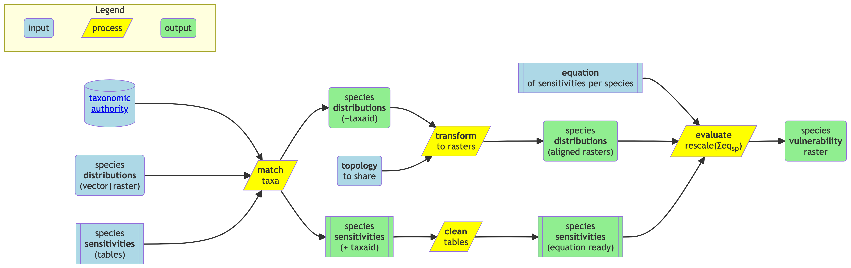
Figure 1.1: Flowchart of process for incorporating marine species sensitivities with distributions and generating a holistic vulnerability map.

2. Science
The term vulnerability ($V$) is a function of exposure ($E$), sensitivity ($S$) and adaptive capacity ($A$).
$$V=f\left(E,S,A\right) \left(2.1\right)$$
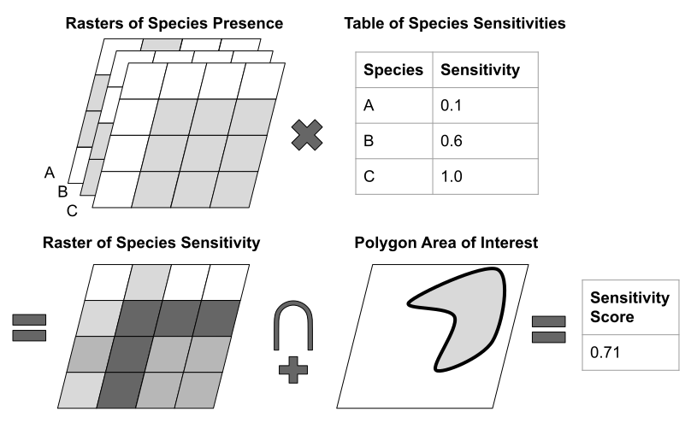
Figure 2.1: Overview of process.
cellS=spp​p*w 2.2
The raster of sensitivity ($S$) contains cells representing a sum across species ($spp$) of presence ($p$) multiplied by the sensitivity weight ($w$) (Equation 2.2).

3. Stressors

3.1 Offshore Wind Energy
Evaluation of stressors from the offshore wind industry needs to be evaluated based on human activities given the phase of development, whether pre-construction, construction, operation or decommissioning (Figure 3.1).
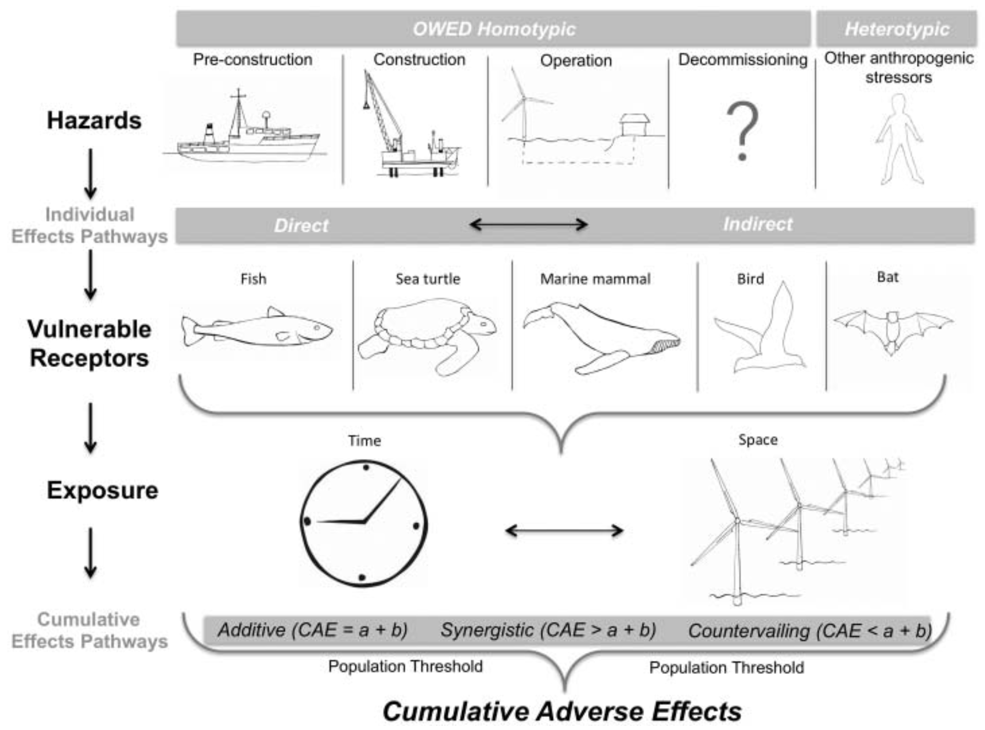
Figure 3.1: Cumulative adverse effects of offshore wind energy development on wildlife (Goodale and Milman 2016).

3.2 Oil & Gas

4. Receptors
Receptors are the species and habitats that are potentially impacted by the human activity.

4.1 Corals

4.2 Invertebrates

4.3 Fish

4.4 Marine Mammals

4.5 Seabirds

4.6 Sea Turtles

5. Exposure
Cumulative exposure (Figure 3.1) is important for understanding impacts to a population.

6. Software

6.0.1 Interactive Applications
We have developed a series of interactive applications to explore the data and results of the MS project. These applications allow users to visualize the data, explore the results, and interact with the data in a more intuitive way. The applications are built using the shiny package in R, which allows us to easily create a user interface with complex reactivity for an interactive web application easily accessed through a web browser. The applications are designed to be user-friendly and intuitive, with interactive maps, charts, and tables that allow users to explore the data in a more dynamic way.

6.0.2 Overcoming Challenges with Large Spatial Data
The MS project incorporates many large spatial datasets that are problematic to render in a typical interactive application. For instance, the most common interactive mapping R package leaflet has a 4MB limitation for displaying rasters (see “Large Raster Warning” in Raster Images • leaflet). Vectors (i.e., points, lines and polygons) get smoothed when containing many vertices, but contiguity gets lost between polygons and rendering degrades to non-usable depending on the internet speed of the user’s connection.
To work around these limitations, we have implemented “cloud native” web services and formats (see also Cloud-Optimized Geospatial Formats Guide). Our implementations effectively reduce the size of any given spatial object based on the zoom level of the user’s browser. For rasters, we use cloud-optimized GeoTIFFs (COGs) and for vectors, we use Mapbox Vector Tiles (MVT). These formats are designed to be fast and efficient for web mapping applications, and they allow us to display large spatial datasets in an interactive web application without sacrificing performance or usability. Let’s take a closer look at implementation of each.

6.0.2.1 Raster: Cloud-Optimized GeoTIFFs (COGs) and Titiler
Historically, to read a raster, such as a GeoTIFF, from the web, the client software would have to read the entire file before rendering. Cloud Optimized GeoTIFFs (COGs) take advantage of HTTP GET range requests to read only the part of the file needed for rendering. So a COG stores quadtree simplifications of the original raster at multiple zoom levels and metadata for accessing their byte ranges in the file in the metadata header. This allows the client software to request only the parts of the file needed for rendering, which can greatly reduce the amount of data transferred and speed up rendering. This is for accessing the raw data in pixel values, e.g., for a raster of species distribution then the abundance of a species in each cell. We would want to also apply a color ramp to visualize the data. The open-source (TiTiler software is a lightweight web service that serves up these color ramped tiles on the fly. So COGs can be stored on a simple file server (like Amazon S3 or Azure Blob Storage) and served up as interactive web maps with TiTiler as an intermediary between the COG files and the client accessing the interactive Shiny mapping app (Figure 6.1).
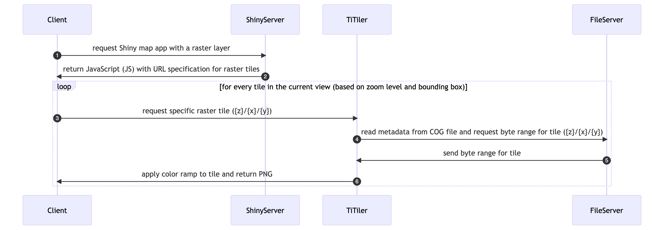
Figure 6.1: Sequence diagram implementing large raster interactive display using Cloud-Optimized GeoTIFFs (COGs) and Titiler in a Shiny mapping app.

6.0.2.2 Vector: Mapbox Vector Tiles (MVTs) and pg_tileserv
Although “cloud native” vector formats exist for simple file storage (see Cloud-Optimized Geospatial Formats Guide), none of these allow for flexible filtering and manipulation. Instead, we use PostgreSQL with the spatial extension (PostGIS) to store the vector data and serve it as Mapbox Vector Tiles (MVTs) using the pg_tileserv web service written in the language Go, which is very fast. This means that we don’t have to pre-render the MVTs (such as you might do with tippecanoe), but can instead serve the raw vector data directly from the database and let pg_tileserv handle the rendering on the fly. Filters (in the form of CQL) can be applied to the request. Symbology is rendered client-side via JavaScript, which allows for interactive hover and click events on vector objects (e.g., BOEM aliquot). Some speed-up is enabled by implementing a Varnish cache service in between. We can even write our own database functions for customized rendering, such as H3 hexagonal summaries. This allows us to serve vector data as web maps with minimal configuration and setup, and it provides a fast and efficient way to display large vector datasets in an interactive web application (Figure 6.2).
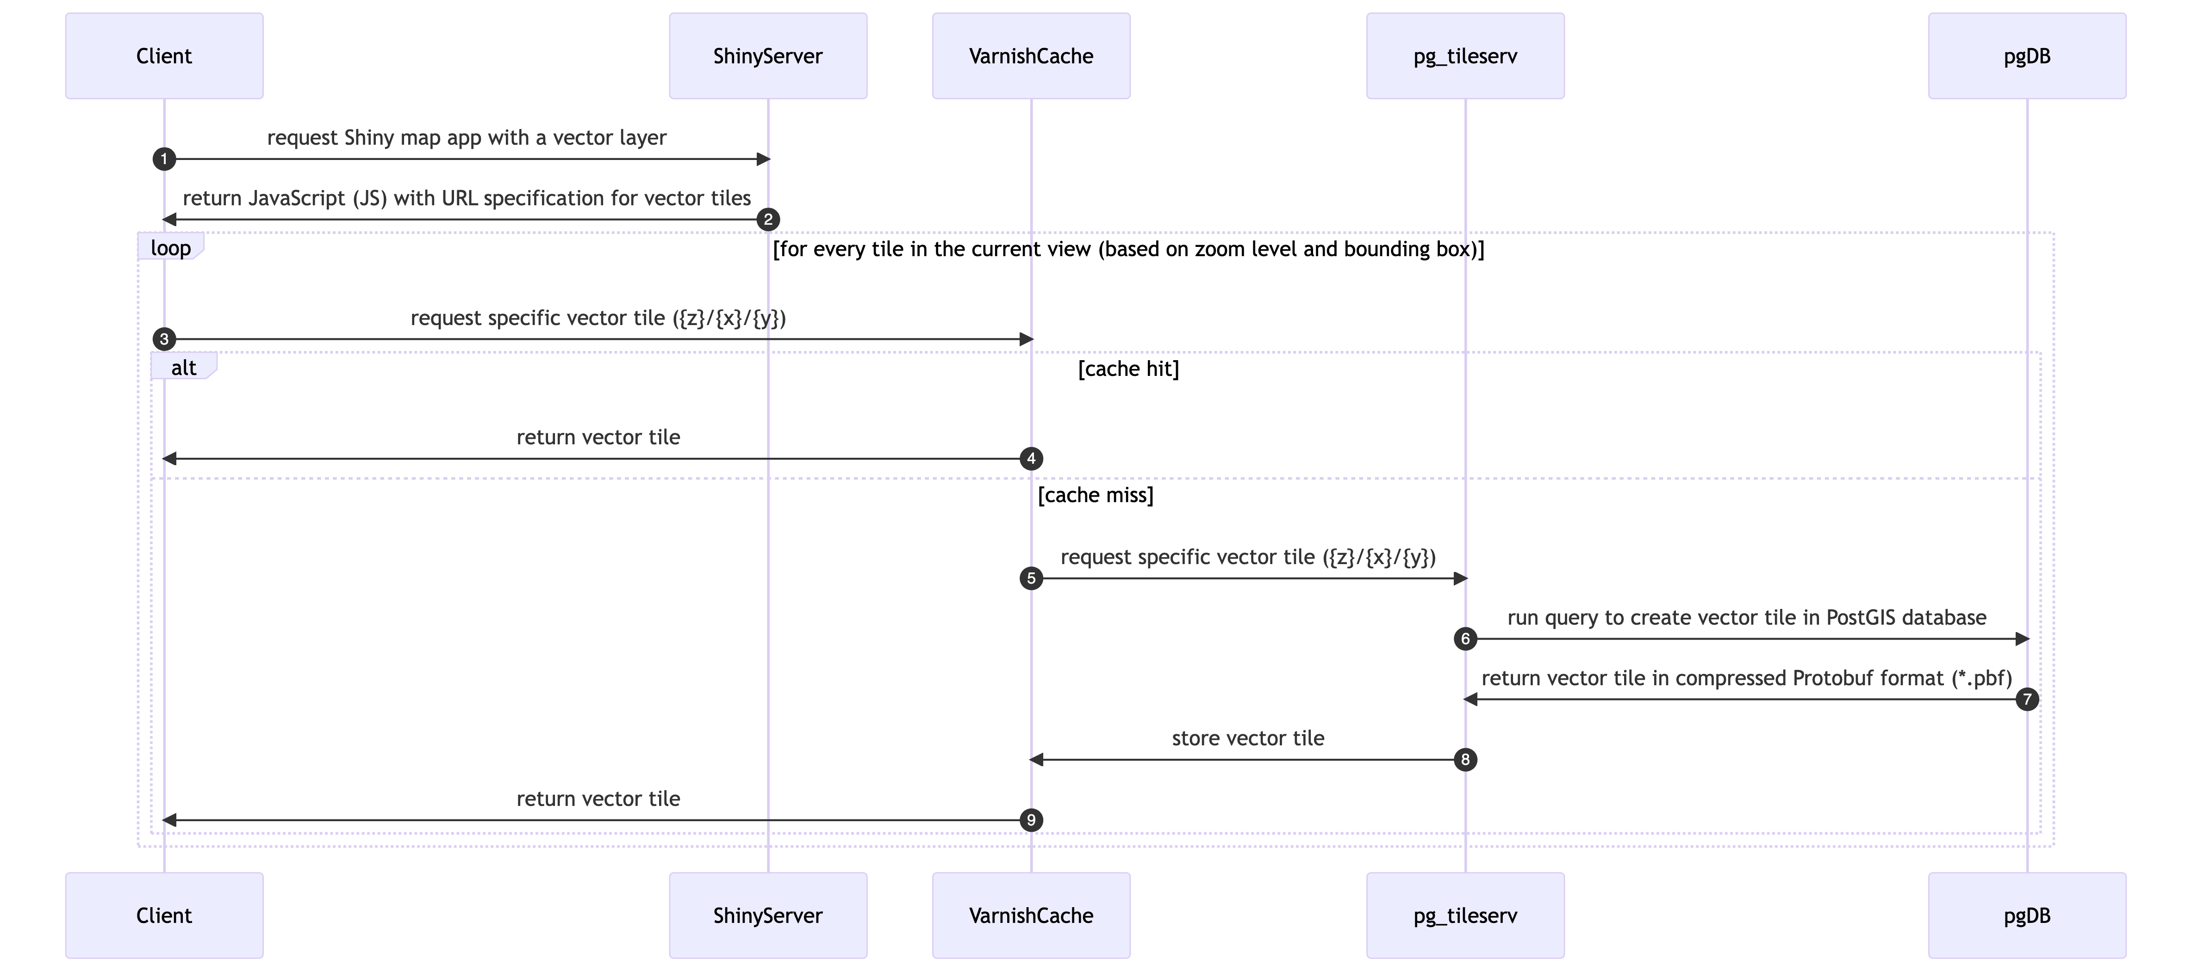
Figure 6.2: Sequence diagram implementing large vector interactive display using Mapbox Vector Tiles (MVTs) and pg_tileserv in a Shiny mapping app.

6.0.3 Github Repositories
repo | description
api | application programming interface (API) using R Plumber package
apps | Shiny applications
docs | documentation for BOEM’s offshore environmental sensitivity index products
manuscripts | Manuscripts with review of sensitivities by industry and receptors (species, habitats, human uses)
MarineSensitivity.github.io | default website
msens | R library of functions for mapping marine sensitivities, sponsored by BOEM
objectives | repository for issues spanning multiple repositories and doing big picture roadmapping
server | server setup for R Shiny apps, RStudio IDE, R Plumber API, PostGIS database, pg_tileserv
workflows | scripts for testing data analytics and visualization as well as production workflows

6.0.4 Software Components
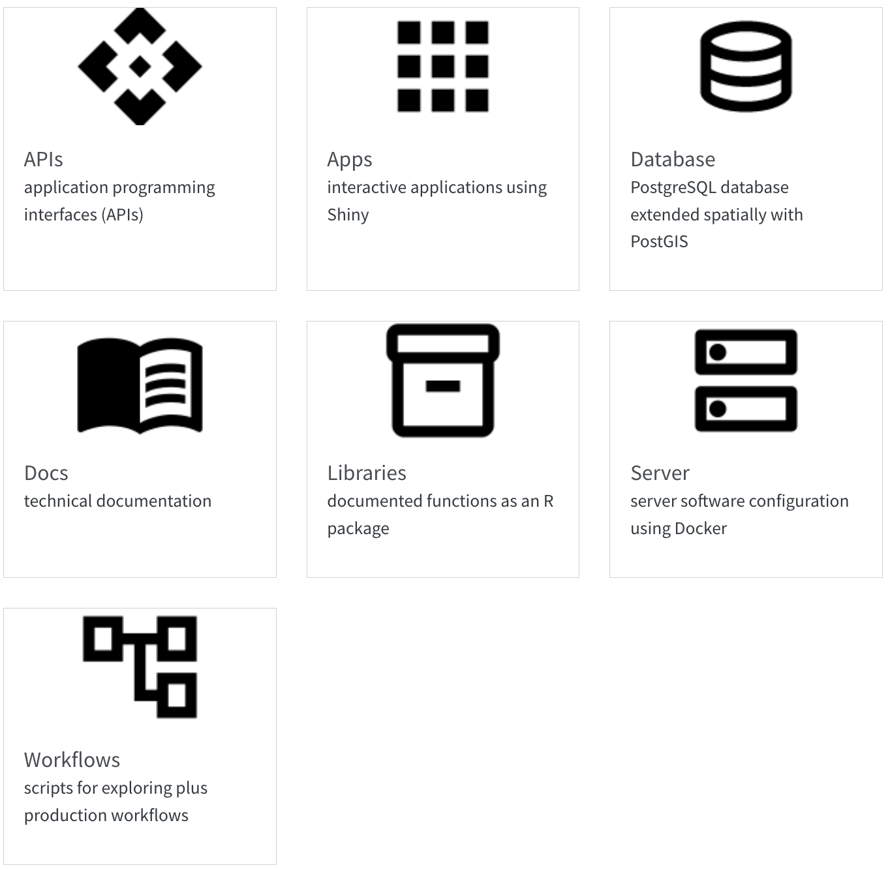

7. Server
The server is for serving up any web services outside those of Github (e.g., website, docs and R package msens) using Docker (see the docker-compose.yml; with reverse proxying from subdomains to ports by Caddy).

7.1 Setup
For instructions on launching an Amazon instance and installing the server software, see Server Setup · MarineSensitivity/server Wiki.

7.2 Services
The server is running the following services:
- RStudio
integrated development environment (IDE) to code and debug directly on the server 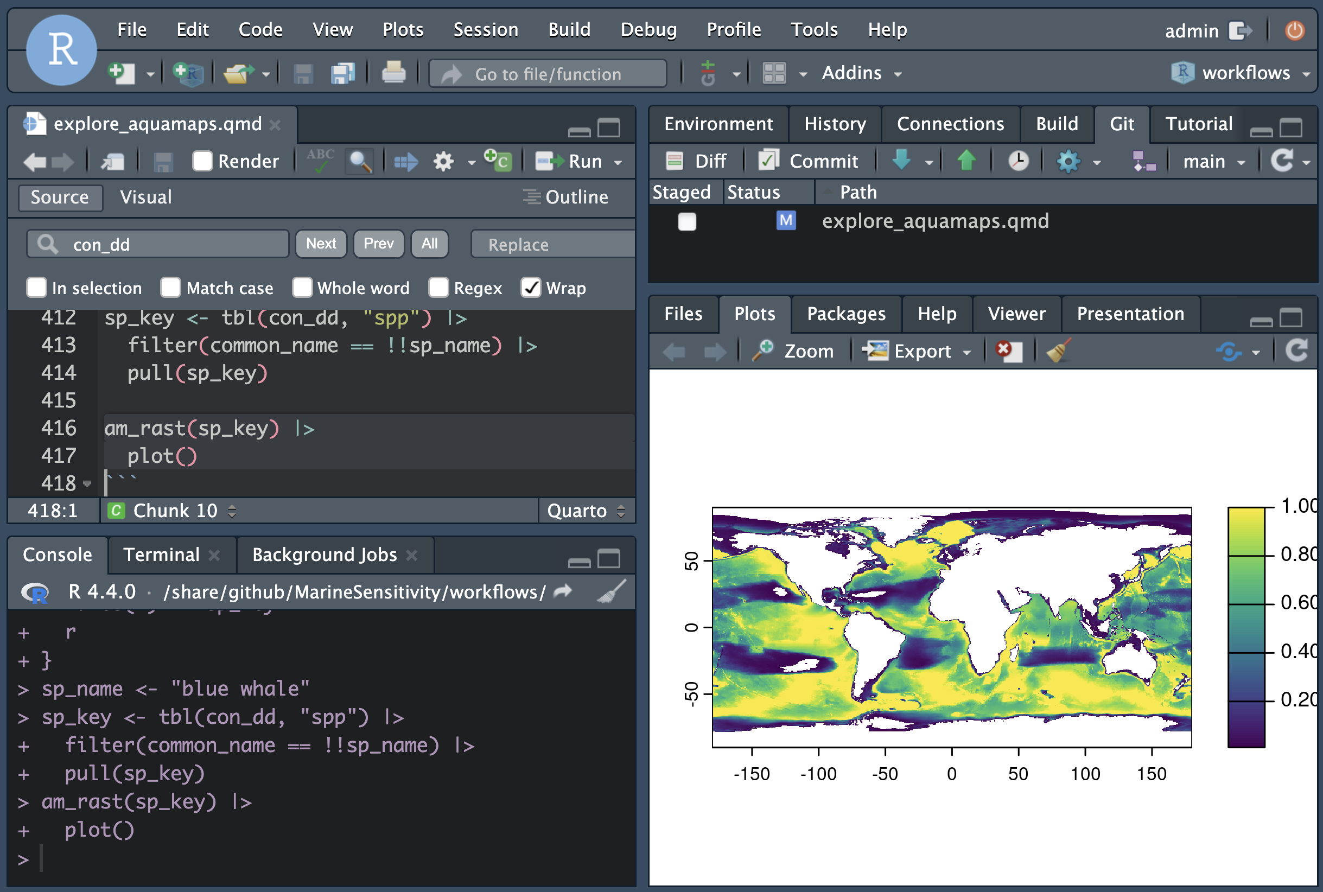
More info..
- Shiny
interactive applications
e.g., shiny.marinesensitivity.org/map
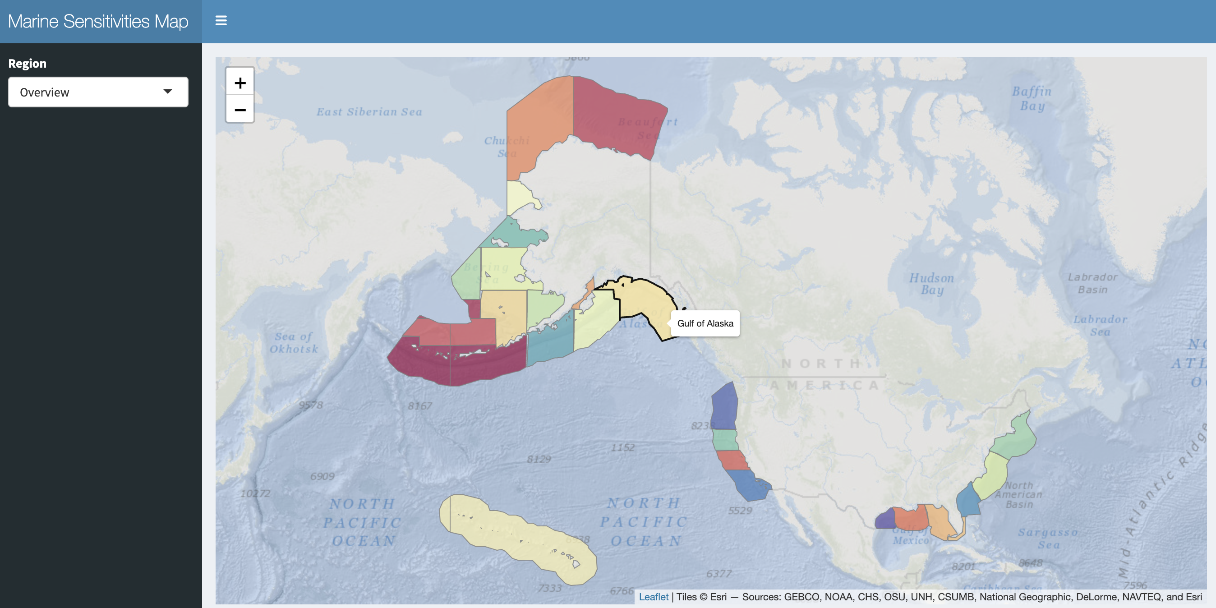
More info..
- PGadmin
PostGreSQL database administration interface
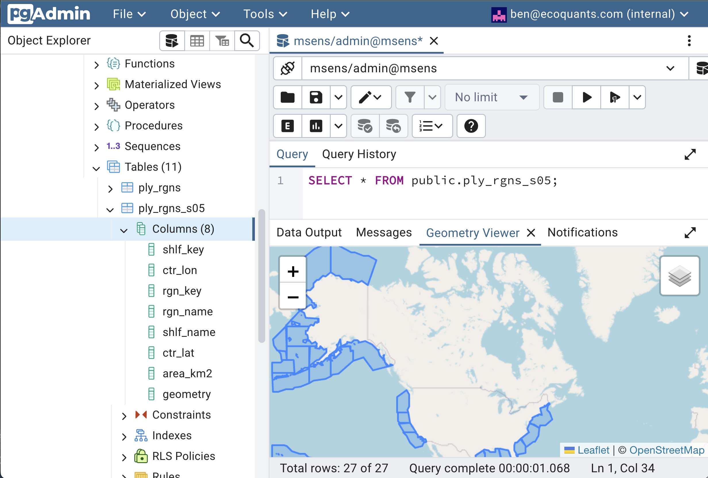
More info..
- api
custom API: using R plumber
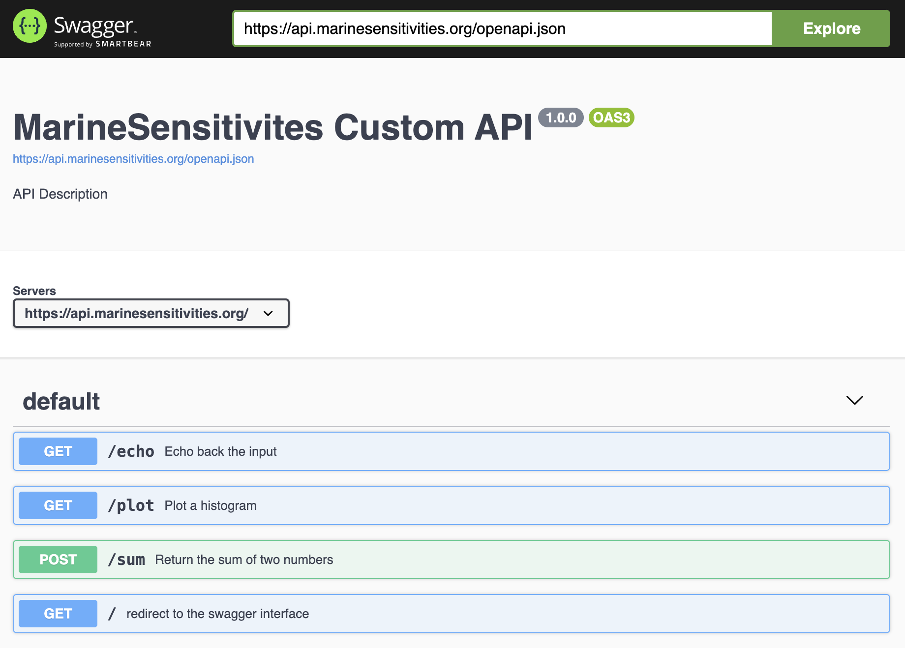
More info..
- swagger
generic database API: using PostGREST
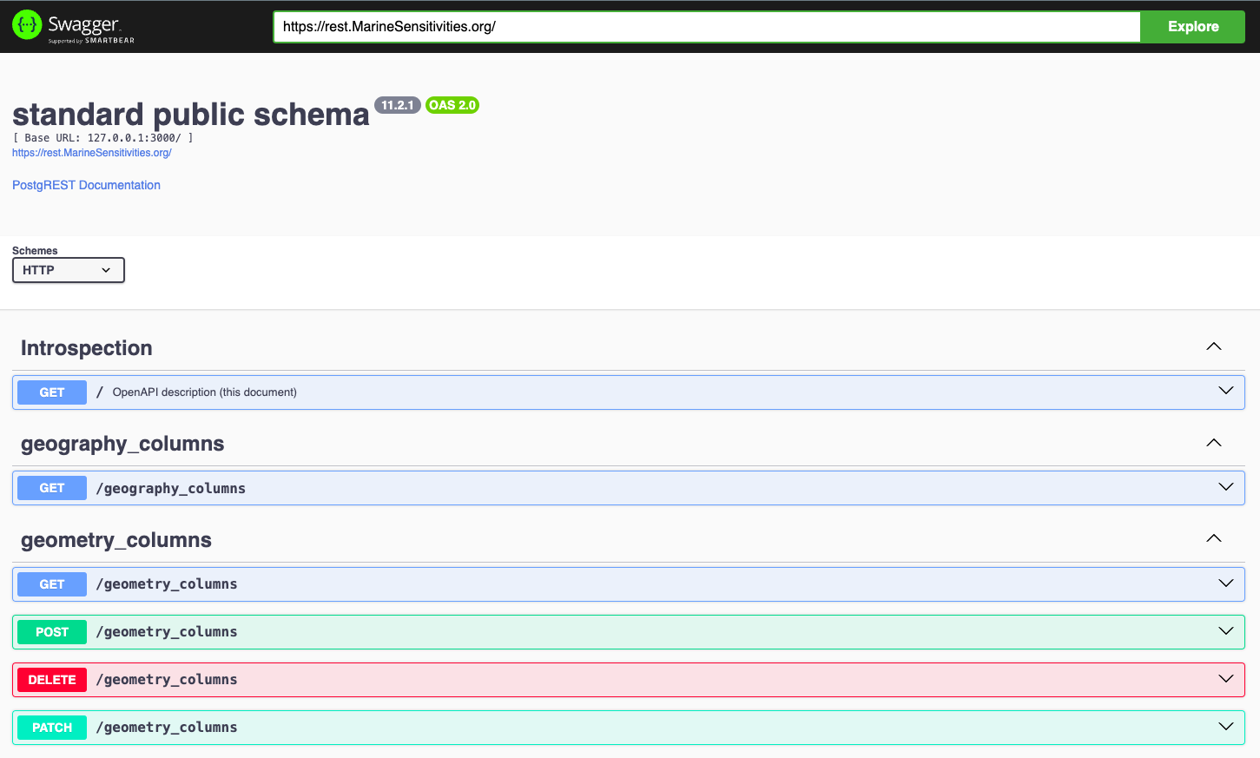
More info..
- tile
spatial database API: using pg_tileserv for serving vector tiles
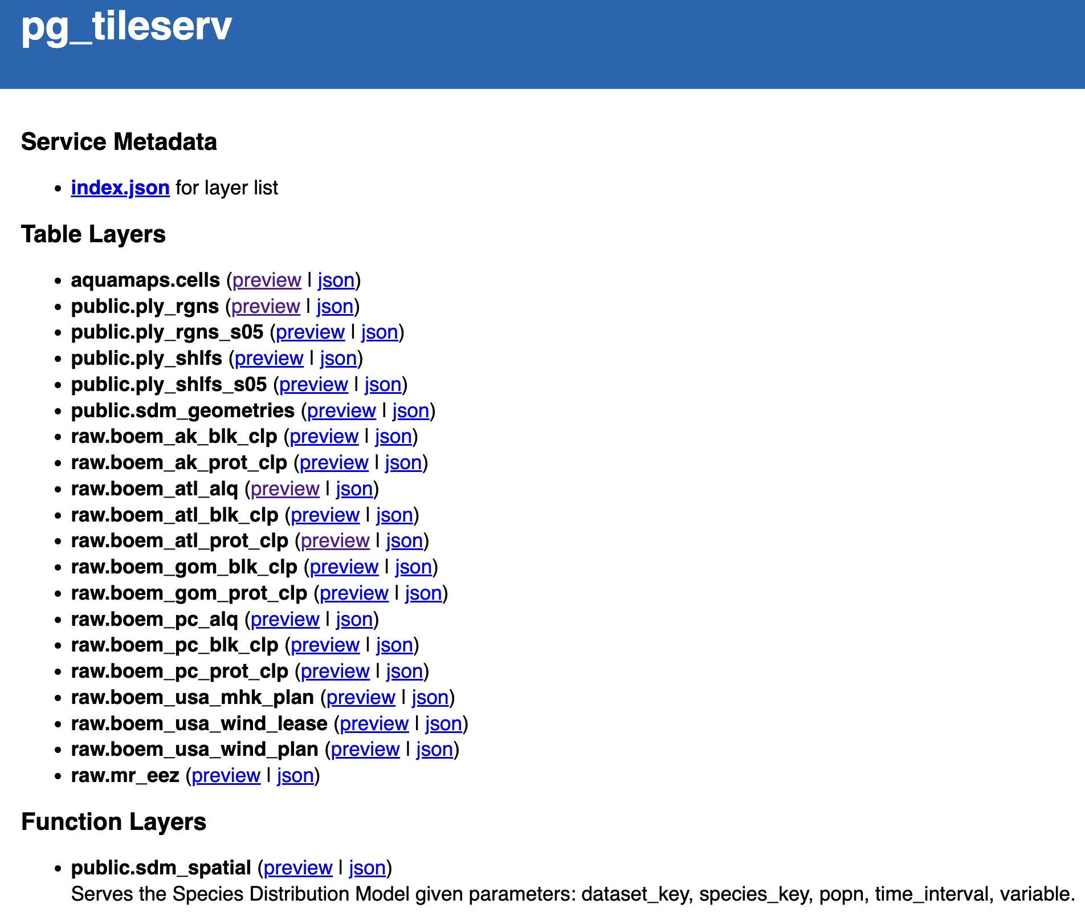
More info..

8. Database

8.1 Table and Column Naming Conventions
- Table names are plural and use all lower case.
- Unique identifiers are suffixed with:
  - *_id for unique integer keys;
  - *_key for unique string keys;
  - *_seq for auto-incrementing sequence integer keys.
- Column names are singular and use snake_case.
- Foreign keys are named with the singular form of the table they reference, followed by _id.
- Primary keys are named id.

8.2 Species Distribution Models
See entity relationship diagram (ERD) for the species distribution models (SDM) database tables in this workflow:
- Create SDM Tables
And example of ingesting SDM outputs into the database in this workflow:
- Ingest GoMex cetacean & sea turtle SDMs

9. Workflows
Workflows are scripts for testing data analytics and visualization as well as production workflows for ingesting data. See:
- marinesensitivity.org/workflows
rendered html pages from the scripts (as Quarto notebooks)
- github.com/MarineSensitivity/workflows
source code in the Github repository

10. APIs
There three APIs, each used for different purposes:
- api
custom API: using R plumber
source: MarineSensitivity/api
- swagger
generic database API: using PostGREST
source: Postgres database, non-spatial
- tile
spatial database API: using pg_tileserv for serving vector tiles
source: Postgres database, spatial

11. Libraries
By creating an R package, we can document functions and make them easily available to other users.
- msens
R library of functions for mapping marine sensitivities, sponsored by BOEM
Functions can read data from the one APIs (which communicate with the Database), analyze the data, visualize the results and store some smaller data.

12. Apps
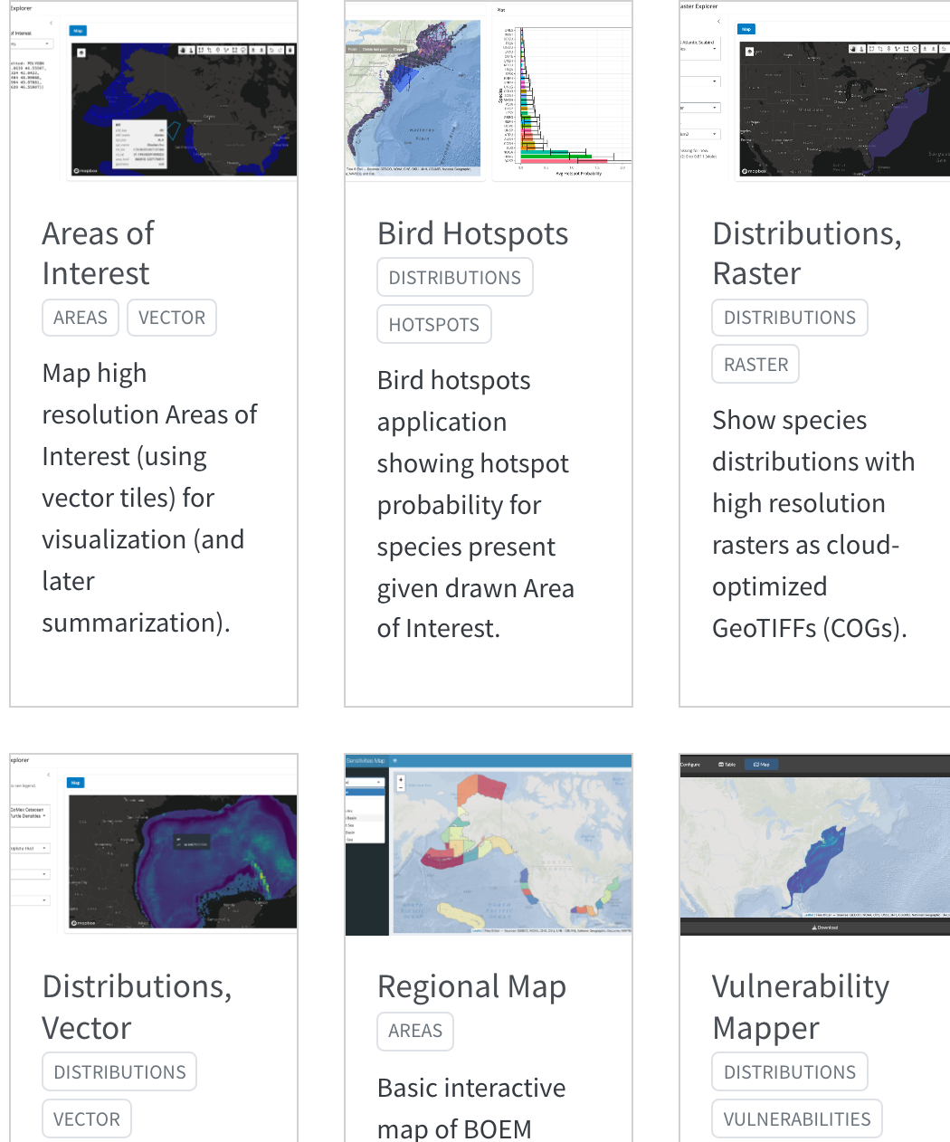
See also details of individual applications in the Appendix.

13. Docs
Technical documentation is principally in this book:
- marinesensitivity.org/docs
the main documentation site
- github.com/MarineSensitivity/docs
source code in the Github repository
But there are also some other self-documenting resources:
- marinesensitivity.org/msens
documented R functions

14. Summary
…

References
Goodale, M. Wing, and Anita Milman. 2016. “Cumulative Adverse Effects of Offshore Wind Energy Development on Wildlife.” Journal of Environmental Planning and Management 0 (0): 1–21. https://doi.org/10.1080/09640568.2014.973483.
Ross, Pauline M., Elliot Scanes, Maria Byrne, Tracy D. Ainsworth, Jennifer M. Donelson, Shawna A. Foo, Pat Hutchings, Vengatesen Thiyagarajan, and Laura M. Parker. 2023. “Surviving the Anthropocene: The Resilience of Marine Animals to Climate Change.” In. CRC Press.

Glossary
acclimatisation
the adjustment of an organism to environmental conditions in the field or environment rather than the laboratory without an adjustment in their genetics. Acclimatisation has been used to describe phenotypically plastic responses in natural conditions. Source: Ross et al. (2023).
adaptation
the evolutionary mechanism where natural selection of traits is genetically passed on, typically over many generations, to create an organism suited to the environment. Source: [rossRoss et al. (2023)
adaptive capacity
the capacity of the ecosystem or organism to improve and reorganise in response to stress such as climate change through phenotypic plasticity (acclimation, acclimatisation) or adaptation, distributional shifts, and rapid evolution of traits suited to new conditions. Source: Ross et al. (2023).
epigenetics
the modification of phenotype plasticity of an organism through altered gene expression without an alteration to the DNA sequence. ‘Epi’ means above the DNA and includes DNA methylation, modification of histones, and non-coding RNA. Source: Ross et al. (2023).
exposure
the magnitude of the change in the environment
fecundity
the maximum physiological potential reproductive output of an organism to produce offspring (reproductive output). This differs from fertility, which is the number of offspring born. Source: Ross et al. (2023)
MBON
Marine Biodiversity Observation Network; see MarineBON.org
resilience
the capacity of an ecosystem, society, or organism to absorb disturbance and reorganise while undergoing change so as to retain essentially the same function, structure, identity, and feedbacks. Resilience reflects the degree to which a complex adaptive system is determined by its capacity to reorganise and adapt in order to avoid being disturbed again. Source: Ross et al. (2023).
sensitivity
the magnitude of response to the change
stressor
the stimulus that causes stress to an organism
vulnerability
combination of exposure and sensitivity

Areas of Interest
Map high resolution Areas of Interest (using vector tiles) for visualization (and later summarization).
- website
- code
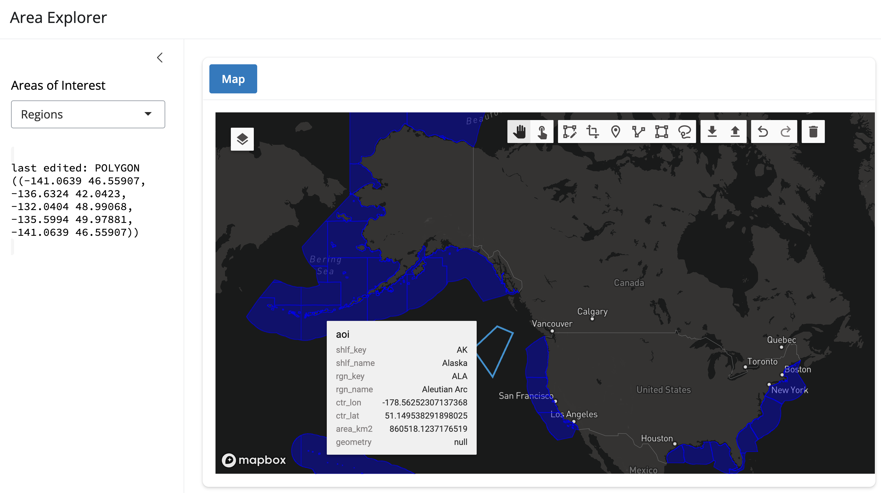

Bird Hotspots
Bird hotspots application showing hotspot probability for species present given drawn Area of Interest.
- website
- code
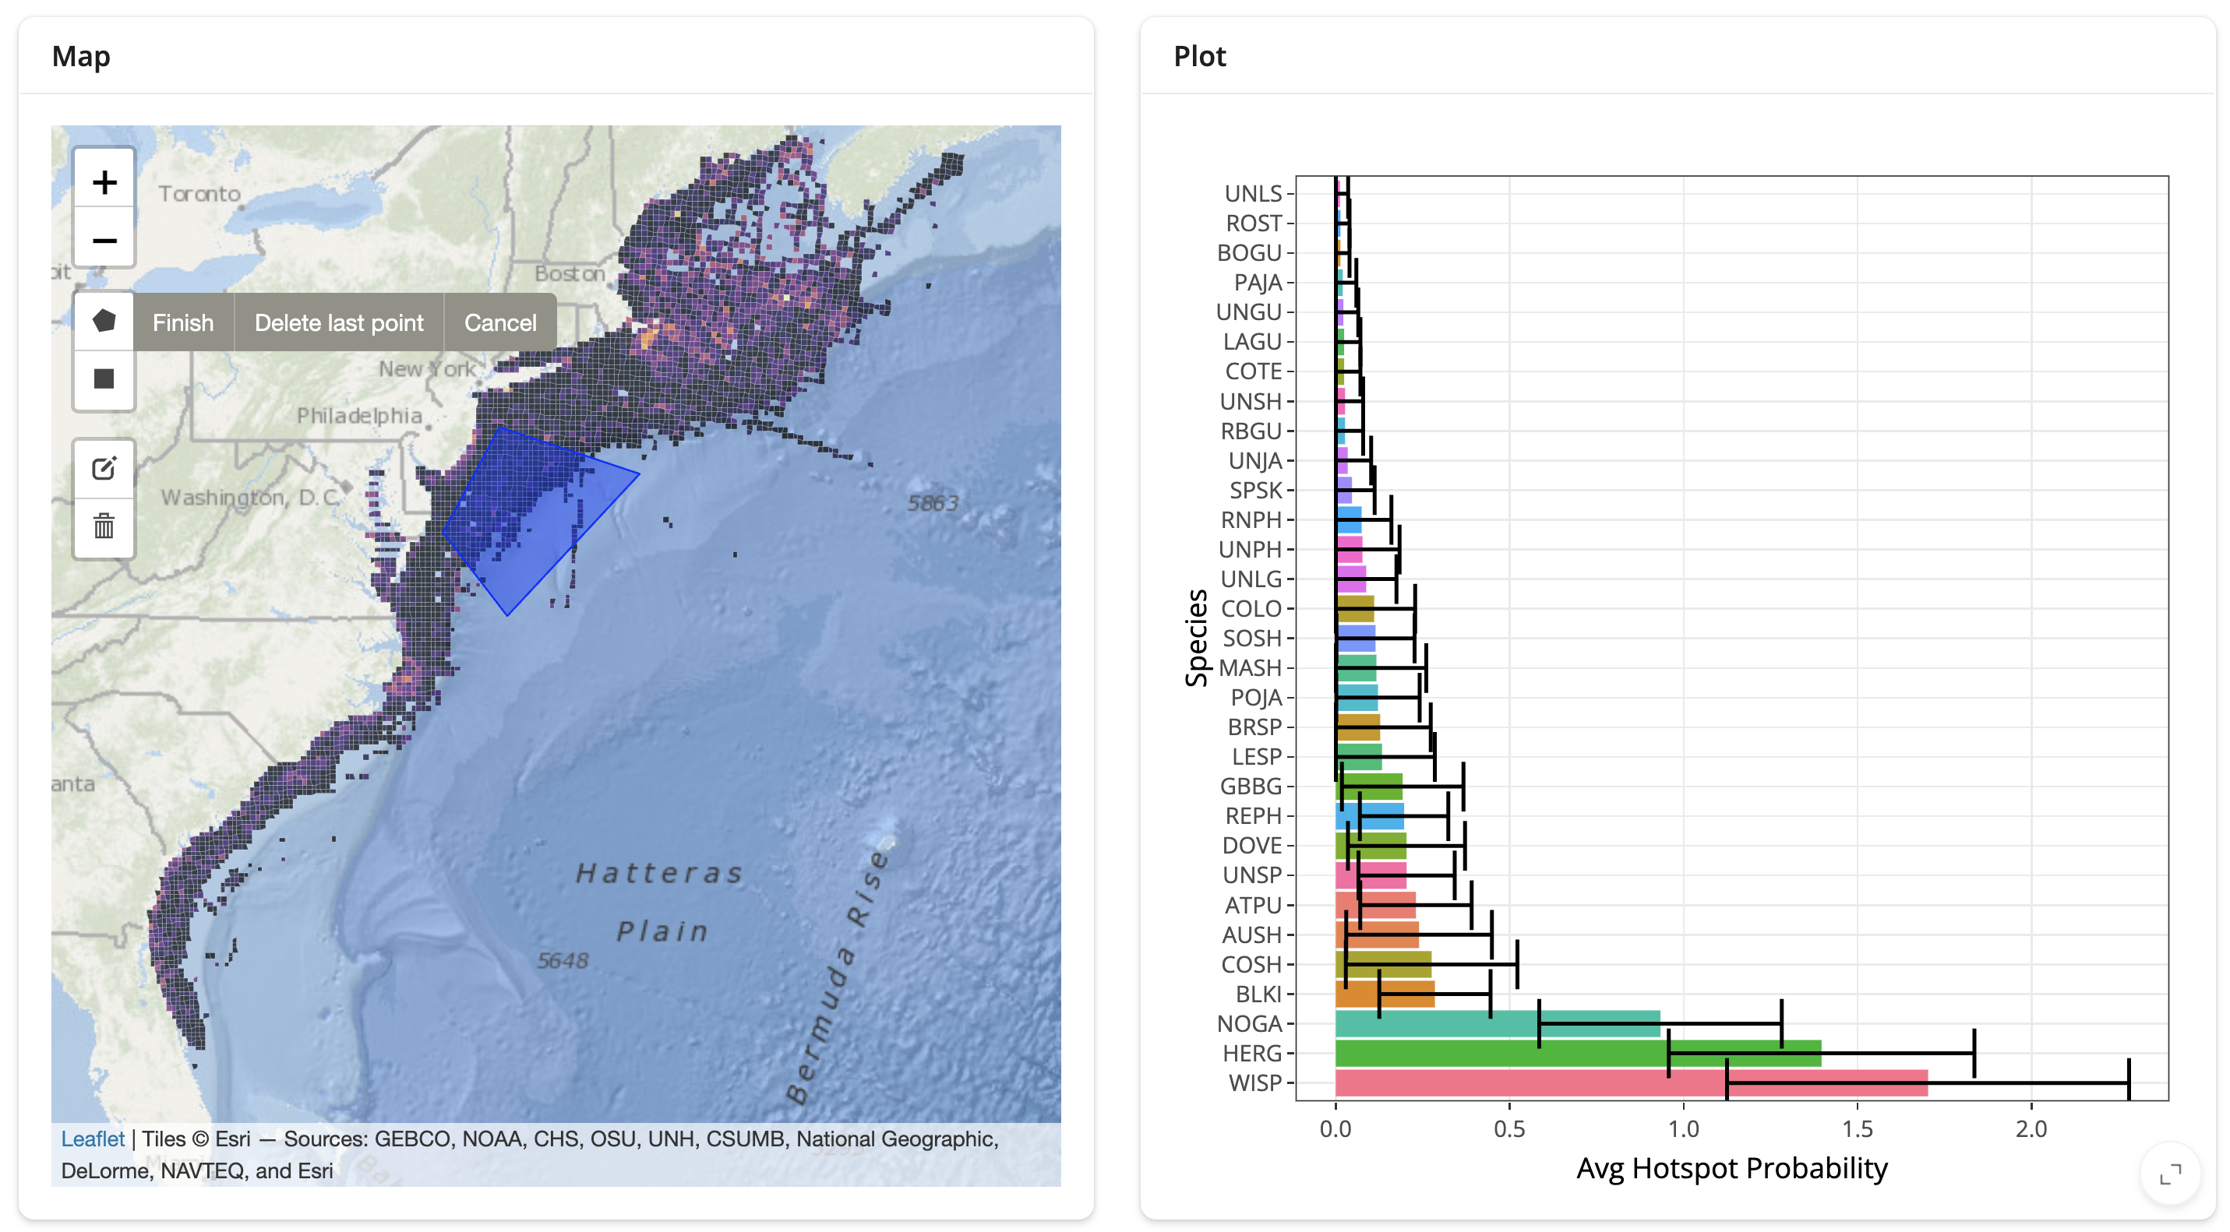

Regional Map
Basic interactive map of BOEM regions.
- website
- code
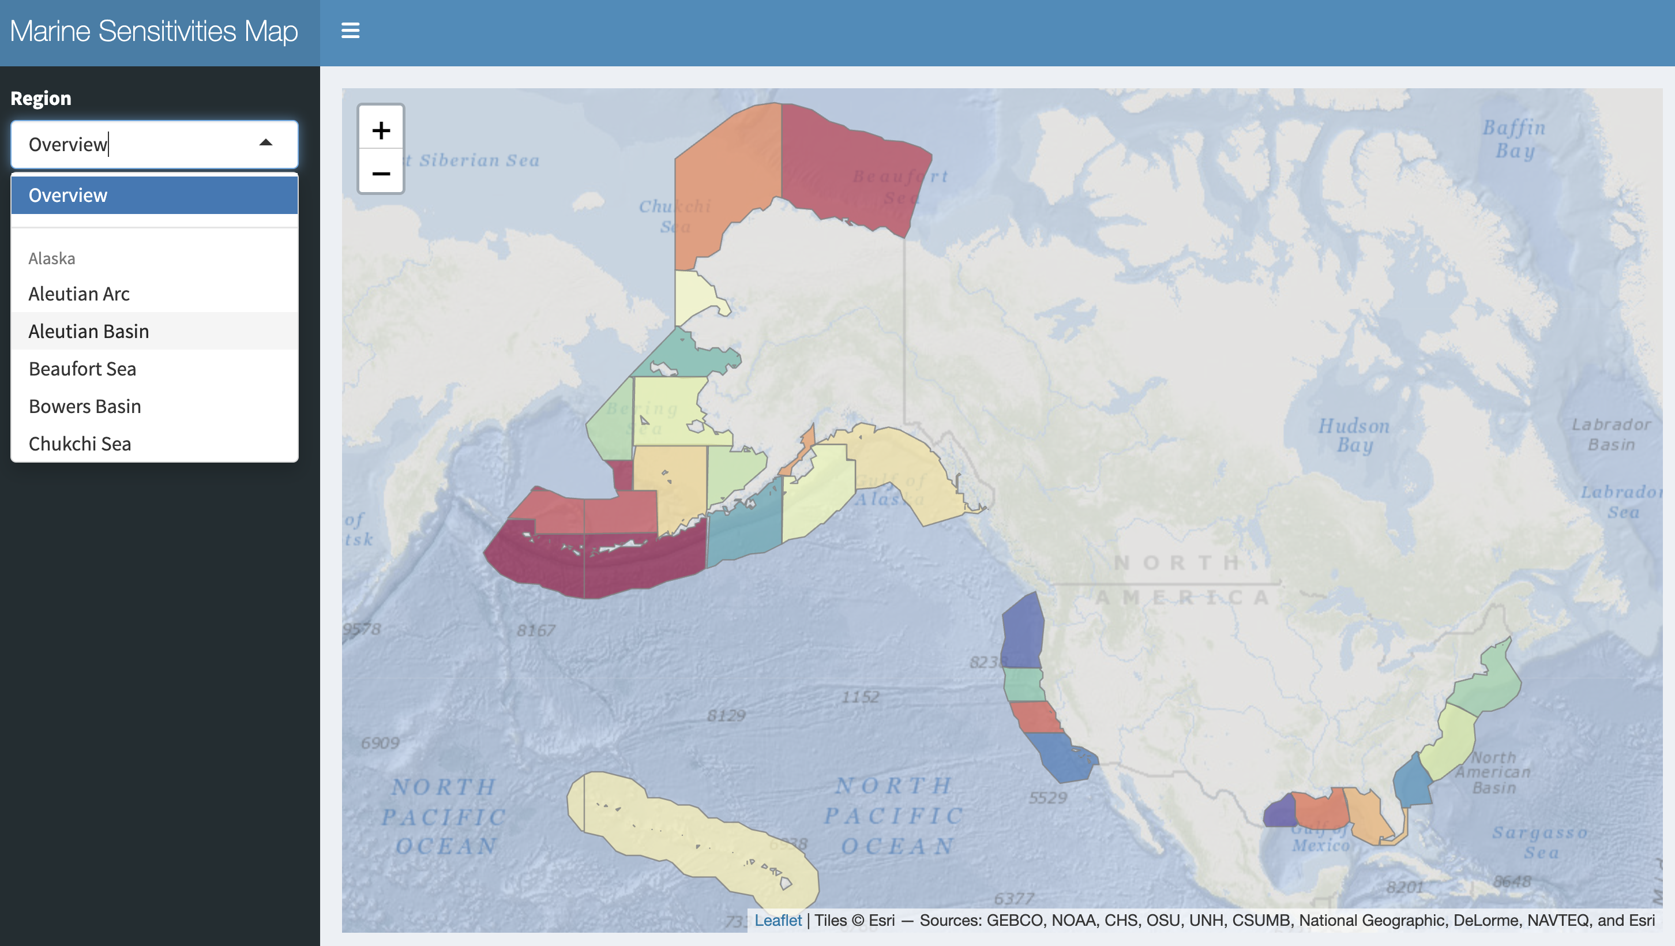

Distributions, Vector
Show species distributions with high resolution vectors (as vector tiles).
- website
- code
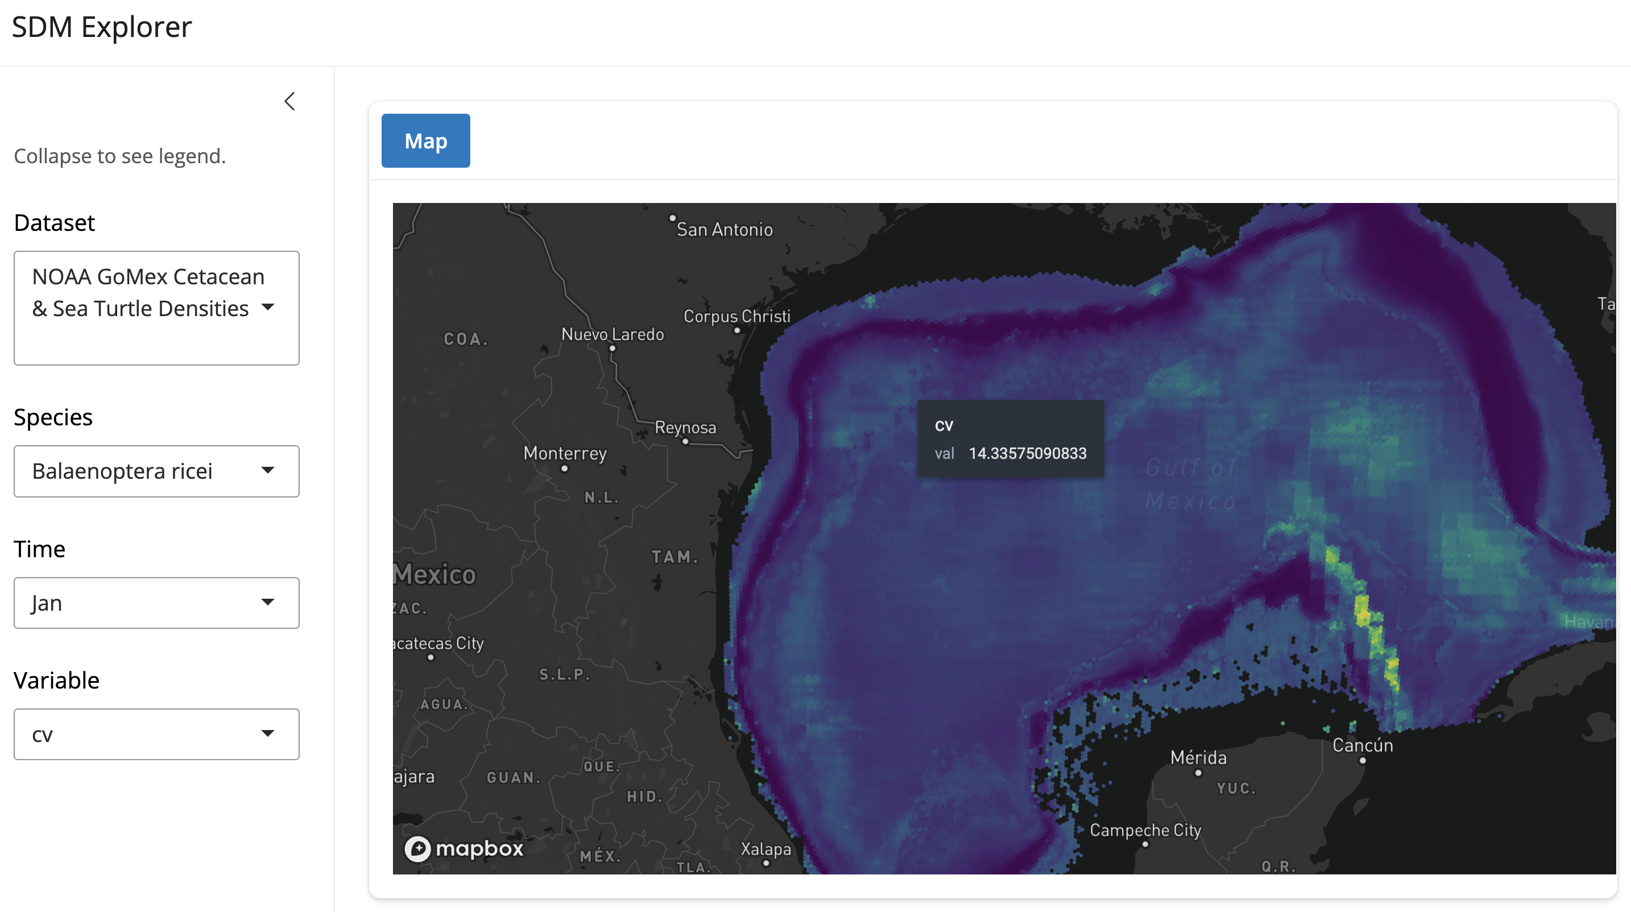

Distributions, Raster
Show species distributions with high resolution rasters as cloud-optimized GeoTIFFs (COGs).
- website
- code
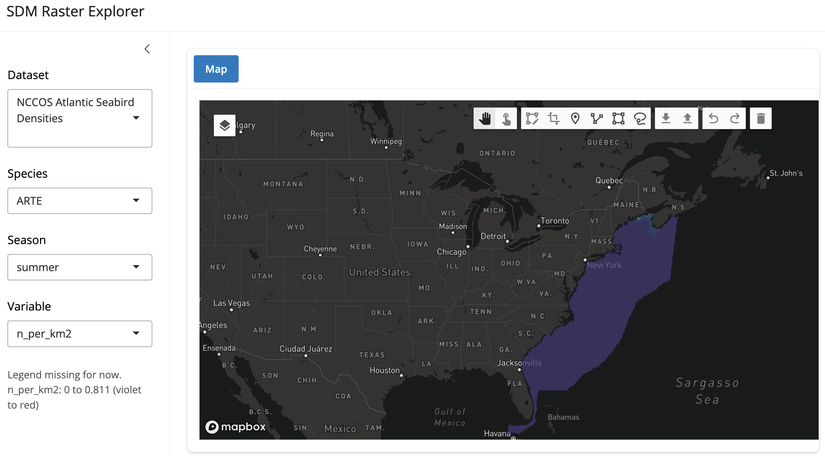

Vulnerability Mapper
Combine species distribution models (raster) and vulnerability metrics (tables) to identify areas of high conservation concern.
- website
- code
