Server Synchronization Plan
  - BOEM Marine Sensitivity Toolkit — Internal/External Server Sync
Ben Best
2026-02-20
Table of contents

1 Motivation
The Marine Sensitivity Toolkit (MST) is a BOEM-funded project that delivers interactive web applications and documentation for assessing the sensitivity of marine ecosystems to offshore energy development. The project is actively developed by the lead contractor, Ben Best (EcoQuants), who maintains:
- Interactive apps (Composite Scores, Species Distribution) built with R Shiny
- Project documentation (marinesensitivity.org/docs) built with Quarto
The lead contractor will be out of the United States for an extended period to have his second child in his wife’s home country of Italy. During this time, active development will continue on a server external to the BOEM network (the existing AWS-hosted development server), while BOEM’s goal is to migrate production web services to a server internal to the BOEM network.
To bridge this gap, the internal production server must initiate all synchronization — pulling software updates (container images), data files, and static web content from the external development server, and pushing log files back for remote debugging. This document describes the architecture, synchronization strategy, implementation scripts, monitoring approach, and government compliance considerations for this arrangement.

2 Architecture Overview
The MST infrastructure spans three tiers: developer laptops, an external cloud server (AWS), and the target internal BOEM server. The following diagram shows the overall software architecture and data flow.

Simple
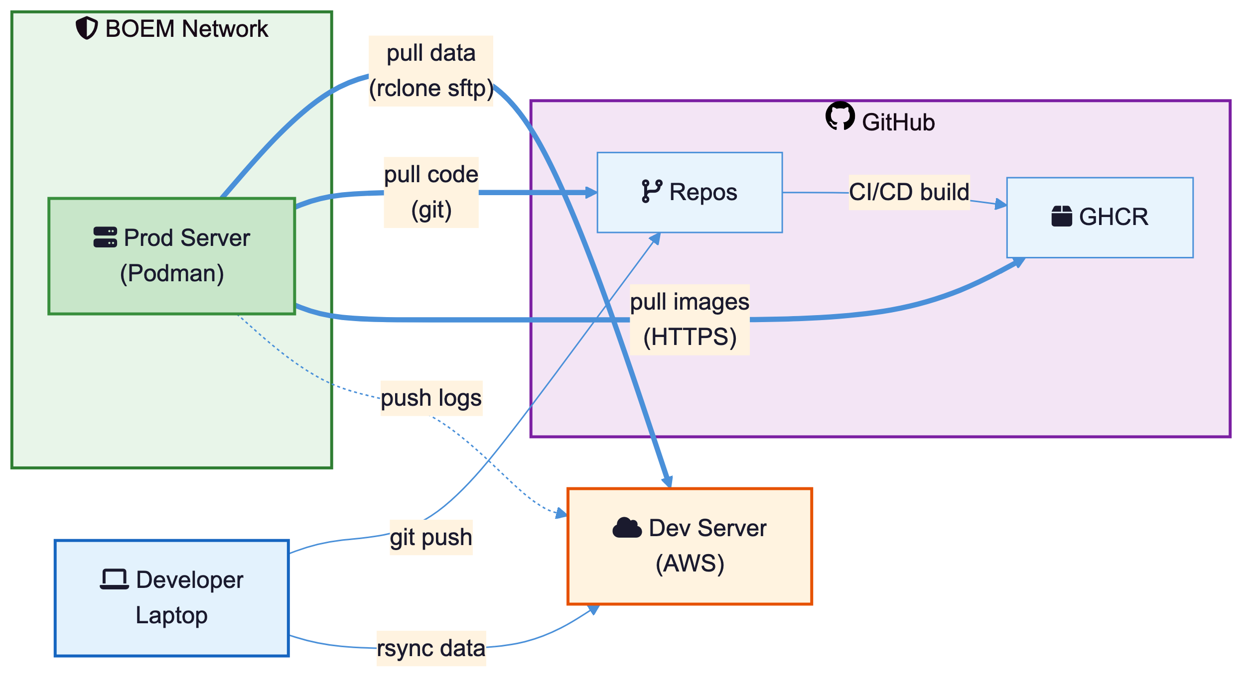
Figure 1: Overall server architecture (simplified): developer laptop pushes code to GitHub and data to the dev server; the BOEM production server pulls everything inbound.

Detailed
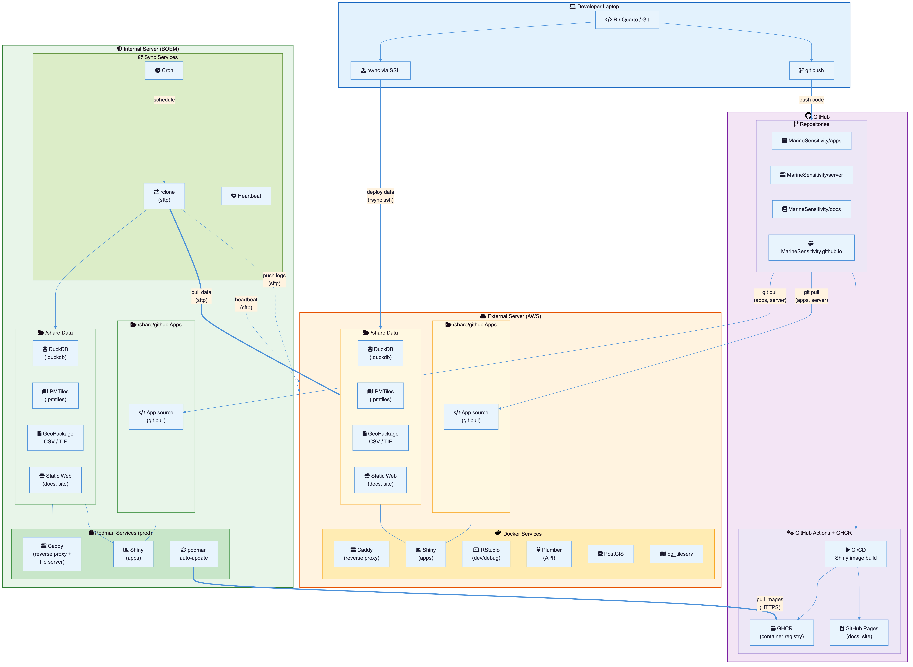
Figure 2: Detailed server architecture showing developer laptop, GitHub (repos + container registry), external AWS server (Docker), and internal BOEM server (Podman) with container services and data flows.
Diagram source files are in diagrams/ — see diagrams/README.md for rendering instructions.

2.1 Current state (external only)
The existing external server on AWS (100.25.173.0) runs the full development stack defined in docker-compose.yml:
Service | Purpose | Port
caddy | reverse proxy + TLS + file server | 80/443
rstudio | development IDE + Shiny Server | 8787/3838
plumber | R API | 8888
postgis | PostgreSQL + PostGIS spatial database | 5432
pgadmin | database admin UI | 8088
pgbkups | automated database backups | —
tile | pg_tileserv (vector tiles from PostGIS) | 7800
tilecache | Varnish cache for tile | 6081
titiler | cloud-optimized GeoTIFF tile server | 8000
titilecache | Varnish cache for titiler | 6082
The current deployment workflow uses two channels:
- Data files — the developer runs deploy_to_server.sh, which uses rsync over SSH to push derived data (DuckDB, GeoPackage, CSV, TIF) from the developer laptop to the external server’s /share/data directory, then restarts the Shiny container.
- App source code — the developer pushes to GitHub, then SSHs into the external server to run git pull in /share/github/MarineSensitivity/apps. The Shiny Server watches the app directories and picks up changes automatically.
Static web content is currently served via GitHub Pages:
- marinesensitivity.org — project homepage (MarineSensitivity.github.io)
- marinesensitivity.org/docs — project documentation (MarineSensitivity/docs)

2.2 Target state (internal production)
The internal BOEM server runs a minimal production stack defined in prod/docker-compose.yml:
Service | Purpose | Port
caddy | reverse proxy + file server + docs | 80
shiny | R Shiny applications | 3838
auto-update | automatic container image updates (podman) | —
Services not needed on production:
- rstudio — development only; debugging happens on external server
- postgis / pgadmin / pgbkups — database migrated to DuckDB (file-based)
- plumber — API either proxied or migrated
- tile / tilecache — vector tiles migrated to PMTiles (file-based)
- titiler / titilecache — raster tiles served differently or proxied
The key architectural simplification is replacing the PostGIS + pg_tileserv stack with PMTiles (a single file format for vector tiles served directly by Caddy as static files) and replacing PostGIS-backed raster queries with DuckDB (an embedded analytical database read directly by Shiny apps).

3 Synchronization Overview
All synchronization is initiated by the internal server — it pulls updates from the external server and pushes logs back. No inbound connections to the BOEM network are required.

Simple
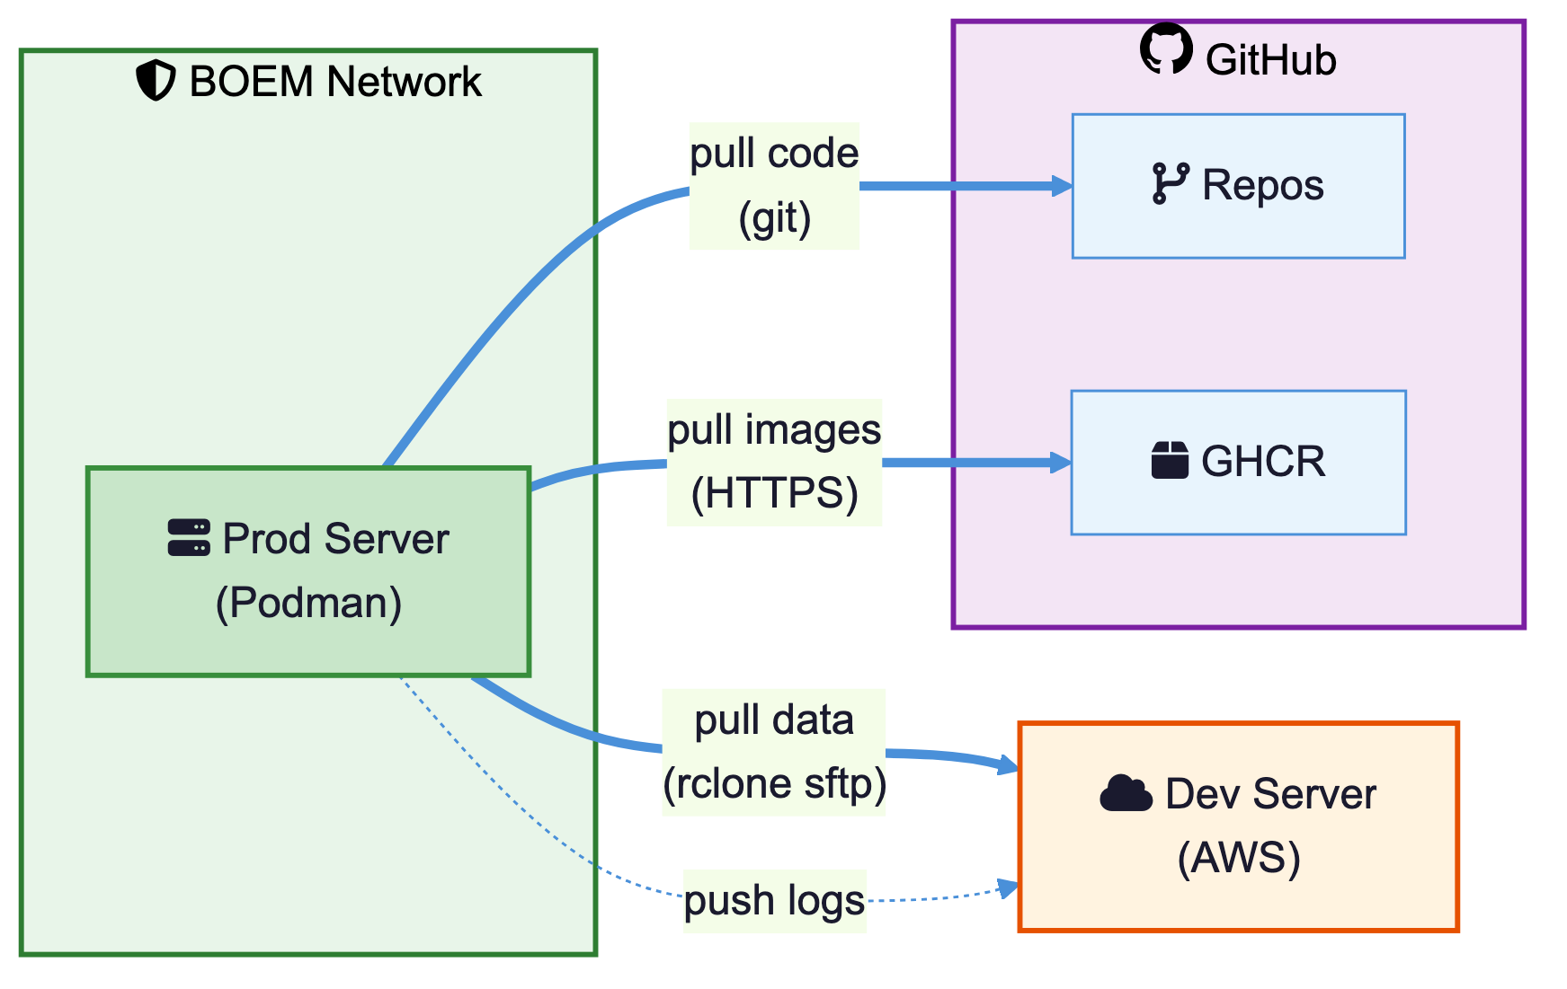
Figure 3: Synchronization flow (simplified): the BOEM production server pulls data, code, and images; pushes only logs.

Detailed
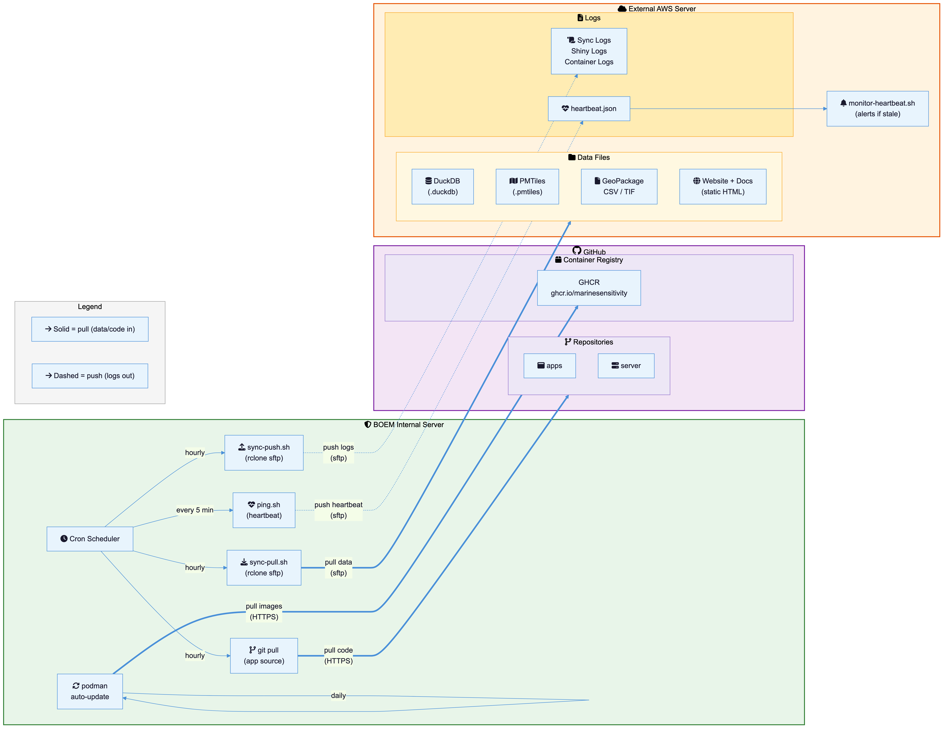
Figure 4: Detailed synchronization flow showing cron jobs, rclone scripts, git pull, podman auto-update, heartbeat monitoring, and all data/log targets.

3.1 Sync summary
What | Direction | Source | Tool | Schedule | Protocol
Data files (duckdb, gpkg, csv, tif) | internal pulls | external server | rclone (sftp) | hourly | SSH
PMTiles | internal pulls | external server | rclone (sftp) | hourly | SSH
Static website/docs | internal pulls | external server | rclone (sftp) | hourly | SSH
Shiny app source | internal pulls | GitHub repos | git pull | hourly | HTTPS
Server config | internal pulls | GitHub repos | git pull | hourly | HTTPS
Container images | internal pulls | GitHub GHCR | update-images.sh (cron) | daily | HTTPS
Sync/Shiny/container logs | internal pushes | external server | rclone (sftp) | hourly | SSH
Heartbeat | internal pushes | external server | rclone (sftp) | every 5 min | SSH

4 Implementation

4.1 Prerequisites
On the internal BOEM server (RHEL 8.10):
# install rclone (not in standard RHEL/EPEL repos — use official script)
curl https://rclone.org/install.sh | sudo bash
# alternatives:
# sudo yum install -y epel-release && sudo yum install -y rclone # if EPEL available
# download binary from https://rclone.org/downloads/ and install manually
# install podman (included in RHEL 8 AppStream)
sudo yum install -y podman
sudo systemctl enable --now podman.socket
# fix UID/GID mapping for rootless podman (if needed)
sudo usermod --add-subuids 100000-165535 --add-subgids 100000-165535 $USER
podman system migrate
# install podman-compose via Python 3.8 (RHEL 8 ships Python 3.6, which is too old)
sudo dnf install -y python38
sudo pip3.8 install podman-compose
# create log directory
sudo mkdir -p /var/log/msens
sudo chown $USER:$USER /var/log/msens
# create data and service directories
sudo mkdir -p /share/data /share/public/www /share/github/MarineSensitivity \
/share/logs /share/caddy/data /share/caddy/config /share/private
 Always use sudo python3.8 -m podman_compose on RHEL 8
On RHEL 8, the bare podman-compose command may not be on $PATH or may use the wrong Python version. Always invoke it as:
sudo python3.8 -m podman_compose up -d
# or restart
sudo python3.8 -m podman_compose down && sudo python3.8 -m podman_compose up -d
The sudo is required for binding to port 80. The python3.8 -m podman_compose form ensures the correct Python interpreter is used.

4.2 SSH key setup
Generate an SSH key pair on the internal server for passwordless authentication to the external server:
# on internal server
ssh-keygen -t ed25519 -f ~/.ssh/msens_sync -N "" -C "msens-sync@boem"
# set restrictive permissions on private keys
chmod 600 ~/.ssh/msens_sync
chmod 600 ~/.ssh/msens_key_pair.pem # if using an AWS .pem key
# copy public key to external server (one-time manual step)
ssh-copy-id -i ~/.ssh/msens_sync.pub ubuntu@msens1.marinesensitivity.org
If the external server only allows key-based authentication (no password login), you need an existing authorized key to bootstrap. Use an AWS .pem key pair that is already authorized on the target:
# bootstrap: use existing .pem key to copy the new sync key
ssh-copy-id -i ~/.ssh/msens_sync.pub \
-o "IdentityFile=~/.ssh/msens_key_pair.pem" \
ubuntu@msens1.marinesensitivity.org
After this, the msens_sync key is authorized and can be used by rclone and cron jobs without needing the .pem key.

4.3 SELinux context for container volumes
RHEL 8 runs SELinux in enforcing mode by default. Podman containers cannot read or write host-mounted volumes unless those files carry the container_file_t SELinux type label. Without this, containers start but apps fail with “permission denied” errors — even when standard Unix permissions look correct.
Apply the context to the entire /share tree:
# apply SELinux context to all shared data (recursive)
sudo chcon -R -t container_file_t /share
For more targeted application, label specific paths:
sudo chcon -R -t container_file_t /share/data
sudo chcon -R -t container_file_t /share/private
sudo chcon -R -t container_file_t /share/public
sudo chcon -R -t container_file_t /share/caddy
sudo chcon -t container_file_t /share/github/MarineSensitivity/server/prod/Caddyfile
 container_file_t vs svirt_sandbox_file_t
container_file_t is the modern, preferred SELinux type name. The older name svirt_sandbox_file_t is an alias and still works, but container_file_t is what chcon and audit logs use on RHEL 8+.

 Re-run after sync creates new files
The chcon context does not propagate to newly created files. After running sync-pull.sh for the first time (or whenever new files appear in /share), re-run:
sudo chcon -R -t container_file_t /share

Verify the context is applied:
# check SELinux labels on data files
ls -lZ /share/data
# check for recent SELinux denials
sudo ausearch -m avc -ts recent

4.4 rclone configuration
Configure rclone on the internal server to connect to the external server via SFTP:
# create rclone config
rclone config
# or write directly:
cat >> ~/.config/rclone/rclone.conf <<'EOF'
[ext_dev]
type = sftp
host = msens1.marinesensitivity.org
user = ubuntu
key_file = /home/<user>/.ssh/msens_sync
shell_type = unix
EOF
Test the connection:
rclone lsd ext_dev:/share/data/derived/

4.5 Sync scripts
The sync scripts live in prod/ and handle pulling data and pushing logs:
- prod/sync-pull.sh — pulls data files, PMTiles, static website, and Shiny apps from the external server
- prod/sync-push.sh — pushes sync logs, Shiny logs, and container logs to the external server for remote debugging
- prod/ping.sh — sends a heartbeat JSON with system health info every 5 minutes
Make scripts executable:
chmod +x prod/sync-pull.sh prod/sync-push.sh prod/ping.sh

4.6 Auto-update container images
 podman auto-update does not work with podman-compose
Podman’s built-in auto-update requires containers managed as individual systemd services (via podman generate systemd). Containers started with podman-compose run inside a pod and produce the error:
Error: looking up pod's systemd unit: pod has no infra container: no such container
The io.containers.autoupdate label in docker-compose.yml has no effect in this setup.

Instead, the prod/update-images.sh script handles automatic image updates. It runs daily via cron and:
- Pulls the latest ghcr.io/marinesensitivity/shiny:latest image
- Compares the image digest to the currently running version
- If changed: runs podman-compose down + up -d to restart with the new image
- If unchanged: exits without disruption
- Re-applies SELinux context and logs all actions to /var/log/msens/update-images.log
# manual one-time run
sudo /share/github/MarineSensitivity/server/prod/update-images.sh
# make script executable (first time)
chmod +x /share/github/MarineSensitivity/server/prod/update-images.sh
When the developer pushes a new Shiny image to GitHub Container Registry (GHCR), the daily cron job will detect the update, pull the new image, and restart the container automatically.

4.7 Cron schedule
Add the following to the internal server’s crontab (crontab -e):
# marine sensitivity toolkit sync jobs
# pull data and content from external server (hourly at :05)
5 * * * * /share/github/MarineSensitivity/server/prod/sync-pull.sh
# push logs to external server (hourly at :35)
35 * * * * /share/github/MarineSensitivity/server/prod/sync-push.sh
# heartbeat ping (every 5 minutes)
*/5 * * * * /share/github/MarineSensitivity/server/prod/ping.sh
# check for new container images and restart if updated (daily at 3:15 AM)
15 3 * * * /share/github/MarineSensitivity/server/prod/update-images.sh

4.8 Monitoring and alerting
The heartbeat strategy uses a push model — the internal server pushes a heartbeat.json file to the external server every 5 minutes. The external server runs a monitor script that checks the heartbeat age and sends email alerts if it goes stale.
On the external server, add to crontab:
# check internal server heartbeat (every 10 minutes)
*/10 * * * * /share/github/server/prod/monitor-heartbeat.sh
The heartbeat JSON includes:
{
"timestamp": "2026-02-19T14:30:00Z",
"hostname": "boem-msens-prod",
"uptime_since": "2026-02-01 08:00:00",
"disk_free": "142G",
"mem_free": "8.2G",
"services": {
"caddy": "running",
"shiny": "running"
}
}
If no heartbeat arrives for 15 minutes, the monitor sends an email alert with the last known service states.

5 Production Stack
The production container configuration (prod/docker-compose.yml, run with podman-compose) provides only the essential services:
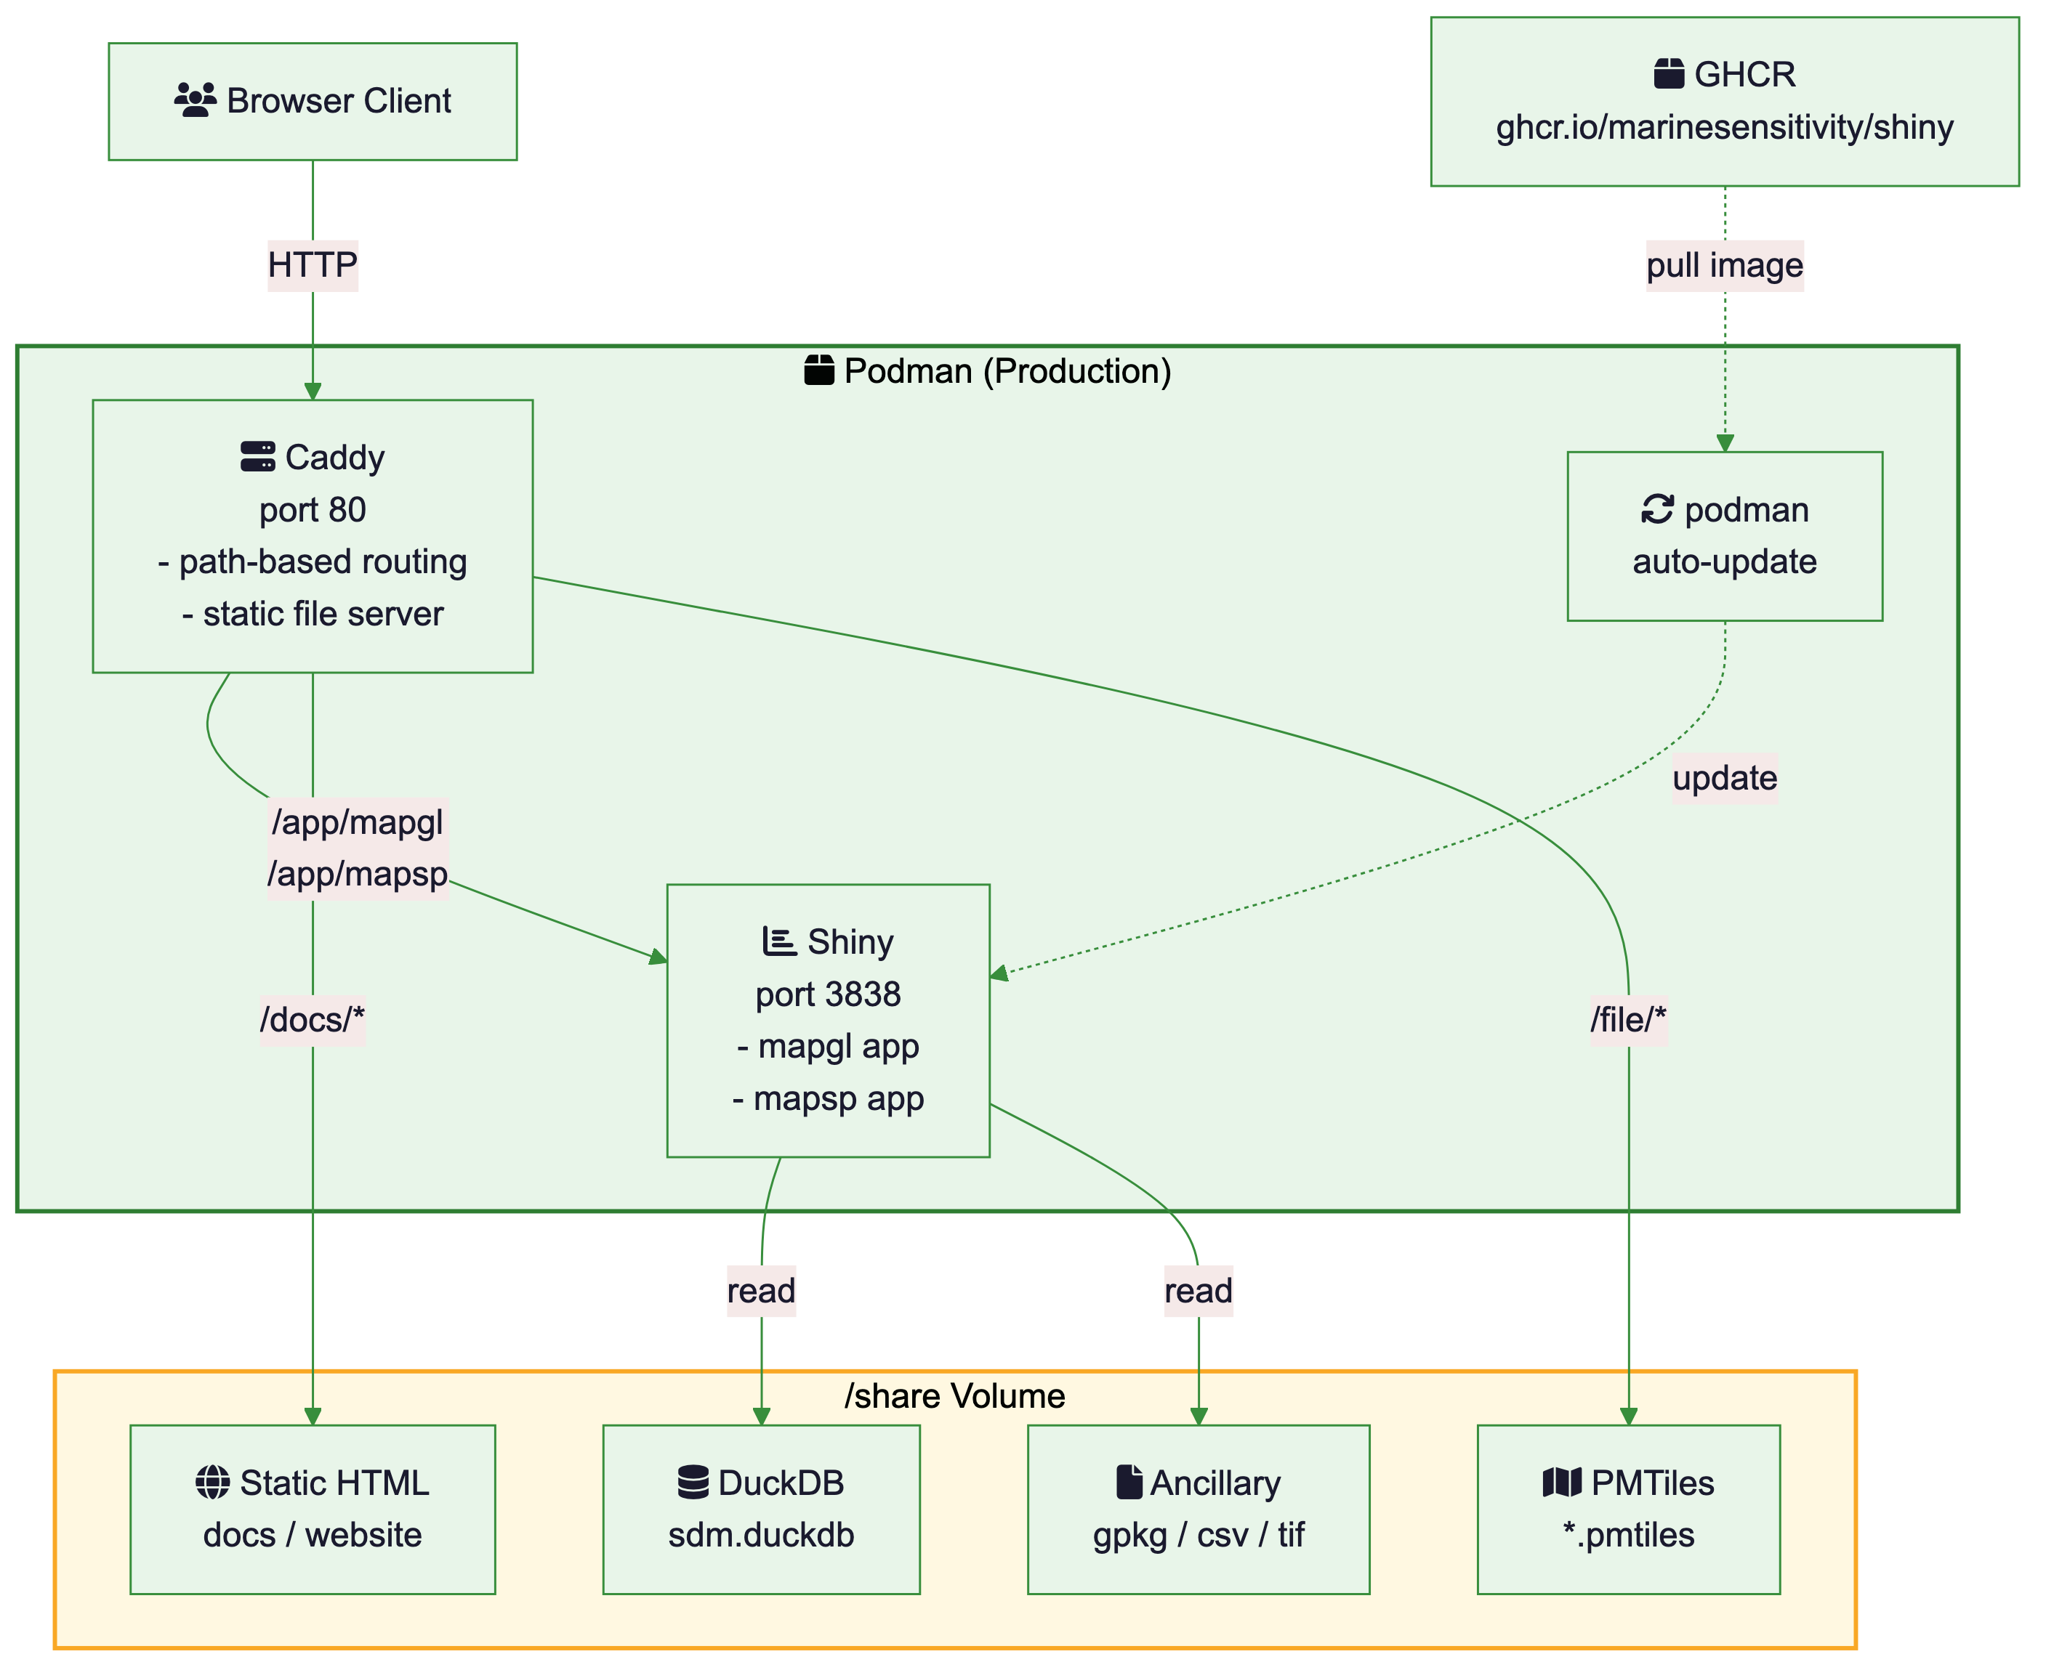
Figure 5: Production server Podman services and data flow. Caddy serves static content and proxies Shiny. Data files are mounted as volumes.

5.1 Container image build and distribution
The production Shiny image (ghcr.io/marinesensitivity/shiny:latest) is built from prod/shiny/Dockerfile and pushed to GitHub Container Registry (GHCR). A GitHub Actions workflow automatically builds and pushes the image when the Dockerfile changes on main. Manual builds can also be triggered via workflow_dispatch.
When to rebuild: only when R package dependencies change (adding/removing/upgrading packages). App code changes do not require an image rebuild — app source is mounted as a volume.

5.1.1 R package version pinning (PPM snapshots)
The rocker/geospatial base image configures R to install packages from a Posit Public Package Manager (PPM) date-pinned snapshot. This means install2.r and install.packages() install the versions available on the snapshot date — not the latest CRAN versions.
This can cause problems when a Shiny app depends on a newer package version than what was available on the snapshot date. For example, on rocker/geospatial:4.4.1 (PPM snapshot ~Oct 2024), mapgl installed as 0.1.3 — but the mapgl Shiny app requires 0.4.4+ (which introduced mapboxgl() and maplibre() functions used by the app).
Fix: upgrade the base image to rocker/geospatial:4.5.2 (PPM snapshot ~Jan 2026), which includes much newer package versions. As additional insurance, an explicit CRAN override is added in the Dockerfile after the install2.r block:
# override PPM snapshot for packages that need the very latest CRAN version
RUN Rscript -e "install.packages(c('mapgl', 'dplyr'), repos='https://cran.r-project.org')"
This ensures mapgl and dplyr are always installed from live CRAN regardless of the PPM snapshot date.

5.1.2 First-time GHCR setup
Both docker (developer laptop) and podman (RHEL production server) produce OCI-compatible images — either can build/push to GHCR.
# authenticate to GHCR (docker on laptop, podman on production server)
cat ~'/My Drive/private/GITHUB_PAT_full-scope_2024-12-03_no-expiration.txt' | docker login ghcr.io -u bbest --password-stdin
After pushing the first image, set the GHCR package visibility to Public in the package settings at https://github.com/orgs/MarineSensitivity/packages/container/shiny/settings.
GHCR package must be Public for unauthenticated pulls
If the GHCR package is not set to Public, podman pull on the internal server will fail with an authentication error. Either set the package to Public (recommended for this open-source project) or run podman login ghcr.io on the internal server with a GitHub Personal Access Token.

5.1.3 Manual build and push (from developer laptop)
# build locally (docker on laptop)
# docker build -t ghcr.io/marinesensitivity/shiny:latest ./prod/shiny
docker build --platform linux/amd64 -t ghcr.io/marinesensitivity/shiny:latest ./prod/shiny
# push to GHCR
docker push ghcr.io/marinesensitivity/shiny:latest

5.1.4 Pull on internal server
# pull the latest image
podman pull ghcr.io/marinesensitivity/shiny:latest
# restart with the new image
cd /share/github/MarineSensitivity/server/prod
sudo python3.8 -m podman_compose up -d
The update-images.sh cron job (Section 4.6) automates this — it checks GHCR daily and restarts containers when a newer image is available.

5.1.5 Offline fallback (save / load)
If the internal server cannot reach ghcr.io, transfer the image manually:
# on a machine with internet access (docker on laptop)
docker pull ghcr.io/marinesensitivity/shiny:latest
docker save ghcr.io/marinesensitivity/shiny:latest | gzip > shiny-latest.tar.gz
# transfer shiny-latest.tar.gz to internal server (e.g., via rclone, scp, USB)
# on internal server (podman)
gunzip -c shiny-latest.tar.gz | podman load
podman-compose up -d

5.2 Deployment
Container registry prompt on RHEL
When pulling images with Podman on RHEL 8, you may be prompted to select a registry (e.g., docker.io, quay.io, registry.fedoraproject.org). Select docker.io/library/caddy:latest for Caddy. To avoid the prompt, configure /etc/containers/registries.conf with unqualified-search-registries = ["docker.io"].

# clone repos on internal server
mkdir -p /share/github/MarineSensitivity
cd /share/github/MarineSensitivity
git clone https://github.com/MarineSensitivity/server.git
git clone https://github.com/MarineSensitivity/apps.git
# apply SELinux context to /share (RHEL 8 — see @sec-selinux)
sudo chcon -R -t container_file_t /share
# pull the shiny image from GHCR (first time)
podman pull ghcr.io/marinesensitivity/shiny:latest
# start services
cd server/prod
sudo python3.8 -m podman_compose up -d
# verify
podman ps
curl -s http://localhost/app/mapgl | head -5
The Shiny apps are mounted as a volume from the apps repo clone at /share/github/MarineSensitivity/apps into the Shiny container at /srv/shiny-server. This means app code updates only require a git pull in the apps repo — no image rebuild needed.

5.2.1 Required data files checklist
The following files must be present on the internal server for the Shiny apps to function correctly:
File / path | Source | Notes
/share/private/mapbox_token_bdbest.txt | manual copy | Mapbox API token — not in git or rclone sync
/share/data/big/{version}/sdm.duckdb | rclone sync | Species distribution model database (~5 GB); currently v3
/share/data/derived/{version}/*.gpkg, *.csv, *.tif | rclone sync | Derived spatial datasets; currently v3
apps/mapgl/data/taxonomic_hierarchy_worms_*.csv | git pull | Taxonomy lookup tables (bundled in apps repo)

Mapbox token is a secret
The file /share/private/mapbox_token_bdbest.txt contains a private API key and must be manually copied to the server. It is not included in git repos or rclone sync scripts. Without this file, the mapgl app cannot render base map tiles.

Shiny app_cache write permission
Shiny Server may log a non-fatal warning about not being able to write to app_cache/ directories inside the mounted app volume. This can be ignored or resolved by creating writable cache directories:
mkdir -p /share/github/MarineSensitivity/apps/mapgl/app_cache
chmod 777 /share/github/MarineSensitivity/apps/mapgl/app_cache

5.3 Migrating static web content
The project website and documentation currently served by GitHub Pages can be served internally by Caddy as static files:
Content | Current URL | Internal URL | Internal path
Project homepage | marinesensitivity.org | ioemazeudmar01.mms.doi.net/ | /share/public/www/
Project documentation | marinesensitivity.org/docs | ioemazeudmar01.mms.doi.net/docs/ | /share/public/www/docs/
Composite Scores app | app.marinesensitivity.org/mapgl | ioemazeudmar01.mms.doi.net/app/mapgl | (Shiny container)
Species Distribution app | app.marinesensitivity.org/mapsp | ioemazeudmar01.mms.doi.net/app/mapsp | (Shiny container)
Public file server | file.marinesensitivity.org | ioemazeudmar01.mms.doi.net/file/ | /share/public/
The sync-pull.sh script automatically syncs these from the external server where they are built by GitHub Actions and deployed to /share/public/www/.

6 Government Compliance
This section reviews the relevant IT policy statutes and guidelines applicable to BOEM (Bureau of Ocean Energy Management), the Department of the Interior (DOI), and federal .gov requirements, and describes how the proposed synchronization arrangement is acceptable.

6.1 Federal Information Security Modernization Act (FISMA)
FISMA requires federal agencies to implement information security programs. The proposed arrangement is compliant because:
- All connections are outbound from the BOEM network — the internal server initiates all SSH/SFTP transfers to the external server. No inbound ports need to be opened on the BOEM firewall.
- Data classification — the MST data (species distribution models, sensitivity scores) is publicly available scientific data with no Controlled Unclassified Information (CUI) or Personally Identifiable Information (PII). All data will eventually be published openly.
- Encryption in transit — all transfers use SSH (SFTP) with Ed25519 key authentication, providing FIPS 140-2 compliant encryption.
- Principle of least privilege — the sync account on the external server has read-only access to data directories and write-only access to log directories.

6.2 NIST SP 800-53 (Security and Privacy Controls)
The NIST 800-53 framework applies to DOI systems. Relevant control families:
Control Family | Control | Compliance Approach
AC (Access Control) | AC-3, AC-6 | SSH key-based auth, least privilege, no shared credentials
AU (Audit) | AU-2, AU-3 | All sync operations logged with timestamps; logs pushed to external for review
CM (Configuration Mgmt) | CM-2, CM-3 | Podman containers provide immutable, versioned configurations; update-images.sh only updates from trusted GHCR registry
IA (Identification & Auth) | IA-2, IA-5 | Ed25519 SSH keys (no passwords); keys stored with restricted permissions
SC (System & Comms Protection) | SC-8, SC-13 | All data in transit encrypted via SSH; TLS for HTTPS
SI (System & Info Integrity) | SI-2, SI-3 | Red Hat yum updates for OS patching; container images scanned upstream

6.3 DOI Information Security Policy
The DOI Departmental Manual Part 375 and DOI Cybersecurity Program require:
- Authority to Operate (ATO) — the internal server should be registered in the DOI System Inventory and receive an ATO. The low-risk nature of the data (public scientific information) supports a streamlined assessment.
- Continuous monitoring — the heartbeat mechanism and log synchronization provide continuous visibility into server health without requiring inbound network access.
- Incident response — if the external server is compromised, the internal server’s pull-only model limits exposure: it only reads data files and container images from trusted sources (GHCR, known SFTP endpoint).

6.4 FedRAMP and Cloud Services
The external development server runs on AWS, which holds a FedRAMP authorization at the High impact level. This means:
- The cloud infrastructure meets federal security requirements
- AWS provides the physical and infrastructure security controls
- The MST application layer (containers, data files) operates within this authorized environment
The internal server is not a cloud service — it is a BOEM-managed on-premises server. The synchronization only reads from the FedRAMP-authorized AWS environment.

6.5 Trusted Internet Connection (TIC) 3.0
TIC 3.0 guidance from CISA allows for more flexible network architectures than the original TIC model. The proposed arrangement:
- Uses outbound-only connections from the BOEM network, consistent with TIC guidance allowing authorized outbound traffic
- Does not require opening inbound ports or creating network exceptions
- SSH/SFTP traffic can be monitored by existing BOEM network security appliances (firewalls, IDS/IPS)

6.6 BOEM-Specific Considerations
- Data sensitivity: all MST data is non-sensitive, publicly releasable scientific information. Species distribution models, extinction risk scores, and sensitivity metrics are derived from publicly available datasets (AquaMaps, IUCN, NOAA, USFWS).
- Contractor access: the lead contractor maintains the external development server under the existing BOEM contract. Development artifacts are delivered to BOEM via the synchronization mechanism described here.
- Open source: all MST source code is published on GitHub under MIT license, consistent with federal open-source policies (M-16-21, Federal Source Code Policy).

6.7 Compliance summary
Requirement | Status | Notes
FISMA compliance | Compliant | outbound-only connections, encrypted, public data
NIST 800-53 controls | Addressed | see control mapping above
DOI security policy | Requires ATO | low-risk system; streamlined assessment recommended
FedRAMP (external) | Compliant | AWS holds FedRAMP High authorization
TIC 3.0 | Compliant | outbound SSH/HTTPS only
Data classification | Low risk | public scientific data, no CUI/PII
Open source policy | Compliant | MIT-licensed on GitHub

7 Issues
The following items require clarification or action before full deployment:

7.1 1. Operating system compatibility
The internal BOEM server runs Red Hat Enterprise Linux 8 (RHEL 8) with yum-based package management, while the external development server runs Ubuntu with apt. This should not be a concern because:
- All application services run inside containers, which are OS-independent
- The internal server uses podman and podman-compose (included in RHEL 8); the external server uses Docker — both run OCI-compatible containers
- Only host-level tools differ: rclone, podman/docker, cron — all available on both platforms
- Container images built on Ubuntu will run identically on a RHEL host under podman
- OS updates (via yum on RHEL, apt on Ubuntu) are independent of the containerized services
Confirmed deployment on RHEL 8.10 with the following key findings:
- rclone is not in the standard RHEL/EPEL repos — must be installed via the official install script (curl https://rclone.org/install.sh | sudo bash)
- podman-compose on RHEL 8 requires Python 3.8 (dnf install python38) and is invoked as sudo python3.8 -m podman_compose (not bare podman-compose)
- SELinux enforcing mode requires container_file_t context on mounted volumes — see Section 4.3
Action: Resolved. See Section 4 for updated prerequisites.

7.2 2. Internal web server access (firewall rules)
Firewall rules on the BOEM network may restrict server access to web content ports. To serve the MST applications internally:
- Port 80 (HTTP) needs to be open for inbound traffic from BOEM users (or at least the BOEM internal network). Port 443 is not required since we serve HTTP-only internally.
- On RHEL, this may involve firewalld (preferred) or iptables:
# firewalld (recommended on RHEL)
sudo firewall-cmd --permanent --add-service=http
sudo firewall-cmd --reload
# or iptables
sudo iptables -A INPUT -p tcp --dport 80 -j ACCEPT
sudo iptables-save
- Internal DNS: the server hostname ioemazeudmar01.mms.doi.net is already assigned by BOEM IT. All services are accessed via subdirectory paths on this hostname (e.g., ioemazeudmar01.mms.doi.net/app/mapgl).
Action: confirm port 80 is open for internal traffic on the BOEM network.

7.3 3. External access and domain management
The marinesensitivity.org domain is currently managed by the lead contractor through SquareSpace. Questions to resolve:
- Keep marinesensitivity.org? The domain is well-established and used in publications. Advantages: continuity, contractor can manage DNS. Disadvantages: not a .gov domain, may need to transition at contract end.
- Use a BOEM.gov subdomain? (e.g., marinesensitivity.boem.gov or mst.boem.gov). Advantages: clearly government-affiliated, managed by BOEM IT. Disadvantages: requires DOI IT approval, potential delays.
- Hybrid approach? Use marinesensitivity.org externally (public-facing, contractor-managed) and a .boem.gov subdomain internally. The internal server would serve the same content under both names.
Action: decide on domain strategy and coordinate with BOEM IT and SquareSpace as needed.

7.4 4. SSH outbound access from BOEM network
The synchronization depends on the internal server being able to make outbound SSH connections (port 22) to the external server. If the BOEM network restricts outbound SSH:
- Request a firewall exception for outbound SSH to the specific AWS IP (100.25.173.0)
- Alternative: use HTTPS-based sync (e.g., rclone with WebDAV or S3) if SSH is blocked
- Alternative: use an SSH tunnel over HTTPS (port 443) if only HTTPS outbound is allowed
Action: confirm outbound SSH (port 22) is permitted from the internal server to the external server IP.

7.5 5. Container registry access
podman auto-update needs outbound HTTPS access to GitHub Container Registry (ghcr.io) to pull the production Shiny image (ghcr.io/marinesensitivity/shiny:latest). If HTTPS to external registries is restricted:
- Request firewall exception for ghcr.io (IP ranges published by GitHub)
- Alternative: manually transfer container images via podman save / podman load:
# on a machine with internet access
podman pull ghcr.io/marinesensitivity/shiny:latest
podman save ghcr.io/marinesensitivity/shiny:latest | gzip > shiny-latest.tar.gz
# transfer to internal server (e.g., via rclone sftp, scp, or USB)
# on internal server
gunzip -c shiny-latest.tar.gz | podman load
See Section 5.1 for full build and distribution details.
Action: confirm outbound HTTPS to ghcr.io is permitted.

7.6 6. Data volume sizing
The MST data footprint should be estimated for disk provisioning on the internal server:
Data type | Estimated size | Growth rate
DuckDB (sdm.duckdb) | ~5-10 GB | slow (model updates)
PMTiles | ~1-2 GB | slow (boundary updates)
GeoPackage/CSV/TIF | ~2-5 GB | slow
Static website/docs | ~100 MB | moderate (doc updates)
Container images | ~3-5 GB | moderate (app updates)
Logs | ~100 MB | steady
Total | ~15-25 GB

Root partition reached 100% during initial sync
The BOEM server’s root partition (/) is only 17 GB. During the first rclone sync, the disk filled completely, causing sync failures and preventing new container pulls. The sync-pull.sh script syncs only the version specified by the DATA_VERSION variable (currently v3), excluding older dataset versions.

Action: Partially resolved — sync scripts use the DATA_VERSION variable in prod/sync-pull.sh (currently set to v3). To sync a new version, update that variable. Recommend provisioning a dedicated /share volume with 50+ GB capacity separate from the root partition.

7.7 7. Backup strategy for internal server
While the external server has automated PostgreSQL backups, the internal production server should also have a backup plan:
- DuckDB files can be backed up by the regular sync (authoritative copy is on external)
- Podman volumes (Caddy certificates, config) should be included in any BOEM-managed backup system
- The /share directory should be on redundant storage or included in enterprise backup
Action: coordinate with BOEM IT on backup integration.

7.8 8. Caddy TLS certificates on internal network
The production Caddyfile listens on :80 (HTTP only) as the default. Since the internal server hostname (ioemazeudmar01.mms.doi.net) has no public DNS and is not internet-accessible, Caddy cannot use Let’s Encrypt for automatic TLS.
This is acceptable for an intranet-only server on the BOEM network. To upgrade to HTTPS in the future:
- Use Caddy’s internal TLS with a self-signed certificate (browsers will show a warning)
- Use a BOEM-managed internal CA certificate and configure Caddy’s tls directive to use it
- Change the Caddyfile to listen on a hostname instead of :80 and provide the cert/key files
Action: no action needed for initial deployment (HTTP-only is the default). Revisit if BOEM provides an internal CA certificate for HTTPS.

7.9 9. Automatic container image updates
Early planning referenced Watchtower for automatic container image updates. Watchtower requires the Docker socket (/var/run/docker.sock), which does not exist under Podman.
Podman’s built-in auto-update was tried next, but it requires containers to be managed as individual systemd services (via podman generate systemd). Since our containers are started with podman-compose (which creates a pod), podman auto-update fails with:
Error: looking up pod's systemd unit: pod has no infra container: no such container
Status: Resolved. A custom cron script prod/update-images.sh pulls the latest image daily, compares digests, and restarts containers only when a new image is available. See Section 4.6.

7.10 10. R package freshness in container images
The rocker/geospatial base image pins all R packages to a Posit Public Package Manager (PPM) date snapshot corresponding to the image build date. This means install2.r installs the version available on that snapshot date — not the latest CRAN version.
On rocker/geospatial:4.4.1 (PPM snapshot ~Oct 2024), mapgl was installed as 0.1.3, but the Shiny app requires 0.4.4+. Upgrading to rocker/geospatial:4.5.2 (PPM snapshot ~Jan 2026) resolves most version gaps, and an explicit CRAN override in the Dockerfile (Section 5.1.1) ensures critical packages are always current.
Status: Resolved. See Section 5.1.1 for the Dockerfile pattern.

7.11 11. SELinux enforcement on RHEL 8
Red Hat Enterprise Linux 8 runs SELinux in enforcing mode by default. SELinux blocks Podman containers from reading or writing host-mounted volumes unless those files carry the container_file_t SELinux type label.
Symptoms: containers start but apps fail silently or log “permission denied” errors when accessing /share data, even though standard Unix permissions (ls -l) look correct.
Status: Resolved. Apply the container_file_t context to /share before starting containers. See Section 4.3 for commands and verification.

